Reactivity in VueJs(Pros & Cons).

Vue.js is surprisingly easy to start with, offers plenty of essential features out of the box, and provides very good performance. The most exciting thing we love about Vue is the reactivity system. If we change a data value it triggers an update of the page to reflect that change.

So let's get started with what reactivity is and how it works in Vue.
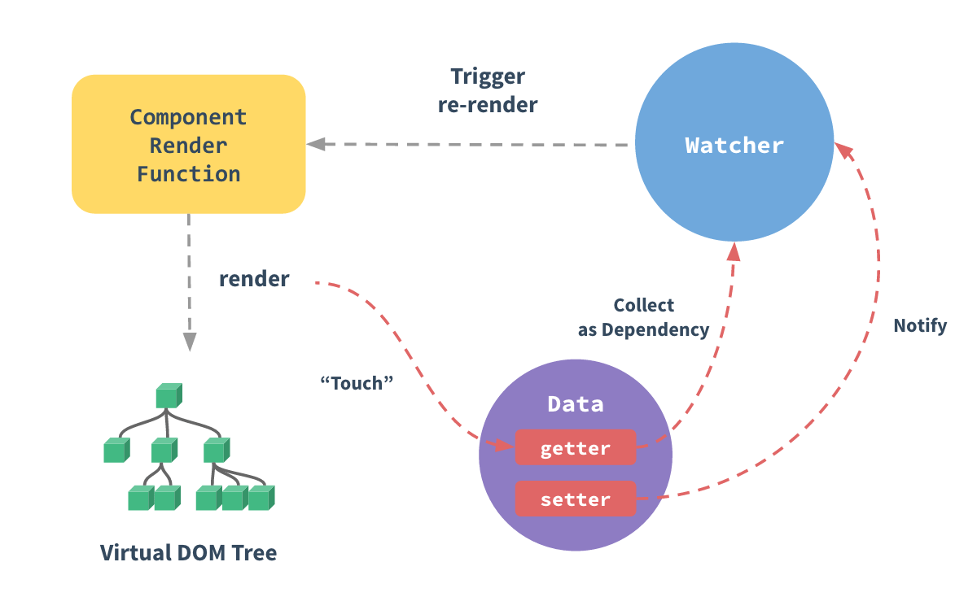

The getter/setters in above image are invisible to the user, but under the hood they enable Vue to perform dependency-tracking and change-notification when properties are accessed or modified.

Code

<iframe width="100%" height="300" src="//jsfiddle.net/RiddhiParekh/Ls4b75hy/embedded/" allowfullscreen="allowfullscreen" allowpaymentrequest frameborder="0"></iframe>

As we know data property has it’s getter and setter. Hence as soon as the variable message is updated a trigger to re-render is fired by its watcher and this is how we see the updated values in the component.

Common mistake done by developers while working with VueJs is while updating values of arrays or objects.
Developers update the values of Arrays/Objects directly i.e without using setters and expect them to be working fine as shown below.
When the properties are not predefined you do not have getters/setters on them. Hence they cannot update reflections as you expect them to be.
Problem
var myObject = {};
Now when you add a new property directly to the object using = it won’t be reactive anymore.
myObject.name = 'Updated my object name'
<iframe width="100%" height="300" src="//jsfiddle.net/RiddhiParekh/tgrLa74n/embedded/" allowfullscreen="allowfullscreen" allowpaymentrequest frameborder="0"></iframe>
You changed the actual behaviour of data property. Hence no more reactive.
Solution

Vue.set
Update the object property as below.
Vue.set(myObject,'name','Updated my object name') or this.$set can also be used.
<iframe width="100%" height="300" src="//jsfiddle.net/RiddhiParekh/tgrLa74n/11/embedded/" allowfullscreen="allowfullscreen" allowpaymentrequest frameborder="0"></iframe>
If you add (or delete) a property after Vue has instantiated (for example in a method or lifecycle hook). Vue does not know about it.
myObject['dynamicProperty'] ='dynamicValue'
Here although dynamicProperty is defined on the object but still there are no getters/setters for it:
// Don't add a property e.g. myObject. dynamicProperty = dynamicValue;
// Instead create a fresh object
var newItem = {
id: item.id,
name: item.name,
dynamicProperty: dynamicValue
};
this myObject = Object.assign({}, newItem)
<iframe width="100%" height="300" src="//jsfiddle.net/RiddhiParekh/aupgr87m/embedded/" allowfullscreen="allowfullscreen" allowpaymentrequest frameborder="0"></iframe>
Or going through the Vue.set approach also works.
Vue.set(myObject,'dynamicProperty','dynamicValue')
Do keep in mind the above applies for arrays too.
Vue wraps array methods like push, splice etc so they will also trigger view updates.
Also you may update array of arrays or array of objects in the above ways.
This is not possible when directly setting an item with the index e.g.
// This array change will not be detected:
app.myArray[index] = newVal;

Again, Vue.set comes to the rescue:
Vue.set(app.myArray, index, newVal);

