**Instructions for Running the Emotion Detection and Estimation (EDE) Paradigm (for RA)**

prepared by **Hilary Ngai, Riddhi Jain, and Frances Jin**

**Before running the experiment**

Physical set-up: keyboard and mouse

Opening the experiment file:

1. Open *Psychopy 3*
2. Click on *File* → *Open → EDE Task* (from the pinned folders in the left-hand-side tab of the file explorer) *→ “****EDE_v1_even****.psyexp”* if the subject no. of the participant is an **even number** and *“****EDE_v1_odd****.psyexp”* if the subject no. of the participant is an **odd number**.

To run the experiment:

1. Click on the green running man icon as indicated by the red arrow in the screenshot below:

1. Enter the participant’s subject no. in the pop-up window in the ‘participant’ section as seen in the screenshot below:

1. Click *OK*

**During the experiment**

Script for briefing the participant:

“This computer task takes about 20 minutes to complete.

There are many fearful face and neutral face images stored in this computer database. Each time the computer program will pick 30 face images, so some of them will be fearful faces and some of them will be neutral faces. You will see 10 of these 30 face images. For each of the 10 faces, you will identify the emotion of the image following the instructions. After viewing all 10 faces, you will be asked to estimate what percentage of the 30 faces are fearful or neutral based on the 10 faces you have just seen.

These faces will be displayed on the computer screen very shortly and according to the instructions, your task is to determine whether the face is fearful or not, or neutral or not as quickly as possible and as accurately as possible. You will need to place your dominant hand’s index finger and middle finger on the ‘V’ and ‘B’ keys. The instructions on the screen will inform you what the keys represent in terms of a response. After each 10 trials, you will answer a question that will require you to respond on a scale, for which you will need to use the mouse.

Let’s now do some practice trials so that you get an idea about the task. Please feel free to ask me any questions throughout the practice rounds, specifically regarding the instructions of the task and how to make a response.

Please try your best to respond.”

[Conduct the practice trials. **Go through the instructions on each of the slides** and answer any questions the participant may have.]

Ensure the participant understands the instructions and what’s required of them after the practice rounds.

* Ensure the participant understands how to make a response with the slider after the practice rounds. Note that they need to click on the number in the box of the scale to submit the response, as seen in the screenshot below:

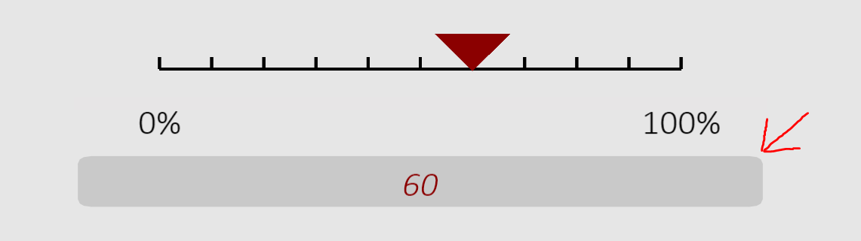

* Please make notes of any abnormal situations and record the subject no. of the participant next to the note. For example, you will need to note if there are any glitches in the experiment, if you think that the participant was falling asleep whilst doing the experiment or if the participant is clearly not paying attention to the task and submitting random responses.

**Debriefing information.**

* Debrief the participant and thank them once again; see the script below:

“Thank you so much for your time and effort in participating and completing the experiment. The aim of this study was to investigate the impacts of top-down attention on emotion-related perceptual decision-making and estimation.”