Investigating the Underlying Mechanisms of Over-Estimating the Likelihood of Threatening Stimuli along the Anxiety Spectrum.
Prepared by Riddhi Jain Pitliya
[Note: I’ve used Nature’s referencing style to allow for easy reading. The methodology is written in past tense, so it is easy to copy and paste paragraphs when writing up the manuscript.]

Introduction
Given the evolutionary salience of threatening stimuli, they are prioritized in information and perceptual processing as the cost of leaving a threat undetected (miss) is higher than the cost of misidentifying a neutral stimulus as being threatening (false alarm), and the cost of missing a threat is higher than the cost of missing a non-threatening (e.g. neutral or pleasant) stimulus.

Researchers have shown that when presented with a range of stimuli, humans automatically detect threats faster and more accurately^{1,2}; this concerns bottom-up perceptual processing – i.e., perceptual processing prompted by stimulus presentation. However, it is well-known that that the process of perception begins prior to encountering a stimulus, with top-down cognitive factors such as expectations and goals playing a key role³⁻⁷. Sussman and colleagues⁸ are the first to demonstrate that in an environment where threatening events are likely to happen, humans automatically become vigilant, orienting our attention towards signals of threats, enhancing perceptual sensitivity of threatening and non-threatening stimuli, leading to faster and more accurate detection of threat-related stimuli.

Additionally, researchers have shown that individuals with higher levels of anxiety overestimate the likelihood of threat in the environment more than individuals with lower levels of anxiety⁹⁻¹⁸. However, there are limitations to the existing investigations on estimations of likelihood of threat. Self-reported questionnaires (such as ^{19,20,21}) have been extensively relied upon by researchers to conclude overestimation of threat in anxiety¹³⁻¹⁸. These measures are highly subjective as participants are required to answer questions that are event-specific, therefore responses are prone to vary due to a high degree of individual differences in personal experience related to that event. Factors that further contribute to the subjectivity of such measures include available heuristics for the event such as recency of the event occurring, frequency of event experienced by the individual and ease of recall¹⁸. Overall, the existing literature provides a qualitative and rather subjective account of estimation, whilst failing to distinguish and conceptualise different components of generating estimations.

This study borrows concepts from mathematics to quantitatively conceptualise two components in the generation of estimations (note that estimation refers to an estimation of the likelihood of a certain stimulus). It has been generally proposed that individuals produce models of the external world using sensory evidence from the environment and produce predictions of the world according to the model^{22,23}. Therefore, this study proposes that the first component concerns estimating the likelihood of the proportion of stimulus in the population dataset (model of external world) inferred from the sample dataset (sensory evidence); this will be referred to as inferential estimation from now onwards. To elaborate, inferential estimation entails uncertainty such that the individual would not have complete information about the true probability distribution in the real world (i.e. objective probability) so they must infer an estimation based on sampling. The second component concerns prediction, where the individual estimates the likelihood of a stimulus being presented next; this phenomenon will be referred to as Bayesian estimation from now onwards as the posterior distribution is used to inform decision-making.

This study explores whether the finding of overestimation of the likelihood of threat is replicated in inferential and Bayesian estimation, along the anxiety spectrum. It is important to investigate how threat is estimated using these two distinct computational mechanisms because they implicate different cognitive dysfunctions and addressing these dysfunctions could translate into clinical interventions for anxiety patients. Enhanced inferential estimation implies lack of information due to uncertainty, thereby providing more information (more sample) would reduce overestimation. Enhanced Bayesian implies dysfunctional risk attitude, thereby intervening risk attitude would reduce overestimation tendencies.

Aims & Hypotheses
This study employs a novel method and has secondary aims to help investigate the main aim: quantitatively examine whether and how threat-oriented attention results in an inflated estimation (i.e., subjective probability) of threats in the environment, and whether this relationship is associated with anxiety severity. We first aim to (A1) examine whether and how threat stimuli are overestimated compared to neutral stimuli. Next, we (A2) examine whether and how happy stimuli overestimated compared to neutral stimuli. We will then compare the overestimations of happy stimuli with threat stimuli to (A3a) investigate whether emotive stimuli in general, compared to neutral stimuli, result in overestimations, and (A3b) whether threat stimuli result in greater extent of overestimation compared to happy stimuli. Finally, we use shapes as stimuli in the task, creating a control task, to (A4) ensure that overestimation only occurs in emotive face images – i.e., that overestimation does not occur as a tendency when any two stimuli are presented to participants.

The hypotheses are:
- H1: Threat stimuli will be overestimated compared to neutral stimuli in inferential and Bayesian estimation.
- H2: Happy stimuli will be overestimated compared to neutral stimuli in inferential and Bayesian estimation.
- H3a: Emotive (threat and happy) stimuli will be overestimated compared to non-emotional (neutral) stimuli in inferential and Bayesian estimation.
- H3b: Threat stimuli will be overestimated compared to happy stimuli in Bayesian estimation only.
- H4: There will be no difference in estimation between the different shapes in inferential and Bayesian estimation.

Methodology
Participants
Participants fluent in English were recruited from the University of Hong Kong (HKU), using poster advertisements and a research participant portal for undergraduate students. Given the rapid presentation of stimuli in the experimental task, it was ensured that participants did not have any history or current diagnosis of seizures or attention-related disorders such as attention deficit hyperactivity disorder (ADHD).

Participants came into the research laboratory at HKU, where they provided consent for their participation after reading the study information sheet. All participants were monetarily compensated for their participation with 50 HKD or course credits. All data from participants was labelled by a 6-digit subject ID to ensure anonymity and confidentiality of personal identifiers. Ethical approval for conducting this study was provided by the Departmental Research Ethics Committee at the Department of Psychology, The University of Hong Kong.

Self-reported Measures
Participants completed the Spielberger State-Trait Anxiety Inventory (STAI)²⁴, Generalized Anxiety Disorder 7-item (GAD-7)²⁵, Liebowitz Social Anxiety Scale (LSAS-SR)²⁶ and Penn State Worry Questionnaire (PSWQ)²⁷.

STAI is designed to measure state level (STAI-S; α=0.881) and trait level (STAI-T; α=0.872) anxiety in adults²⁸, which form the two subscales. There are 20 items in each subscale, and participants respond on a 4-point Likert scale, producing a score between 20-80 for each subscale.

GAD-7 is a seven-item self-report anxiety questionnaire designed to assess generalised anxiety disorder in adults in the previous 2 weeks. The GAD-7 has sensitivity of 89% and specificity of 82% for generalized anxiety disorder; it is also moderately good at screening for panic disorder (sensitivity 74%, specificity 81%) and social anxiety disorder (sensitivity 72%, specificity 80%)²⁹.

LSAS contains 13 social and 11 performance situations that are rated on 4-point (0–3) scales of fear/anxiety and avoidance. A number of subscale scores can be derived from the LSAS including total fear, fear of social interactions, fear of performance, total avoidance, avoidance of social interactions, avoidance of performance, total performance, and total social interaction. The LSAS has good psychometric metrics³⁰.

PSWQ is a 16-item questionnaire to measure worry. It possesses high internal consistency and good test-retest reliability²⁷.

Stimuli
The stimuli comprised of Asian fearful (FF), happy (HF) and neutral face images (NF) from the University of Hong Kong Face Database³¹. There were 5 people (3 males, 2 females) whose face images are taken from the database and they each have an FF, HF and NF (see Appendix 1A for examples of FF and NF), yielding 15 face images in total.

All face images were first manually cropped to 300 x 300 pixels using Adobe Photoshop such that all facial features (eyebrows, eyes, nose, mouth) were within the cropped image; the ears and hair were excluded. All images were converted to grayscale. The cropped face images were processed through the SHINE toolbox in MATLAB³², using the lumMatch algorithm to equalize low-level physical properties such as luminance and contrast. Each stimulus was presented at 0.2 contrast level.

8 mask images were created: 4 were created out of 1 male FF, 1 female FF, 1 male NF, 1 female NF randomly selected faces, and the remaining 4 were created out of 1 male HF, 1 female HF, 1 male NF, 1 female NF randomly selected faces. Each mask image was generated by averaging the 4 faces by segmenting them into 100 blocks and randomly reorganizing the blocks. These masks were also equalized for contrast and luminance using the SHINE toolbox in MATLAB.

There are also two shapes used as stimuli: square and triangle. They were generated on Microsoft Powerpoint for Mac Version 16.46, and the size of the shapes are 300 x 300 pixels.

Task Description
There were three versions of a task that each participant completed, which varied in the combination of stimuli used: Task_FN (task with fear and neutral face stimuli) where FF (Stim1) and NF (Stim2) were presented, Task_HN (task with happy and neutral face stimuli) where HF (Stim1) and NF (Stim2) were presented and Task_S (task with shape stimuli) where squares (Stim1) and triangles (Stim2) were presented. The general task is described below in terms of Stim1 and Stim2, where Stim1 and Stim2 can be replaced for each variation of the task according to the stimuli specified in the previous sentence (e.g., for Task_FN, Stim1 symbolises FF and Stim2 symbolises NF).

The experiment began with the general instructions (see Appendix 2 for an example in Task_Fear). In these instructions, participants were told that the computer has a database comprising of many Stim1 and Stim2. They were then told that the computer randomly selects 100 images from this database and that from this 100-image-dataset, 30 images would be randomly selected. Participants were informed that they would be presented with these 30 images in a rapid sequence and that they will be answering three questions related to the 30 images.

Endogenous attention was manipulated by asking the participants to answer questions (detailed below) from Stim1 perspective in the Stim1 blocks (S1-block) versus Stim2 perspective in the Stim2 blocks (S2-block). Participants completed six blocks of trials that alternated between S1-block and S2-block. The blocks were counterbalanced between participants such that participants with even number subject IDs experienced S1-S2-S1-S2-S1-S2- blocks and participants with odd number subject IDs experienced S2-S1-S2-S1-S2-S1- blocks (see Appendix 1C for an example in Task_Fear). Prior the actual experimental trials, participants completed two practice trials, one from S1-block and one from S2-block. The order of these practice trials was counterbalanced according to the counterbalanced block-type sequence participants completed.

Within each block, there were five trials that were pseudo-randomly sequenced. Each trial consisted of 30 stimuli that were pseudo-randomly sequenced as well. Note that for each S1-block, there was an identical S2-block regarding trial sequence. Objective probability of the proportion of S1 and S2 in the stream of 30 stimuli was manipulated across five levels: 10%, 20%, 50%, 80% or 90%. In the S1-block, the objective probability of 10% indicated 10% of the 30 stimuli were Stim1; similarly, in the S2-block, the objective probability of 10% indicated 10% of the 30 stimuli were Stim2. In the pseudo-randomised order of the 30 stimuli that involved faces, it was ensured that no more than three face images of the same person would be presented consecutively. Also, at the objective probability of 50%, it was ensured that no more than three face images of the same facial expression (i.e. fearful/happy or neutral) were presented consecutively. The pseudo-randomised list of stimuli in each trial is the same across the three variations of the tasks (i.e., block 1 trial 1’s list in Task_FN is the same as block 1 trial 1 in Task_HN and Task_S). Overall, the experiment comprised of 32 trials in total, with 2 practice trials and 30 experimental trials. Throughout the task, each participant completed 3 repetitions of each experimental manipulation combination – endogenous attention (2 levels) x objective probability manipulation (5 levels). Throughout the experiment, each participant completed the three variations of the task, in an order that was counterbalanced between participants:
- Counterbalance A: Task_Fear, Task_Happy, Task_Shapes
- Counterbalance B: Task_Fear, Task_Shapes, Task_Happy
- Counterbalance C: Task_Shapes, Task_Fear, Task_Happy
- Counterbalance D: Task_Shapes, Task_Happy, Task_Fear
- Counterbalance E: Task_Happy, Task_Shapes, Task_Fear
- Counterbalance F: Task_Happy, Task_Fear, Task_Shapes

Each trial began with a fixation cross which was jittered between 1-3 seconds, and this was followed by a mask image for 0.3 seconds. The (pseudo-random) series of 30 stimuli were then displayed, with each stimulus displayed for 0.1 seconds. Another mask image then followed; it was presented for 0.3 seconds. Then, three questions are presented regarding the proportion of Stim1 and Stim2 participants saw in the stream of 30 stimuli depending on the type of block (i.e. S1-/S2-block).

In Question 1, according to the block-type, participants were asked “What is the proportion of [Stim1/Stim2] in the 30 face-images/shapes you just saw?”. Participants responded on a scale of 1 to 100 with 5-unit increments. This question was designed to understand how many of Stim1/Stim2 the participant perceived in the stream of stimuli; this dependent variable is called Perceived Estimation.

In Question 2, participants were asked “What proportion of [Stim1/Stim2] do you think are in the 100 face-images/shapes?”. Participants responded on a scale of 1 to 100 with 5-unit increments. This question was designed to ask participants to infer from the sample of 30 stimuli they had just seen and estimate the proportion of Stim1/Stim2 that would be in the 100-image-dataset from which the 30 images they saw were randomly selected. As the participants were required to infer from their perceived sample data to the dataset population, this question recorded the Inferred Estimation.

Finally, in Question 3, depending on the block-type, participants implicitly indicated, through a series of decisions, what they believe the probability is of one selected image from the 100 -image-dataset to be Stim1/Stim2. The purpose of Question 3 was to measure the Bayesian Estimation. To elaborate, in Question 3, the participant’s subjective value of a probabilistic outcome was obtained by quantitatively arriving at a theoretical indifferent point between a sure gain and a probabilistic gain, derived from previous work on subjective probability and inspired by the concept of willingness-to-accept^{33,34}. This method would be best illustrated with an example. The participant would be told that one stimulus was selected from the 100-image-dataset. The participant would then asked which options they preferred out of two options: (A) a sure gain of 8 tokens or (B) a gain of 10 tokens if the image randomly selected earlier by the computer is Stim1/Stim2 and 0 tokens otherwise; note that option B would state Stim1 or Stim2 according to the block-type. If the participant chose option (A), it indicated that they believed the chance of the one image being a Stim1/Stim2 is lower than 80% (8-tokens/10-tokens). Then, option (A) would be changed to ‘a sure gain of 2 tokens’. If the participant chose option (B), it was inferred that the participant believed the chance of the one image being Stim1/Stim2 is larger than 20% (2-tokens/10-tokens). This process of asking participants to choose between options (A), a sure gain, and (B), a risk, was repeated until an indifference point was deciphered through the staircasing method within each trial; the indifference point is the Bayesian Estimation. The participants were told to aim to gain as many tokens as possible.

It is worth noting that the present study implemented two-level staircasing, adapted from a method that is commonly used in psychophysics experiments³⁵, to quickly arrive at the indifference point. The first level of staircasing assumed that the participant’s indifference point would lie close to the objective probability, therefore the alteration of the number of tokens in option (A) after every response made by the participant would first be ±1, then ±2 and lastly ±3. Again, this method would be best illustrated with an example. When the objective probability manipulation is at 20%, the corresponding number of tokens is 2. The following is the calculation that occurs at the first level of staircasing: 2-1 = 1, 2+1 = 3, 3+2 = 5, 5+3 = 8. Therefore, the number of tokens in option (A) at first level of staircasing would be 1,2,3,5,8 for the trials with the objective probability level of 20%. See Table 1 for the full list of number of tokens in option (A) at first level of staircasing and the order in which they are presented.
The second level of staircasing would instigate ±1 between the points of indifference at the first level of staircasing. Elaborating the previous example, at the 20% proportion level, participants would first be asked which option they prefer between option (A) a sure gain of 8 tokens or (B) a gain of 10 tokens if the one image randomly selected earlier is Stim1/Stim2 and 0 tokens otherwise. If the individual selected (A), the subjective probability would be less than 80%. Then option (A) would be changed to 1 token. If the participant chose option (B), then the subjective probability was higher than 10%. Option (A) would then be changed to 5 tokens. If the participant selected (B), then the subjective probability was higher than 50%. So far, the participant’s behavioural choices reflect that the subjective probability lies between 50% and 80%. Now, the second level of staircasing would be incorporated: option (A) would be presented as 7 tokens. If the participant selected (B), the subjective probability was higher than 70%. Option (A) would finally change to 8 tokens to confirm that the subjective probability lies between 70% and 80%. If the participant selected option (A), they affirmatively indicate a subjective probability below 80%. Therefore, the subjective probability is between 70% and 80%; the present study interpreted and recorded this as 75%. In general, according to the participants choices, the number of tokens in option (A) would change until the system arrives at an indifference point which is attained when the participant affirms their subjective probability lies between two probabilities; the middle number between these two probabilities are recorded. See Appendix C for full details on how the system would change the number of tokens offered in option (A) to arrive at an indifference point for each objective probability manipulation level.

References
1 Hansen, C. H. & Hansen, R. D. Finding the face in the crowd: an anger superiority effect. Journal of personality and social psychology 54, 917 (1988).
2 Öhman, A., Flykt, A. & Esteves, F. Emotion drives attention: detecting the snake in the grass. Journal of experimental psychology: general 130, 466 (2001).
3 Bacon, W. F. & Egeth, H. E. Overriding stimulus-driven attentional capture. Perception & psychophysics 55, 485-496 (1994).
4 Gregory, R. L. Perceptual illusions and brain models. Proceedings of the Royal Society of London. Series B. Biological Sciences 171, 279-296 (1968).
5 Itti, L. & Koch, C. Computational modelling of visual attention. Nature reviews neuroscience 2, 194-203 (2001).
6 Summerfield, C. & De Lange, F. P. Expectation in perceptual decision making: neural and computational mechanisms. Nature Reviews Neuroscience 15, 745-756 (2014).
7 Summerfield, C. et al. Predictive codes for forthcoming perception in the frontal cortex. Science 314, 1311-1314 (2006).
8 Sussman, T. J., Weinberg, A., Szekely, A., Hajcak, G. & Mohanty, A. Here comes trouble: prestimulus brain activity predicts enhanced perception of threat. Cerebral Cortex 27, 2695-2707 (2017).
9 Aue, T. & Okon-Singer, H. Expectancy biases in fear and anxiety and their link to biases in attention. Clinical Psychology Review 42, 83-95, doi:https://doi.org/10.1016/j.cpr.2015.08.005 (2015).
10 Taylor, S. & Rachman, S. J. Stimulus estimation and the overprediction of fear. Br J Clin Psychol 33, 173-181, doi:10.1111/j.2044-8260.1994.tb01108.x (1994).
11 Grupe, D. W. & Nitschke, J. B. Uncertainty and anticipation in anxiety: an integrated neurobiological and psychological perspective. Nature Reviews Neuroscience 14, 488-501 (2013).
12 Paulus, M. P. & Yu, A. J. Emotion and decision-making: affect-driven belief systems in anxiety and depression. Trends in Cognitive Sciences 16, 476-483, doi:https://doi.org/10.1016/j.tics.2012.07.009 (2012).
13 Gasper, K. & Clore, G. L. The persistent use of negative affect by anxious individuals to estimate risk. Journal of Personality and Social Psychology 74, 1350-1363, doi:http://dx.doi.org/10.1037/0022-3514.74.5.1350 (1998).
14 Sookman, D. & Pinard, G. in Cognitive Approaches to Obsessions and Compulsions (eds Randy O. Frost & Gail Steketee) 63-89 (Pergamon, 2002).
15 Moritz, S. & Jelinek, L. Inversion of the “Unrealistic Optimism” Bias Contributes to Overestimation of Threat in Obsessive-Compulsive Disorder. Behavioural and Cognitive Psychotherapy 37, 179-193, doi:10.1017/S1352465808005043 (2009).
16 van Oppen, P. & Arntz, A. Cognitive therapy for obsessive-compulsive disorder. Behaviour Research and Therapy 32, 79-87, doi:https://doi.org/10.1016/0005-7967(94)90086-8 (1994).
17 Steketee, G. & Frost, R. O. Measurement of risk-taking in obsessive-compulsive disorder. Behavioural and Cognitive Psychotherapy 22, 287-298 (1994).
18 Butler, G. & Mathews, A. Anticipatory anxiety and risk perception. Cognitive Therapy and Research 11, 551-565, doi:10.1007/BF01183858 (1987).
19 Obsessive Compulsive Cognitions Working Group. Cognitive assessment of obsessive-compulsive disorder. Behaviour Research and Therapy 35, 667-681 (1997).
20 Steketee, G., Frost, R. O. & Cohen, I. Beliefs in obsessive-compulsive disorder. Journal of anxiety disorders 12, 525-537 (1998).
21 Freeston, M. H., Ladouceur, R., Gagnon, F. & Thibodeau, N. Beliefs about obsessional thoughts. Journal of Psychopathology and Behavioral Assessment 15, 1-21 (1993).
22 Friston, K. The free-energy principle: a unified brain theory? Nature reviews neuroscience 11, 127-138 (2010).
23 Friston, K. & Kiebel, S. Predictive coding under the free-energy principle. Philosophical Transactions of the Royal Society B: Biological Sciences 364, 1211-1221 (2009).
24 Spielberger, C., Gorsuch, R., Lushene, R., Vagg, P. & Jacobs, G. Manual for the state-trait anxiety scale. Consulting Psychologists (1983).
25 Spitzer, R. L., Kroenke, K., Williams, J. B. & Löwe, B. A brief measure for assessing generalized anxiety disorder: the GAD-7. Arch Intern Med 166, 1092-1097, doi:10.1001/archinte.166.10.1092 (2006).
26 Liebowitz, M. R. Social phobia. Modern problems of pharmacopsychiatry (1987).
27 Meyer, T. J., Miller, M. L., Metzger, R. L. & Borkovec, T. D. Development and validation of the Penn State Worry Questionnaire. Behav Res Ther 28, 487-495, doi:10.1016/0005-7967(90)90135-6 (1990).
28 Guillén-Riquelme, A. & Buela-Casal, G. [Meta-analysis of group comparison and meta-analysis of reliability generalization of the State-Trait Anxiety Inventory Questionnaire (STAI)]. Rev Esp Salud Publica 88, 101-112, doi:10.4321/s1135-57272014000100007 (2014).
29 Kroenke, K., Spitzer, R. L., Williams, J. B., Monahan, P. O. & Löwe, B. Anxiety disorders in primary care: prevalence, impairment, comorbidity, and detection. Annals of internal medicine 146, 317-325 (2007).
30 Heimberg, R. G. et al. Psychometric properties of the Liebowitz social anxiety scale. Psychological medicine 29, 199-212 (1999).
31 Zhang, J., Chan, A. B., Lau, E. Y. Y. & Hsiao, J. H. Vol. 42 1-11 (Oxford University Press, United Kingdom, 2019).
32 Willenbockel, V. et al. Controlling low-level image properties: The SHINE toolbox. Behavior research methods 42, 671-684, doi:10.3758/BRM.42.3.671 (2010).
33 De Finetti, B. Vol. I 94-97 (1977).
34 Savage, L. J. The Foundations of Statistics. (Dover Publications, 1972).
35 Cornsweet, T. N. The staircase method in psychophysics. The American Journal of Psychology 75, 485-491, doi:10.2307/1419876 (1962).

Appendices
Appendix 1. Experimental Task Design

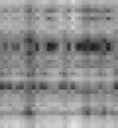
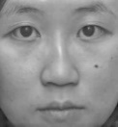

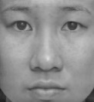
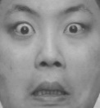
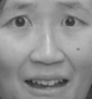
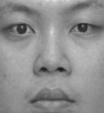
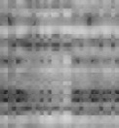
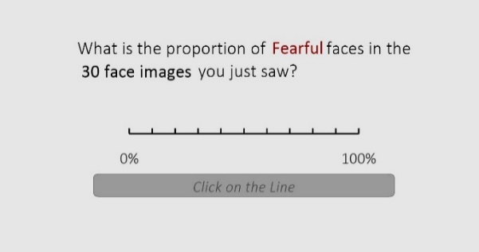
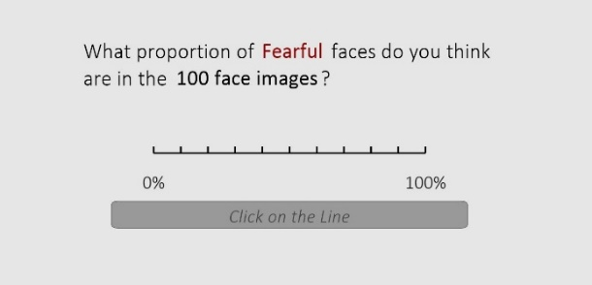
3200ms in total:
100ms per face; 30 face images + 2 masks
The computer has randomly selected 1 face image out of the 100 face images dataset.
If you were to gamble about whether this face is FEARFUL, which option would you prefer?
Option 1:
A sure gain of 8 tokens
Option 2:
A gain of 10 tokens if the face is Fearful or 0 tokens otherwise
LEFT key = Option 1 RIGHT key = Option 2
Now which option do you prefer?
Option 1:
A sure gain of 4 tokens
Option 2:
A gain of 10 tokens if the face is Fearful or 0 tokens otherwise
LEFT key = Option 1 RIGHT key = Option 2
(A) Stimulus Presentation:
(B) The Three Questions:
Question 1:
Question 2:
Question 3:
(C) Block-type and sequence
Even-numbered Subject ID:
Odd-numbered Subject ID:
Fear-block
Neutral-block
Fear-block
Neutral-block
Fear-block
Neutral-block
Neutral-block
Fear-block
Neutral-block
Fear-block
Neutral-block
Fear-block

Appendix 2: Instructions Given to Participants for Experimental Task
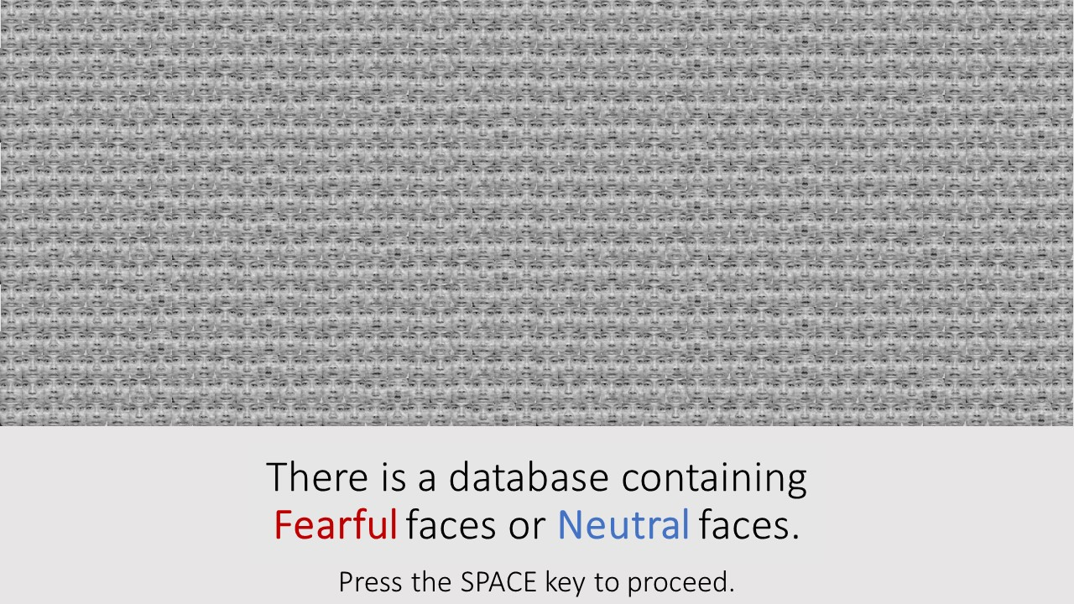
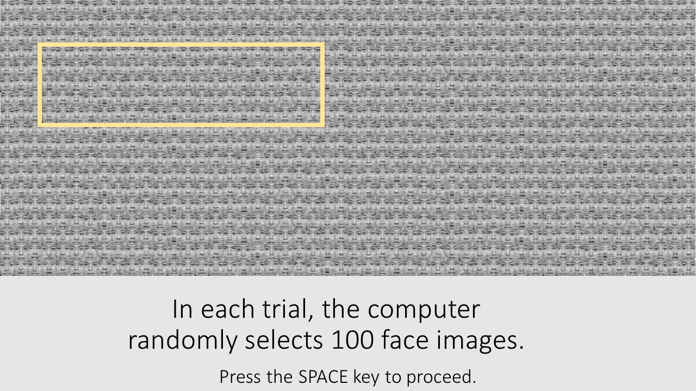
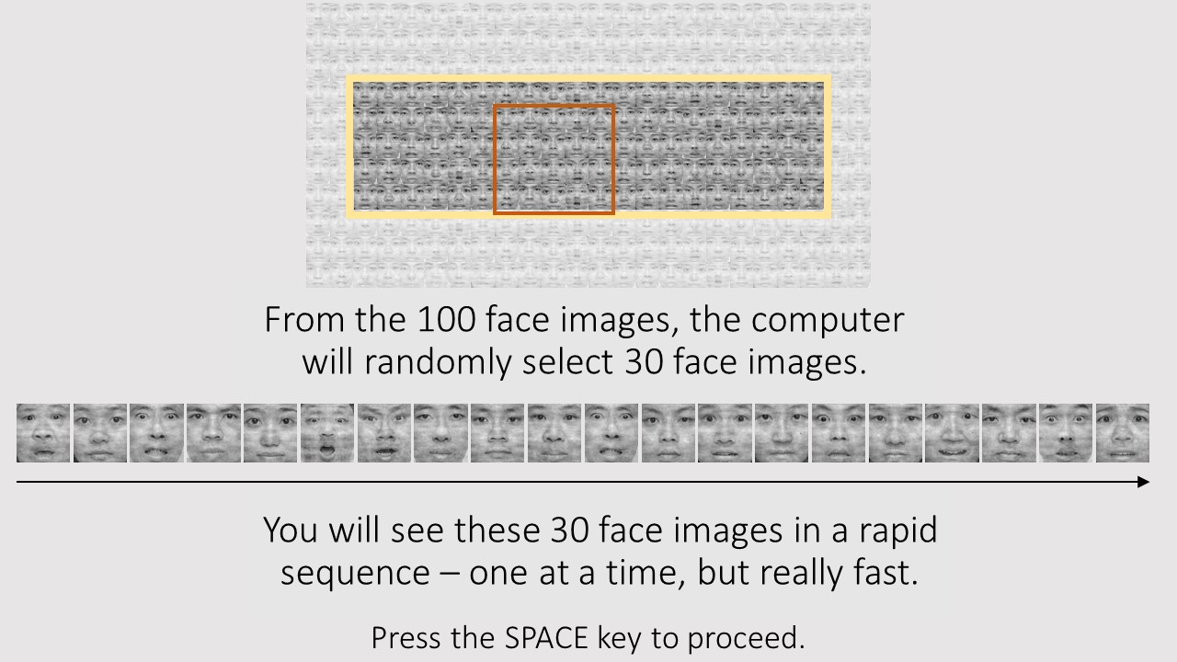
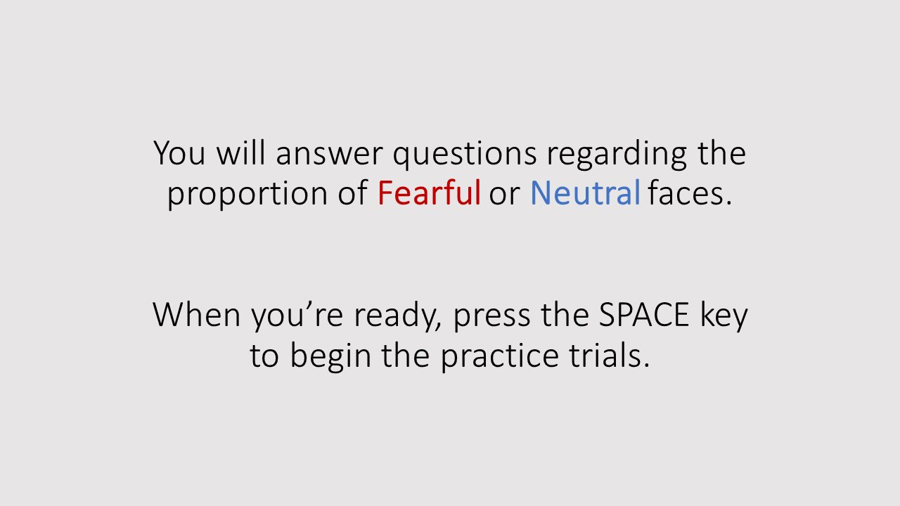

Appendix 3: Tree Diagram Illustrating How the System in Question 3 of the Experimental Task
