EMAIL/SMS SPAM DETECTION
PROJECT REPORT
NLP-Based Text Classification — Model Comparison & Selection
Dataset: SMS Spam Collection (spam.csv)
Approach: NLP Preprocessing → TF-IDF Vectorization → Multi-Model Comparison
July 2026

Executive Summary
This report documents an SMS spam classification project built on the SMS Spam Collection dataset (5,572 raw messages, refined to 5,169 after de-duplication). Messages were cleaned, labeled, and passed through a custom NLP pipeline — lowercasing, tokenization, stopword and punctuation removal, and Porter stemming — before being vectorized with TF-IDF (top 3,000 features).
Eleven classification algorithms were trained and compared on accuracy and precision, with precision treated as the priority metric since misclassifying a genuine message as spam is more costly than letting an occasional spam message through. Random Forest posted the single highest precision (98.3%), but Multinomial Naive Bayes was selected as the final production model for its strong, consistent balance of accuracy (97.9%) and precision (94.6%), its natural fit with TF-IDF text features, and its lightweight, fast inference profile. The final model and vectorizer were serialized for reuse.
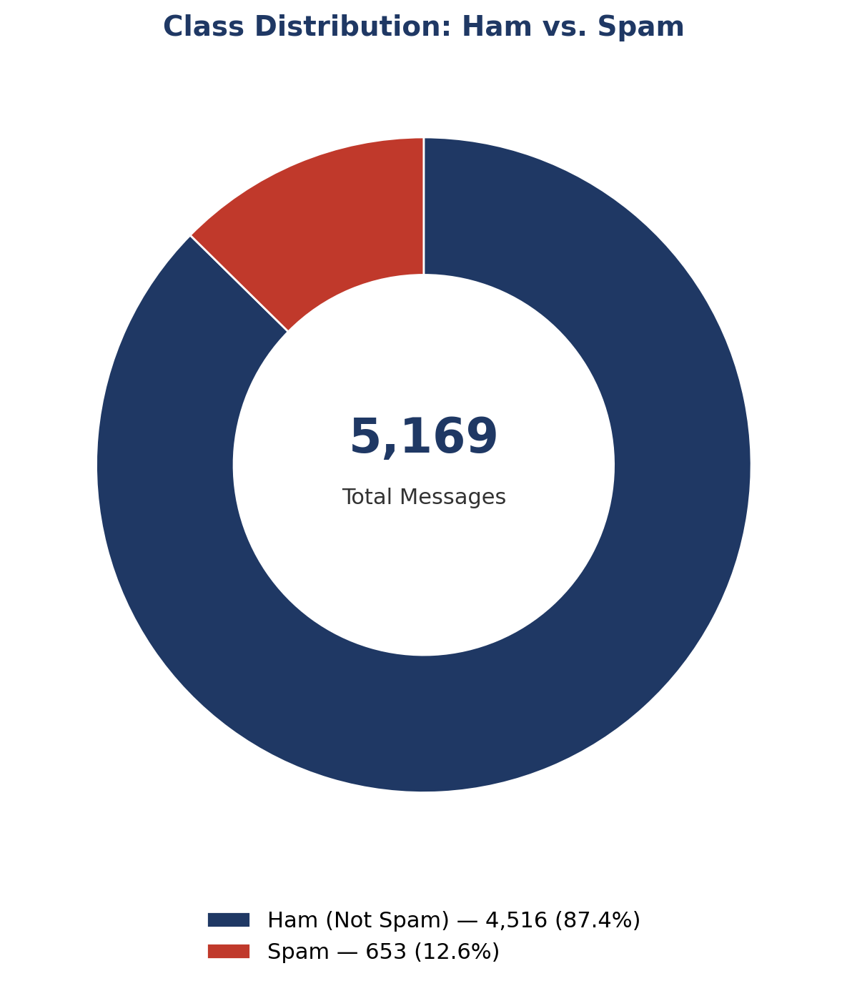
Headline Result:
The final Multinomial Naive Bayes model achieves 97.9% accuracy and 94.6% precision — out of every ~100 messages it flags as spam, roughly 95 genuinely are, with only 7 real messages misclassified as spam out of 896 in the test set.

1. Project Overview & Dataset
SMS spam filtering is a classic text classification problem, but a practically important one: false positives (blocking a real message) are far more costly to a user than false negatives (letting a spam message through). This shaped both the modeling approach and the metric used to select the final model.
Attribute | Value
Source file | spam.csv (latin-1 encoded)
Raw records | 5,572 messages, 5 columns
Duplicates removed | 403
Final dataset size | 5,169 messages, 2 columns
Classes | Ham (0) / Spam (1)
Ham messages | 4,516 (87.4%)
Spam messages | 653 (12.6%)

Note:
The 87/13 class split makes this an imbalanced classification problem — a key reason accuracy alone is not a sufficient evaluation metric, and precision/recall were tracked throughout.

2. Data Cleaning & Exploratory Data Analysis

Cleaning Steps
- Dropped three unnamed, mostly-empty columns retained from the raw CSV export.
- Renamed columns v1 → target, v2 → text.
- Label-encoded the target: ham = 0, spam = 1.
- Removed 403 exact duplicate rows (5,572 → 5,169 records).
- Confirmed zero missing values in either column post-cleaning.

Message Length Analysis
Character, word, and sentence counts were computed per message using NLTK tokenization. Spam messages are consistently longer and more sentence-dense than ham messages — a strong early signal for the classifier.
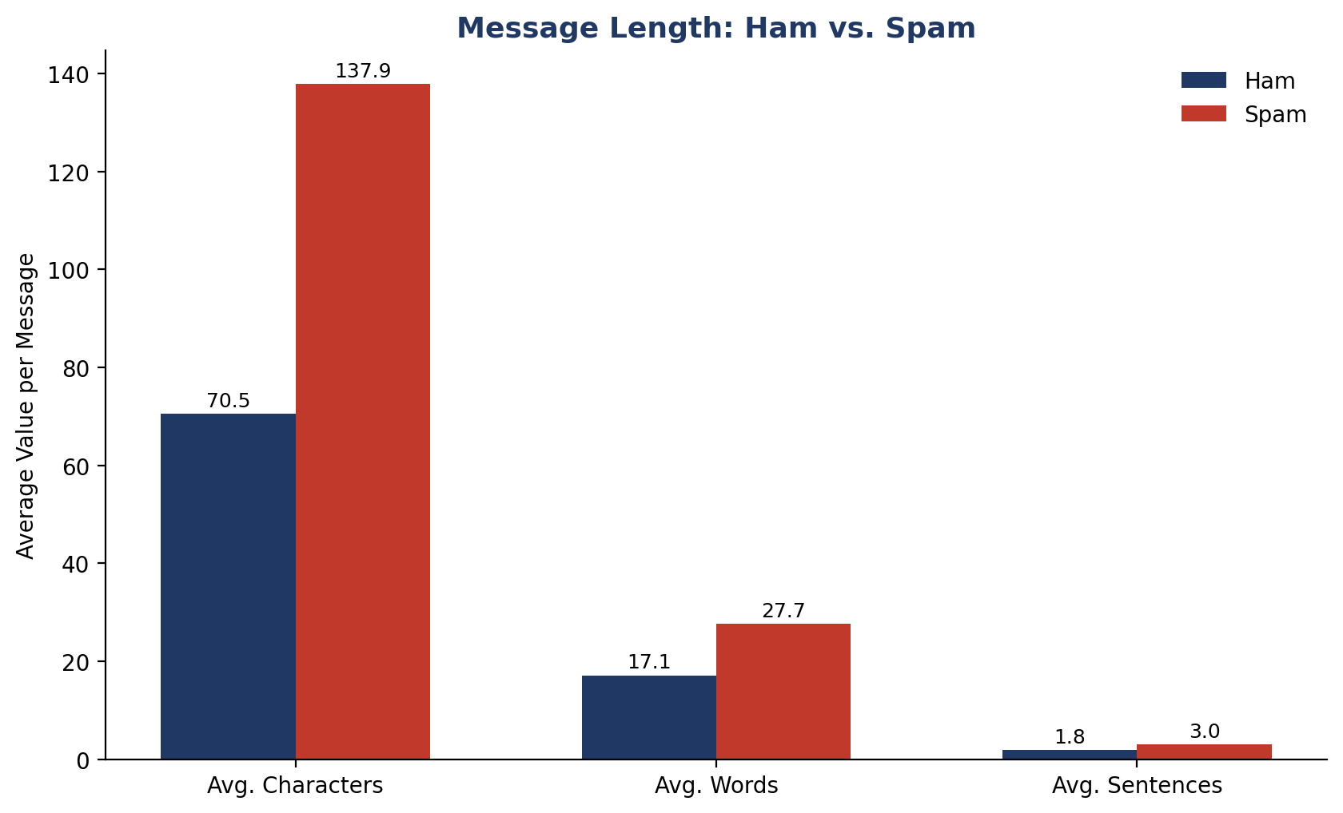
Statistic | Ham — Mean | Spam — Mean
Characters | 70.46 | 137.89
Words | 17.12 | 27.67
Sentences | 1.82 | 2.97

Insight:
Spam messages average nearly double the character count and word count of ham messages, and are almost 3 sentences long on average versus under 2 for ham — consistent with promotional / call-to-action spam copy.

Word clouds and top-30 word-frequency plots were also generated separately for spam (9,939 total tokens after preprocessing) and ham (35,404 total tokens) vocabularies during EDA to visually inspect vocabulary differences between the two classes (see notebook for the rendered word clouds).
3. Text Preprocessing Pipeline
A custom transform_text() function was used to normalize every message before vectorization:
- Lowercase the entire message.
- Tokenize using NLTK's word tokenizer.
- Keep only alphanumeric tokens (strip punctuation-only tokens).
- Remove English stopwords and punctuation characters.
- Apply Porter stemming to reduce words to their root form (e.g. "loving" → "love").
Example transformation:
"I'm gonna be home soon and i don't want to talk about this stuff anymore tonight, k? I've cried enough today." → "gon na home soon want talk stuff anymor tonight k cri enough today"

4. Feature Engineering
Cleaned text was converted to numerical features using TF-IDF (Term Frequency–Inverse Document Frequency), capturing how distinctive each word is to a message relative to the full corpus.

Step | Configuration
Vectorizer | TfidfVectorizer(max_features=3000)
Resulting feature matrix | 5,169 messages × 3,000 features
Scaling | MinMaxScaler applied to the TF-IDF matrix
Train/test split | 80% / 20% (random_state=2)

5. Model Comparison
Eleven classification algorithms were trained on identical TF-IDF features and evaluated on the same held-out test set (1,034 messages), scored on both accuracy and precision.
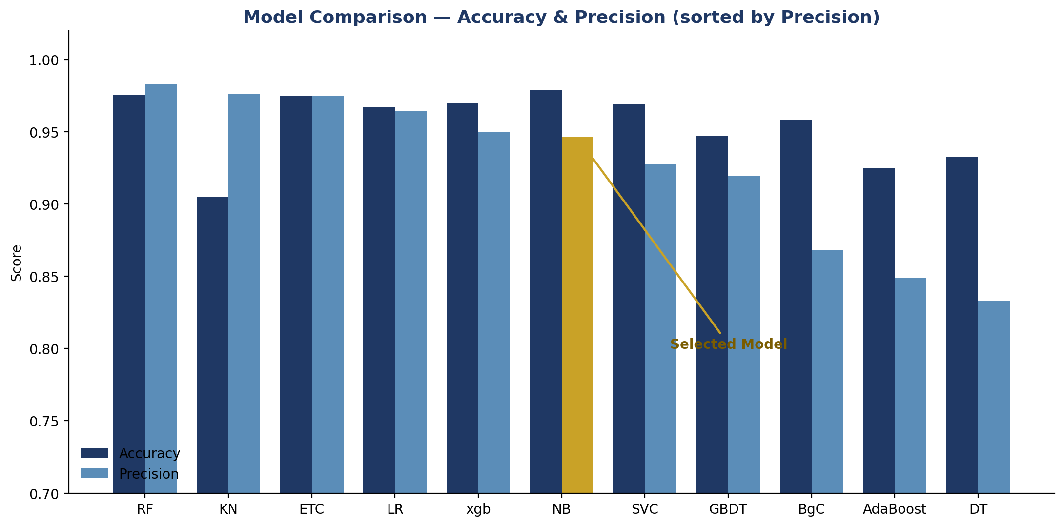
Algorithm | Accuracy | Precision
Random Forest | 97.58% | 98.29%
K-Nearest Neighbors | 90.52% | 97.62%
Extra Trees | 97.49% | 97.46%
Logistic Regression | 96.71% | 96.43%
XGBoost | 97.00% | 94.96%
Multinomial Naive Bayes (selected) | 97.87% | 94.62%
SVM (sigmoid kernel) | 96.91% | 92.74%
Gradient Boosting | 94.68% | 91.92%
Bagging Classifier | 95.84% | 86.82%
AdaBoost | 92.46% | 84.88%
Decision Tree | 93.23% | 83.33%

6. Ensemble Methods Tested
Two ensemble strategies combining the strongest individual models (SVM, Naive Bayes, Extra Trees) were also evaluated:
Ensemble Method | Configuration | Accuracy | Precision
Voting Classifier (soft) | SVM + Naive Bayes + Extra Trees | 97.97% | 96.80%
Stacking Classifier | Same base learners, Random Forest meta-learner | 97.87% | 93.28%

Why ensembling wasn't the final choice:
Both ensembles matched but did not clearly exceed the precision of simpler standalone models like Random Forest or Multinomial Naive Bayes, while adding meaningful complexity and inference cost — not a favorable trade-off for this use case.

7. Final Model: Multinomial Naive Bayes
Multinomial Naive Bayes was selected as the final production model. While Random Forest scored marginally higher on precision, MultinomialNB offers a strong, consistent balance of accuracy and precision, pairs naturally with TF-IDF/count-based text features, trains and predicts near-instantly, and has no hyperparameters requiring extensive tuning — a practical, reliable choice for a text classification task at this scale.
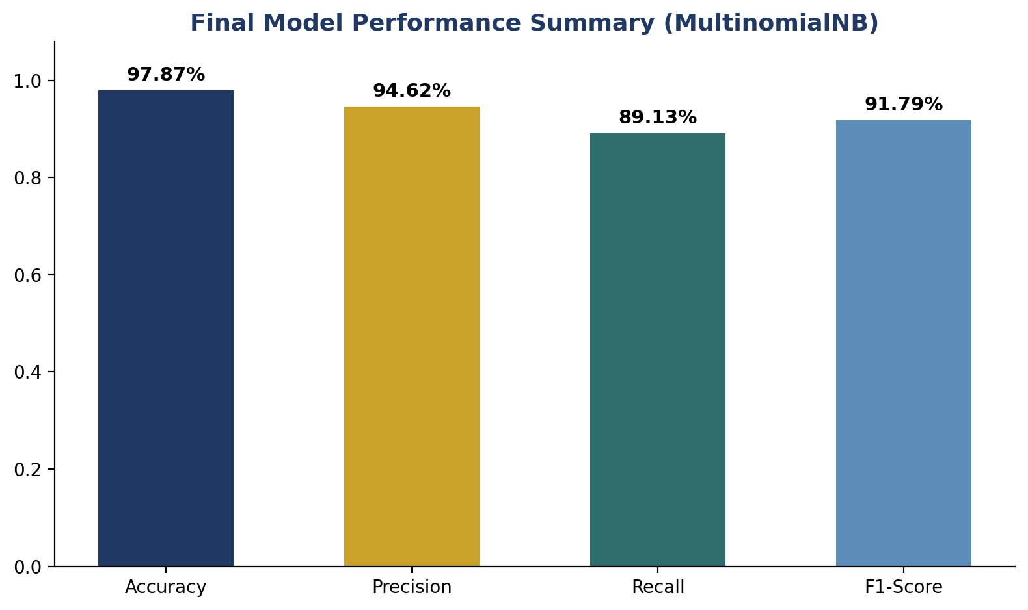
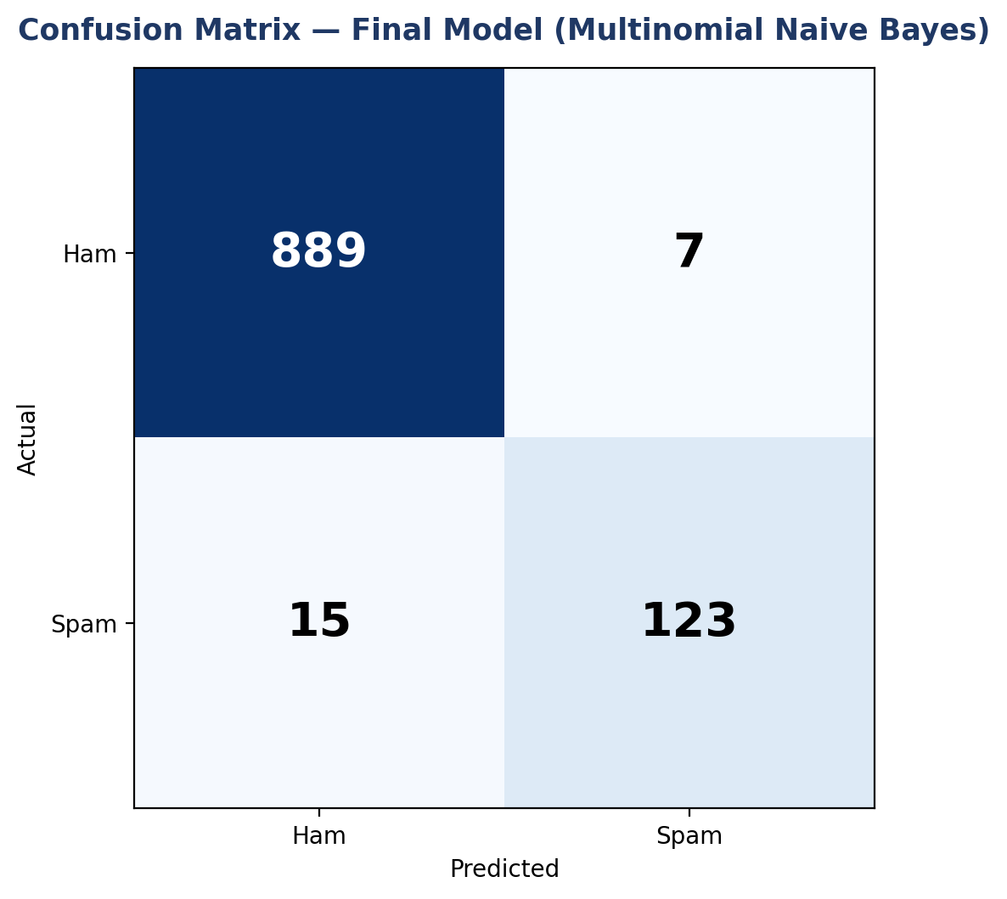
Metric | Value | Interpretation
Accuracy | 97.87% | Overall share of correctly classified messages
Precision | 94.62% | Of messages predicted spam, 94.6% truly are spam
Recall | 89.13% | Of all true spam messages, 89.1% were correctly caught
F1-Score | 91.79% | Harmonic mean of precision and recall

Test set breakdown (n = 1,034):
889 ham messages correctly identified, 7 ham messages incorrectly flagged as spam, 15 spam messages missed (classified as ham), and 123 spam messages correctly caught.

8. Model Serialization & Deployment
The fitted TF-IDF vectorizer and the final Multinomial Naive Bayes model were serialized with pickle for reuse outside the training notebook:
- vectorizer.pkl — the fitted TfidfVectorizer, required to transform new raw text into the same 3,000-feature space.
- model.pkl — the trained MultinomialNB classifier.
At inference time, a new message is passed through the same transform_text() preprocessing, vectorized with the saved TF-IDF vectorizer, and classified by the saved model — ensuring training and inference use identical feature representations.

9. Key Insights & Recommendations

Insights
- Spam messages are structurally different from ham: nearly 2x the character/word count and more sentence-dense, making length-based features informative even before vectorization.
- Precision varied more across models (83.3%–98.3%) than accuracy (90.5%–97.9%), confirming precision is the more discriminating metric for this imbalanced, cost-sensitive problem.
- Random Forest achieved the single highest precision (98.3%), but Multinomial Naive Bayes was chosen for its balance of performance, simplicity, and inference speed.
- Ensembling (voting and stacking) did not clearly outperform the best standalone models, suggesting the individual top models are already capturing most of the separable signal in the TF-IDF feature space.
- The final model still misses roughly 1 in 9 spam messages (89.1% recall) — an acceptable trade-off given the priority on minimizing false positives on genuine messages.

Recommendations
- If false negatives (missed spam) become more costly in practice, revisit Random Forest or an ensemble approach and re-optimize the precision/recall trade-off.
- Address class imbalance explicitly (e.g. class weighting, SMOTE) rather than relying solely on the precision metric to manage it.
- Periodically retrain on newer message samples, since spam language patterns (links, offers, phrasing) evolve over time and can degrade a static model's precision.
- Consider embedding-based features (Word2Vec, transformer embeddings) as a follow-up experiment to see if they outperform TF-IDF on this dataset.

