ASSIGNMENT-1

PROJECTION
1 | Write a query to display all the details from the EMPLOYEE table.  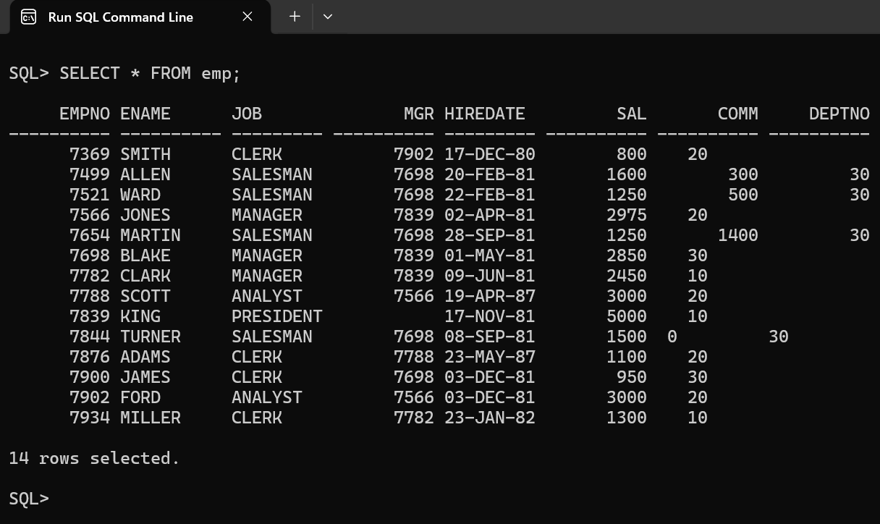
2 | Write a query to display names of all the employees.  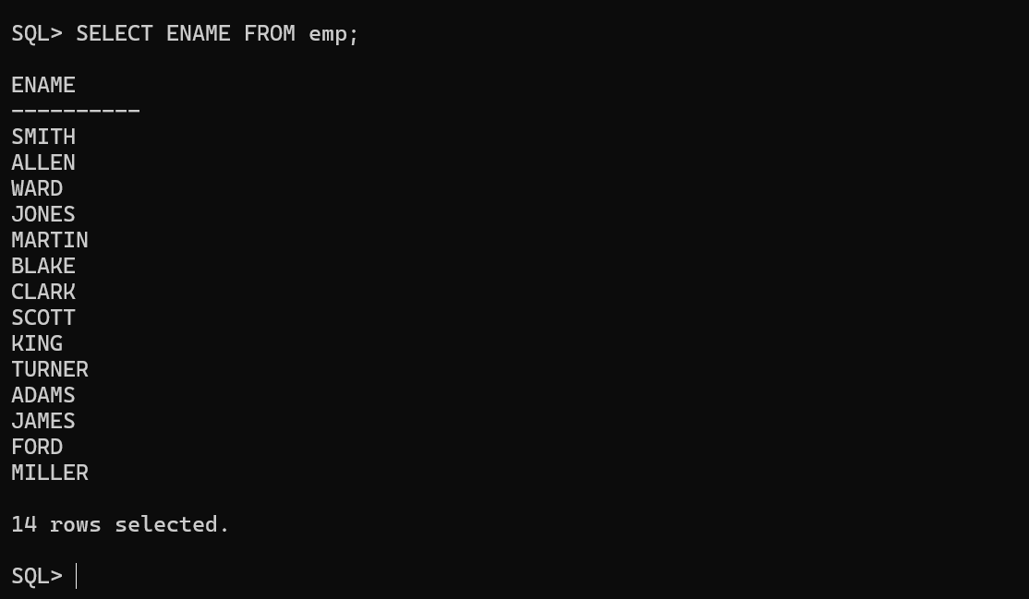
3 | Write a query to display name and salary given to all the employees.  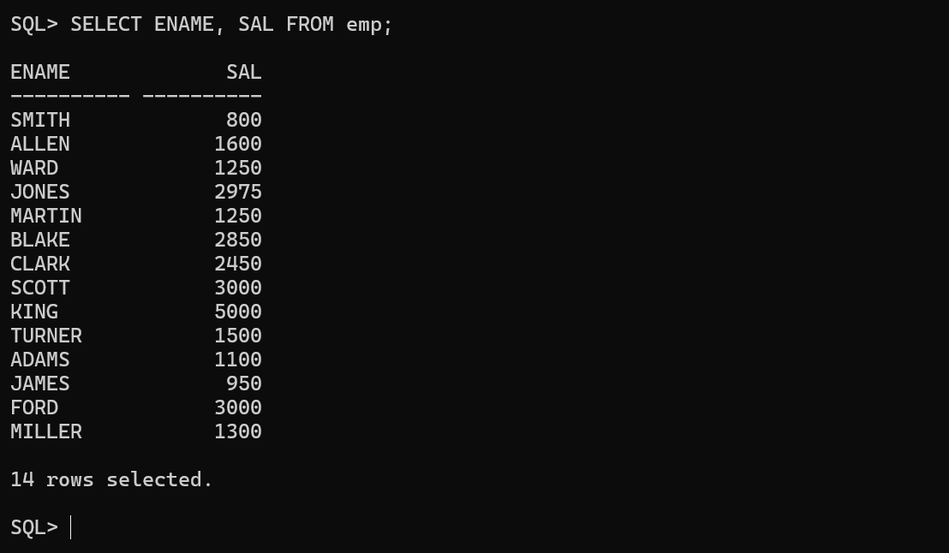
4 | Write a query to display name and commission given to all the employees.  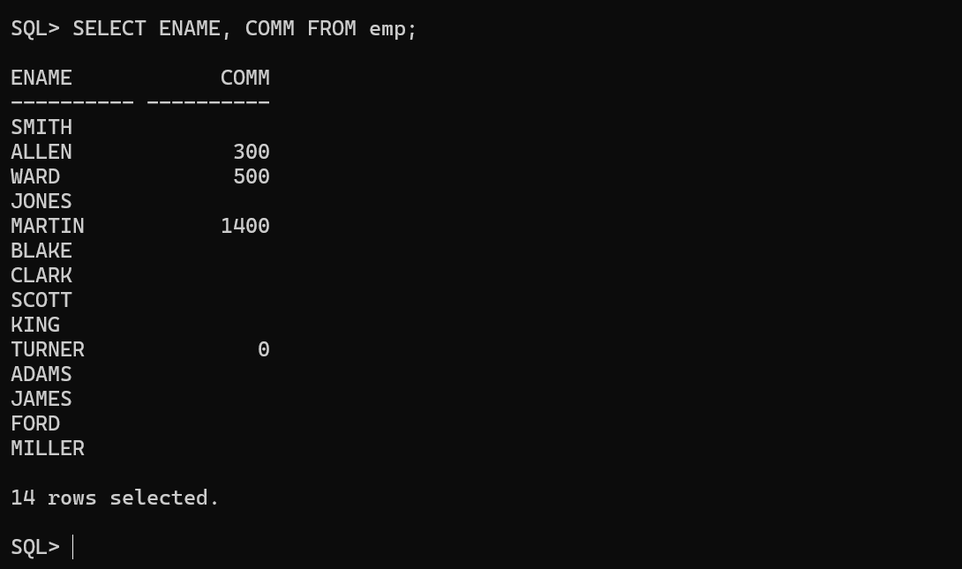
5 | Write a query to display employee ID and department number of all the employees in EMP table.  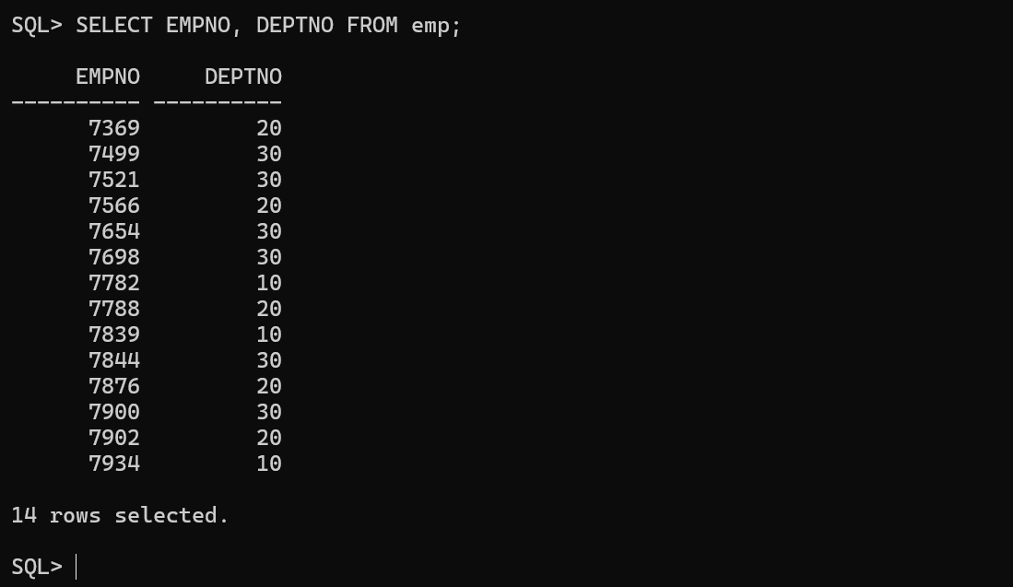
6 | Write a query to display ename and hiredate of all the employees.  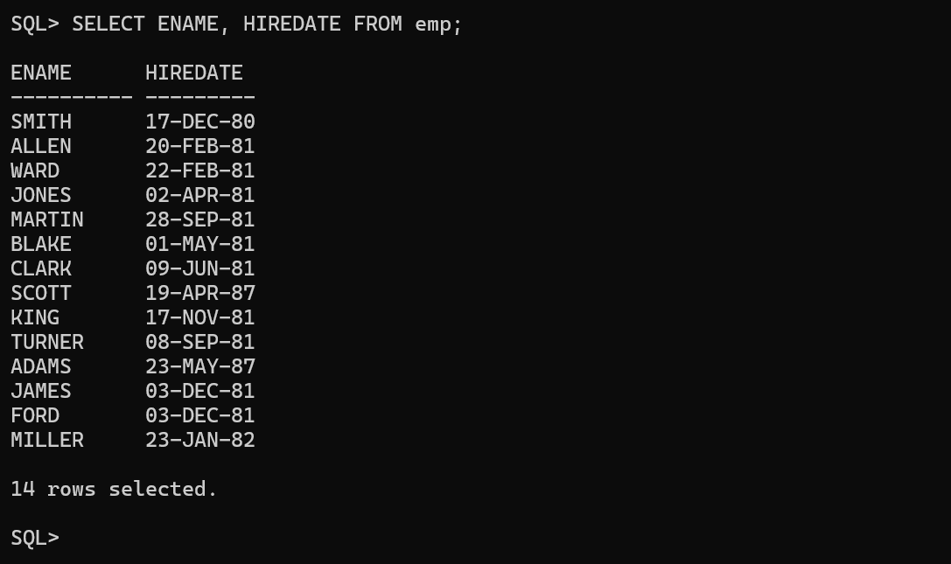
7 | Write a query to display name and designation of all the employees.  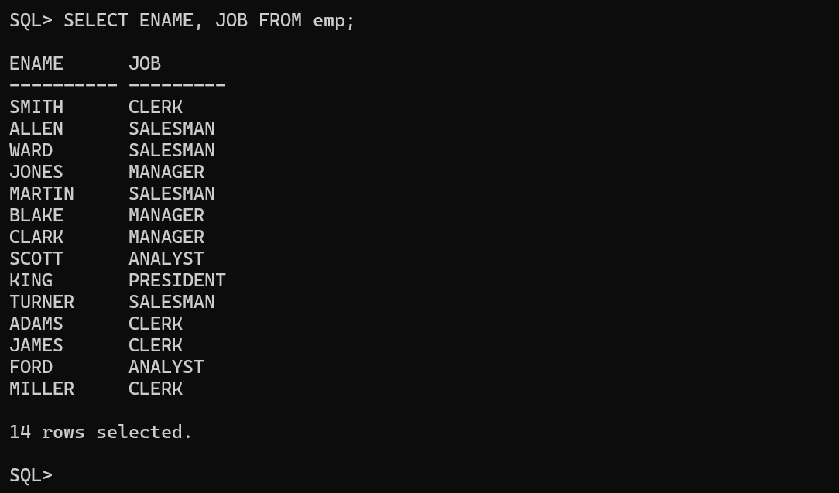
8 | Write a query to display name, job and salary given to all the employees.  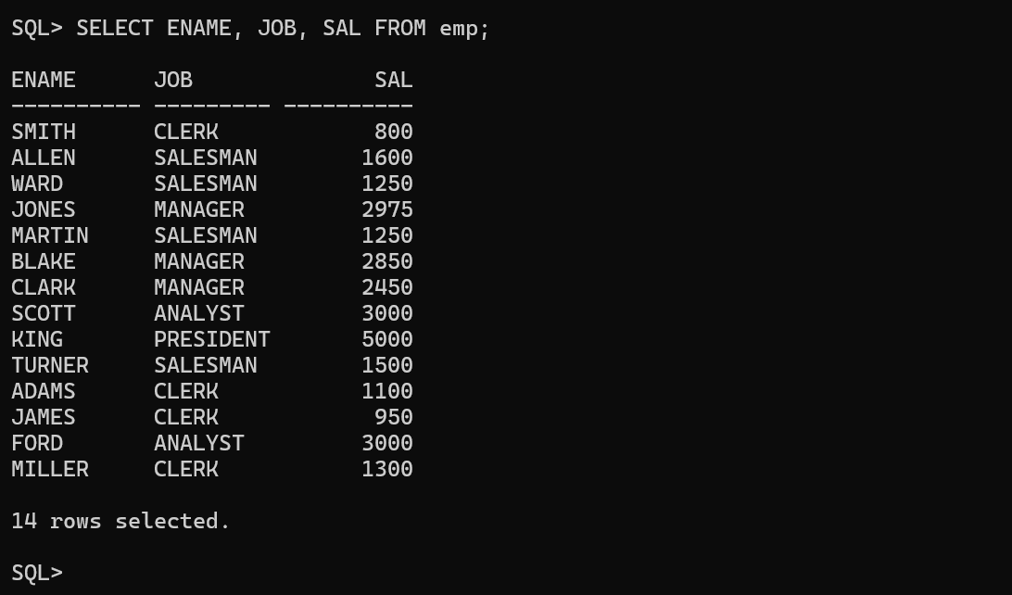
9 | Write a query to display department names present in DEPARTMENT table.  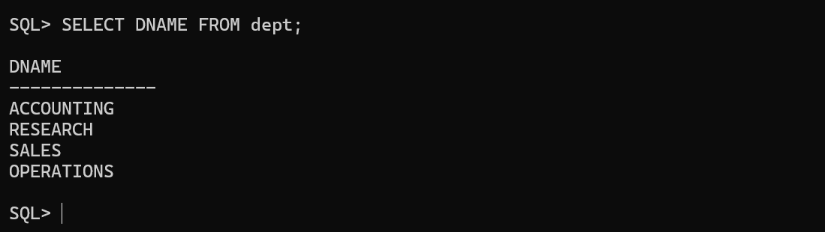
10 | Write a query to display DNAME and LOCATION present in DEPT table.  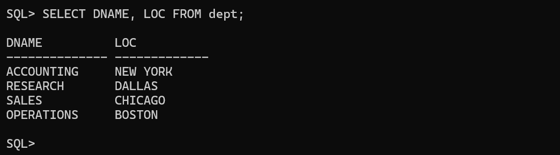

EXPRESSION AND ALIAS
1 | Name of the employee along with their annual salary  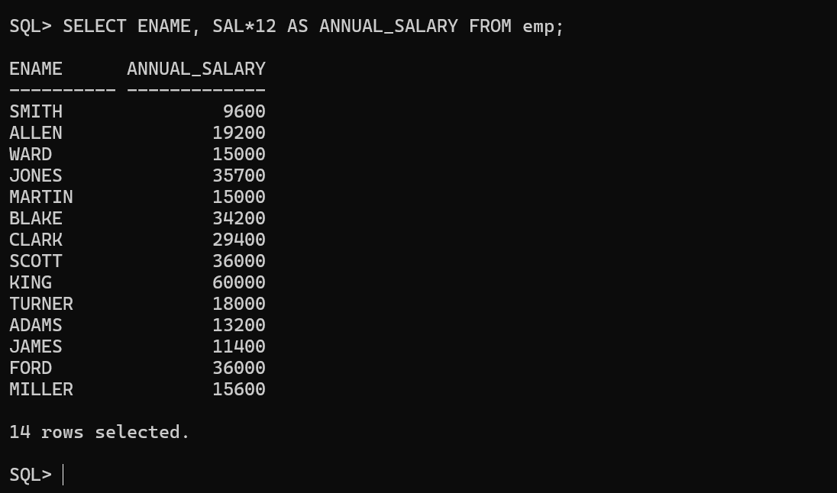
2 | ENAME and JOB for all the employees with their half-term salary  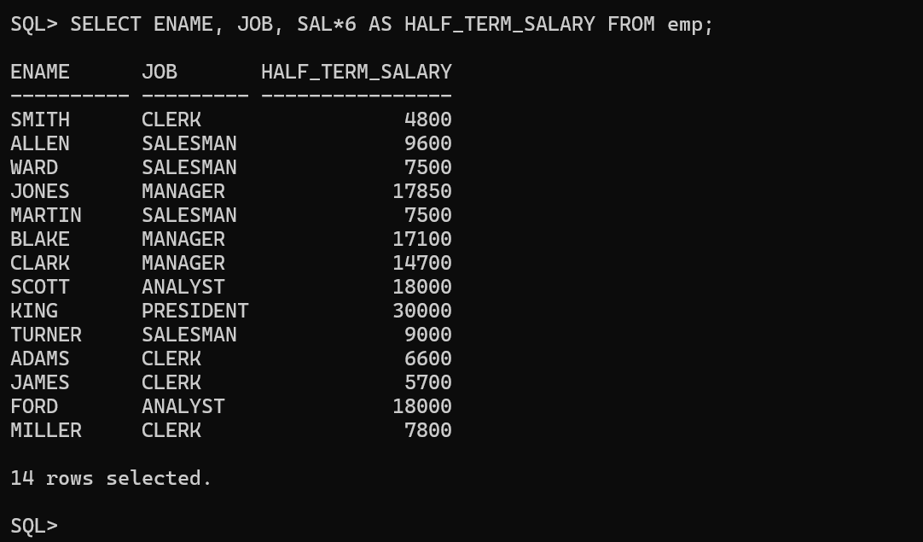
3 | All the details of the employees along with an annual bonus of 2000  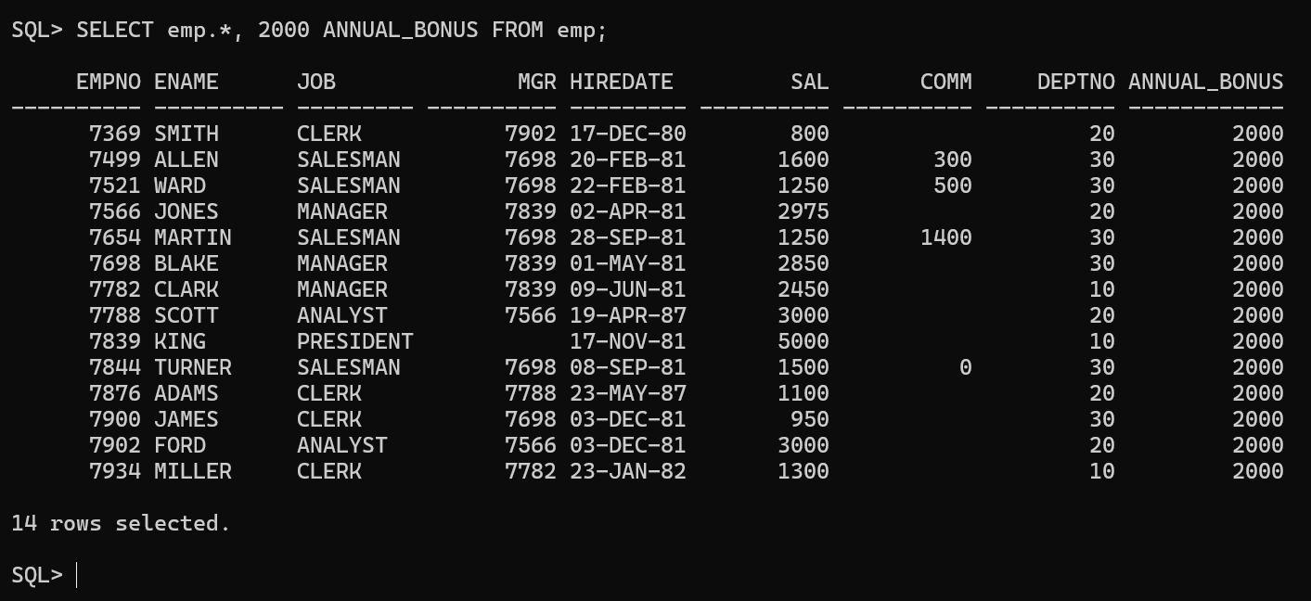
4 | Name, salary and salary with a hike of 10%  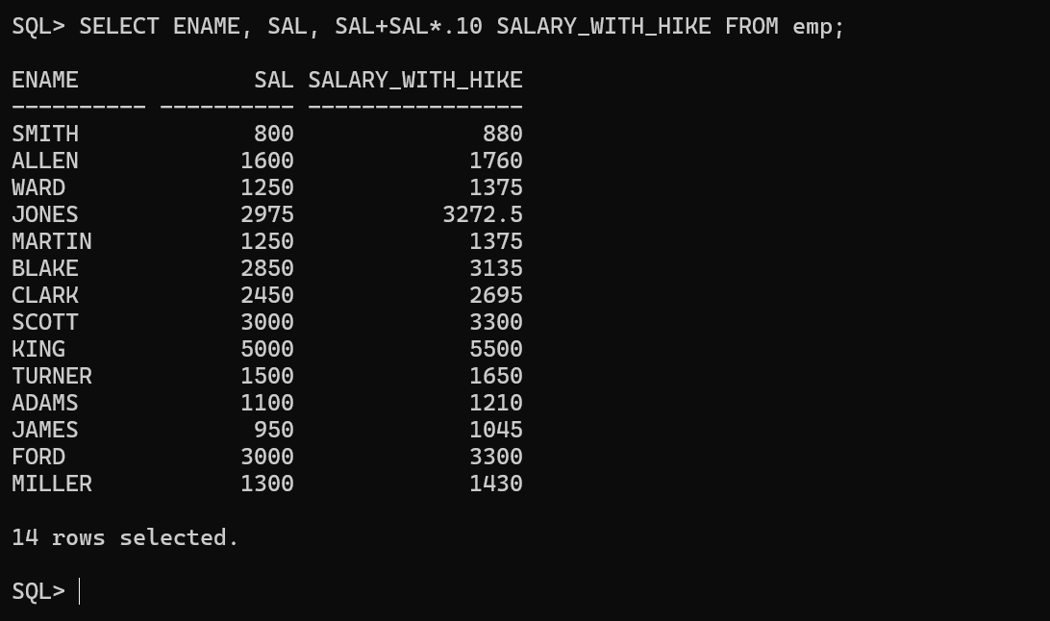
5 | Name and salary with deduction of 25%  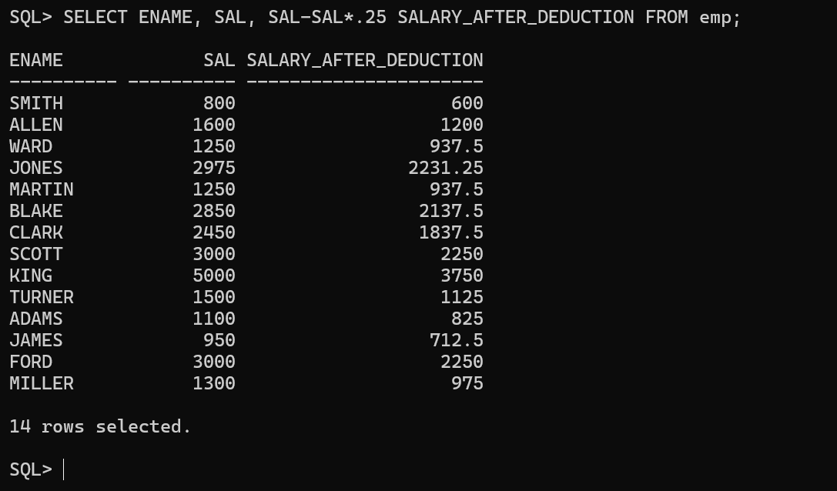
6 | Name and salary with monthly hike of 50  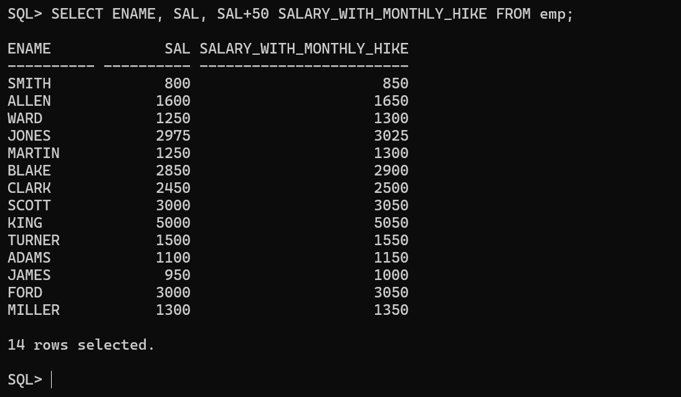
7 | Name and annual salary with deduction of 10%  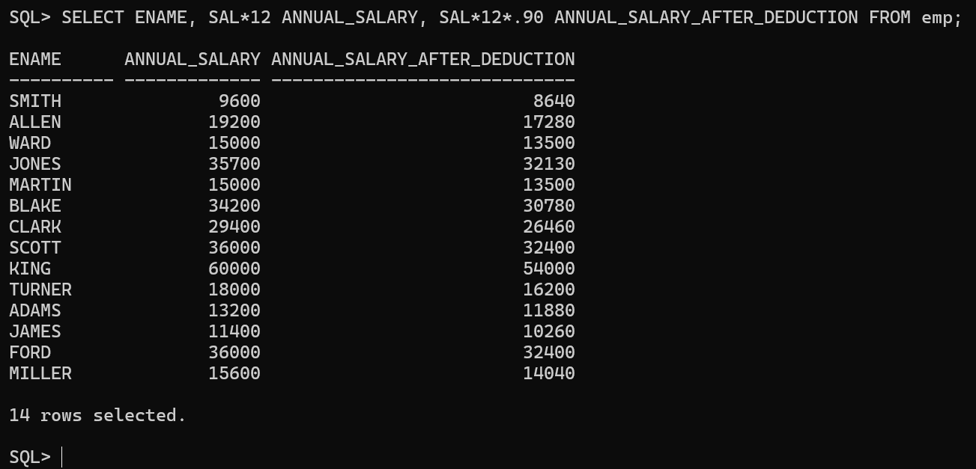
8 | Total salary given to each employee (SAL + COMM)  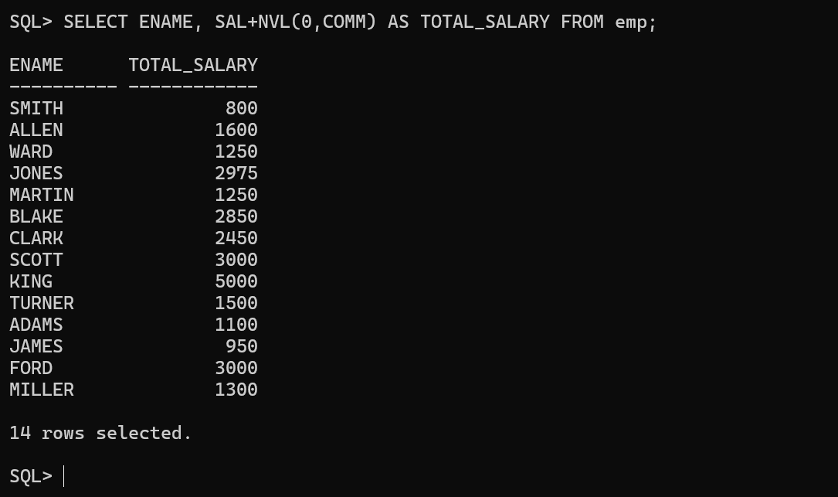
9 | Details of all the employees along with annual salary  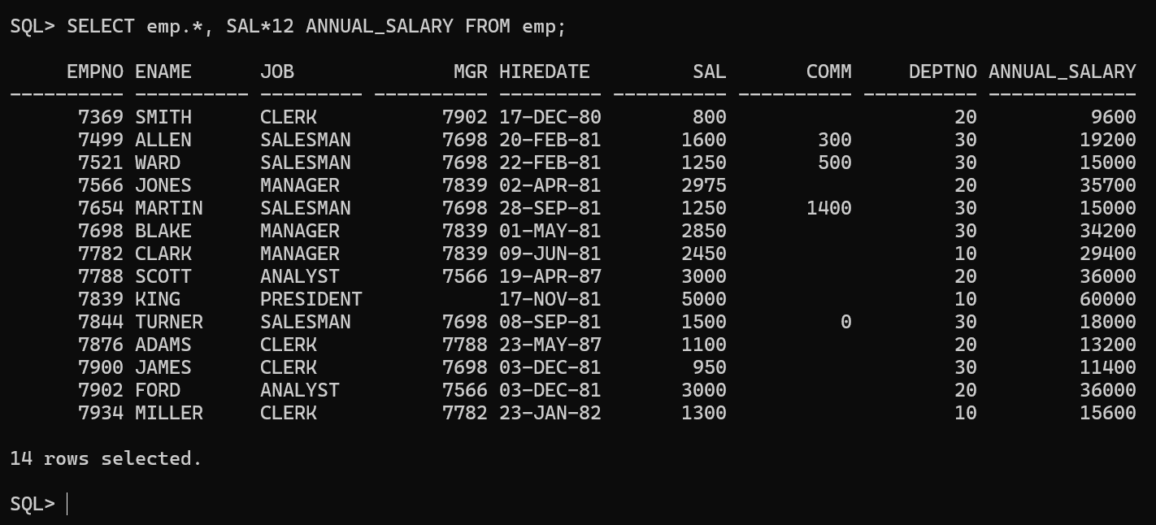
10 | Name and designation along with 100 penalty in salary  