ASSIGNMENT 2

SELECTION
1 | Annual salary of the employee whose name is SMITH  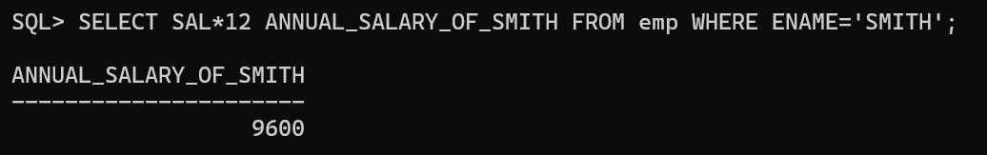
2 | Name of the employees working as CLERK  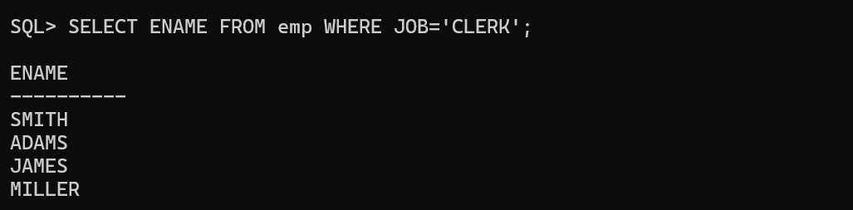
3 | Salary of the employees who are working as SALESMAN  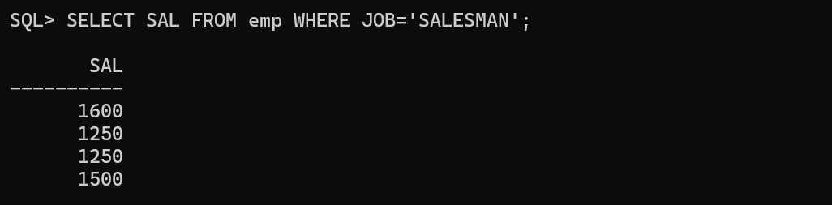
4 | Details of the employee who earns more than 2000  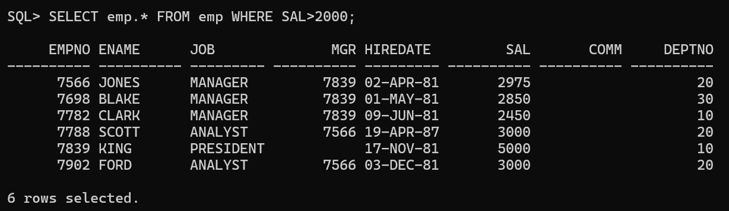
5 | Details of the employee whose name is JONES  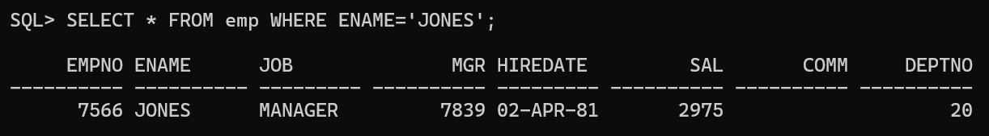
6 | Details of the employee who was hired after 01-JAN-81  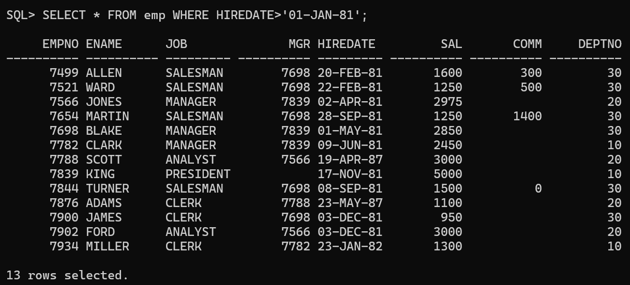
7 | Name and salary with annual salary if annual salary > 12000  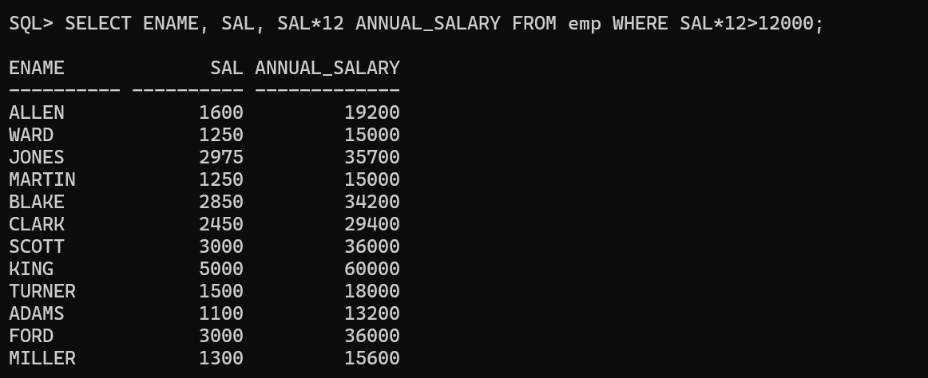
8 | Empno of the employees working in department 30  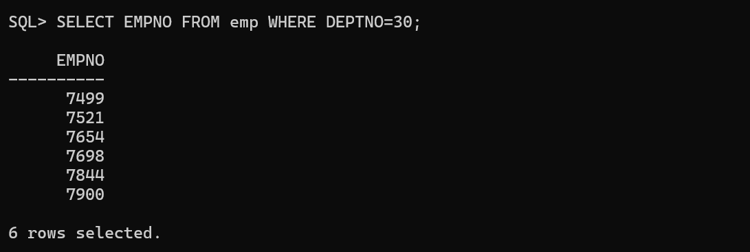
9 | Ename and hiredate of employees hired before 1981  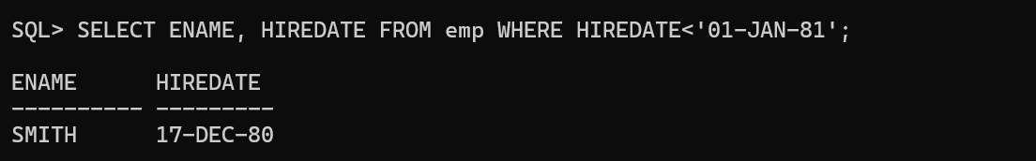
10 | Details of the employees working as MANAGER  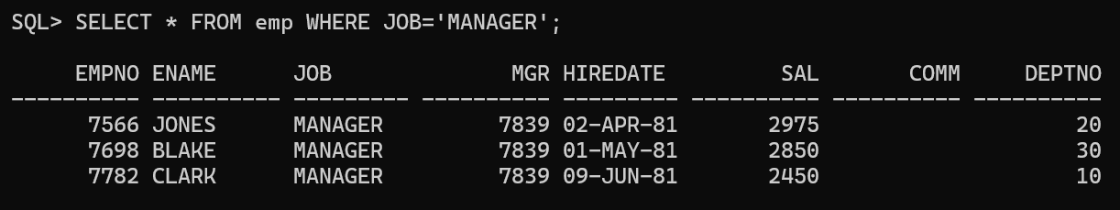
11 | Name and salary of employee earning commission of 1400  
12 | Details of employees having commission more than salary  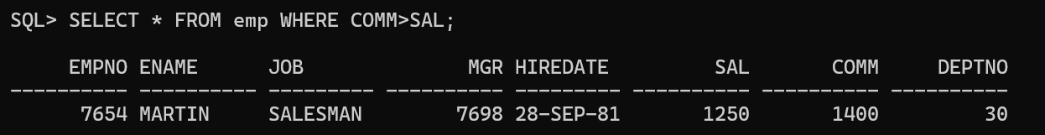
13 | Empno of employees hired before the year 1987  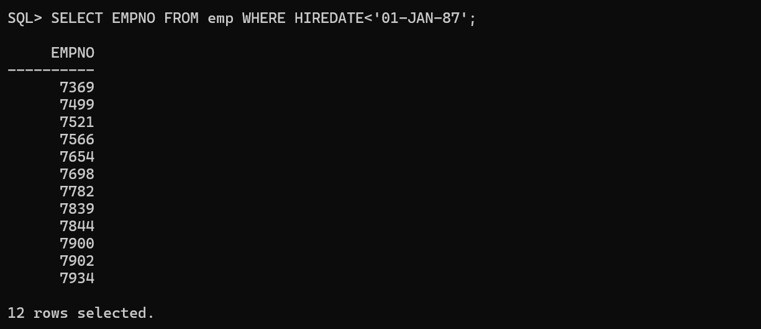
14 | Details of employees working as an ANALYST  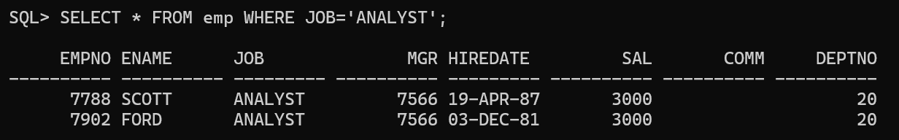
15 | Details of employees earning more than 2000 per month  