**ROOM BOOKING**

Aim:

Develop a website for booking a room for any particular purpose for a given time duration.

Also, design separate windows for both admin and users by adding all the necessary features.

Technology used:

**FOR BACK-END**

The back-end is the portion of the website you don’t see . It is responsible for storing and organizing data,and ensuring everything on the client-side actually works.

We have used following technologies for website’s backend development:-

* **Python django**

**FOR FRONT-END**

The layer above the backend is the front-end and it launches all software or hardware that is part of a user interface. Users interact directly with various aspects of the front end of the program,including user-entered data, buttons,programs,websites and other features.

We have used following technologies for website’s front-end development:-

* **HTML**
* **CSS**
* **JavaScript**
* **Bootstrap**

Features added to website:

We have added all the necessary features required for an user and admin both to their respective websites for tackling all the day to day needs. Some of them are mentioned below:-

**FOR USER’S WEBSITE**

* **Email notification :** This feature is very interesting as useful for both user and the admin. Each time a user login to his account he/she will get a notification through his/her registered email. Even for resetting of the password ,cancellation of booked room and for sending any request to the admin the email notification feature is very helpful.

* **Forget password** : If the registered user forgets his/her password of login then he/she has the option to reset the password using his/her registered e-mail id. Each time a user is resetting his/her password ,an **OTP** will be sent to the registered email for verification.
* **Gallery :** We have also added the feature for viewing the the images of the room ,so that the user can get a clear and concise idea of the the rooms available before booking .It is very helpful in deciding the room to be booked according to the needs and purpose of room booking of user.
* **Cancellation :** We have also added the feature to cancel the Room which has already been booked by the user. In case if user wants to cancel the booked room due to any reason he/she can enter his/her registered username and all necessary detail demanded to cancel the room.
* **Feedback :** In case if the user has any suggestions regarding any services then he/she can send direct feedback to the admin using this feedback feature. This feature is very useful for admin for improving their services.
* **Contact Us :** We have also included the feature to directly contact the admin in case of any emergency or any problem occurred to the user.If a user wants to booked the room which is unavailable then he/she can send the request for booking that room to the admin, if possible then admin can arrange that room for the user based on the conditions.

**FOR ADMIN WEBSITE:**

* **Message :** The messaging feature is also added to the admins website. Through this feature admin can view and response to the issue faced by the user or any suggestions send by them.
* **Accepted Request :** This option enables admin to see the approved request for room booking. By using this feature admin can have look on the history of the past customers.
* **Room Request :** If any user send request for room bookingthen this feature plays it’s role. Through this option admin has the option either to decline or to accept the new room request based on the circumstances.
* **User List :** This option is useful when admin wants to get the data of the present customers who have their current bookings of rooms.

Applications:

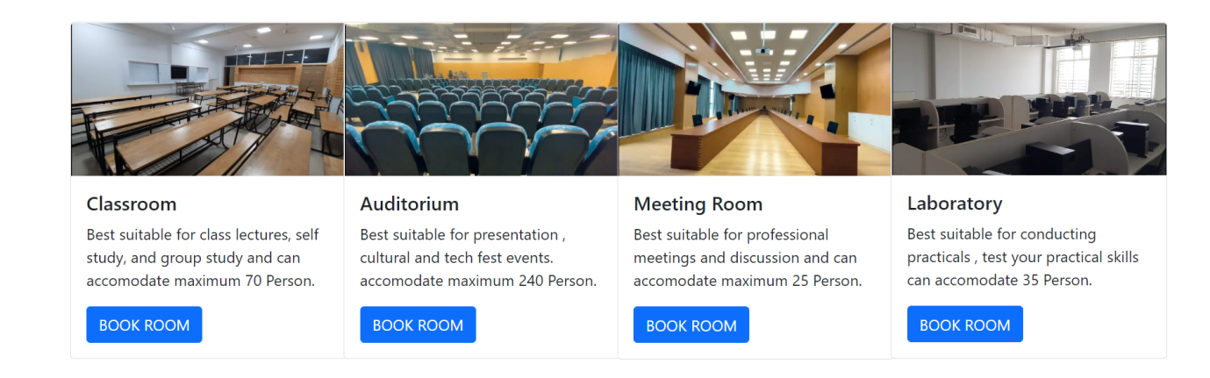

**Our website can be used for various purposes based on different conditions for instance:-**

* If the requirement is for class lectures, self study and group study then we can book **classrooms.**
* For the purpose of presentation, Cultural and tech fest then we can book  **Auditorium.**
* If the requirement is for professional meetings and discussions then**, Meeting rooms** can be booked.
* **Laboratories** can also be booked for the purpose of conducting practicals.
* **Hostel Room** bookings can also be done.

Team Members:

|  |  |  |
| --- | --- | --- |
| **NAME** | **REGISTRATION N0.** | **CONTRIBUTION** |
| Riddhish Ganesh Mahajan | 21BCS094 | Front-end development |
| Shivam Kumar | 21BCS112 | Front-end development |
| Sahil Kirti | 21BCS097 | Text formatting and Image editing |
| Samarth Sinde | 21BCS110 | Back-end development |