First, understand what a microbit is. Think of it as a robot which would do whatever you ask it do. But you must specify the instructions for the microbit in terms of code. Which is the language you use to talk to your robot.

Let us start with a simple exercise. In this exercise, we are going to make a simple animation of a flashing heart.

The first step is to understand what an animation means. Animation is simply series of images placed together that makes you think that the media form is performing some action.

Let us try this simple exercise and you can create some motion of images yourself on the devices that are given to you.

Step 0: Let us first understand how microbit works.

* You drag drop and give instruction on a web page
* Download a file (.hex) and send it to your microbit
* Microbit starts performing what you instructed it to do.

Step 1: Go to <https://makecode.microbit.org/#>

You will see something like what is shown below

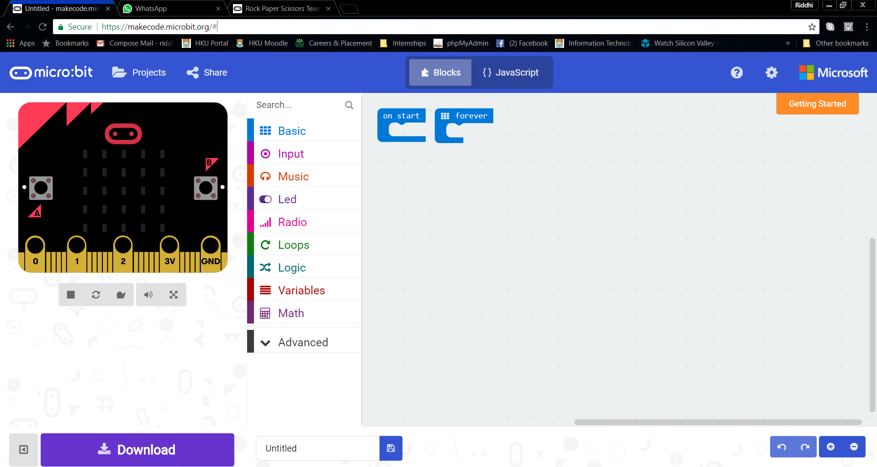

Let us now understand what the different options on the screen mean.



This portion of the screen is a simulator which allows you to see your commands before downloading them to the microbit.



Options for you to choose from to code. Expand and try to read them and ask your instructor to explain this portion further.



This will be your code editor where you will write instructions for microbit.

Step 2: As you can see there are 2 things on the screen - on start and on forever. The names describe their functionality to their best. On start will make microbit do the instructions when you turn it on. On forever will make your microbit do the instructions forever until you turn it off.

Let us see the behaviour in action.

Remember the options row? Click on basic and drag and drop show string option below the on start instruction. (You might have to click on the on forever and move it a little away from on start to avoid overlapping)

It will look like this:

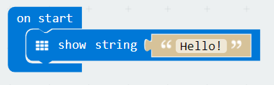

Look at the simulator. It shows hello!

Press on the download button and name your first instruction file – hello. Remember where you saved your file.

Go to the folder where you saved your file and send the file to your microbit. After the file is transferred, take a look at the microbit, it will show you “hello!”.

Step 3: We want to now see how does on forever behave. So, place the show string from on start to on forever. You can change the words of the string. For eg; type “You are nice!”

Download and save the file and send to the microbit and see that the string will never stop displaying “You are nice!”

Step 4: We are one step closer to make an animated heart on our microbit.

Delete the show string from on forever and go to basics and drag and drop