This document describes some basic things that you can do with Microbits.

**Exercise 1:** Basics

Step 1: Go to [https://makecode.microbit.org/#](https://makecode.microbit.org/)

Step 2: Click basics option and drag and drop show string into on start. It will look like this:

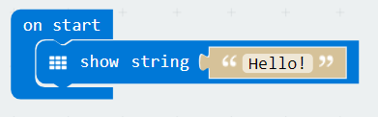

Step 3: Press on the download button and name your first instruction file – hello. Remember where you saved your file.

Go to the folder where you saved your file and send the file to your microbit. After the file is transferred, take a look at the microbit, it will show you “hello!”.

**Exercise 2:** Random Number Generator