Robert Cuevas
November 4, 2026
Module 2_3
Data Models

Relational model
USER is the central entity. A user can have zero or more roles and dependents, while each user has one birthdate.
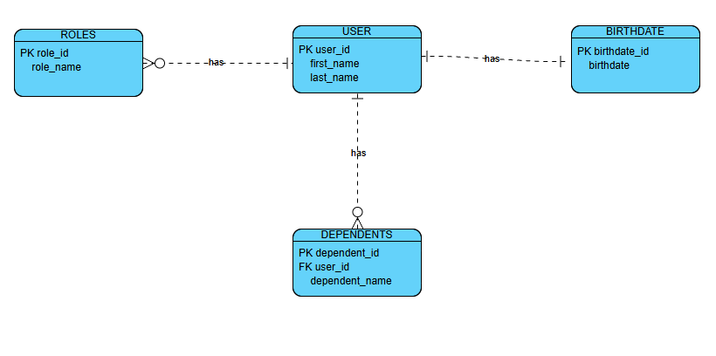

NoSQL Document Structure
The document model embeds a user's roles and dependents inside one USER document. The birthdate is stored as a single value, so related information can be retrieved together.


