
Tribhuvan University
Faculty of Humanities and Social Sciences
Gym/workout package system
a Project Report
Submitted to
Department of Computer Application
Patan Multiple Campus
Patan Dhoka, Lalitpur, Nepal
In partial fulfillment of the requirements for the Bachelor in Computer Application
Submitted by
Ridesh Maharjan (2202348)
Shreewong Tamang (2202363)
February 2025

Under the Supervision of
Mr. Bhupendra Ram Luhar

Tribhuvan University
Faculty of Humanities and Social Sciences
Universal College

Supervisor’s Recommendation
I hereby recommend that this project prepared under my supervision by Ridesh Maharjan and Shreewong Tamang entitled Gym/workout Package system in partial fulfillment of the requirement for the degree of Bachelor in Computer Application is recommended for the final evaluation.

……………………
Mr. Bhupendra Ram Luhar
project supervisor
Patan Multiple Campus
Patan Dhoka, Lalitpur, Nepal


Tribhuvan University
Faculty of Humanities and Social Sciences
Universal College

Letter of Approval
….………………………….  Mr.Bhupendra Ram Luhar  Project Supervisor  Department of Computer Application  Patna Multiple Campus  Patan Dhoka, Lalittpur, Nepal | ….………………………..  Asst. Prof.Roshan Tandukar  Program Director  Department of Computer Application  Patna Multiple Campus  Patan Dhoka, Lalittpur, Nepal
….……………………………………  Internal Examiner | ….………………………………………….  External Examiner
This is to certify that this project prepared by ridesh maharjan and Shreewong tAmang entitled “Gym/Workout Package System” in partial fulfillment of the requirements for the degree of Bachelor in Computer Application has been well studied. In our opinion, it is satisfactory in the scope and quality of the required degree.

Abstract
The Nepal Workout Package System addresses the growing demand for structured, accessible fitness guidance in Nepal's evolving health and wellness landscape. This web-based platform connects certified fitness professionals with individuals seeking personalized workout programs, creating a digital marketplace for exercise packages that can be performed both with and without gym equipment. Built using PHP and MySQL, the system enables trainers to design, price, and market customized workout plans while providing users with a transparent platform to browse, purchase, and follow exercise routines tailored to their goals and available resources. By digitizing the fitness package life-cycle from professional creation to user implementation this solution bridges the gap between fitness expertise and public accessibility, particularly valuable in a market where traditional gym memberships remain inaccessible to many. The system implements secure user management, role-based access control, and comprehensive package handling specifically designed for Nepal's unique digital and economic context, offering a scalable model for fitness service digitization that accommodates varying equipment availability and user circumstances.

Keywords: Workout Package System, Fitness Digitalization, PHP Application, Web Platform

Acknowledgement
"We wish to express our deepest gratitude to Mr. Bhupendra Ram Luhar, our esteemed supervisor, whose guidance and mentor-ship have been invaluable throughout the development of our Gym/Workout Package System (GWPS) project. His expertise and encouragement have inspired us to delve deeper into the realm of workout package, enriching our understanding and enhancing the quality of our work.
Special recognition is also owed to Mr. Roshan Tandukar, the diligent BCA Program Coordinator, for his unwavering support and guidance, which played a pivotal role in our personal and professional growth during this project. His insightful advice and constructive feedback have been instrumental in shaping our project's success.
We extend our heartfelt appreciation to Patan Multiple Campus for their continuous support, guidance, and provision of necessary resources throughout the project's life-cycle. Their unwavering commitment to our academic and professional development has been instrumental in achieving our goals.
Additionally, we are deeply grateful to our parents and friends whose unwavering support and encouragement provided us with the motivation and strength to overcome challenges and achieve success within the project's timeline.
Finally, we would like to express our gratitude to Tribhuvan University for providing us with the opportunity to undertake this project as part of the Computer Application course. This experience has not only enhanced our technical skills but also instilled in us a deeper understanding of project management principles and ethics."

Yours sincerely,
Ridesh Maharjan
Shreewong Tamang

Table of Contents
Supervisor’s Recommendation i
Letter of Approval ii
Abstract iii
Acknowledgement iv
List of Abbreviations vii
List of Figures viii
List of Tables : ix
Chapter 1: Introduction 10
1.1 Introduction 10
1.2 Problem Statement 10
1.3 Objectives 11
1.4 Scope and Limitation 11
1.4.1 Scope 11
1.4.2 Limitation 11
1.5 Report Organization 12
Chapter 2: Background Study and Literature Review 13
2.1 Background Study 13
2.2 Literature Review 14
Chapter 3: System Analysis and Design 15
3.1 System Analysis 15
3.1.1 Requirement Analysis 16
3.1.2 Feasibility Analysis 17
3.1.3 Data Modelling(ER-Diagram) 19
3.1.4 Process Modelling (DFD) 20
3.2 System Design 22
3.2.1 Architectural Design 22
3.2.2 Database Schema Design 23
3.2.3 Interface Design 23
3.2.4 Physical DFD 28
Chapter 4: Implementation and Testing 29
4.1 Implementation 29
4.1.1 Tools Used 29
4.1.2 Implementation Details of Modules 30
4.2 Testing 30
4.1.1 Test Case for Unit Testing 30
Chapter 5: Conclusion and Future Recommendations 38
5.1 Lesson Learnt 38
5.2 Conclusion 38
5.3 Future Recommendations 38
Chapter 6: References 39

List of Abbreviations
Abbreviation | Definition
CRUD | Create, Read, Update and Delete
CSS | Cascading Style Sheet
DFD | Data Flow Diagram
ER | Entity Relationship
GWPS | Gym/Workout Package System
HTML | Hypertext Markup Language
MySQL | Microsoft Server Structured Query Language
UI | User Interface

List of Figures
Figure 3.1: Waterfall model for Gym/Workout Package System 15
Figure 3.2: Use Case diagram of Gym/Workout package System 16
Figure 3.3 Gantt chart of Gym/Workout Package System 18
Figure 3.4: Entity Relationship Diagram of Gym/Workout package System 19
Figure 3.5: Level 0 DFD of Gym/Workout System 20
Figure 3.6: Level 1 DFD of Gym/Workout System 21
Figure 3.7: Architectural design of Gym/Workout System 22
Figure 3.8: Login Page of Gym/Workout package System 23
Figure 3.10: Home page of Gym/Workout package System 24
Figure 3.11: Admin Dashboardd page of Gym/Workout package System 25
Figure 3.13: Add package page of Gym/Workout package System 25
Figure 3.14: Manage package page of Gym/Workout package System 26
Figure 3.15 User Dashboard Page of Gym/Workout package System 26
Figure 3.16: Buy package page of Gym/Workout package System 27
Figure 3.17: Users package page of Gym/Workout package System 27
Figure 3.18: Physical dfd of Gym/Workout package System 28

List of Tables :
Table 1 Testing Admin Login Form 31
Table 2 Testing Admin Dashboard 32
Table 3 Testing Add Package 34
Table 4 Testing Edit Package Form 35
Table 5 Testing Manage Package Form 36

Introduction

Introduction
As health consciousness grows, Nepal's fitness scene is changing dramatically. However, access to expert exercise advice is still restricted by informational, financial, and geographic constraints. There is a need for flexible fitness options that can be done anywhere, with or without specialist equipment, despite the fact that urban areas are home to an increasing number of gyms. The lack of digital platforms that allow trained professionals to successfully disseminate their knowledge outside their immediate, in-person clientele further exacerbates the gap between public accessibility and fitness expertise.
This market requirement is directly addressed by the Gym Workout Package System, which establishes a structured digital environment where exercise regimens are made available as standardized goods rather than unofficial, location-bound ones.This project creates a comprehensive web-based system that rethinks fitness regimens as digital package's, standalone workout regimens that consumers may buy and follow on their own. The solution democratizes access to fitness expertise and opens up new business options for experts by decoupling workout instruction from physical location and equipment dependencies.
With a particular focus on Nepal, the implementation takes into account variables such as varying internet connectivity, a range of socioeconomic backgrounds, and the practical fact that many users will carry out workouts at home with little to no equipment. This strategy goes beyond gym administration to exercise knowledge management, marking a substantial shift in the conception, provision, and consumption of fitness services in the Nepali market.

Problem Statement
This system tackles the three interrelated issues facing the Nepali fitness industry. First, the lack of digital channels for organizing, pricing, and disseminating their exercise expertise as scalable products restricts the earning potential and professional reach of fitness practitioners. Second, people looking for exercise advice frequently turn to generic web content of dubious quality and safety because they are unable to get trustworthy, structured workout plans that fit their own goals, equipment availability, and skill levels. Third, there isn't a defined method for designing, evaluating, and buying approved exercise programs that are suited to Nepal's unique requirements, taking into account factors like population fitness levels, space limitations, and restricted access to equipment.

Objectives
The objectives of the system are highlighted below:
- To create a online platform that allows fitness experts to design, oversee, and market structured training as digital packages.
- To give consumers a method for finding and buying fitness programs that may be used with or without gym equipment.

Scope and Limitation

Scope
From conception to consumption, the solution includes full digital management of fitness packages. Fitness experts are able to create packages that include comprehensive descriptions, workout guidelines, time constraints, and equipment needs. Customers can purchase and access their selected programs through customized accounts after perusing packages by category, degree of difficulty, equipment requirements, and fitness objectives. For maximum inclusion, the platform offers a variety of package kinds, including body-weight workouts, minimal equipment routines, and gym-based programs. Administrative responsibilities oversee user identification, transaction oversight, and system maintenance.

Limitation
Some of the limitations of the system are listed below:
- This system is only available as a web solution.
- This system doesn’t provide a notification system
- No progress tracking applications or visual demonstration.
.

Report Organization
The report can be organized into 5 chapters which are below:
Chapter 1 provides us with information about the system with objectives, scope and limitations of the system.
Chapter 2 provides a background study with already-known information from the previous work related to the system.
Chapter 3 analyses the system by performing various requirements and feasibility analyses. This chapter also provides all the system designs of the project.
Chapter 4 includes various implementation methods and tools used to develop the system and also contains a brief description of testing.
Chapter 5 includes the conclusion, outcome of the system and future recommendations about what features can be added to the future system

Background Study and Literature Review

Background Study
An advancement in the conception and delivery of exercise coaching in digital formats can be seen in the idea of planned workout packages. Traditional methods of passing down fitness expertise in Nepal have included informal sharing among enthusiasts, gym apprenticeship models, or business agreements requiring in-person presence. Opportunities to package this information into standardized, transferable goods that preserve professional integrity and achieve scalability are presented by the digital age. This change is comparable to advancements in the culinary arts (recipe platforms) and education (online courses), where knowledge is packaged for wider consumption.
However, the fitness industry has its own set of difficulties: motivational components benefit from planned progression, individual variances necessitate customization possibilities all of which must be taken into consideration when designing digital packages.The unique environment of Nepal has a big impact on how exercise regimens should be planned and executed. According to research, 65% of urban Nepali families lack enough room for traditional exercise equipment, and official gym access is still mostly found in wealthy urban areas. Additionally, cultural views on exercise differ greatly among groups; many people prefer privacy or encounter social obstacles when it comes to going to the gym. These facts call for fitness regimens that prioritize body-weight exercises, employ little or no household equipment, and offer newcomers clear development routes.
Additionally, the digital platform must support different literacy levels and provide clear instructions, especially for users with no technical expertise or prior exercise experience.Due to limited market access, this fragmentation limits income possibilities, hinders professional development through limited community engagement, and lowers service quality through a lack of peer evaluation. By establishing a marketplace with user review systems, standardized display formats, and quality verification procedures, a digital package system can solve these problems and improve industry standards while benefiting both customers and providers.
.

Literature Review
Several crucial success elements that are pertinent to the Nepali context are shown by academic research on digital fitness platforms. Research on exercise adherence highlights that structured programs with measurable goals, clear progression, and incentive elements perform noticeably better than general exercise advice [1]. Instead of just listing exercises, digital implementations must make sure that packages include these components. Lightweight design, offline accessibility features, and balanced digital-human service integration are necessary to overcome the main obstacles identified by research on technology adoption in emerging fitness markets [2], which include device limitations, data cost concerns, and a preference for human interaction.
The three types of digital fitness solutions that are now available have minimal relevance to Nepal's requirements. International platforms such as Fitbod and JEFIT provide advanced equipment tracking and workout planning, but they require subscription models that are out of reach for the ordinary Nepali's income and presuppose access to gym facilities. Regional applications from nearby nations, such as India's Cure.Fit, integrate local information but emphasize relationships with metropolitan gyms rather than adaptable at-home workouts. The majority of local Nepali efforts have been informational websites or social media pages that lack structured program delivery, quality control, and transaction capabilities. According to the literature, there is a glaring need for platforms that include expert package design, adaptable distribution for a range of equipment circumstances, and transaction methods appropriate for Nepal's digital payment development.
According to an analysis of healthcare platforms [3], service providers' verification systems are essential to fostering user confidence. Hybrid cash-digital payment solutions considerably boost transaction completion rates during periods of payment infrastructure change, according to an analysis of e-commerce adoption [4]. In order to accommodate Nepal's unique market development stage and user behavior patterns, these findings significantly guide the design of the Nepal Workout Package System, especially in the areas of provider verification, package structuring, and payment flexibility.

System Analysis and Design

System Analysis
This system is designed following the waterfall model of SDLC. Waterfall model provided a clear, linear structure suitable for project timeline. Requirements were well-defined from the start, and each phase—planning, design, implementation, testing, and deployment could be completed sequentially before moving to the next. This approach ensured proper documentation, milestone tracking, and easy management for two-person team.
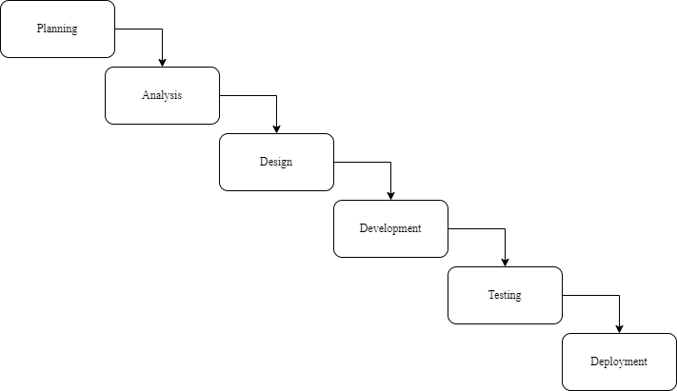
Figure 3.1: Waterfall model for Gym/Workout Package System

Requirement Analysis

Functional Requirements

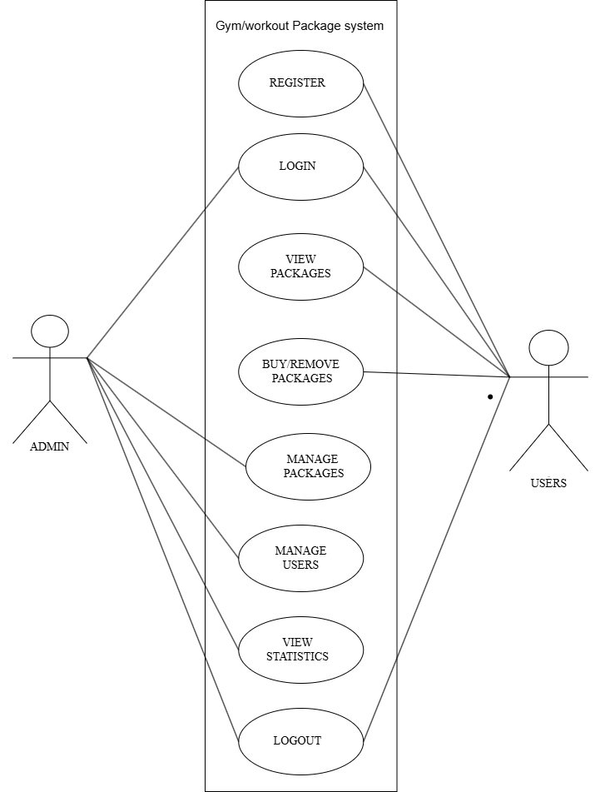
Figure 3.2: Use Case diagram of Gym/Workout package System

This use case diagram represents the interactions between a user and an admin with gwps. The admin is able to login and logout from the system manage packages, a view brief statistics. Users can register into the system, login, logout, view packages and make purchases.

Non-Functional Requirements
Below are some of the non-functional requirements:
      - Availability: Being a web-based application, it is available to anyone who can access it.
      - Performance: The system is designed to perform in such a way where the admin shall be able to manage the system and users shall able to use the system.
      - Reliability: The system is very reliable. It can yield correct output in the correct time duration.

Feasibility Analysis

Technical Feasibility
An Gym/Workout Package System is a web-based application, that is accessible anywhere, anytime through computers, tablets, smartphones, and any other smart devices that have a web browser. Being a web-based application, it is made up of HTML and CSS as frontend PHP, and MYSQL as backend.

Operational Feasibility
The project is feasible to operate. Adequate throughput and response are provided by the existing mode of operation. Therefore, as long as the user has a browser installed on their device, this project is fully functional and can be used on a variety of platforms.

Economic Feasibility
This system is economically feasible, as it can be developed using freely available and open-source tools like VS Codes for HTML, CSS and PHP, and Draw.io for creating diagrams. These tools help keep the project development free of costs while still delivering an effective and attractive system

Schedule Feasibility
The project timeline was divided into phases with specific deadlines. All major milestones were completed within the given time frame.

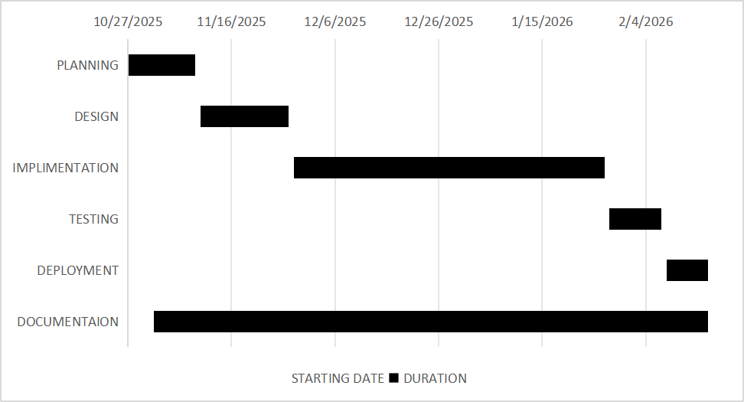

Figure 3.3 Gantt chart of Gym/Workout Package System
The Gantt chart outlines the schedule for developing GWPS from November to February. The project begins with the Planning phase, which spans the first three weeks of November. Following this, the Analysis phase takes the entire month of February. The Design phase is scheduled from the first week to the last week of March. The Coding phase begins in the second week of March and extends until the third week of April. Testing is scheduled to start in the second week of April and continue until the third week of May. Finally, the Documentation phase starts in the second week of March and runs concurrently until the end of May. Each task is broken down into weekly intervals, providing a clear timeline for project completion.

Data Modelling(ER-Diagram)

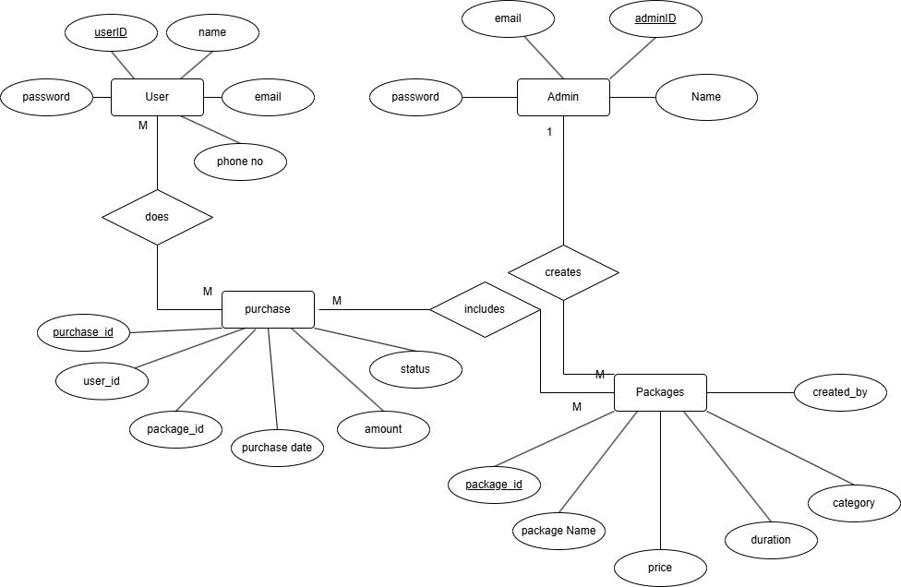
%3CmxGraphModel%3E%3Croot%3E%3CmxCell%20id%3D%220%22%2F%3E%3CmxCell%20id%3D%221%22%20parent%3D%220%22%2F%3E%3CmxCell%20id%3D%222%22%20parent%3D%221%22%20style%3D%22text%3Bhtml%3D1%3BwhiteSpace%3Dwrap%3BstrokeColor%3Dnone%3BfillColor%3Dnone%3Balign%3Dcenter%3BverticalAlign%3Dmiddle%3Brounded%3D0%3B%22%20value%3D%22M%26lt%3Bdiv%26gt%3B%26lt%3Bbr%26gt%3B%26lt%3B%2Fdiv%26gt%3B%22%20vertex%3D%221%22%3E%3CmxGeometry%20height%3D%2215%22%20width%3D%2230%22%20x%3D%22350%22%20y%3D%22350%22%20as%3D%22geometry%22%2F%3E%3C%2FmxCell%3E%3C%2Froot%3E%3C%2FmxGraphModel%3E
Figure 3.4: Entity Relationship Diagram of Gym/Workout package System

The ER diagram represents GWPS, detailing entities such as Admin, Users, Purchase and Packages. Admins creates multiple Packages, each linked to a specific Purchase made by Users. The diagram captures the relationships and attributes necessary for managing Packages and making purchases within the system.

Process Modelling (DFD)

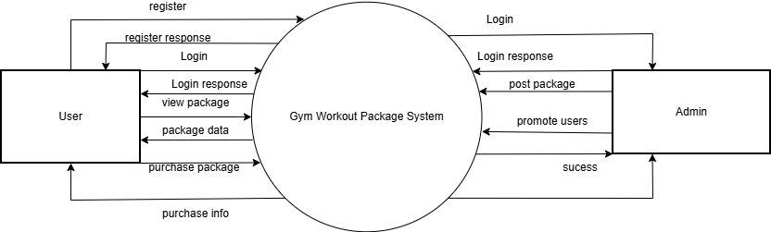

Figure 3.5: Level 0 DFD of Gym/Workout System
The GWPS context diagram identifies the flows of data between the system and external entities. The context diagram shows the basic overview of the Gym/Workout Package System. Here the external entities are Users and Admin. Users can register/login into the system to view and purchase packages. Admin is another external entity that can login to the system to post packages,edit and promote users to admins.
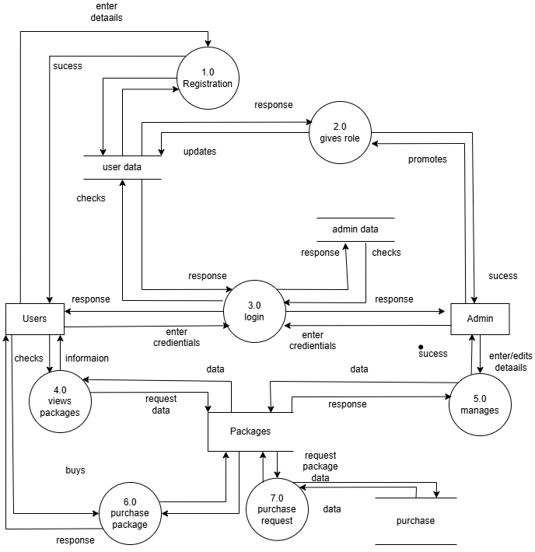

Figure 3.6: Level 1 DFD of Gym/Workout System
In Level-1 DFD, the context diagram is decomposed into multiple processes. At this level, we highlight the main functions of the system and break down the high-level process of the context diagram into sub-processes. The above level-1 DFD shows detailed information about the system. The above figure shows all the actions that the admin and user can take.

System Design
To realize the different functional requirement of the system in graphical form, different design diagram of the system has been prepared which are as follows:

Architectural Design
For this system, three tier architecture is used which includes user interface, web server and database. In architectural design, basic structure of the system is shown.
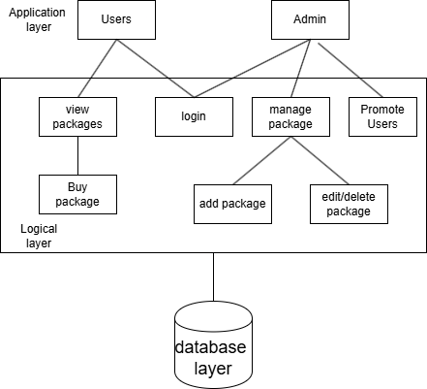

Figure 3.7: Architectural design of Gym/Workout System
Here a user sends a request through the web browser to the HTTP Apache server and the server communicates with the database and returns the desired data to the user. So, this architectural design is used for our project. For the presentation layer HTML and CSS have been used, for the business logic layer PHP has been used and for the database layer MySQL has been used.

Database Schema Design
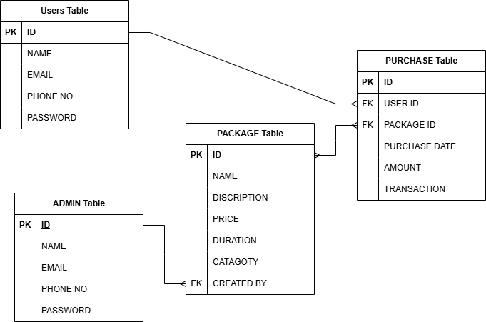
The database named "gwps" has been created for this project. It consists of a total of 4 tables: admin, users, package, and purchase each with corresponding primary keys: id respectively with the required attributes. The foreign keys are also shown in the diagram above.

Interface Design
- Login Page
The interface for the login page is shown below. The page from where the admin and users can log in to the system. It asks for the email and password and redirects to the respective dashboard if successfully logged in.
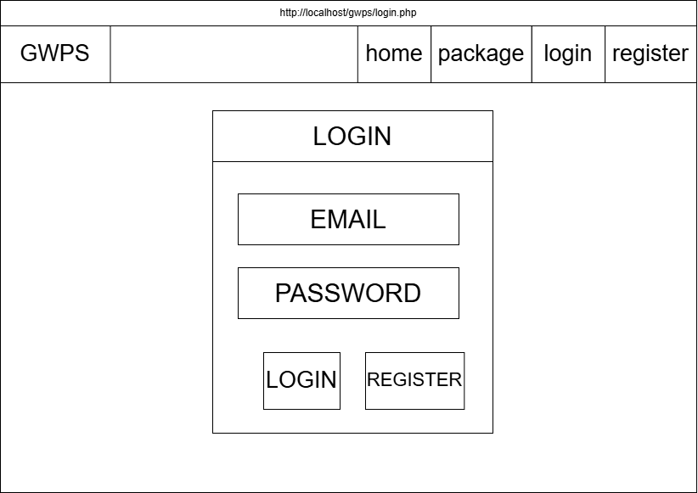
Figure 3.8: Login Page of Gym/Workout package System
- Register Page
The interface for the register page is shown below. The page from where the admin and users can create account in to the system. It asks for the required credentials and redirects to the logged in page if successfully registered.
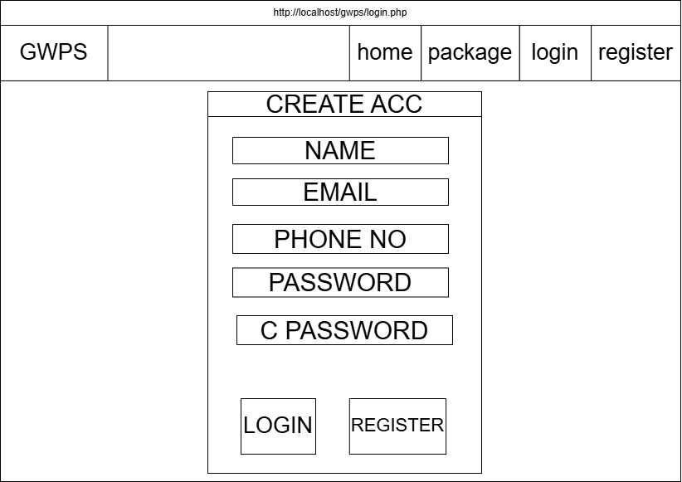
Figure 3.9 Register Page of Gym/Workout package System
- Home page
The interface for the homepage is shown below displays the main page of the system.
Everyone including admins,users sees this page upon opening the system.
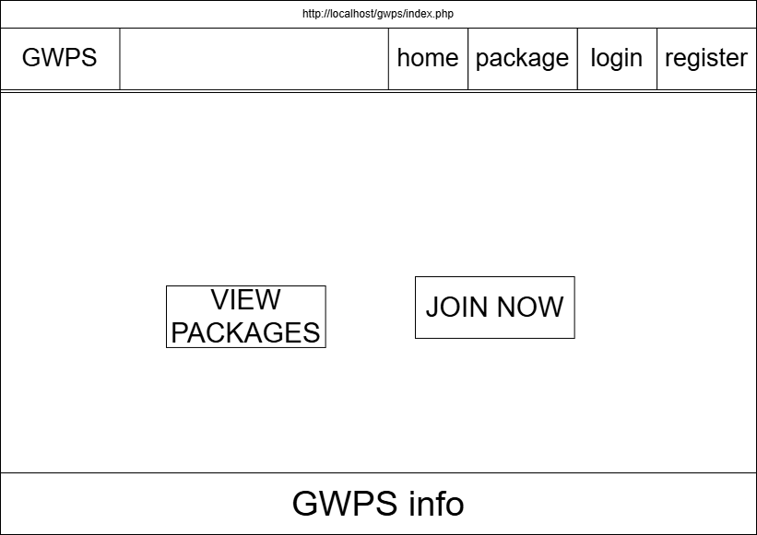
Figure 3.9: Home page of Gym/Workout package System
- Admin Dashboardd page
The interface for the admin dashboard is shown below displays the dashboard of the admin after successful login. From this page, the admin can manage the packages and add packages.
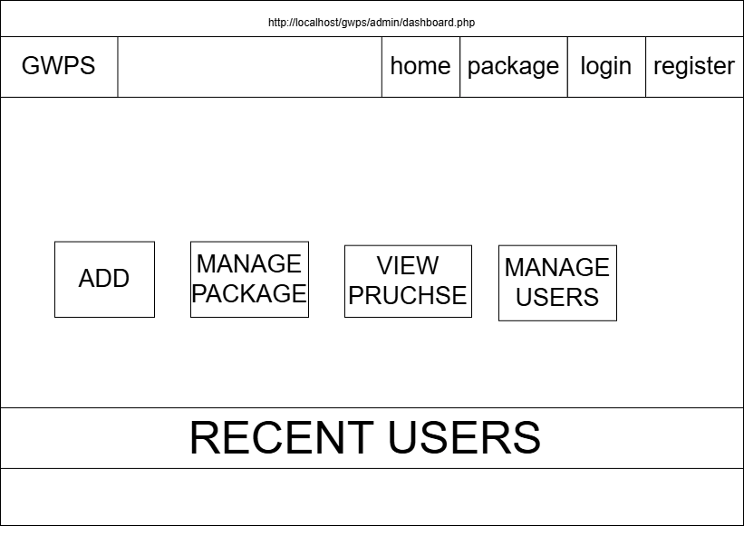
Figure 3.10: Admin Dashboardd page of Gym/Workout package System
- Add package page
The interface to the Add Packages page is shown which below depicts the add movie page. Admins can add packages through this page.
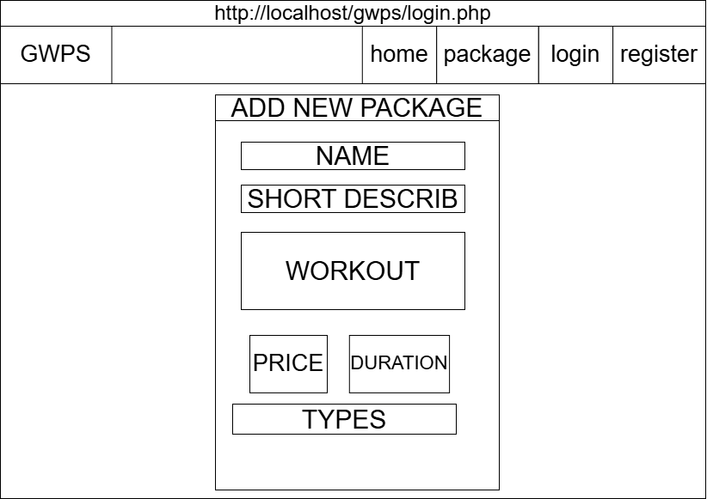
Figure 3.11: Add package page of Gym/Workout package System
- Manage package page
The interface to Manage package is shown below which. Admins can update,edit and manage packages through this page.
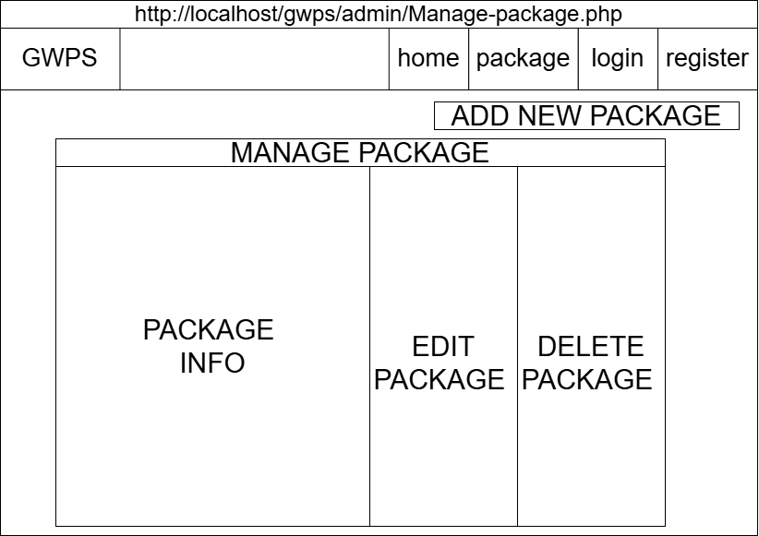
Figure 3.12: Manage package page of Gym/Workout package System
- User Dashboard
The interface for the user dashboard is shown below displays the dashboard of the users after successful login. From this page, the users can view their purchased packages and use them.
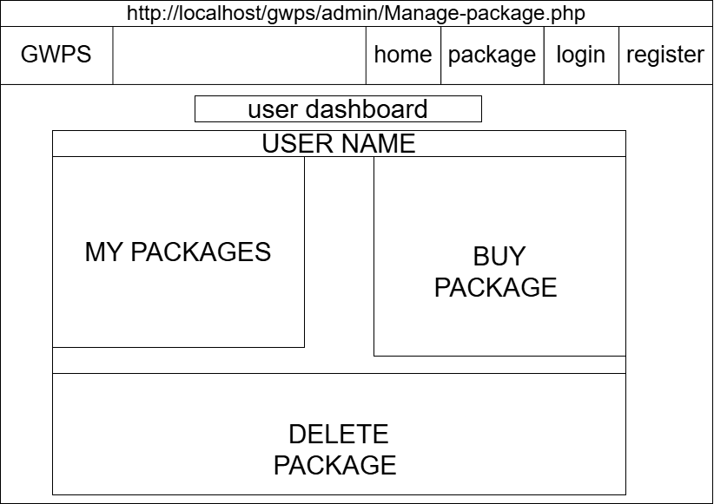
Figure 3.13 User Dashboard Page of Gym/Workout package System
- Buy package page
The interface to buy package is shown below where users can buy packages through this page.
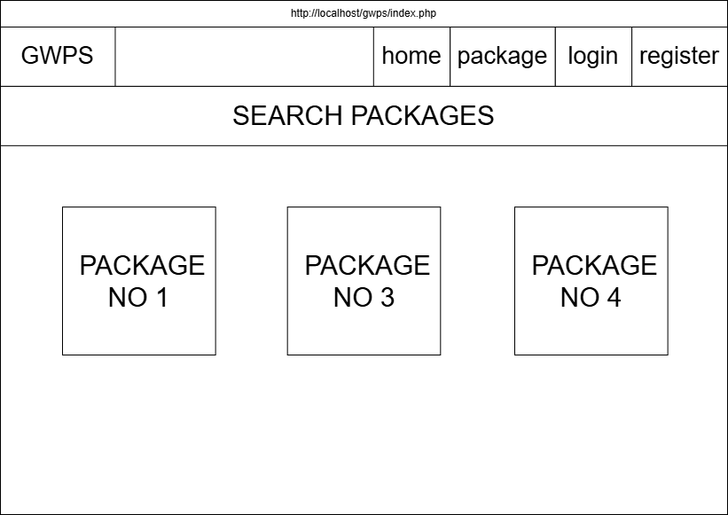
Figure 3.14: Buy package page of Gym/Workout package System
- Users package page
The interface to Users package is shown below where users view all packages they bought through this page.
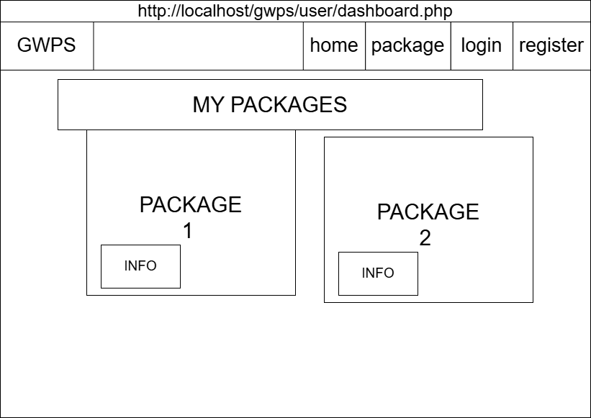
Figure 3.15: Users package page of Gym/Workout package System

Physical DFD
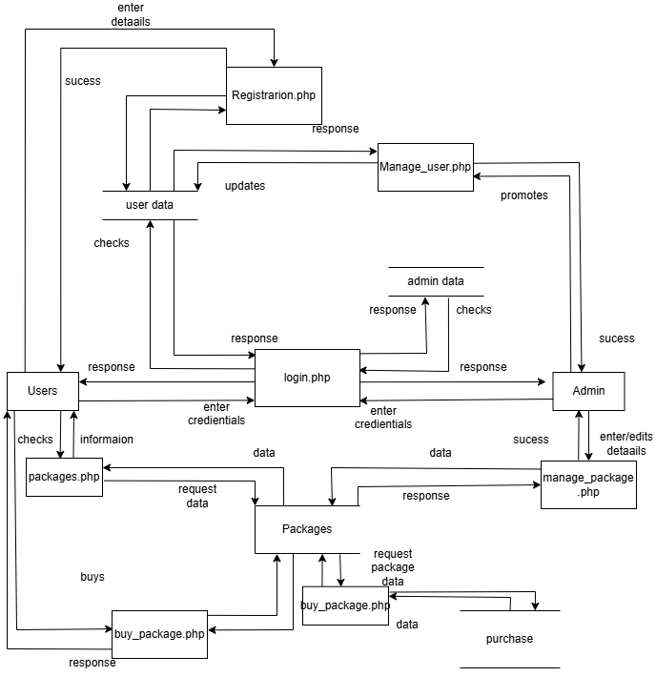
Figure 3.18: Physical DFD for Gym/Workout package System
The physical data flow diagram of the GWPS focus on how things happen in an information flow. These diagrams specify the software, hardware, files, and people involved in an information flow. A detailed physical data flow diagram can facilitate the development of the code needed to implement a data system.

Implementation and Testing

Implementation

Tools Used
Following are the tools and framework used for the accomplishment of this project:

Front end
The following tools were used for frontend:

HTML
In Gym/Workout package System, HTML is used for creating different web-page and sites. It is used to create and structure sections, headings, links, paragraphs using various tags and elements. We also define headers, paragraphs, links, and images of Gym/Workout Package System by using HTML.

CSS
In Gym/Workout package System, CSS is used for designing different tags of HTML. It is also used to design different component by the help of class and id. Different CSS are used such as inline CSS, internal CSS, and external CSS to design this system. It is used for defining the styles for web pages. By using CSS, we can control the text color, font style, the spacing between paragraphs, sizing of columns, layout designs, and many more.

Backend
The following tools were used for backend:

MySQL
MySQL is mainly used for the purpose of database. It is a place where data is stored. Even when the device is shut down, data remains the same with the help of databases. MySQL is mostly used to make different tables for different roles and store different values.

XAMPP
XAAMP is used for local server and database to fulfill the need of the project and MySQL is used as local server and database.

Implementation Details of Modules
User Registration: Users are required to register with the system before accessing its features. During registration, users must fill out a form containing text boxes.
Login: Registered users and admins can log in using the email and password they provided during sign-up.
Package: Packages logged into the system can be bought by users and managed by admins.
User Dashboard Panel: Users after login have access to the user dashboard panel where they can view their bought packages and check if they completed it .
Admin Dashboard Panel: Admin after login has access to the admin dashboard panel where the admin can manage users and packages.
User and Admin Logout: Users and admin can log out of the system at their discretion.

Testing
Testing is conducted to ensure the functionality and reliability GWPS. The system undergoes rigorous testing to verify and validate its proper operation, absence of errors, and fulfillment of requirements.

Test Case for Unit Testing
The gwps comprises a registration form, login form, admin dashboard, and user dashboard. Unit testing is performed for each component to identify and fix any defects, ensuring smooth functionality.

Table 1 Testing Admin Login Form
Pre-conditions: The admin has a valid email and password
Dependencies: Admin Login Module
SN | Test  Case ID | Test Case Name | Test Case Description | Step | Expected Result |  |  | Actual Result | Test  Case status
01 | TC_AL_01 | Email validation - non-existent | Check email that doesn't exist | Input email which does not exist in database |  | Display message: "Invalid email or password" | Display message: "Invalid email or password" |  | Pass
02 | TC_AL_02 | Password validation incorrect | Verify password for respective email | Input a password which does not match |  | Display message: "Invalid email or password" | Display message: "Invalid email or password" |  | Pass
03 | TC_AL_03 | Empty email field | Check validation when email is empty | Leave email field empty and submit |  | Display message: "Please enter your email" | Display message: "Please enter your email" |  | Pass
04 | TC_AL_04 | Empty password field | Check validation when password is empty | Leave password field empty and submit |  | Display message: "Please enter your password" | Display message: "Please enter your password" |  | Pass
05 | TC_AL_05 | Valid credentials - admin | Login with valid admin credentials | Input valid admin email and password |  | Redirect to admin dashboard | Redirected to admin dashboard |  | Pass
06 | TC_AL_06 | Valid credentials - user | Login with valid user credentials | Input valid user email and password |  | Redirect to user dashboard | Redirected to user dashboard |  | Pass
07 | TC_AL_07 | CSRF protection | Submit form without CSRF token | Remove CSRF token and submit |  | Display error message: "Invalid form submission" | Form submitted without error |  | Fail
Post-conditions: User login successfully.

Table 2 Testing Admin Dashboard
Pre-conditions: The admin has a valid email and password.
Dependencies: Admin Dashboard Module
SN | Test Case  ID | Test Case  Name | Test Case Description | Step | Expected Result | Actual Result | Test Case  status
01 | TC_AD_01 | View total users count | Verify total registered users display | Navigate to admin dashboard | Display total number of users | Total users count displayed | Pass
02 | TC_AD_02 | View total packages count | Verify total workout packages display | Navigate to admin dashboard | Display total number of packages | Total packages count displayed | Pass
03 | TC_AD_03 | View total purchases count | Verify total purchases made | Navigate to admin dashboard | Display total number of purchases | Error: "Undefined variable" shown | Fail
04 | TC_AD_04 | View total revenue | Verify total revenue calculation | Navigate to admin dashboard | Display total revenue amount | Total revenue displayed correctly | Pass
05 | TC_AD_05 | View recent users list | Verify recent users table loads | Navigate to admin dashboard | Display 5 most recent users | Only 3 users shown, pagination missing | Fail
06 | TC_AD_06 | Navigate to Add Package | Verify link to Add Package page | Click on "Add New Package" action card | Add Package page opens | Add Package page opened successfully | Pass
Post-conditions: The Admin dashboard successfully performed all the activities.

Table 3 Testing Add Package
Pre-conditions: The admin has a valid email and password.
Dependencies: Add Package Module
SN | Test Case  ID | Test Case Name | Test Case Description | Step | Expected Result | Actual Result | Test  status
01 | TC_AP_01 | Validate empty package name | Check validation when name is empty | Submit form without package name | Display "Package name is required" | Error message displayed | Pass
02 | TC_AP_02 | Validate short description length | Check max length validation | Input 1500 characters in short description | Display "Short description too long (max 1000 characters)" | No error message, form accepts input | Fail
03 | TC_AP_03 | Validate price with negative value | Check negative price validation | Input "-500" in price field | Display "Valid price is required" | Form accepts negative value | Fail
04 | TC_AP_04 | Validate duration with invalid format | Check duration format validation | Input "7d" in duration field | Display "Invalid format! Use: '30 days', '12 weeks'" | Error message displayed | Pass
05 | TC_AP_05 | Validate duration days range | Check maximum days validation | Input "400 days" in duration field | Display "Maximum 365 days allowed" | Error message displayed | Pass
06 | TC_AP_06 | Add package with valid data | Test successful package addition | Input all valid data and submit | Display "Package added successfully!" | Package added, success message shown | Pass
Post-conditions: Package added successfully.

Table 4 Testing Edit Package Form
Pre-conditions: The admin has a valid email and password.
Dependencies: Edit Package Module
SN | Test Case  ID | Test Case Name | Test Case Description | Step | Expected Result | Actual Result | Test  status
01 | TC_EP_01 | Load existing package data | Verify package loads correctly | Click edit on existing package | Package details pre-filled in form | Package details load successfully | Pass
02 | TC_EP_02 | Update package price | Test price update functionality | Change price from 2999 to 3499 and submit | Price updates to 3499 | Price remains 2999 after update | Fail
03 | TC_EP_03 | Update with invalid duration | Test validation on edit | Change duration to "xyz" and submit | Display error message | Error message displayed | Pass
04 | TC_EP_04 | Live preview functionality | Test real-time preview | Type in name field | Preview updates in real-time | Preview does not update | Fail
05 | TC_EP_05 | Delete package with confirmation | Test delete functionality | Click delete button and confirm | Package deleted, redirect to manage page | Package deleted successfully | Pass
06 | TC_EP_06 | Delete package with existing purchases | Test delete restriction | Try to delete package that has purchases | Display error message: "Cannot delete: Package has purchases" | Package deletes anyway, foreign key error | Fail
Post-conditions: Package updated successfully.

Table 5 Testing Manage Package Form
Pre-conditions: The admin has a valid email and password.
Dependencies: Manage Package Module
SN | Test Case  ID | Test Case Name | Test Case Description | Step | Expected Result | Actual Result | Test  status
01 | TC_MU_01 | View all users | View list of all users | Navigate to Manage Users page | List of all users displayed | List of all users displayed | Pass
02 | TC_MU_02 | Change user role to admin | Promote user to admin | Select "admin" from dropdown | User role updated to admin | User role updated | Pass
03 | TC_MU_03 | Change admin role to user | Demote admin to user | Select "user" from dropdown | Display error if last admin | Error message displayed | Pass
04 | TC_MU_04 | Cannot change own role | Try to change own role | Current admin tries to change own role | Dropdown should be disabled | Dropdown disabled | Pass
05 | TC_MU_05 | View role badges | Check role display | View user table | Admin badge for admins, User badge for users | Badges displayed correctly | Pass
06 | TC_MU_06 | User join date | Check join date display | View user table | Join date shown in correct format | Join date displayed | Pass
Manage packages successfully performed.

Conclusion and Future Recommendations

Lesson Learnt
This project was helpful in teaching some important lessons.
- Firstly, about how the requirements should be collected.
- After that how the database should be designed to achieve those requirements.
- Then the critical importance of Admin- design and the need for a seamless and intuitive interfaces.

Conclusion
In conclusion, this project seeks to make the House rental space more digital and more streamlined. It tries to reduce the stress and time consumption of finding a proper Package for rent. It provides a good interface for Admins to rent the Package they wanted. They can check for their booking status or cancel that rent. The Admins can add new Package, edit the existing Package they added.

Future Recommendations
Some of the features that can be implemented in the future can be:
- Mapping of the Package can be added.
- Adding forgot password option.
- An Online payment system can be added.
- More categories for Package can be added.
- A mobile application can be developed.

References

[1] | M. R. Beauchamp, Y. Liu, W. L. Dunlop and e. al., "Psychological mediators of exercise adherence among older adults in a group-based randomized trial," Health Psychology, vol. 40, no. 3, pp. 166-177, 2021.
[2] | W. C. &. H. Cho, "The role of technology readiness in individuals' intention to use health and fitness applications: a comparison between users and non-users," Asia Pacific Journal of Marketing and Logistics, vol. 33, no. 3, pp. 807-825, 2021.
[3] | A. K. M. B. S. J. S. G. Aditi Shrestha, "Effects of Social Media Marketing on Consumer Buying Behavior," New Perspective: Journal of Business and Economics, vol. 6, no. 1, p. 74–82, 2023.
[4] | P. T. Ganesh Bhattarai, "An Empirical Study on E-Commerce and Its Determinants in the Context of Nepalese Small and Medium Enterprises," International Research Journal of MMC, vol. 5, no. 5, p. 109–122, 2024.

