ARP is **the protocol used to associate the IP address to a MAC address**. When a host wants to send a packet to another host, say IP address 10.5. 5.1, on its local area network (LAN), it first sends out (broadcasts) an ARP packet.

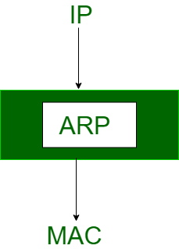

**Reverse Address Resolution Protocol** (RARP) is a protocol a physical machine in a local area network (LAN) can use to request its IP address. It does this by sending the device's physical address to a specialized RARP server that is on the same LAN and is actively listening for RARP requests.

