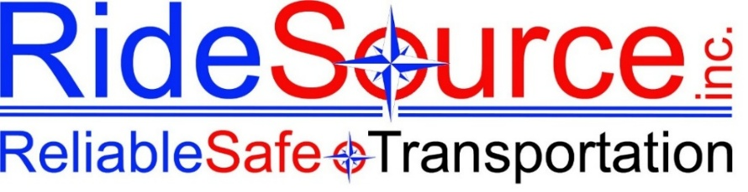

ATTENDANCE WARNING – TERMINATION RISK
RideSource Inc. — HR Department

Dear [Employee Name],

This correspondence serves as a Final Written Warning regarding your continued attendance violations.

Despite previous discussions and/or written warnings concerning your attendance, you have continued to accumulate call-outs. To date, you have recorded [number] call-out(s) within [timeframe], which does not meet the attendance standards required for your position.

As previously communicated, reliable attendance is an essential job function. Repeated call-outs disrupt operations, impact service commitments, place strain on team members, and affect the company’s ability to meet organizational goals.

This Final Written Warning places you on notice that any further attendance violations may result in additional disciplinary action, up to and including termination of employment.

Immediate and sustained improvement is required. We expect full compliance with company attendance policies moving forward.

If there are circumstances you believe should be considered, you must notify your supervisor immediately.

Sincerely,
Management Team
RideSource

