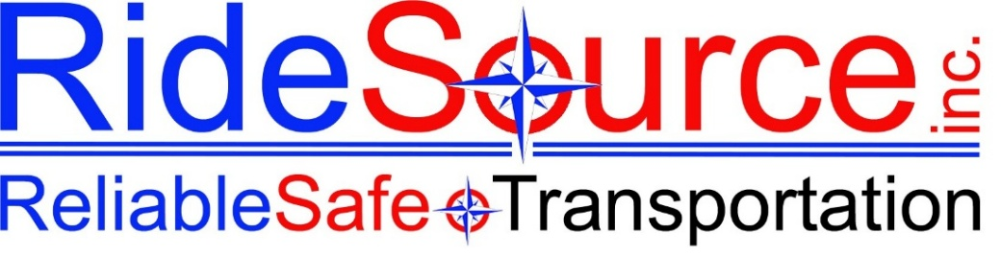

ATTENDANCE WARNING
RideSource Inc. — HR Department

EmPloyee Information
Employee Name: |  | Date of Warning:

Position / Title: |  | Location:

Department / County: |  | Supervisor:

Incident Details
Date of Incident: |  | Time:

Description of Attendance Issue:
__________________________________________________________________________________________________________________________________________________________________________________________________________________________________________________________________________________________________________________________________________________________________________________________________________________________________________________________________
Attendance Record
Total Call-Outs / Absences (Last 90 Days):

Previous Warnings on File:

Policy Reminder

POLICY | This written warning is being issued due to attendance concerns. The attendance issues documented below are considered a violation of RideSource's Attendance & Punctuality Policy. Reliable attendance is essential to our ability to provide dependable service to our passengers and community.
Corrective Action Required
The employee is expected to demonstrate immediate and sustained improvement in attendance. Any further violations of the Attendance & Punctuality Policy may result in further disciplinary action, up to and including termination of employment.

Additional Comments / Action Plan:
__________________________________________________________________________________________________________________________________________________________________________________________________________________________________________________________________________________________________________________________________________________________________________________________________________________________________________________________________
Acknowledgment
Employee signature below acknowledges receipt of this warning. It does not necessarily indicate agreement with the content.

Employee Signature | Date

Supervisor / Manager Signature | Date

HR Representative (if applicable) | Date

FILE | A copy of this document must be retained in the employee's personnel file.

RideSource, Inc. | Reliable Safe Transportation | Confidential HR Document

