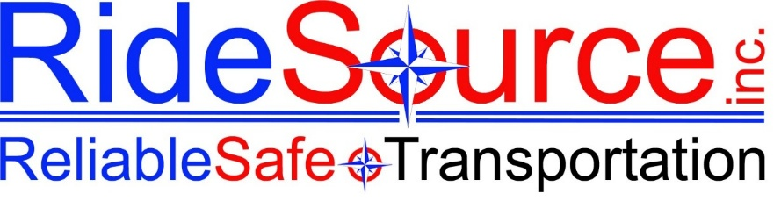

DRIVER INTERVIEW GUIDE
For Internal Use Only — HR & Management

NOTICE | For internal use only. Do not ask about age, national origin, religion, marital/family status, disability, pregnancy, or any other protected characteristics.

Applicant Name: | ☐ FT ☐ PT ☐ Agency ☐ Volunteer

Interview Date: | Rate of Pay:

Location:

For Volunteer:
☐ License | ☐ Insurance Declaration 100–300 | ☐ Registration
General
How did you hear about this position?
Are you familiar with what we do at RideSource?
Do you have any relevant experience or certifications for this position?
☐ Yes | ☐ No
If yes, please explain:
Background & Eligibility
Are you okay with having a background check, motor vehicle check, and fingerprints done?
☐ Yes | ☐ No
This position requires transporting DHHS members and requires a valid driver's license, a clean driving record that meets our insurance carrier's standards, and the ability to pass required state and federal background checks. Do you meet these requirements?
☐ Yes | ☐ No
If No, please explain:
Have you ever been convicted of a felony/crime or a driving-related offense that would prevent you from legally operating a motor vehicle for employment purposes?
☐ Yes | ☐ No
If yes, please explain:
Driving & Situational
How would you rate your driving record?
How do you handle the following stressful situations? (Give examples)
Disgruntled clients:
Last-minute changes:
Inclement weather:
Technology & Reliability
What is your experience level with Android devices?
If we spoke to a prior supervisor and asked them to describe your attendance and punctuality, what would they say?

~ Explain why punctuality and attendance are essential in this position
Availability
What is your availability?
☐ Monday | ☐ Tuesday | ☐ Wednesday | ☐ Thursday | ☐ Friday

☐ Saturday | ☐ Sunday | ☐ Nights

From: | To:

Do you have any upcoming time-off requests?
☐ Yes | ☐ No
If yes, list dates:
Additional
☐ Yes | ☐ No
Are you willing to transport children or students?

Do you have any questions for us?
Interviewer Notes & Decision
Comments:

☐ Hire  ☐ Do Not Hire | Reason (if not hired):

Interviewer Signature | Date

RideSource, Inc. | Reliable Safe Transportation | For Internal Use Only

