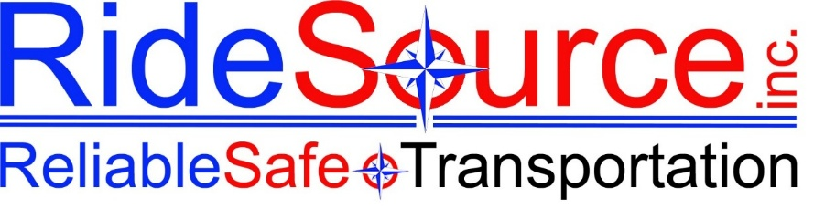

Date:

Applicant Name:

Address:

City, State, ZIP:

Dear [Applicant Name],

Thank you for your interest in joining the RideSource team and for taking the time to interview for the [Position Title] position. We genuinely appreciate the time and effort you invested in our process.

After careful consideration, we have decided to move forward with another candidate whose qualifications more closely match our current needs. This was a difficult decision, as we had many strong applicants.

We encourage you to apply for future openings at RideSource that align with your skills and experience. We will retain your application on file for [30/60/90] days.

We wish you the very best in your job search and future endeavors.

Sincerely,

NOTE | This letter is sent on behalf of RideSource Inc. and is confidential.

