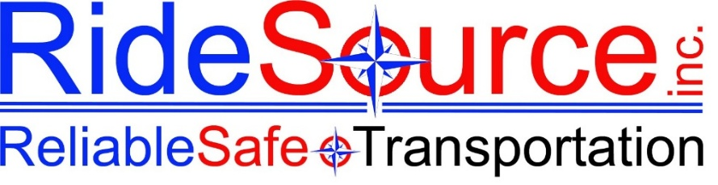

EMPLOYEE ACCOLADES & COMMENDATION FORM
RideSource Inc. — Recognizing Excellence in Service

Use this form to record a compliment, commendation, or positive feedback received about a RideSource employee. Completed forms are filed in the employee’s personnel record and may be used in performance reviews and recognition programs. Thank you for taking the time to recognize great work!
SECTION 1 — HOW THE COMPLIMENT WAS RECEIVED
Date Received: |  | Received By:
Method of contact (check one):
☐ Phone Call | ☐ Email / Written | ☐ In-Person Comment | ☐ Other  _____________________
SECTION 2 — MEMBER / CALLER INFORMATION
Complete as much as the caller is willing to share. Anonymous compliments are welcome.
Caller / Member Name: |  | Phone / Contact (optional):
Member ID / Trip # (if known): |  | Date of Trip / Service (if known):

☐ Passenger / Client | ☐ Family Member / Caregiver | ☐ Other (facility staff, agency, etc.)

Caller requested follow-up? ☐ Yes ☐ No If yes: ____________________________________________________

SECTION 3 — EMPLOYEE BEING RECOGNIZED
Employee Name: |  | Position / Title:
Department / County: |  | Supervisor:
Vehicle / Route (if applicable): |  | Date of Service Referenced:
SECTION 4 — NATURE OF THE COMPLIMENT
What was the employee recognized for? (check all that apply)
☐ Safety — safe, careful, attentive driving | ☐ Reliability — on time, dependable, well-prepared
☐ Kindness — warm, compassionate, patient demeanor | ☐ Professionalism — appearance, communication, conduct
☐ Assistance — went above and beyond to help the member | ☐ Confidentiality — handled sensitive information with care
☐ Problem Solving — handled a difficult situation well | ☐ Team Support — helped a colleague or covered a shift
☐ Vehicle Cleanliness — clean, well-maintained vehicle | ☐ Other (describe below)

Additional detail on what was recognized:
SECTION 5 — MEMBER’S COMPLIMENT
Record the member’s exact words if possible, or a close summary of what they said.
“ What the member said ” — Record verbatim or summarize below:
SECTION 6 — OVERALL SERVICE RATING
If the caller offered an overall impression of the service, select the closest rating:
Caller’s overall impression of service:
☐ ★ Outstanding | ☐ ★ Excellent | ☐ ★ Very Good | ☐ ★ Good | ☐ ★ Positive

SECTION 7 — ADDITIONAL CONTEXT & NOTES
Any additional context, background, or notes from the person receiving this call:

Was this incident or trip flagged for any other reason? ☐ Yes ☐ No If yes, note separately.

SECTION 8 — RECOGNITION & FOLLOW-UP ACTIONS
Actions taken or planned (check all that apply):
☐ Filed in employee personnel record | ☐ Verbally shared with employee
☐ Shared with supervisor | ☐ Nominated for employee recognition program
☐ Written acknowledgment sent to employee | ☐ Shared with team (with employee consent)
☐ Noted for upcoming performance review | ☐ Other (describe below)
SECTION 9 — ACKNOWLEDGMENT & SIGNATURES
Supervisor or HR signature confirms this record has been reviewed and filed. Employee signature acknowledges receipt of the commendation — receiving a commendation is always voluntary to acknowledge.

Recorded By (Print Name) |  | Signature & Date

Supervisor / Manager (Print Name) |  | Signature & Date

Employee Acknowledged (Print Name) |  | Signature & Date

RideSource, Inc. | Reliable Safe Transportation | Employee Recognition Record | Norway, Maine

