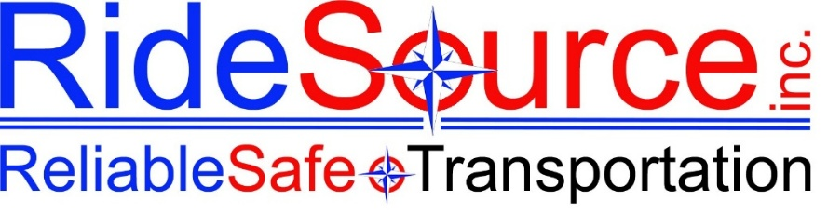

SUPERVISOR / HR INVESTIGATION FORM
RideSource Inc. — Internal Use Only | Do Not Share Without HR Authorization

This form is to be completed by the investigating supervisor or HR representative. All information is strictly confidential and must be stored securely in the employee's personnel file. This form follows the investigation procedures outlined in the Employee Handbook §10.2 and the Employee Policy Packet §10.
SECTION 1 — CASE / COMPLAINT INFORMATION
Case / File #: |  | Date Opened:
Date Complaint Received: |  | Complaint Received By:

Investigation Status: | ☐ Open ☐ In Progress ☐ On Hold ☐ Closed ☐ Referred to Law Enforcement

Priority Level: | ☐ Routine ☐ Elevated ☐ Urgent / Safety Risk

Type of Complaint / Incident (check all that apply):
☐ Harassment / Discrimination | ☐ Conduct / Policy Violation
☐ Passenger Complaint / Safety Incident | ☐ Attendance / Punctuality Issue
☐ HIPAA / Confidentiality Violation | ☐ Workplace Violence / Threat
☐ Retaliation | ☐ Vehicle / Equipment Misuse
☐ Documentation / Billing Irregularity | ☐ Other (describe below)

Other / Additional incident type details:

SECTION 2 — PARTIES INVOLVED
Complainant
Name: |  | Position / Title:
Department / County: |  | Date of Hire:
Respondent / Subject of Investigation
Name: |  | Position / Title:
Department / County: |  | Date of Hire:
Supervisor: |  | Currently Active? ☐ Yes ☐ No ☐ Suspended

Prior disciplinary history on file? ☐ Yes ☐ No If yes, describe:

Prior discipline summary:
SECTION 3 — INCIDENT DETAILS
Date of Incident: |  | Time of Incident:
Location: |  | Vehicle / Route (if applicable):

Summary of alleged incident / complaint (in investigator's own words):

SECTION 4 — EVIDENCE REVIEWED
Check all evidence sources reviewed during investigation:
☐ Employee Complaint Form | ☐ Dash Camera Footage
☐ Text / Email Communications | ☐ Parascope / Trip Records
☐ GPS / Vehicle Location Data | ☐ Timekeeping / TWE Records
☐ Witness Statements (see §5) | ☐ Prior disciplinary records
☐ Personnel file | ☐ Photos / Video
☐ Accident / Incident Reports | ☐ Other (describe below)

Evidence description / notes (include dates, sources, and any chain of custody notes):

Dash Camera Footage Reviewed? ☐ Yes ☐ No ☐ N/A Vehicle ID / Date:
Footage Retained? ☐ Yes — stored at: ☐ No ☐ N/A
SECTION 5 — WITNESS INTERVIEWS
Witness 1
Name: |  | Position / Title:
Date Interviewed: |  | Method: ☐ In-Person ☐ Phone ☐ Written

Summary of witness statement:
Witness 2
Name: |  | Position / Title:
Date Interviewed: |  | Method: ☐ In-Person ☐ Phone ☐ Written

Summary of witness statement:
Witness 3
Name: |  | Position / Title:
Date Interviewed: |  | Method: ☐ In-Person ☐ Phone ☐ Written

Summary of witness statement:
SECTION 6 — RESPONDENT INTERVIEW & RESPONSE
Date Respondent Interviewed: |  | Method: ☐ In-Person ☐ Phone ☐ Written

Summary of respondent's account / response to allegation:

Did respondent deny the allegation? ☐ Yes ☐ No ☐ Partial Admission ☐ Full Admission
SECTION 7 — MANDATORY REPORTING & REGULATORY ASSESSMENT
Per RideSource policy and Maine law, certain incidents require mandatory reporting to DHHS, law enforcement, or MaineCare. Complete this section for every investigation.

☐ Suspected abuse / neglect of a vulnerable adult or minor (Maine 22 M.R.S. §4011-A / §3477)
☐ HIPAA breach — client PHI potentially disclosed
☐ MaineCare billing irregularity / fraud
☐ Criminal conduct (theft, assault, DUI, etc.)
☐ Workplace violence — law enforcement notification required
☐ None of the above apply to this incident

Mandatory report filed? ☐ Yes ☐ No ☐ N/A |  | Agency / Authority Notified:
Report Filed By: |  | Date Filed:

Mandatory reporting notes / tracking number:
SECTION 8 — INVESTIGATION FINDINGS
Finding: | ☐ Substantiated ☐ Unsubstantiated ☐ Inconclusive ☐ Pending Further Review

Summary of findings and basis for determination:

Policy / handbook sections violated (cite specific sections):

SECTION 9 — CORRECTIVE ACTION & DISCIPLINARY OUTCOME
Action(s) taken (check all that apply):
☐ No action — complaint unsubstantiated | ☐ Verbal warning issued
☐ Written warning issued | ☐ Final written warning issued
☐ Performance Improvement Plan (PIP) initiated | ☐ Suspension — with pay
☐ Suspension — without pay | ☐ Demotion / reassignment
☐ Termination | ☐ Referred to law enforcement
☐ Training / coaching assigned | ☐ Other (describe below)

Description of corrective action / disciplinary outcome and rationale:

Effective Date of Action: |  | Reviewed by Owner / Management? ☐ Yes ☐ No
SECTION 10 — FOLLOW-UP & MONITORING
Follow-up required? ☐ Yes ☐ No If yes, describe:
Follow-up review date:
Drug test required? ☐ Yes — type: ☐ No ☐ Completed

Monitoring plan / additional notes:

Complainant notified of outcome? ☐ Yes ☐ No ☐ N/A Date notified:
Was retaliation risk assessed? ☐ Yes ☐ No Notes:
SECTION 11 — AUTHORIZATION & SIGNATURES
All signatures below confirm review and authorization of this investigation record. Employee signature acknowledges receipt of outcome only — not necessarily agreement with findings.

Investigating Supervisor (Print Name) |  | Signature

Date Investigation Completed |  | Date Corrective Action Delivered

HR Representative (Print Name) |  | Signature

Employee / Respondent (Print Name) — Receipt Only |  | Signature & Date

Management / Owner Review (Print Name) |  | Signature & Date

Document Retention Location / File Path:

Date Filed in Personnel Record:

RideSource, Inc. | Reliable Safe Transportation | INTERNAL — FOR SUPERVISOR / HR USE ONLY | Norway, Maine

