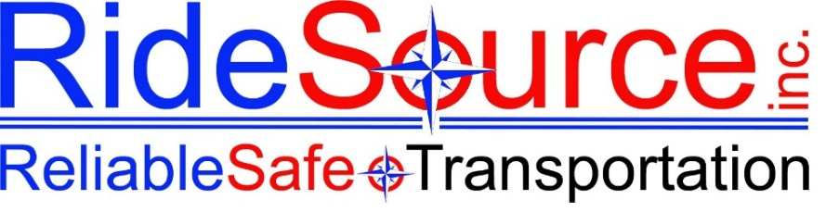

[Date]

Dear [Employee First Name],

On behalf of the entire RideSource team, it is my sincere pleasure to welcome you as our newest team member. We are genuinely excited to have you with us, and we want you to know that this decision was made with real confidence in what you bring to our organization.
RideSource exists to connect people to the care and resources they need — every trip, every time. The work we do matters deeply to the individuals and communities we serve, and the people behind the wheel are at the heart of that mission. That's you.

Your Position & Start Details
Position:

Start Date:

Report Time:

Report Location:

Your Contact:

Phone:

Before Your First Day
To ensure your first day of hands-on training goes smoothly, please complete the following online training courses prior to your arrival. These can be completed from any device from the comfort of your home. RideSource covers the full cost of all required courses — you simply need to complete them.
These courses will be sent you by our HR Staff via the email address you provided. Please check your spam or junk folder if you do not see them in your inbox. HR Staff will send you one training at a time.
Upon completing each course, you will receive a certificate by email. Please forward your completed certificates to tiffanyb@ridesourcemaine.com as soon as they are received. Hands-on CPR training will be scheduled within your first 60 days.
.

REQUIRED | PASS Certification • Defensive Driving • First Aid, CPR & AED

ONLINE TRAINING | RideSource does not pay an hourly wage for online training.  You will not be able to move forward with hands-on (paid) training until your online training is complete.

What to Expect on Day One
Your first day will be spent getting oriented, meeting the team, and laying the groundwork for your training:
- Overview of RideSource's mission, values, and culture
- Review of your role, responsibilities, and daily expectations
- Team introductions and facility orientation
- Vehicle and phone assignment
- Required documentation (if not already completed)
- Badge photo and ID setup
- Time off requests, timekeeping, and payroll systems

Important Information
A secure document containing your Driver ID, door code, vehicle assignment, and phone information will be presented to you on your first day of employment.

QUESTIONS?

We are looking forward to seeing you on [Start Date]. Welcome to the RideSource family — we are glad you're here.

Warmly,

