Mastering Embedded Linux
Raspberry Pi Edition

Table of Contents
Chapter 1: 3
Introduction to Embedded Linux 3
1.1 History of Linux 4
Early Development (1991–1993) 4
Rise of Linux (1994–2000) 5
Linux Matures (2001–2010) 5
Modern Linux Era (2011–Present) 5
1.2 Domains and Industries Utilizing Linux 6
Example: Open Source Contributions 8
1.3 Overview of Linux Kernel Architecture and Its Modularity 8
Kernel Architecture 8
Main Components of the Linux Kernel: 8
Modularity Through Loadable Modules 9
1.4 Differences Between General-purpose Linux Distributions and Embedded Linux Systems 9
Linux Distribution: A Linux distribution is a complete operating system built around the Linux kernel, combined with a collection of software, package managers, and system tools. Each distribution (or "distro") packages the kernel with different applications, desktop environments, and configurations to serve specific needs, such as general-purpose computing, server deployment, security, or lightweight performance. Popular examples include Ubuntu, Fedora, Debian, and Arch Linux. 10
Embedded Linux: 10
What Embedded Linux Really Means 11
Expanded Side-by-Side Comparison 12
Concrete Scenario Comparison 12
Why the Difference Matters 13
1.5 Introduction to Cross-Compilation and Toolchains. 13
1.5.1 Why Cross-Compile? 14
1.5.2 Toolchains: 15
1.5.3 Practical Mini-Lab — Your First Cross-Compiled Hello World 17
Step 1 — Create the Source File 17
Step 2 — Write a Minimal Makefile 17
Step 3 — Build on the Host by default 18
Step 4 — Build on the Host to Target 18
1.6 Boot Flow Process: From PowerOn the Board to the Kernel 18
1.6.1 BootRom: 19
1.6.2 Bootloader: 19
1.6.3 Linux Kernel: 20
Chapter 2: Bootloaders and U-Boot (Table of Contents) 21
2.1 Bootloaders in Embedded Systems: 21
2.2 Raspberry pi boot chain: 21
2.3 Create your own Bare metal boot with EEPROM Only: 21
2.4 Introduction U-Boot: 21
2.5 Building U-Boot for Raspberry Pi: 22
2.6 Flashing and First boot test: 22
2.7 Navigating the U-Boot CLI: 22
2.8 Environment Variables & Boot Scripts: 22
2.9 Advanced Configuration Via menuconfig 22
2.10 Security & Signing Considerations 22
2.11 Troubleshooting U-Boot 22

Chapter 1:

Introduction to Embedded Linux
Before we dive into the technical details, let's face it—like every technical book, we need to start from the very beginning and understand how Linux was created. I know, this might just be the most boring part of the entire book for some, but to make my book appear more professional, I need to include the history of Linux. Let's treat this section as the "Roman phase" of the book—necessary, foundational, and perhaps a little lengthy.

1.1 History of Linux
Linux originated in 1991 when Linus Torvalds, a computer science student at the University of Helsinki, announced that he was developing a free operating system kernel as a personal project. His goal was to create a system similar to MINIX, a Unix-like operating system developed by Andrew S. Tanenbaum, but with expanded functionality and open collaboration.

Early Development (1991–1993)
Initially, Torvalds released Linux under a restrictive license, limiting commercial use. However, he soon adopted the GNU General Public License (GPL), which allowed the code to be freely shared, modified, and distributed. This move rapidly accelerated Linux's growth by fostering community contributions.
Key milestones in this early phase:
- Version 0.01 (1991): First publicly announced kernel, featuring basic process scheduling and file systems.
- Version 0.12 (1992): GPL licensing begins, increasing adoption and community participation.
- Version 0.99 (1993): Significant improvements in stability, introducing networking support (TCP/IP), enhancing its suitability for broader use.

Rise of Linux (1994–2000)
Throughout the mid to late 1990s, Linux evolved dramatically. Major tech companies recognized its potential, and distributions like Slackware, Debian, and Red Hat emerged, making Linux accessible to broader audiences.
Key developments:
- Linux 1.0 (1994): Marked Linux’s official transition from hobbyist tool to stable, reliable OS kernel suitable for production use.
- Linux 2.0 (1996): Introduced support for symmetric multiprocessing (SMP), vastly expanding Linux’s usability on multi-processor systems.
- Commercial Interest: IBM, Oracle, and other industry giants began investing in Linux, fueling rapid growth and enterprise credibility.

Linux Matures (2001–2010)
In the early 2000s, Linux penetrated deeply into enterprise environments, driven by stability, scalability, and security.
Key milestones:
- Linux 2.4 (2001): Improved scalability and hardware support, used extensively in servers and embedded systems.
- Linux 2.6 (2003): Significant architectural improvements, enhanced support for threading, real-time applications, and embedded systems.
- Enterprise Adoption: Major deployments by Google, Amazon, and Facebook firmly established Linux in global infrastructure.

Modern Linux Era (2011–Present)
Today, Linux powers everything from smartphones (Android), embedded devices, IoT systems, automotive infotainment systems, to virtually all of the world's supercomputers.
Key developments:
- Linux 3.x–6.x: Continuous performance enhancements, security improvements, and wider hardware compatibility.
- Embedded Linux: Growth in embedded markets, driven by projects like Raspberry Pi, Arduino (Linux-based variants), and platforms like Android and Yocto.
- Community and Corporate Synergy: Modern Linux development combines extensive community participation with corporate backing (Intel, Red Hat, Google), resulting in rapid innovation.
This history underlines how Linux transitioned from a modest student project to a global technological cornerstone, especially vital in the embedded systems domain.

1.2 Domains and Industries Utilizing Linux
Linux's flexibility and open-source nature have enabled its widespread adoption across diverse industries and domains. Here are some primary sectors:
- Servers and Data Centers: Linux dominates server environments, powering web hosting, cloud computing platforms such as Amazon Web Services (AWS) and Google Cloud, and enterprise infrastructures.
Figure 1: Data Center
- Mobile and Embedded Devices: Android, built on the Linux kernel, runs billions of smartphones and tablets worldwide. Embedded devices, such as smart TVs, routers, and IoT devices, extensively utilize Linux for its reliability and adaptability.
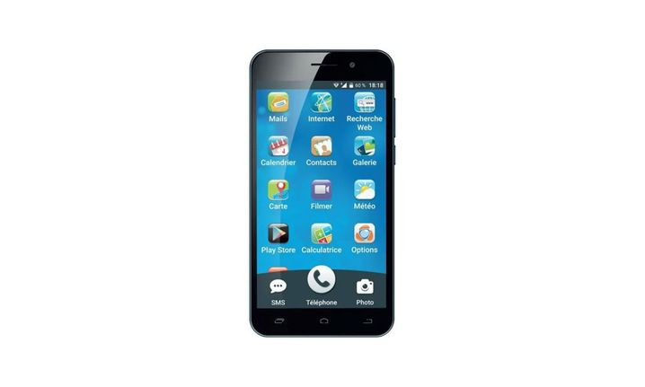Figure 2: SmartPhone

- Automotive Industry: Linux is increasingly utilized in automotive systems, particularly in infotainment and navigation systems through platforms like Automotive Grade Linux (AGL).
- Supercomputing and Research: Linux powers the majority of the world's fastest supercomputers, facilitating cutting-edge scientific research and computational tasks.
- Industrial and Automation: In industrial environments, Linux provides robust control systems for manufacturing processes, robotics, and automation tasks.

Example: Open Source Contributions
One notable example highlighting Linux's adoption is the Raspberry Pi—a versatile, low-cost computing platform that leverages Linux for educational purposes, DIY projects, and commercial applications.
The Raspberry Pi exemplifies the power of Linux to democratize computing, encouraging widespread innovation and community participation.

1.3 Overview of Linux Kernel Architecture and Its Modularity
The Linux kernel is the core component of a Linux operating system, acting as a bridge between software applications and the physical hardware of the computer. It manages hardware resources, enabling multiple applications to run concurrently.

Kernel Architecture
The Linux kernel has a monolithic architecture, meaning all kernel services run within a single kernel space. However, it offers modularity through loadable kernel modules (LKMs), allowing dynamic addition and removal of functionalities without needing to reboot.

Main Components of the Linux Kernel:
- Process Management: Handles scheduling and execution of processes.
- Memory Management: Manages RAM, virtual memory, paging, and protection.
- File Systems: Provides abstraction for storing and organizing data.
- Device Drivers: Software interfaces to hardware devices, enabling communication and control.
- Networking Stack: Implements various network protocols and manages network connections.

Modularity Through Loadable Modules
Linux kernel modules (LKMs) are key to the kernel’s flexibility, allowing functionalities such as device drivers or file systems to be loaded and unloaded dynamically. This modularity reduces memory footprint and increases flexibility and efficiency, essential in embedded environments.
This architecture and modularity are foundational to Linux’s adaptability across numerous computing platforms, from powerful servers to small embedded devices.

1.4 Differences Between General-purpose Linux Distributions and Embedded Linux Systems
Linux, the open-source operating system kernel pioneered by Linus Torvalds, has evolved far beyond its origins into a global ecosystem powering everything from supercomputers to smartwatches. Its adaptability lies in two key realms: general-purpose distributions, which cater to desktops, servers, and everyday computing, and embedded Linux, which drives specialized, often invisible systems in devices we interact with daily. While distributions like Ubuntu or Fedora prioritize user-friendliness and software abundance, embedded Linux strips away excess to deliver efficiency and reliability in constrained environments like medical devices, routers, and industrial controllers. Understanding these branches reveals how Linux’s modular design supports both the visible and invisible pillars of modern technology.

Linux Distribution:
A Linux distribution is a complete operating system built around the Linux kernel, combined with a collection of software, package managers, and system tools. Each distribution (or "distro") packages the kernel with different applications, desktop environments, and configurations to serve specific needs, such as general-purpose computing, server deployment, security, or lightweight performance. Popular examples include Ubuntu, Fedora, Debian, and Arch Linux.
Distributions may vary in their target audience, stability, software availability, and philosophy (e.g., open-source purity vs. user convenience). Some are maintained by communities (e.g., Debian), while others are backed by companies (e.g., Red Hat Enterprise Linux).
A Linux distribution (often shortened to distro) is a complete operating-system stack that bundles:
- the Linux kernel;
- GNU user-space utilities (coreutils, bash, grep, etc.);
- an init system (systemd, SysV init, OpenRC, etc.);
- a package-management system (dpkg + APT, RPM + DNF, pacman, etc.);
- a curated software repository with thousands of pre-built packages;
- a release policy & update mechanism (security fixes, LTS vs rolling);
- optional desktop environment(s), documentation, installers, and community or commercial support.
Well-known examples include Ubuntu, Fedora, openSUSE, Debian, Arch Linux and Red Hat Enterprise Linux. These distros target general-purpose workloads—desktops, laptops, servers, and cloud VMs—where storage is measured in GBs, RAM in GBs, and a fast network is assumed.

Embedded Linux:
The Linux embedded world refers to the use of the Linux operating system in specialized, resource-constrained computing environments where efficiency, reliability, and low power consumption are critical. Unlike traditional desktop or server distributions, embedded Linux systems are tailored for dedicated hardware—such as IoT devices, industrial machines, medical equipment, networking routers, and automotive systems—often running without a graphical interface.

What Embedded Linux Really Means
An embedded Linux system is not a shrink-wrapped distro. Instead it is a custom firmware image created for one specific board or product. Typically generated by tools such as Buildroot, Yocto/OpenEmbedded, OpenWrt, or vendor SDKs, it usually contains:
- a tailored kernel with only the required drivers and subsystems;
- a minimal C library (musl or uClibc) instead of glibc;
- BusyBox or Toybox replacing hundreds of GNU utilities;
- a very small init (BusyBox init, runit, systemd-minimal) and maybe an rc script;
- read-only or overlay root-fs stored in squashfs/UBI;
- application(s) built in-house, often running as PID 1;
- OTA update mechanism (A/B partitions, RAUC, SWUpdate) if required.
The driving goals are footprint, determinism, security, and fast boot on hardware that may have:
- 64 MB – 512 MB of RAM,
- ≤ 256 MB of flash/eMMC,
- no display (headless),
- tight power or real-time constraints.

Expanded Side-by-Side Comparison
Aspect | General-Purpose Linux Distro | Embedded Linux Firmware
Typical storage footprint | 2 – 8 GB (desktop) / 600 MB (server net-install) | 8 – 100 MB (squashfs)
Kernel | Generic binary with most drivers = large | Stripped-down, board-specific
Init system | systemd with dozens of services | BusyBox init or minimal systemd
Package mgmt | APT/RPM/zypper; thousands of packages on demand | None in production image (read-only); packages built at image-creation time
Boot time | 10 – 60 s typical | 300 ms – 5 s target
Updates | Online pkg updates; user-initiated or automatic | Full-image atomic OTA; A/B or dual-bank schemes
Example use case | Ubuntu Server on AWS EC2 | Smart thermostat firmware running Buildroot

Concrete Scenario Comparison
Ubuntu 24.04 LTS Server on an x86-64 cloud VM arrives as a 1.2 GB ISO, installs ~800 packages, enables OpenSSH, systemd, journald, snapd, cloud-init, and a full GNU userland. The admin chooses what extra software to install via apt.
A smart-home thermostat firmware built with Buildroot contains:
- Linux 6.6 kernel (≈ 8 MB) with only SPI, I²C, GPIO, and Wi-Fi drivers;
- BusyBox (≈ 1 MB) providing ≈ 200 Unix commands;
- a musl C library (≈ 700 kB);
- an application written in C++ that talks to sensors and a cloud API;
- read-only squashfs rootfs (≈ 22 MB) flashed to NAND;
- a second inactive partition for safe OTA updates.
Boot time is < 2 s from power-on to UI ready, and total RAM usage is < 40 MB.

Why the Difference Matters
- Footprint & Cost – Smaller images mean cheaper flash and faster updates.
- Security Surface – Fewer moving parts → fewer CVEs to patch.
- Determinism – No surprise package updates breaking reproducibility.
- Custom Hardware – BSP-level tweaks impossible in off-the-shelf distros.
These constraints are exactly why build systems (Buildroot, Yocto, OpenWrt) exist: they let engineers compose a purpose-built Linux, much like linking source files into a single firmware binary.
Conclusion:
- General-purpose Linux distributions (e.g., Ubuntu, Fedora, Debian) are designed to cater to a wide range of computing needs, offering comprehensive packages, user-friendly interfaces, and extensive software repositories. They are optimized for desktop and server environments, prioritizing user convenience, flexibility, and ease of software management.
- Embedded Linux systems, on the other hand, are tailored specifically for constrained hardware environments such as IoT devices, automotive systems, and industrial equipment. They are designed to optimize performance, reduce footprint, and minimize resource consumption.
Feature | General-Purpose Linux | Embedded Linux
Resource Usage | High memory and storage | Minimal memory and storage
Kernel Customization | Standard kernel with broad compatibility | Highly customized kernel
Boot Time | Slower, not optimized for rapid booting | Fast, optimized for quick booting
Package Management | Robust, extensive repositories | Minimal, selective package inclusion
System Updates | Frequent updates, large size | Less frequent, carefully controlled

1.5 Introduction to Cross-Compilation and Toolchains.
Developing software for embedded Linux systems introduces a fundamental challenge: how to build code on a powerful host machine (like a PC) that must run on a vastly different target device (like a microcontroller or ARM-based board). This is where cross-compilation, toolchains, and build systems become essential.
Cross-compilation allows developers to generate executable binaries for one architecture (e.g., ARM) while working on another (e.g., x86). This process relies on a cross-compilation toolchain—a specialized set of compilers, linkers, and libraries tailored for the target hardware. Meanwhile, build systems like Yocto, Buildroot, or CMake automate the complexity of configuring, compiling, and deploying software across diverse environments.
Together, these tools form the backbone of embedded Linux development, enabling efficient, scalable, and portable firmware creation—whether for IoT devices, industrial controllers, or custom hardware. Understanding their interplay is crucial for any developer working at the intersection of software and hardware.

1.5.1 Why Cross-Compile?
Cross-compilation is the art of building software on one machine (the host) that will ultimately run on a different machine (the target)—exactly the situation we face in embedded Linux work. Because the Raspberry Pi 4 cannot reasonably compile an entire kernel in a few minutes, we ask your fast x86-64 laptop to do the heavy lifting.

- The target often lacks CPU horsepower, RAM, or storage to build large projects.
- A single host can produce firmware for dozens of boards (ARM 32-bit, ARM64, RISC-V, MIPS) in a CI pipeline.
- Build reproducibility: we freeze compiler versions and libraries so every image is identical.
Tip If you ever see a file named lib64/ld-musl-aarch64.so.1 on your PC, that is a cross-built ARM64 library—it will not run on x86-64.
Examples:
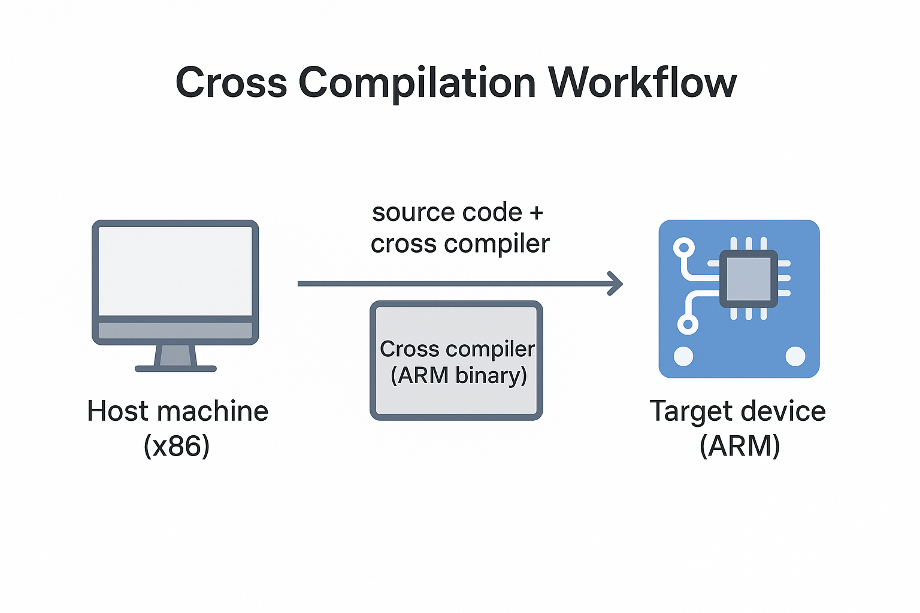Figure 3: Cross Compilation for Arm target in x86 machine
Here’s a simple visual figure 3 you can drop into slides or docs when you need to describe cross-compilation:
How to read it
- Host machine (x86) – where you edit source code.
- The cross-compiler on that host converts the code into a binary for a different CPU architecture (here, ARM).
- The resulting ARM binary is transferred (arrow) to the target device (ARM) for execution.
The clean separation helps audiences grasp why the build happens on one box while the program runs on another. Let me know if you’d like extra details (e.g., libraries, sysroot, debug cycle) or a different style/format!

1.5.2 Toolchains:
A toolchain is the foundational set of tools required to transform source code into executable programs for a target system. In embedded Linux development, where the host and target architectures often differ, a properly configured toolchain is critical for successful cross-compilation. It consists of several interdependent components working together to compile, assemble, link, and debug software for the target device.
Components of a Toolchain
A typical embedded Linux toolchain includes:
- Compiler (GCC or Clang) – Translates high-level code (C, C++, etc.) into machine-specific assembly.
- Assembler (GNU as) – Converts assembly code into binary object files.
- Linker (GNU ld) – Combines object files and libraries into a final executable.
- Libraries (glibc, musl, uClibc) – Provide system APIs for file operations, memory management, and more.
- Binary Utilities (binutils) – Tools like objcopy, strip, and readelf for manipulating binaries.
- Debugger (GDB) – Allows low-level debugging of applications running on the target.
Types of Toolchains
- Native Toolchain – Runs and builds software for the same system (e.g., compiling on x86 for x86).
- Cross-Toolchain – Built to generate code for a different architecture (e.g., compiling on x86 for ARM).
- Bare-Metal Toolchain – Used for firmware development without an OS (e.g., microcontrollers).
- SDK Toolchains – Pre-configured by vendors for specific hardware (e.g., Raspberry Pi, Yocto SDK).
Why Toolchains Matter in Embedded Linux
Since embedded devices often lack the resources to compile software natively, cross-toolchains enable development on a powerful host machine while producing optimized binaries for the target. Choosing the right toolchain—whether a prebuilt one (like Linaro for ARM) or a custom-built one (via Crosstool-NG or Buildroot)—impacts performance, binary size, and compatibility.
Understanding toolchains is essential for troubleshooting build errors, optimizing code, and ensuring that software runs correctly on constrained embedded systems. Whether you’re developing for IoT, industrial automation, or custom hardware, mastering toolchains unlocks the full potential of embedded Linux.

1.5.3 Practical Mini-Lab — Your First Cross-Compiled Hello World
Let’s start with the absolute basics: a single-file C program that prints “Hello World!” and a tiny Makefile that uses the cross-compiler. This gets you comfortable with the toolchain before we jump into full-blown packages.

Step 1 — Create the Source File
Create a new directory on your host PC and add helloWorld.c:
#include <stdio.h>

int main(void)
{
printf("Hello World!");
return 0;
}

Step 2 — Write a Minimal Makefile
Save this as Makefile in the same directory:
# Default compiler and flags
CC := $(CROSS_COMPILE)gcc
CFLAGS := -Wall -g -Werror

# Target bin and source
TARGET := helloWord
SRCS := helloWord.c
OBJS := helloWord.o

# Entry point
all: $(TARGET)

# Default target (build the binary)
$(TARGET): $(OBJS)
$(CC) $(CFLAGS) -o $@ $^

# Rule to compile .c into .o
$(OBJS): $(SRCS)
$(CC) $(CFLAGS) -c -o $@ $<

#clean target
clean:
rm -f $(TARGET) *.o

.PHONY: clean

Step 3 — Build on the Host by default
ridha@noomane:~/Desktop/myBook/chapter1/cross_compilation$ make
gcc -Wall -g -Werror -c -o helloWord.o helloWord.c
gcc -Wall -g -Werror -o helloWord helloWord.o
ridha@noomane:~/Desktop/myBook/chapter1/cross_compilation$ file helloWord
helloWord: ELF 64-bit LSB pie executable, x86-64, version 1 (SYSV), dynamically linked, interpreter /lib64/ld-linux-x86-64.so.2, BuildID[sha1]=f829b76c1ebc23eb9410a8f8a312f6d0cf46bfac, for GNU/Linux 3.2.0, with debug_info, not stripped
As you can see the result by default is executable file which works on host machine with x86-64.

Step 4 — Build on the Host to Target
Now, let’s compile with arm64 architecture:
ridha@noomane:~/Desktop/myBook/chapter1/cross_compilation$ make CROSS_COMPILE=aarch64-linux-gnu-
aarch64-linux-gnu-gcc -Wall -g -Werror -c -o helloWord.o helloWord.c
aarch64-linux-gnu-gcc -Wall -g -Werror -o helloWord helloWord.o
ridha@noomane:~/Desktop/myBook/chapter1/cross_compilation$ file helloWord
helloWord: ELF 64-bit LSB pie executable, ARM aarch64, version 1 (SYSV), dynamically linked, interpreter /lib/ld-linux-aarch64.so.1, BuildID[sha1]=959f9c4d3287829e343d57aa7198291017aae3c1, for GNU/Linux 3.7.0, with debug_info, not stripped
Here you can see when we mention the toolchain aarch64-linux-gnu- of ARM64 architecture we had as result file works on Arm64.
Note: be sure to already installed aarch64-linux-gnu-gcc compiler.
Note: be sure to run make clean before every execute make.
Congratulations! You have performed a full cross-compile cycle: host-build → transfer → execute on target. From here, building larger software in multiple platform will feel familiar.

1.6 Boot Flow Process: From PowerOn the Board to the Kernel

Before diving into kernel development, application creation, or system customization, it’s essential to understand the full boot sequence of an embedded Linux system. From the moment power is applied (Power-On Reset) until the login prompt appears, a carefully orchestrated chain of events occurs—spanning hardware initialization, bootloaders, the Linux kernel, and user-space services.
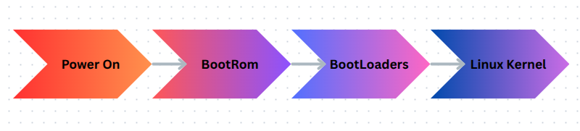Figure 4: Boot Flow in Embedded Linux System

1.6.1 BootRom:
When power is applied to a Raspberry Pi, the CPU immediately loads the stack pointer from address 0x0000 0000 and then jumps to the reset vector at 0x0000 0004, handing control to the immutable, vendor-supplied Boot ROM. This first-stage bootloader, only about 16–32 KB in size, is stored in read-only memory and therefore cannot be altered. Its sole purpose is to locate, verify, and load the next boot stage from persistent storage. To accomplish that task, it brings up only the hardware that is strictly necessary: the SD-card interface (so it can read the next bootloader when booting from an SD card), a single CPU core, and—if USB boot is enabled—the USB controller. On a Raspberry Pi 4 or later, the Boot ROM executes directly from on-chip memory, consults the EEPROM configuration, scans the configured boot devices (SD card, USB, network, and so on), loads the second-stage bootloader into the L2 cache, and finally transfers control to that code, completing the first stage of the Raspberry Pi’s power-on sequence.

1.6.2 Bootloader:
By definition a bootloader is a small, purpose-built program that runs immediately after a computer or embedded system receives power; it initializes the minimal hardware required to operate, locates an operating system (or the next boot stage) in non-volatile storage, verifies its integrity, and then loads it into memory and passes control to it.
After bootrom finish execution he will jump to the entry point of EEPROM bootloader
which will initialize SDRAM, UART(if configured) and SD/USB interface, loads start4.elf (GPU firmware) into RAM and last steps is hands control to the GPU.
We will go deep inside next chapter.

1.6.3 Linux Kernel:
The Linux kernel is the core, privileged software layer of the Linux operating system. Sitting directly above the hardware, it abstracts and manages every fundamental resource a computer offers—CPU time, memory, I/O devices, and networking—so that user programs can run safely and concurrently. It schedules processes and threads, enforces memory protection, routes system calls, handles interrupts, manages filesystems, and loads or unloads device drivers as modules. Written primarily in C (with a bit of architecture-specific assembly), the Linux kernel follows a monolithic yet modular design: most services reside in the single kernel address space for efficiency, but many can be added or removed at runtime as loadable modules. Because it is released under the GNU GPL v2, anyone may study, modify, and redistribute it, and thousands of contributors worldwide—coordinated through the Linux Foundation—continually evolve the code to support an enormous range of processors, from tiny embedded SoCs to the largest supercomputers.
Right now keep this small definition of kernel linux because after for next chapter we will go deep inside talking about kernel and how it works.

Chapter 2: Bootloaders and U-Boot (Table of Contents)

2.1 Bootloaders in Embedded Systems:
Define what a bootloader is, its roles (initialisation, hand-off, recovery) and why it matters.

2.2 Raspberry pi boot chain:
Quick recap of BootROM, EEPROM, GPU firmware, Pi-specific quirks.

2.3 Create your own Bare metal boot with EEPROM Only:
Show how the Pi can boot a raw kernel8.img without U-Boot; discuss limitations.

2.4 Introduction U-Boot:
History, design philosophy, and core features (CLI, scripting, drivers).

2.5 Building U-Boot for Raspberry Pi:
Step-by-step cross-compile (make rpi_4_defconfig), SPL vs U-Boot proper, toolchain requirements.

2.6 Flashing and First boot test:
Copying u-boot.bin via FAT partition, editing config.txt, and verifying serial console output.

2.7 Navigating the U-Boot CLI:
Common commands (help, printenv, setenv, saveenv, load, booti, mw, md).

2.8 Environment Variables & Boot Scripts:
Persistent env storage, boot.cmd → boot.scr, conditional logic, failsafe boot.

2.9 Advanced Configuration Via menuconfig
Enabling USB, network, FIT images, DFU; creating a minimal custom build.

2.10 Security & Signing Considerations
FIT image signatures, redundant SPL, anti-rollback strategies.

2.11 Troubleshooting U-Boot
UART diagnostics, iminfo, bdinfo, common build/boot errors.

