Pizza’s sales SQL Query

A.KP1

1.Total Revenue

select SUM(total_price) as Total_Revenue from pizza_sales

*output-*

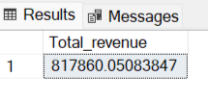

2.Average order value

select sum(total_price)/ COUNT(DISTINCT order_id ) as Avg_order_sales from pizza_sales

*output-*

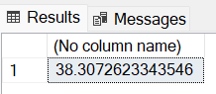

3.Total Pizza Sold

select sum(quantity) as Total_Pizza_Sold from pizza_sales

*output-*

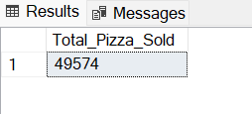

4.Total Orders

select COUNT(DISTINCT order_id) as Total_Order from pizza_sales

*output-*

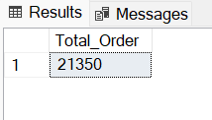

5.Average Pizza Per order

select cast(cast(SUM(quantity)as decimal(10,2))/

cast(COUNT(DISTINCT order_id)as decimal(10,2)) as decimal(10,2)) as Avg_Pizza_per_order from pizza_sales

*output-*

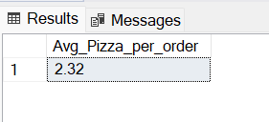

6.Daily Trend for total orders

select DATENAME(DW,order_date) AS Order_Day, COUNT(DISTINCT order_id) as Total_Order

from pizza_sales

group by DATENAME(DW,order_date)

*output-*

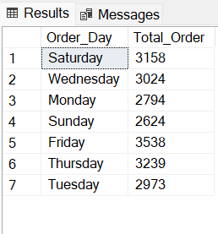

7.Monthly trend per total order

select DATENAME(MONTH,order_date) AS Month_Name,COUNT(DISTINCT order_id) as Total_order

from pizza_sales

group by DATENAME(MONTH,order_date)

*output-*

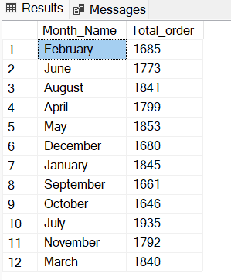

8.Percentage of Sales per Category

select pizza_category , sum(total_price) as Total_Sales, sum(total_price) *100 / (select SUM(total_price)from pizza_sales)as PCT

from pizza_sales

group by pizza_category

*output-*

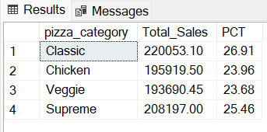

9. % of Pizza_Size

select pizza_size , cast(sum(total_price)as decimal(10,2)) as Total_Sales,

cast(sum(total_price) *100 / (select SUM(total_price)from pizza_sales)as decimal(10,2))as PCT

from pizza_sales

group by pizza_size

*output-*

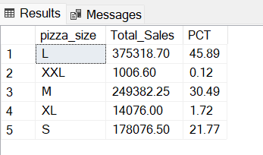

B. Top 5 best Sellers by revenue

select top 5 pizza_name, SUM(total_price) as Total_Revenue from pizza_sales

group by pizza_name

order by Total_Revenue desc

*output-*

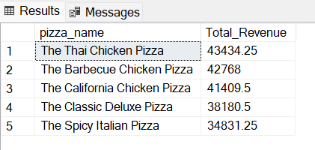

C.Bottom 5 Pizzas by Revenue

select top 5 pizza_name, SUM(total_price) as Total_Revenue from pizza_sales

group by pizza_name

order by Total_Revenue asc

*output-*

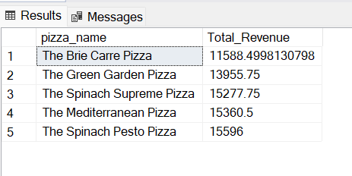

D. Top 5 pizza by Quantity

select top 5 pizza_name, SUM(quantity) as Total_Quantity from pizza_sales

group by pizza_name

order by Total_Quantity desc

*output-*

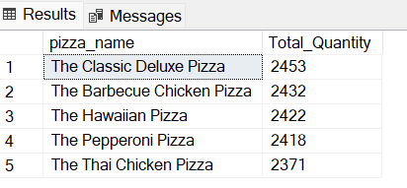

E. Bottom 5 pizzas by Quantity

select top 5 pizza_name, SUM(quantity) as Total_Quantity from pizza_sales

group by pizza_name

order by Total_Quantity asc

*output-*

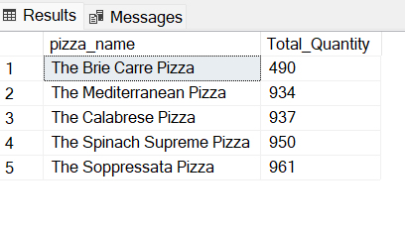

F.Top 5 pizzas by Total_order

select top 5 pizza_name, count(distinct order_id) as Total_Orders from pizza_sales

group by pizza_name

order by Total_Orders desc

*output-*

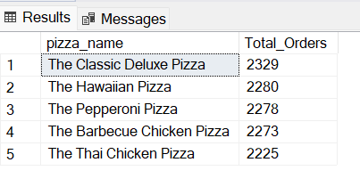

G. Bottom 5 pizzas by Total_Orders

select pizza_name,COUNT(distinct order_id)as Total_Orders from pizza_sales

group by pizza_name

order by Total_Orders asc

*output-*

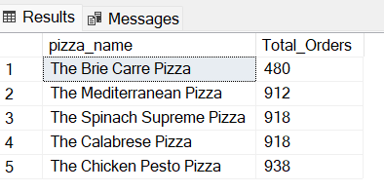

Note-

If you want to apply the Month,Quator,Week filter to above query

Can use Where clause,Follow some of below query

select pizza_category , sum(total_price) as Total_Sales, sum(total_price) *100 / (select SUM(total_price)from pizza_sales)as PCT

from pizza_sales

where MONTH(order_date) =1

group by pizza_category

*Here Month(order_date)=1 indicate that the output of the Month of January, Month(order_date)=4 Indicate the output of the Month of April