Market Basket Analysis Project

Objective
This project focuses on finding frequently bought product combinations in transactional data using the Apriori algorithm. It helps businesses identify product associations and improve cross-selling strategies.

Transaction Table
Transaction | Bread | Butter | Milk | Coffee | Sugar | Eggs
0 | True | False | True | False | False | False
1 | True | True | False | False | False | False
2 | True | True | True | False | False | False
3 | True | True | False | False | False | False
4 | False | False | True | True | False | False

Frequent Itemsets Table
Itemset | Support
Bread | 0.42
Butter | 0.24
Milk | 0.40
Butter & Bread | 0.22
Bread & Milk | 0.22
Coffee & Sugar | 0.14

Association Rules Table
Rule | Support | Confidence | Lift
Butter → Bread | 0.22 | 0.91 | 2.18
Bread → Butter | 0.22 | 0.52 | 2.18
Coffee → Sugar | 0.14 | 0.87 | 3.97
Eggs → Milk | 0.14 | 0.77 | 1.94
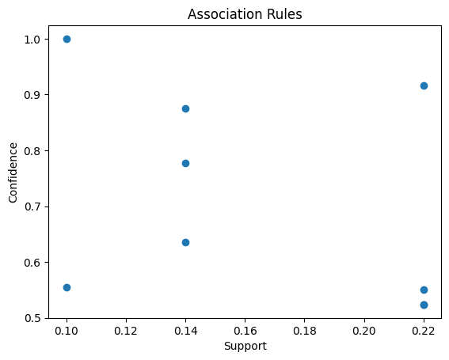

Conclusion
Strong associations found between products like Butter & Bread and Coffee & Sugar. These insights help in recommendation systems and marketing.

