Software Requirements Specification

for

MILK DISTRIBUTOR MANAGEMENT SYSTEM

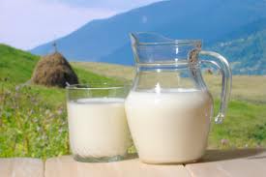

Prepared by

|  |
| --- |
| **Name Roll No.** |
| * Smrutika Bhadole 37007 |
| * Bhavana Dhadge 37016 |
| * Ridhima Joshi 37029 |