**Synopsis**

**Title of the Project:** FutureMobile CRM in Automotive & Tourist Area.

**Group Members Name:** 1) Shubham Chandak,

2) Ridhima Joshi,

3) Madhur Lahoti,

4) Radhika Sawant.

**Description:**

1. **Aim of the Project:**

Aim of this project deal with finding tourist attractions, optimal path finding for tourist attraction, suggestions for way of transportation, and if the tourist is opting for Rented Vehicle then calculation of the fare using optimal path distance calculation provided by Google Maps API.

This project also helps the tourist to lodge a complaint against the Tourist Guide’s, Rented Vehicle Drivers for diverting the tourist and charging him unfair tariff & finding out emergency numbers for the particular city.

1. **Introduction and Scope of the Project:**

CRM has been defined in numerous ways and with many descriptions. It can be defined as the art of acquiring customers and having a long-lasting relationship with them. Companies must take the initiative to actualize and implement CRM. Also, CRM is a combination of people, processes, and technology in order to understand and obtain customers for the company. It focuses on customer retention and builds up the relationship.

Using CRM, companies can maximize their interactions with customers and obtain a 360-degree vision of customers.CRM is a systematic management of relationships across all parts of the business, focusing on customers, providing long-term value for them, and increasing customer interaction. It also includes communication channels and offers of different services, thereby producing customer retention and loyalty.

**The Scope of our Project is limited to:**

* Detecting the source of the User.
* Listing of the tourist places.
* Calculating the optimal path with approximate fare, distance and time to travel.
* Tracking the path and alerting the user if any divergence is occurred.
* Fare calculation.
* Lodge a Complaint.
* Listing of the emergency numbers for the city.
* Report Generation.

1. **Block Diagram (System Architecture):**

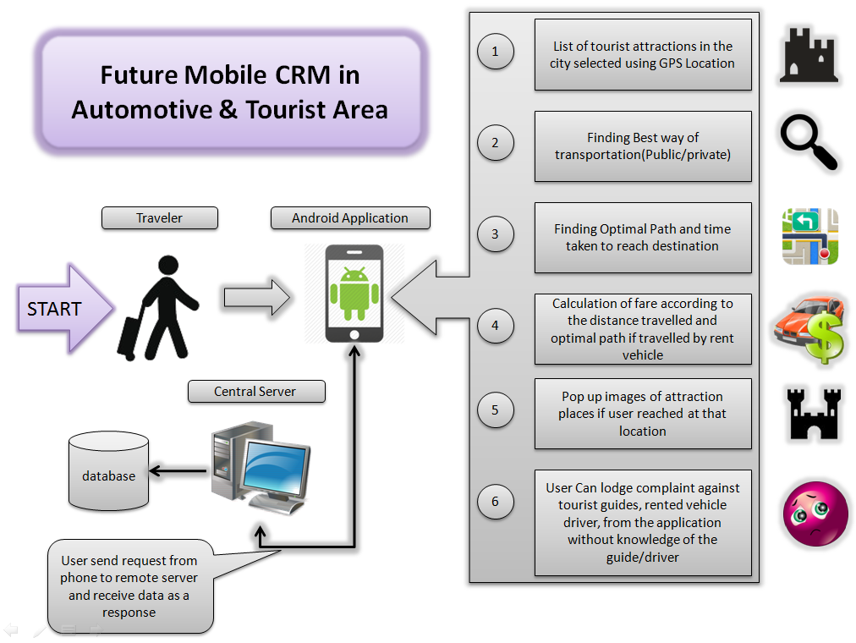

1. **Literature Survey:**
2. International Journal of Emerging Technology and Advanced Engineering Website: www.ijetae.com (ISSN 2250-2459, ISO 9001:2008 Certified Journal, Volume 4, Issue 3, March 2014).
3. **Algorithm:**

1. Distance base GPS algorithm and

2. Location base algorithm.

**Software Requirement:**

* UML.
* Java.
* Android SDK.

**Hardware Requirements:**

* System : Pentium IV 2.4.
* Memory : 512 MB RAM.
* Hard Disk : 40 GB.

**Advantages:**

1. User can get tourist places from any local area with all description.
2. Displays route on Map.
3. User can see fare of local taxi.
4. Facility to launch complaints.
5. Pop up’s images.