# 

**UHCL Communicator Report**

|  |  |  |  |
| --- | --- | --- | --- |
| **Project Information** | | | |
| **Project Title** | UHCL COMMUNICATOR | | |
| **Start Date** | 09/27/2017 | **End Date** | 4th Dec 2017 |
| **Institution** | University of Houston Clear Lake | | |
| **Project Team Name** | Tech Astros | | |
| **Project Members** | Nagarajan Sivagnanam Easwaramoorthi | | |
| **Project Members** | Ridhima Joshi | | |
| **Project Members** | Lakshmi Sudheera Dama | | |
| **Project Members** | Mounika Vootukuru | | |
| **Contact email** | [SivagnanamEaN5623@UHCL.edu](mailto:SivagnanamEaN5623@UHCL.edu)  [joshir7494@uhcl.edu](mailto:joshir7494@uhcl.edu)  damal9643@uhcl.edu | | |
| **Project Web URL** | https://drive.google.com/open?id=1aHl2heT1TDAW2jAZkHmhYOap3eYO5u9Z | | |

|  |  |  |  |
| --- | --- | --- | --- |
| **Document Information** | | | |
| **Author(s)** | Ridhima Joshi  Nagrajan Sivagnanam Eshwaramoorthi  Lakshmi Sudheera Dama  Mounika Vootukuru | | |
| **Project Role(s)** | Database: Nagarajan Sivagnanam Easwaramoorthi  Development: Ridhima Joshi  Documentation: Lakshmi Sudheera Dama, Mounika Vootukuru | | |
| **Date** | Sept-27-2017 | **Filename** | UHCL Communicator Report |
| **URL** |  | | |
| **Access** | This report is for general dissemination | | |

|  |  |  |
| --- | --- | --- |
| **Document History** | | |
| **Version** | **Date** | **Comments** |
| Version 1 | Dec - 10 - 2017 | First draft of the report |

**Table of Contents**

**Acknowledgements** **3**

**Project Summary** **4**

**UHCL Communicator** **5**

Project Outputs and Outcomes 13

How did you go about achieving your outputs / outcomes? 13

What did you learn? 13

Immediate Impact 13

Future Impact 14

**Conclusions** **15**

**Recommendations** **15**

**Implications for the future** **15**

**References** **16**

**Appendices** **17**

# Acknowledgements

We would like to express our gratitude towards the international students who helped us in gathering the challenges that they faced before coming to the university regarding various problems such as the coursework, accommodation, cultural background and many other challenges.

We are thankful to our professor Dr. Soma Datta for guiding and supporting us in the project and making the project successful.

A special thanks to Research Assistant Vennela for helping us in our database connectivity.

# Project Summary

UHCL Communicator is an android application that is created to help newly admitted students in UHCL. The international students face many challenges regarding the coursework, accommodation, climatic conditions, college culture and a few more.

By using this application:

* Newly admitted students can get email id and major of the current students and alumni.
* Students can post a query related to their problems.
* The students can view all the posts and the replies of other students.
* Students can reply to other students post simultaneously.

**Use of Waterfall methodology:**

* The waterfall model is a linear sequential (non-iterative) design approach for software development when the requirements are pre-defined.
* The progress flows in one direction downwards like a waterfall through the phases of requirements gathering, analysis, design, construction, testing, deployment and maintenance.
* We followed this waterfall methodology to develop our application since we had all the requirements well defined.

# UHCL Communicator

**Use Case Diagram:**

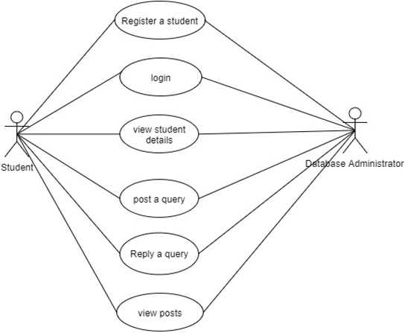

Figure 1: Use case Diagram

**Class Diagram:**

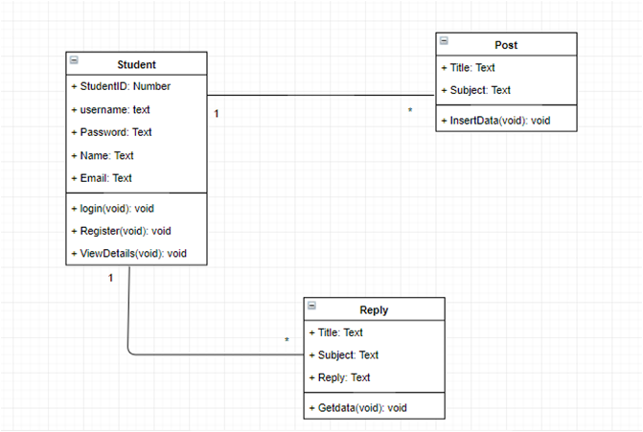

Figure 2: Class Diagram

**Sequence Diagram:**

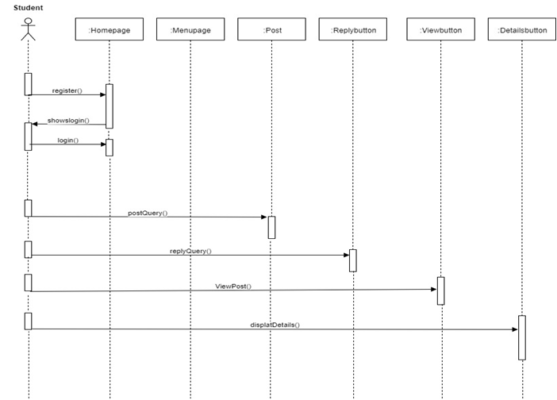

Figure 3: Sequence Diagram

**Architecture Diagram:**

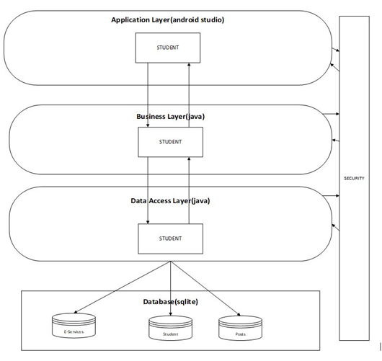

Figure 4: Architecture Diagram

**DFD of UHCL Communicator:**

**Context diagram:**

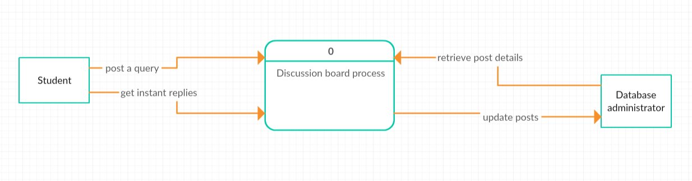

**Code: For Database Connectivity of Login**

package com.uhclcommunicator.uhclcommunicator.sql;  
  
import android.content.ContentValues;  
import android.content.Context;  
import android.database.Cursor;  
import android.database.SQLException;  
import android.database.sqlite.SQLiteDatabase;  
import android.database.sqlite.SQLiteException;  
import android.database.sqlite.SQLiteOpenHelper;  
import android.provider.Settings;  
import android.widget.ListView;  
  
import com.uhclcommunicator.uhclcommunicator.model.Student;  
  
public class DatabaseHelper extends SQLiteOpenHelper {  
  
 public static final int DATABASE_VERSION = 1;  
  
 public static final String DATABASE_NAME = "Communicator.db";  
  
 public static final String TABLE_NAME = "student";  
  
 public static final String COLUMN_1 = "username";  
 public static final String COLUMN_2 = "student_name";  
 public static final String COLUMN_3 = "student_email";  
 public static final String COLUMN_4 = "student_course";  
 public static final String COLUMN_5 = "password";  
  
 public DatabaseHelper(Context context) {  
  
 super(context, DATABASE_NAME, null, 1);  
 }  
  
 @Override  
 public void onCreate(SQLiteDatabase dB) {  
 dB.execSQL("create table " + TABLE_NAME +  
 "(" + COLUMN_1 + "TEXT," + COLUMN_2 + "TEXT," + COLUMN_3 + "TEXT," +COLUMN_4+ "TEXT," + COLUMN_5 + "TEXT)");  
 }  
  
 @Override  
 public void onUpgrade(SQLiteDatabase dB, int oldVersion, int newVersion) {  
 dB.execSQL("DROP TABLE IF EXISTS " + TABLE_NAME);  
  
 onCreate(dB);  
 }  
  
 public boolean insertData(String username, String student_name, String student_email, String student_course, String password){  
 SQLiteDatabase dB = this.getWritableDatabase();  
  
 ContentValues contentValues = new ContentValues();  
  
 contentValues.put(COLUMN_1,username);  
 contentValues.put(COLUMN_2,student_name);  
 contentValues.put(COLUMN_3,student_email);  
 contentValues.put(COLUMN_4,student_course);  
 contentValues.put(COLUMN_5,password);  
  
 long result = dB.insert(TABLE_NAME,null ,contentValues);  
  
 if(result == -1) {  
 return false;  
 }else {  
 return true;  
 }  
  
 }  
  
 public Cursor getAllData() {  
 SQLiteDatabase dB = this.getWritableDatabase();  
  
 Cursor res = dB.rawQuery("select * from "+TABLE_NAME,null);  
  
 return res;  
 }  
  
 public boolean loginData(String username, String password) {  
  
 SQLiteDatabase dB = this.getReadableDatabase();  
 try {

Cursor mCursor = dB.rawQuery("SELECT username, password FROM " + TABLE_NAME + " WHERE " + COLUMN_1 + " = " + username + " AND " + COLUMN_5 + " = \'"+ password+"\'", null);  
  
 if (mCursor != null) {  
 if (mCursor.getCount() > 0) {  
 mCursor.moveToFirst();  
  
 String _username = mCursor.getString(mCursor.getColumnIndex(DatabaseHelper.COLUMN_1));  
 String _password = mCursor.getString(mCursor.getColumnIndex(DatabaseHelper.COLUMN_5));  
 return true;  
 }  
 // return false;  
 }  
  
 }catch(SQLiteException e){  
 System.out.println("ERRRROR");  
  
 }  
 return false;  
 }

**Screen shots:**

# 

# Login Screen Register Screen Main Menu

# 

# 

# 

**Post a Query Screen Email Id’s Screen Reply a Query Screen**

## Project Outputs and Outcomes

|  |  |
| --- | --- |
| **Output / Outcome Type** | **Brief Description and URLs** |
| Android | Learnt android components such as List view, Recycler view  https://developer.android.com/index.html |
| SQLite Database | Learnt new database |
| Team Work | Working in a team |
| Time Management | Completing the project in given period of time |

## How did you go about achieving your outputs / outcomes?

The project was decided with the database of MySQL and Eclipse. While adding the Android SDK libraries in Eclipse, file not found error occurred. Hence we shifted to Android Studio from Eclipse. In Android Studios, firstly we started using MySQL database. The MySQL database needed PHP for connectivity and we faced some issues with the MySQL such as adding of the libraries of MySQL and MySQL Connector.

We finally decided on using the local database of Android Studio which is SQLite. We needed to study about the SQLite connectivity as none of the team members had worked with SQLite.

We had some issues with the application as the application was crashing down, but with the help of Professor, Research Assistant and classmates we were able to solve them.

We firstly went around interview the international students and finding out the challenges they faced when they first came to the university. Accordingly we developed the use cases, DFDs and the UML Diagrams and then started with the database and the coding part. At the end we tested the whole application.

## What did you learn?

Throughout the project we learnt:

* Complete Waterfall methodology
* The techniques of requirement gathering like interviewing the students.
* Designing of the requirements needed for the project
* Designing of an android application
* New database: SQLite Database
* Android Studio platform
* Unit Testing

## Immediate Impact

The application provides a platform to the newly admitted students as well as current students to solve their issues. It helps to build a rapport between the students.The application has been helpful to all the international students in all the ways as it helps in communicating with other students.

## Future Impact

The students will be impacted from the application. In future this platform can also help to establish communication between the students and the faculty or the teaching assistants.

# Conclusions

The newly admitted student can get solutions for the challenges he/she faces before joining the university by using this application. The student can post a query and even view or reply to the queries posted by other students.

## Recommendations

The SQLite database is easy to use while developing an android application as it is a local database. The application can also be developed on a web platform, but android application comes handy.

# Implications for the future

* This android application facilitates the newly admitted students to overcome the challenges faced before joining the university.
* The application can further be developed by adding the details of the professors and the courses they would be teaching for the following semesters.
* The application allows the student to post, view and reply to the queries posted by other students. The database of this application can be connected to the universities database so that the information of the students and professors can be gathered directly requiring no other database.

# References

* <https://www.tutorialspoint.com/sdlc/sdlc_waterfall_model.htm>

* <https://www.nytimes.com/2014/08/28/nyregion/students-inventing-programs-to-streamline-their-colleges-data.htm>

* <https://en.wikipedia.org/wiki/Android_Studio>

* <https://developer.android.com/index.html>

* <https://www.androidauthority.com/android-app-development-complete-beginners-658469/>

* <https://en.wikipedia.org/wiki/Waterfall_model>

* <http://www.softwaretestinghelp.com/what-is-sdlc-waterfall-model/>

# Appendices

* **Android:** It is software for mobile phones and tablets. It is an open source project by Google.
* **Android Studio:** Android Studio is the official Integrated Development Environment (IDE) for Android app development.
* **SQLite Database:** A local database in Android Studio.