Game Design Document

Fill up the following document

1. Write the title of your project.

Defeating Corona Virus

1. What is the goal of the game?

To kill maximum amount of virus using mask

1. Write a brief story of your game.

Because of the corona pandemic people are getting infected at a higher rate so in order to protect the human beings we have masked which will protect us against the corona virus

1. Which are the playing characters of this game?

* Playing characters are the ones who respond to the user based on the input from the user.
* Cars, monkeys, dinos, wizards, etc., are the playing characters in the game.

|  |  |  |
| --- | --- | --- |
| Number | Character Name | What can this character do? |
| 1 | Mask 1 | Destroyes virus |
| 2 | Mask 2 | Destroyes virus |
| 3 |  |  |
| 4 |  |  |
| 5 |  |  |
| 6 |  |  |
| 7 |  |  |
| 8 |  |  |

1. Which are the Non-Playing Characters of this game?

* Non-Playing characters are the ones that don't have an action or behavior when the user interacts with the game.
* Hurdles, stones, bananas, coins, etc., are non-playing characters in the game.

|  |  |  |
| --- | --- | --- |
| Number | Character Name | What can this character do? |
| 1 | Corona Virus 1 | Infects human Beings |
| 2 | Corona Virus 2 | Infects human Beings |
| 3 | Corona Virus 3 | Infects human Beings |
| 4 |  |  |
| 5 |  |  |
| 6 |  |  |
| 7 |  |  |
| 8 |  |  |

Draw your imagination of this game. What does this game look like?

* Draw the game either on your computer or on paper.
* Add images of the game scenes to show each of the playing and non-playing characters at least once.

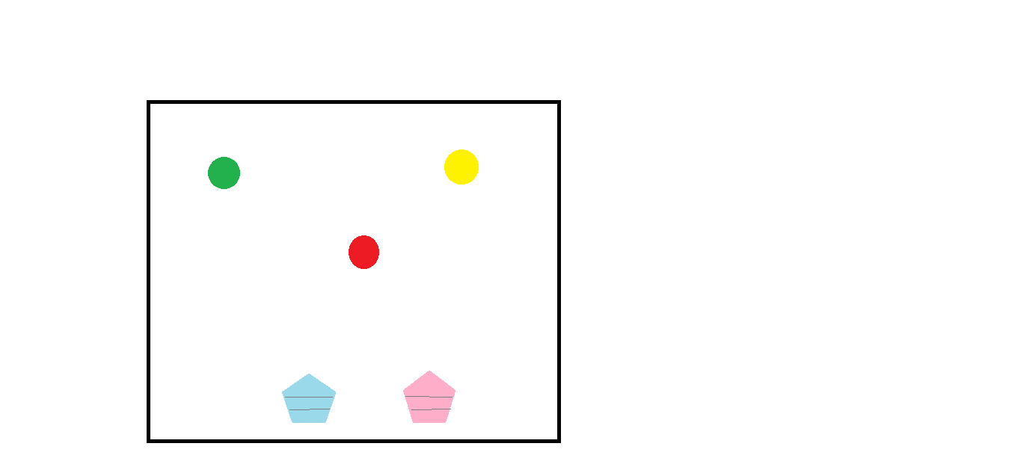

How do you plan to make your game engaging?

By adding good visuals and adding sound effects.