Freight Rate Prediction: Validation & Split Approach
Machine Learning Engineer assessment: Spotter

1. Problem framing
The labeled data (train_test.csv) contains 48,000 loads dated 2025-01-01 to 2025-10-31. The 12,000 loads to predict are dated 2025-11-01 to 2025-12-31. Every prediction target therefore lies after the last training date, so this is a forecasting problem, not an interpolation problem. A random train/test split would leak same-period information (market conditions, seasonality) and overstate accuracy, so I did not use one.

2. Validation and split approach
- Rolling-origin (expanding window) backtests: train on months 1..k, test on the following two months. Folds: Jan-Jun → Jul-Aug, Jan-Jul → Aug-Sep, Jan-Aug → Sep-Oct. Two-month test windows mirror the two-month forecast horizon of the real validation set.
- All model choices (target transform, loss, features, hyperparameters, whether to use market features) were made on these folds, and the final model is refit on all labeled data.
- Unseen-city check: 8 cities in validation never appear in training (1,447 of 12,000 rows touch one). I simulated this by dropping 8 known cities from training and testing on their later loads: MAE about $52 vs about $45 for known cities, so coordinate features generalize to new cities.
- No leakage: cleaning statistics (weight medians) come from training only. The daily market-index median uses feature columns only, never labels.

3. Data-quality issues and handling
- Weights: 292 negative values in train and 145 in validation, all sign flips (minimum absolute value is the 5,000 lb floor). Fixed with abs().
- Missing values: 300 weights and 374 market_index values in train (165 and 249 in validation). Weight imputed with the equipment median; market_index with that day's median index.
- Corrupted labels: about 1.4% of training rates (677 rows; 340 high, 337 low) are the true rate multiplied or divided by roughly 2 to 6. Out-of-fold residuals from a robust model show a clean gap between ±0.4 and ±0.6 in log space, so I flagged |residual| > 0.5 and excluded those rows from training. They are still included in an "all rows" score to show the impact.
- quote_signal is unreliable: its relationship to rates changes sign from month to month and it hurt out-of-time accuracy, so it is not used.
- market_index tracks the daily rate level in-sample but did not generalize forward (adding it raised backtest MAE from $47 to $73), so it is not used. Its absence also makes the fixed December scenario well-defined.
- Distances are consistent (route distances stay within about ±15% of each route's median; a 70-mile floor exists). City coordinates are synthetic but constant per city.

4. Model and backtest results
Chosen model: LightGBM with L1 loss, predicting log($ per mile) and converting back to dollars. Features: distance, log distance, haversine distance and their ratio, equipment, weight, pickup/delivery coordinates and their differences, and day of week. Final predictions average 5 seeds trained on all clean labeled loads.
Model | Mean MAE | Mean MAPE | Mean R²
Baseline: equipment median $/mile | $178 | 8.07% | 0.962
Baseline: lane + equipment median $/mile | $94 | 3.98% | 0.989
LightGBM + market_index + quote_signal | $73 | 3.21% | 0.994
LightGBM, log $/mile, no market features (chosen) | $47 | 1.96% | 0.997
Mean over the three folds, scored on clean test loads.
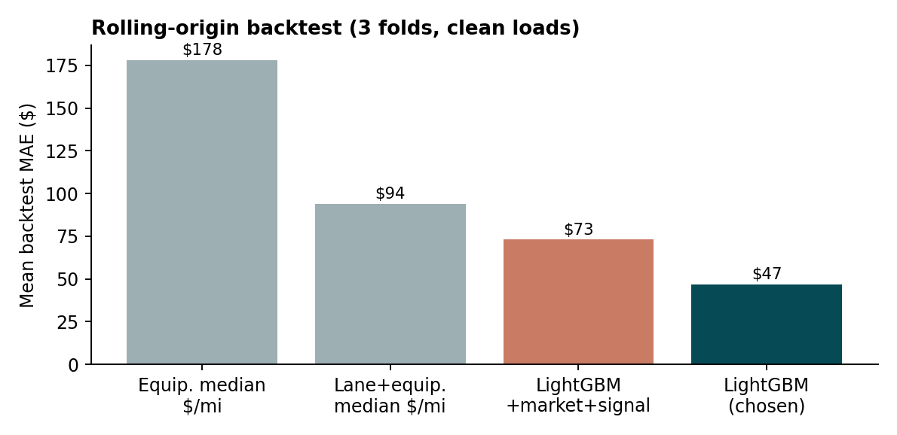
If test loads with corrupted labels are included, MAE rises to about $99 (R² 0.83) for every model, since those labels cannot be predicted; the gap is the same for all approaches.

5. Fixed December prediction chart
Chart produced by the provided score.py for Lexington to Fort Wayne, 360 miles, Dry Van, 32,000 lb. Predictions range from about $815 to $834 and follow a weekly cycle (highest Thursday, lowest Sunday). The model has no seasonal or market term, because none improved out-of-time accuracy, so the weekday pattern is the only date effect.
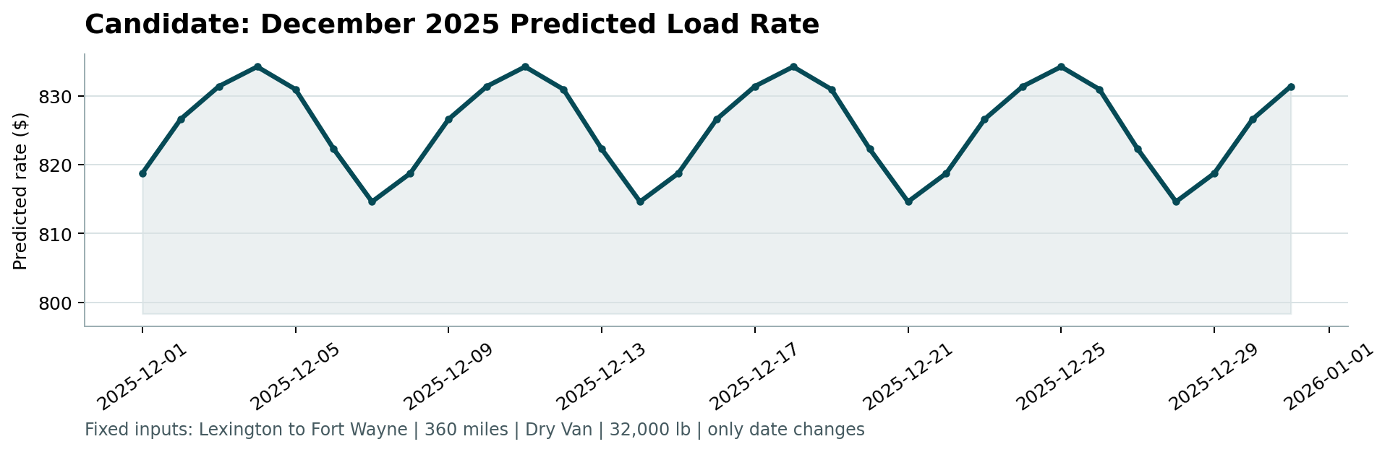

6. Limitations
- Only 10 months of history, so annual seasonality cannot be learned; December is extrapolated from weekday patterns and the load features.
- Any true market-wide shift in November and December would not be captured, since market_index proved unreliable as a forward predictor.

