Name: RIDHIMA CHHABRA

Enrollment number: 161B175

Batch:: B6(BY)

Library Management System

FIRST WINDOW:

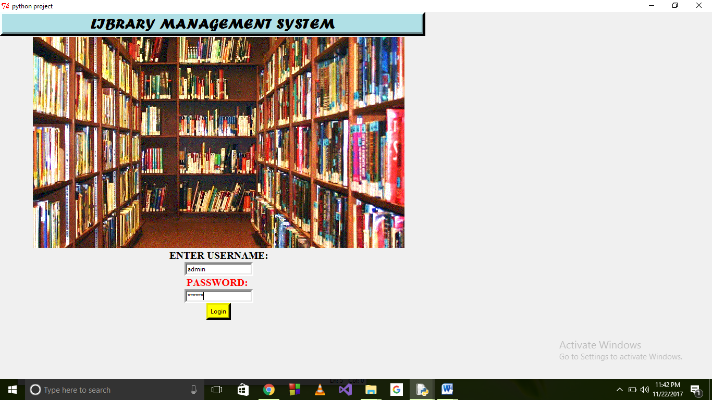

First window asks the user to enter the username and password(here username=admin and password=secret). As you enter the username and password and click on the ‘login’ button the button to the next window appears and as you click on the button ‘next page’ the new window appears.

SECOND WINDOW:

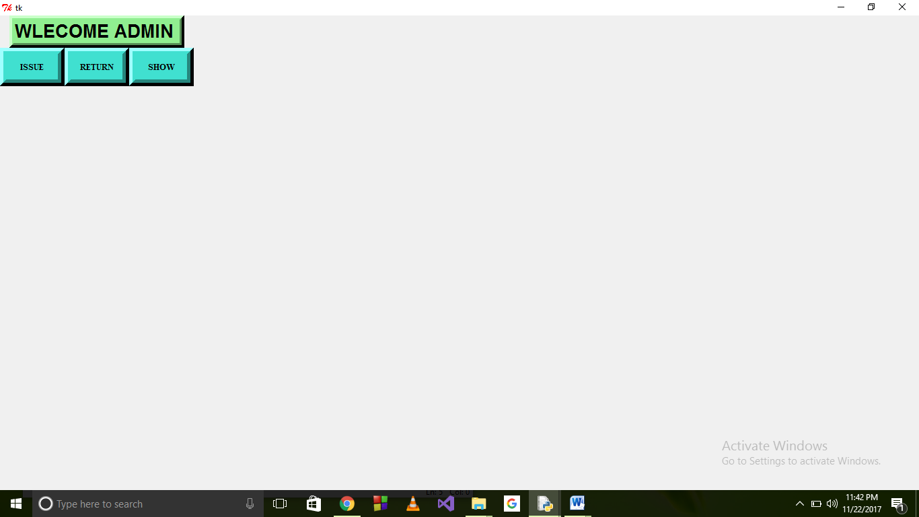

Here in the second window the user is asked the options whether he wants to issue or return or show the information.

As the user click on the ‘issue’ button a new window opens where the user is asked to select the subject of which the user wants to issue the book.

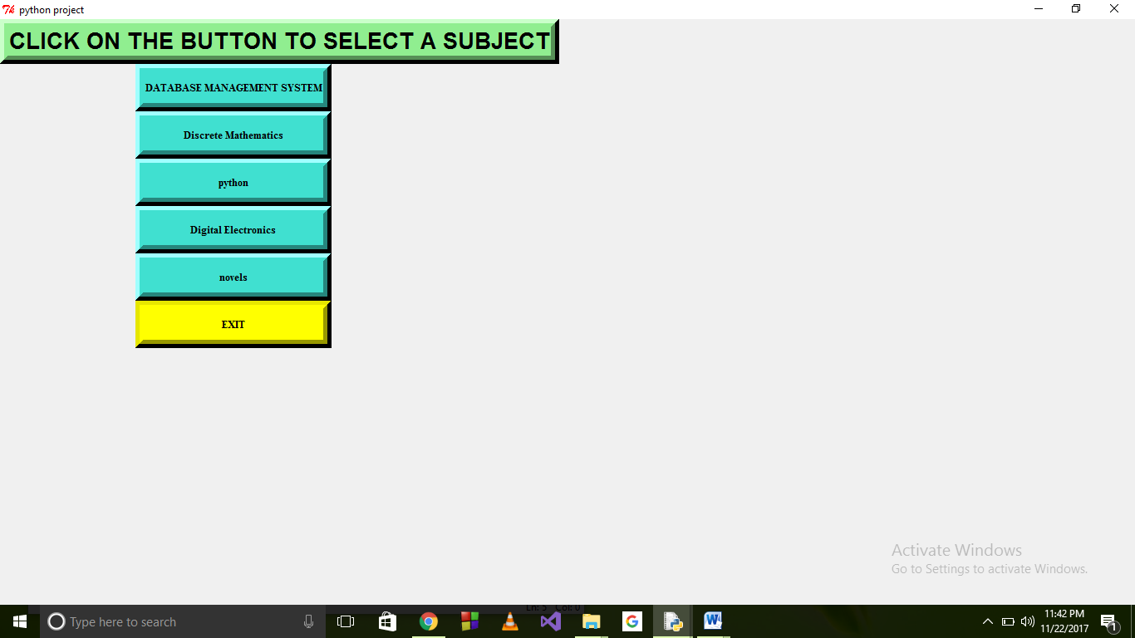

Suppose the user click on the database management system button a new window appears where the user is provided with checkbuttons so that the user can select the book which he wants to issue.

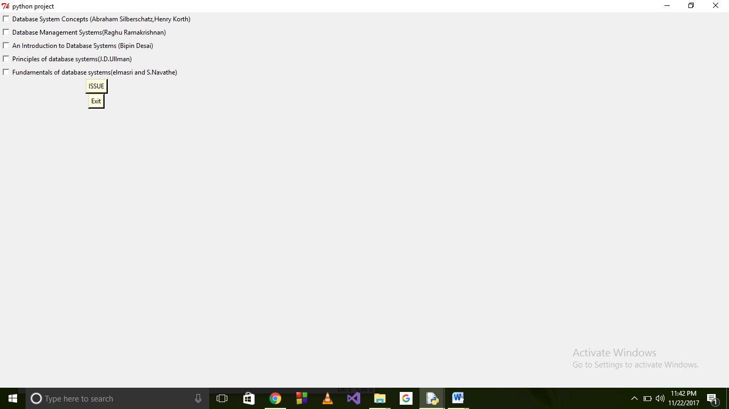

As the user select the book which he wants to issue and clicks on the issue button then the book gets stored in the database. Using the exit button the window gets destroyed.

Now if the user clicked on the return button a new window appears asking the user to enter the details of the book like the book title and the name of the author. As soon as the user click on the return button a message will be shown that if the book was issues then the return is successful. But if there was no such book issued then a message will be shown saying no such book was issued.

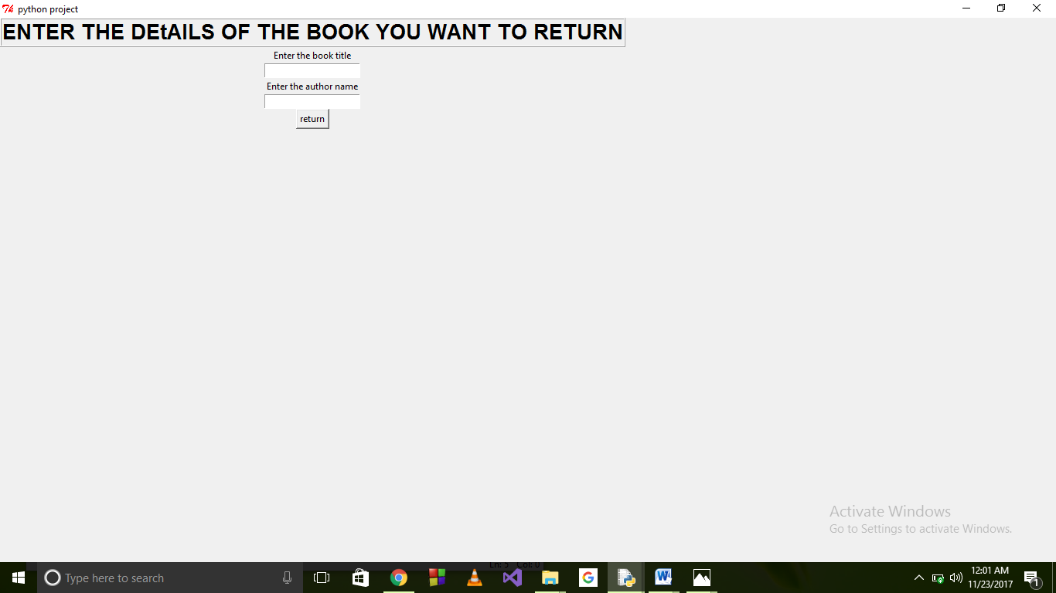

Also there is a button named as show. It shows the details of the book which has been issued by the user.