Name – Ridhima Batch – 2C32

Roll number: 1024030466

Ques 1. Develop a menu driven program demonstrating the following operations on a Stack using array:

(i) push(), (ii) pop(), (iii) isEmpty(), (iv) isFull(), (v) display(), and (vi) peek().

cout<<"Stack is Empty ";

Code: #include<iostream> using namespace std;

const int MAX = 5;

class stack{ private:

int arr[MAX]; int top;

public:

stack(){

top = -1;

}

bool isEmpty(){

return (top == -1);

}

bool isFull(){

return (top == MAX-1);

}

void push(int a){

if (isFull()) {

cout << "Stack Overflow! Cannot push " << a << endl;

} else {

arr[++top] = a;

cout << a << " pushed into stack." << endl;

}

}

void pop(){

if (isEmpty()){

cout<<"Stack Underflow! Cannot pop"<<endl;

}

else{

cout << arr[top--] << " popped from stack." << endl;

}

}

void peek(){

if(isEmpty()){

}

else{

cout<<"The peak element is: "<<arr[top]<<endl;

}

}

void display(){

if (isEmpty()) {

cout << "Stack is empty" << endl;

} else {

cout << "Stack elements are : "; for (int i = top; i >= 0; i--) {

cout << arr[i] << " ";

}

cout << endl;

}

}

};

int main(){

stack s;

int choice ,value; do{

cout << "\n--- Stack Menu ---" << endl; cout << "1. Push" << endl;

cout << "2. Pop" << endl; cout << "3. Peek" << endl;

cout << "4. isEmpty" << endl; cout << "5. isFull" << endl; cout << "6. Display" << endl; cout << "7. Exit" << endl;

cout << "Enter your choice: "; cin >> choice;

switch(choice){ case 1:

cout << "Enter value to push: "; cin >> value;

s.push(value); break;

case 2:

s.pop(); break;

case 3:

s.peek(); break;

case 4:

if (s.isEmpty())

cout << "Stack is empty." << endl; else

cout << "Stack is not empty." << endl; break;

case 5:

if (s.isFull())

cout << "Stack is full." << endl; else

cout << "Stack is not full." << endl; break;

case 6:

s.display(); break;

case 7:

cout << "Exiting program." << endl; break;

default:

cout << "Invalid choice! Try again." << endl;

}

} while (choice != 7);

return 0;

}

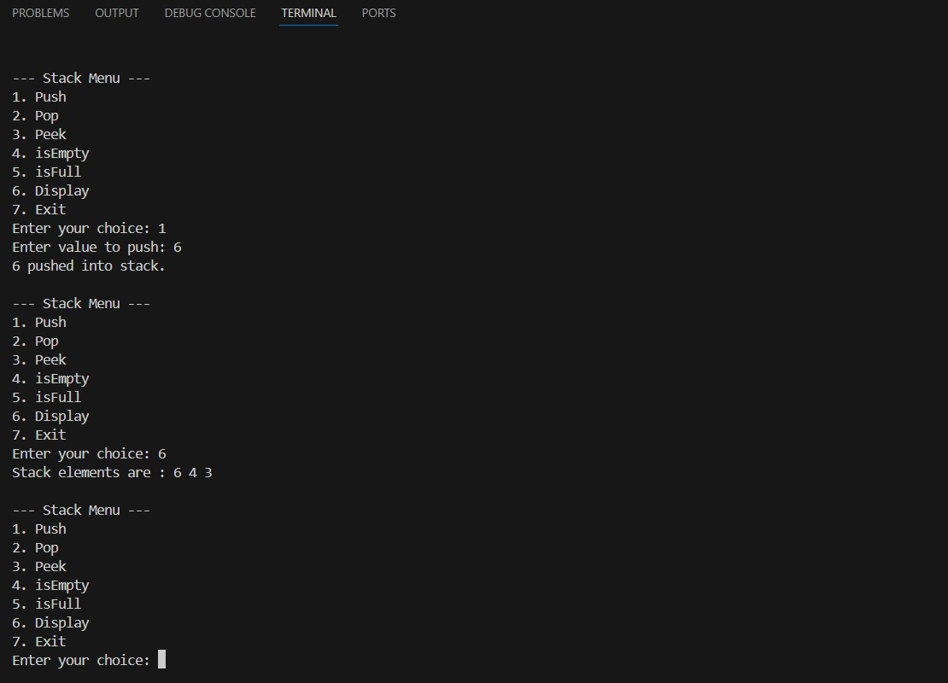Output:

Ques2. Given a string, reverse it using STACK. For example “DataStructure” should be output as

“erutcurtSataD.”

Code: #include <iostream> using namespace std;

class Stack { private:

char \*arr; int top;

int capacity;

public:

Stack(int size) {

capacity = size;

arr = new char[capacity]; top = -1;

}

void push(char c) {

if (top == capacity - 1) {

cout << "Stack Overflow!" << endl; return;

}

arr[++top] = c;

}

char pop() {

if (top == -1) {

cout << "Stack Underflow!" << endl; return '\0';

}

return arr[top--];

}

bool isEmpty() {

return top == -1;

}

};

int main() {

string str;

cout << "Enter a string: "; getline(cin, str);

Stack s(str.length());

for (int i = 0; i < str.length(); i++) { s.push(str[i]);

}

string reversed = ""; while (!s.isEmpty()) {

reversed += s.pop();

}

cout << "Reversed string: " << reversed << endl; return 0;

}

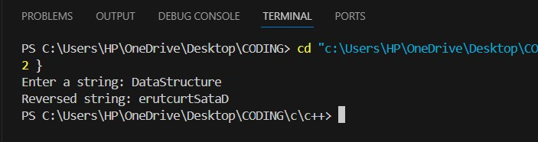Output:

Ques3. Write a program that checks if an expression has balanced parentheses. Code:

#include<iostream>

using namespace std; const int MAX = 100; class stack{

private:

int arr[MAX]; int top;

public:

Stack() {

top = -1;

}

bool isEmpty() {

return top == -1;

}

bool isFull() {

return top == MAX - 1;

}

void push(char ch) { if (isFull()) {

cout << "Stack Overflow!" << endl; return;

}

else{

arr[++top] = ch;

}

}

char pop() {

if (isEmpty()) {

cout << "Stack Underflow!" << endl; return '\0';

}

return arr[top--];

}

char peek() {

if (!isEmpty())

return arr[top]; return '\0';

}

};

bool isbalanced(string exp){ stack s;

for (int i = 0; i < exp.length(); i++) { char ch = exp[i];

if (ch == '(' || ch == '{' || ch == '[') { s.push(ch);

}

else if (ch == ')' || ch == '}' || ch == ']') { if (s.isEmpty())

return false;

char top = s.pop();

if ((ch == ')' && top != '(') ||

(ch == '}' && top != '{') ||

(ch == ']' && top != '[')) { return false;

}

}

}

return s.isEmpty();

}

int main() {

string exp;

cout << "Enter an expression: "; cin >> exp;

if (isbalanced(exp))

cout << "Parentheses are balanced." << endl; else

cout << "Parentheses are NOT balanced." << endl;

return 0;

}

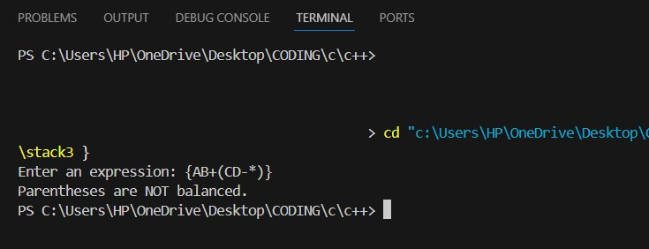Output:

Ques4. Write a program to convert an Infix expression into a Postfix expression. Code:

#include <iostream> #include <cstring>

using namespace std; const int MAX = 100;

class Stack {

private:

char arr[MAX]; int top;

public:

Stack() {

top = -1;

}

bool isEmpty() {

return top == -1;

}

bool isFull() {

return top == MAX - 1;

}

void push(char c) { if (!isFull()) {

arr[++top] = c;

} else {

cout << "Stack Overflow!" << endl;

}

}

char pop() {

if (!isEmpty()) {

return arr[top--];

} else {

cout << "Stack Underflow!" << endl; return '\0';

}

}

char peek() {

if (!isEmpty()) {

return arr[top];

} else {

return '\0';

}

}

};

int precedence(char op) {

if (op == '+' || op == '-') return 1; if (op == '\*' || op == '/') return 2; if (op == '^') return 3;

return 0;

}

bool isOperator(char c) {

return (c == '+' || c == '-' || c == '\*' || c == '/' || c == '^');

}

void infixToPostfix(char infix[]) { Stack s;

char postfix[MAX]; int k = 0;

for (int i = 0; i < strlen(infix); i++) { char c = infix[i];

// If operand, add to postfix

if ((c >= 'A' && c <= 'Z') || (c >= 'a' && c <= 'z') || (c >= '0' && c

<= '9')) {

postfix[k++] = c;

}

else if (c == '(') { s.push(c);

}

else if (c == ')') {

while (!s.isEmpty() && s.peek() != '(') { postfix[k++] = s.pop();

}

s.pop();

}

else if (isOperator(c)) {

while (!s.isEmpty() && precedence(s.peek()) >= precedence(c)) { postfix[k++] = s.pop();

}

s.push(c);

}

}

while (!s.isEmpty()) {

postfix[k++] = s.pop();

}

postfix[k] = '\0';

cout << "Postfix Expression: " << postfix << endl;

}

int main() {

char infix[MAX];

cout << "Enter Infix Expression: "; cin >> infix;

infixToPostfix(infix); return 0;

}

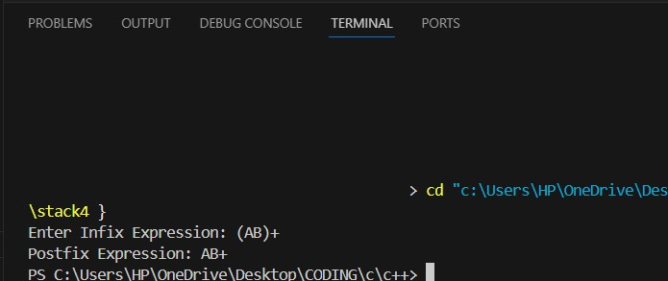Output:

Ques 5. Write a program for the evaluation of a Postfix expression. Code:

#include <iostream> #include <cstring> #include <cctype>

using namespace std; #define MAX 100

class Stack {

int arr[MAX]; int top;

public:

Stack() { top = -1; }

void push(int x) {

if (top == MAX - 1) {

cout << "Stack Overflow\n"; return;

}

arr[++top] = x;

}

int pop() {

if (top == -1) {

cout << "Stack Underflow\n"; return -1;

}

return arr[top--];

}

bool isEmpty() {

return (top == -1);

}

int peek() {

if (top == -1) {

cout << "Stack Empty\n"; return -1;

}

return arr[top];

}

};

int evaluatePostfix(char exp[]) { Stack st;

int len = strlen(exp);

for (int i = 0; i < len; i++) { char ch = exp[i];

// Skip spaces if (ch == ' ')

continue;

// If operand, push it if (isdigit(ch)) {

st.push(ch - '0'); // convert char to int

}

else {

// Operator case

int val2 = st.pop(); int val1 = st.pop();

switch (ch) {

case '+': st.push(val1 + val2); break; case '-': st.push(val1 - val2); break; case '\*': st.push(val1 \* val2); break; case '/': st.push(val1 / val2); break;

}

}

}

return st.pop();

}

int main() {

char exp[MAX];

cout << "Enter a postfix expression (single-digit operands): "; cin.getline(exp, MAX);

cout << "Result = " << evaluatePostfix(exp) << endl; return 0;

}

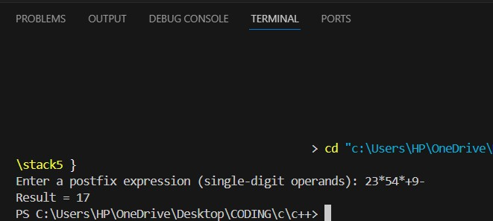Output: