Student Dropout Risk & Education Retention Analytics System
Capstone Project Documentation

1. Project Purpose
This project implements an end-to-end analytics system to identify, analyze, and monitor student dropout risk using academic performance, attendance behavior, and demographic indicators.
Academic and student data is spread across multiple sources and systems. Manual analysis often fails to identify high-risk students early-on. Early identification improves retention rates and timely intervention.
The solution emphasizes:
- scalable data processing
- explainable risk metrics
- automated orchestration
- data-driven dashboards for stakeholders

2. Data Model & Scope
Datasets Overview
The system is built on four logically separated datasets forming a student-centric analytical model:
- Student Demographics
  - Static reference data
  - Socio-economic and background indicators
- Student Academics
  - Subject-wise academic performance
  - Scores, grades, pass/fail outcomes
- Student Attendance
  - Attendance percentage per subject
  - Participation and engagement scores
- Student Retention
  - Historical retention outcomes
  - Dropout flags and contributing reasons
  - Used as the analytical ground truth
Design Considerations
- 1000 current students spread over 2 institutions
- 5 core subjects, academic years from 2023-24 and 2024-25
- Retention data represents historical cohorts (Academic Years 2020 to 2023)
- No direct dependency between simulated demographics and retention outcomes
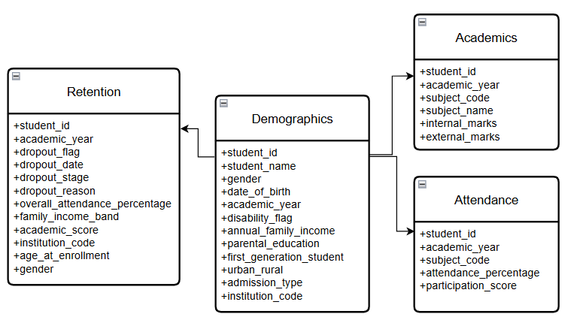

3. Data Architecture (Bronze–Silver–Gold)
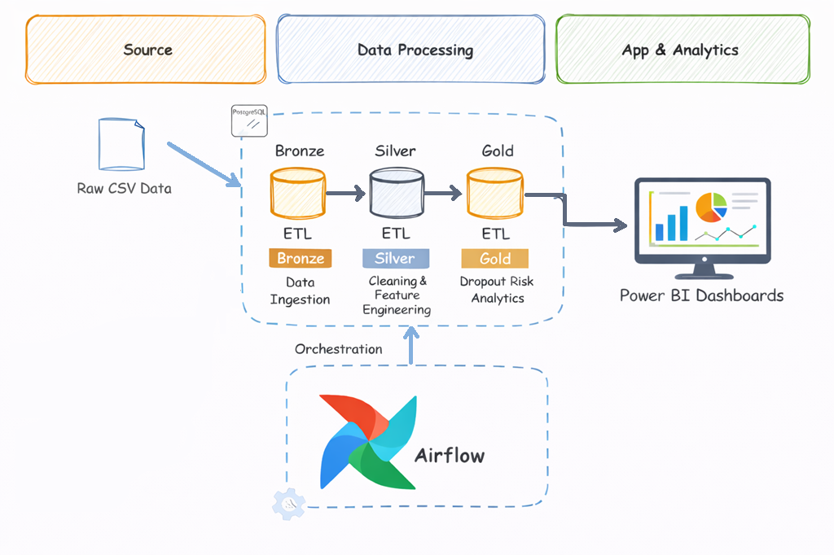
Bronze Layer – Raw Ingestion
Purpose: Data preservation and auditability
- Raw CSV ingestion with schema inference
- Original structure retained
- No transformations applied
- Duplicates, nulls, and inconsistencies intentionally preserved
- Serves as the system of record for reprocessing

Silver Layer – Cleaning & Feature Engineering
Purpose: Analytics-ready standardized datasets
Data Cleaning
- Duplicate handling
- Data type normalization
- Standardization of categorical attributes:
  - Gender
  - Institution codes
  - Urban/Rural indicators
- Missing value handling using statistical and rule-based methods
Feature Engineering
- Academic features:
  - Total marks
  - Grade derivation
  - Pass/fail flags
- Attendance features:
  - Average attendance
  - Participation aggregation at student-year level
- Demographic features:
  - Income bands
  - First-generation learner flag
  - Age-based risk indicators
The Silver layer represents clean and enriched datasets suitable for analytics.

Gold Layer – Risk & Retention Analytics
Purpose: Business-level insights and reporting
Aggregations
- Student-level and student-year-level summaries
- Subject-wise and institution-wise summaries
Risk Indicators
Derived risk flags:
- Academic risk flag = 1 if avg_academic_score<40 & failed_subject_count >=3
- Attendance risk flag = 1 if avg_attendance_percentage < 40 & low_attendance_subjects >=3
- Socio-economic risk flag = 1if income_band == 1 & first_gen_student == 1 & region = ‘RURAL’
- Age-based risk flag = 1 if age<17 & age>22
Analytical Outputs
- Dropout indicators
- Retention trend summaries
- High-risk student segments
- Data structured for BI consumption
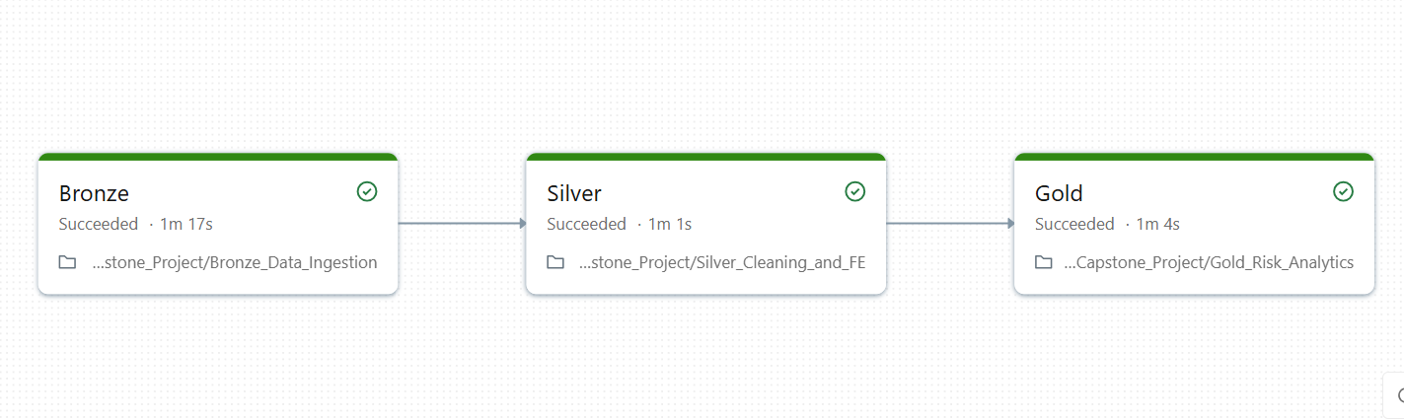

4. Workflow Orchestration (Airflow DAG)
DAG Objective
Automate and orchestrate the end-to-end ETL process by triggering the Databricks analytics pipeline.
DAG Design
- Single orchestration DAG
- Uses DatabricksRunNowOperator
- Triggers a serverless Databricks Job that executes:
  - Bronze ingestion
  - Silver cleaning and feature engineering
  - Gold risk analytics
Key DAG Characteristics
- Manual trigger (on-demand execution)
- Retry logic with configurable delay
- Centralized logging
- Success and failure callbacks for observability
- Separation of orchestration logic from transformation logic
Monitoring & Reliability
- Task-level success and failure logs
- Automatic retries on transient failures
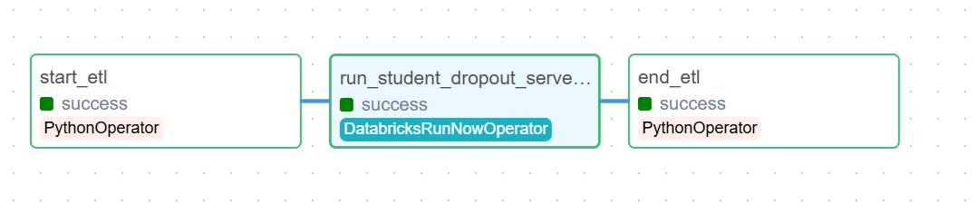

5. Technical Stack
- Data Processing: Python, Pandas, NumPy
- Big Data Analytics: Databricks, PySpark
- Workflow Orchestration: Apache Airflow
- Storage: CSV, Delta Tables
- Visualization: Power BI

6. Power BI Dashboard – Features
A. Student Dropout Risk Overview
- Total students vs at-risk students
- Risk distribution by:
  - Academic performance
  - Attendance levels
  - Socio-economic bands
  - Age
  - Institution
- Overall dropout risk percentage
B. Retention Trends & Patterns
- Historical dropout rates
- Institution-level retention comparison
- Early-warning risk indicators for intervention planning

C. Academic Planning & Intervention Metrics
- Overall risk percentages
- Early Intervention candidates
- Identification of Risk Groups
- Average scores and attendance percentages

D. Subject-Level Insights
- Attendance vs Engagement per subject
- Subject Performance
- Pass/Fail pressure by Subject

Planning and Intervention Solutions:
- Targeted Academic Support
Subject-wise performance and failure patterns help academic teams design focused tutoring programs, and curriculum adjustments for high-risk subjects.
- Attendance Improvement Strategies
Persistent low-attendance trends highlight the need for attendance counselling, and engagement-driven initiatives such as mentorship or activity-based learning.
- Socio-Economic Assistance Planning
Risk segmentation by income band and first-generation status supports data-backed decisions on scholarships, fee support, and welfare programs.

7. Final Outcome
- Built a scalable analytics pipeline
- Converted raw educational data into decision-ready insights
- Implemented real-world ETL orchestration with monitoring
- Delivered interpretable dropout risk indicators
- Provided data-driven dashboards for stakeholders’ decision making and planning

