**WEEK - 3**

**Spring Core and Maven**

**Exercise 1: Configuring a Basic Spring Application**

**Code:**

Pom.xml

<project xmlns="http://maven.apache.org/POM/4.0.0" xmlns:xsi="http://www.w3.org/2001/XMLSchema-instance"

xsi:schemaLocation="http://maven.apache.org/POM/4.0.0 <http://maven.apache.org/xsd/maven-4.0.0.xsd>">

<modelVersion>4.0.0</modelVersion>

<groupId>com.library</groupId>

<artifactId>library</artifactId>

<version>0.0.1-SNAPSHOT</version>

<packaging>jar</packaging>

<name>library</name>

<url>http://maven.apache.org</url>

<properties>

<project.build.sourceEncoding>UTF-8</project.build.sourceEncoding>

</properties>

<dependencies>

<dependency>

<groupId>junit</groupId>

<artifactId>junit</artifactId>

<version>3.8.1</version>

<scope>test</scope>

</dependency>

<!-- Spring Core -->

<dependency>

<groupId>org.springframework</groupId>

<artifactId>spring-context</artifactId>

<version>5.3.30</version> <!-- Use the latest compatible version -->

</dependency>

</dependencies>

</project>

ApplicationContext.xml

<?xml version="1.0" encoding="UTF-8"?>

<beans xmlns="http://www.springframework.org/schema/beans"

xmlns:xsi="http://www.w3.org/2001/XMLSchema-instance"

xsi:schemaLocation="

<http://www.springframework.org/schema/beans>

<https://www.springframework.org/schema/beans/spring-beans.xsd>">

<bean id="bookRepository" class="com.library.repository.BookRepository" />

<bean id="bookService" class="com.library.service.BookService">

<property name="bookRepository" ref="bookRepository"/>

</bean>

</beans>

BookService.java

**package** com.library.service;

**import** com.library.repository.BookRepository;

**public** **class** BookService {

**private** BookRepository bookRepository;

**public** **void** setBookRepository(BookRepository bookRepository) {

**this**.bookRepository = bookRepository;

}

**public** **void** addBook(String bookName) {

System.***out***.println("Adding book: " + bookName);

bookRepository.saveBook(bookName);

}

}

BookRepository.java

**package** com.library.repository;

**public** **class** BookRepository {

**public** **void** saveBook(String bookName) {

System.***out***.println("Saving book: " + bookName);

}

}

LibraryApplication.java

**package** com.library.library;

**import** com.library.service.BookService;

**import** org.springframework.context.ApplicationContext;

**import** org.springframework.context.support.ClassPathXmlApplicationContext;

**public** **class** LibraryApplication {

**public** **static** **void** main(String[] args) {

ApplicationContext context =

**new** ClassPathXmlApplicationContext("applicationContext.xml");

BookService bookService = (BookService) context.getBean("bookService");

bookService.addBook("The Great Gatsby");

}

}

**Output:**

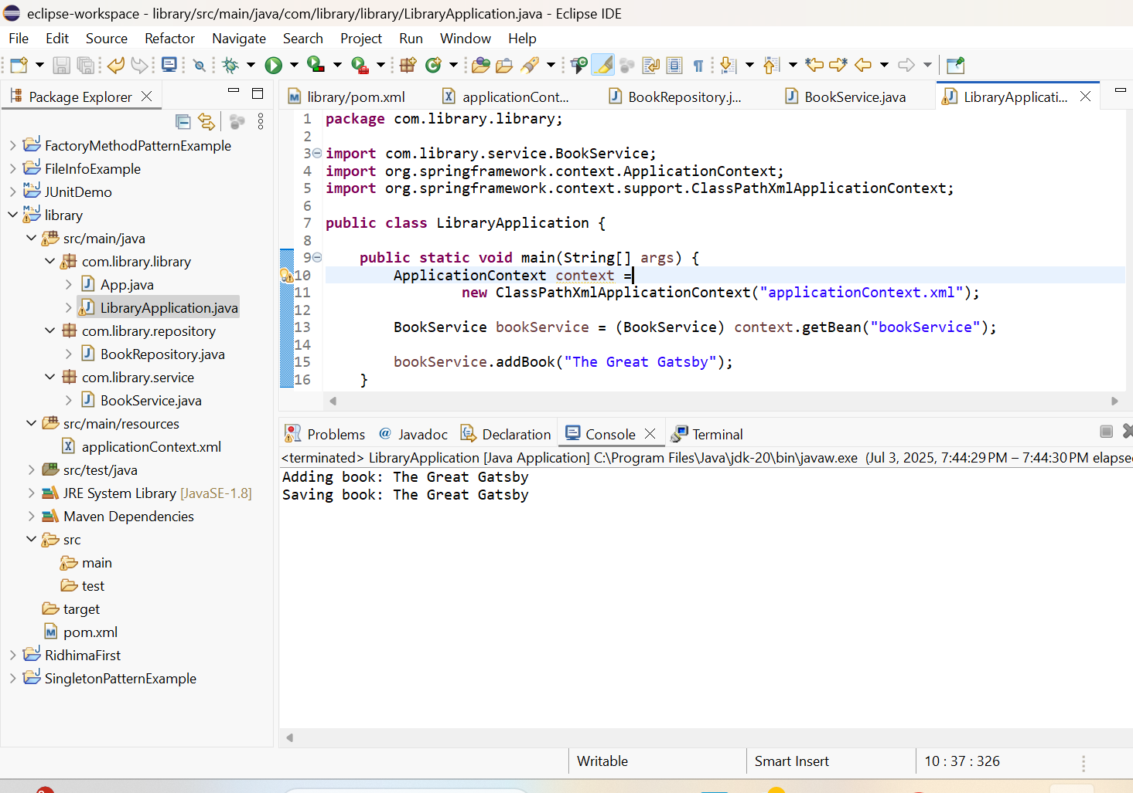

**Exercise 2: Implementing Dependency Injection**

**Code:**

ApplicationContext.java updated

<?xml version="1.0" encoding="UTF-8"?>

<beans xmlns="http://www.springframework.org/schema/beans"

xmlns:xsi="http://www.w3.org/2001/XMLSchema-instance"

xsi:schemaLocation="

<http://www.springframework.org/schema/beans>

<https://www.springframework.org/schema/beans/spring-beans.xsd>">

<!-- Define BookRepository Bean -->

<bean id="bookRepository" class="com.library.repository.BookRepository" />

<!-- Define BookService Bean and inject BookRepository -->

<bean id="bookService" class="com.library.service.BookService">

<property name="bookRepository" ref="bookRepository" />

</bean>

</beans>

BookService.java (updated)

**package** com.library.service;

**import** com.library.repository.BookRepository;

**public** **class** BookService {

**private** BookRepository bookRepository;

// Setter for dependency injection

**public** **void** setBookRepository(BookRepository bookRepository) {

**this**.bookRepository = bookRepository;

}

**public** **void** addBook(String bookName) {

System.***out***.println("Adding book: " + bookName);

bookRepository.saveBook(bookName);

}

}

**Output:**

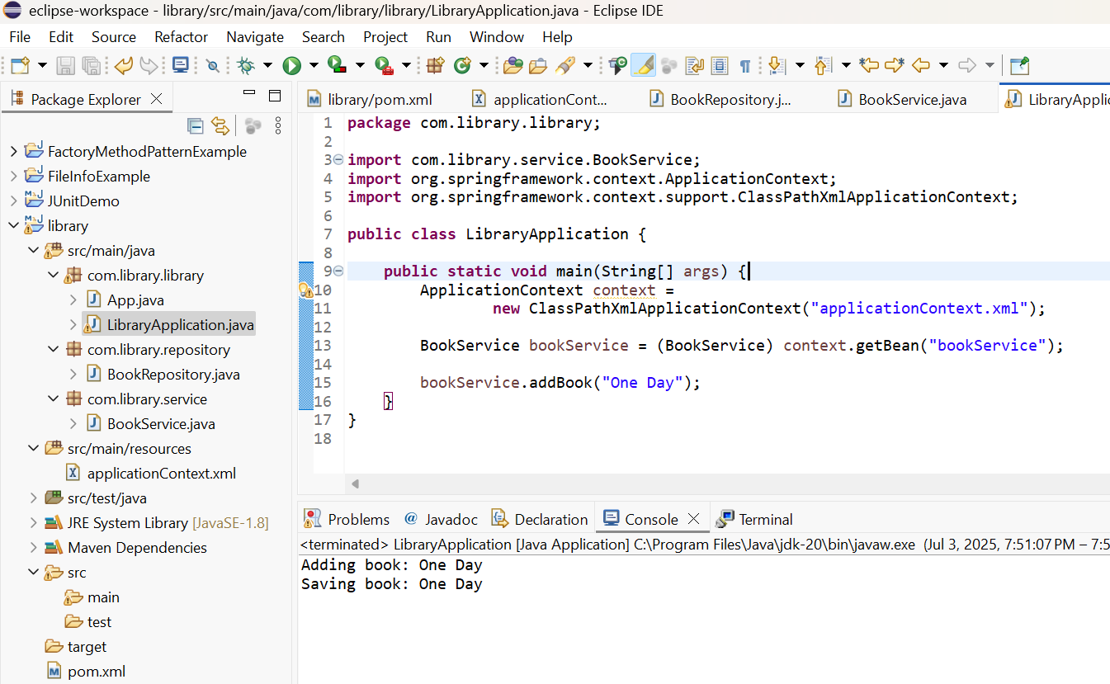

**Exercise 4: Creating and Configuring a Maven Project**

**Code:**

<?xml version="1.0" encoding="UTF-8"?>

<project xmlns="http://maven.apache.org/POM/4.0.0" xmlns:xsi="http://www.w3.org/2001/XMLSchema-instance"

xsi:schemaLocation="http://maven.apache.org/POM/4.0.0 <http://maven.apache.org/xsd/maven-4.0.0.xsd>">

<modelVersion>4.0.0</modelVersion>

<groupId>com.library</groupId>

<artifactId>LibraryMgmtSystem</artifactId>

<version>0.0.1-SNAPSHOT</version>

<packaging>jar</packaging>

<name>LibraryMgmtSystem</name>

<url>http://www.example.com</url>

<properties>

<project.build.sourceEncoding>UTF-8</project.build.sourceEncoding>

<maven.compiler.source>1.8</maven.compiler.source>

<maven.compiler.target>1.8</maven.compiler.target>

</properties>

<dependencies>

<dependency>

<groupId>org.junit.jupiter</groupId>

<artifactId>junit-jupiter-engine</artifactId>

<version>5.7.1</version>

<scope>test</scope>

</dependency>

<dependency>

<groupId>org.junit.jupiter</groupId>

<artifactId>junit-jupiter-params</artifactId>

<version>5.7.1</version>

<scope>test</scope>

</dependency>

<!-- Spring Context (Core IoC Container) -->

<dependency>

<groupId>org.springframework</groupId>

<artifactId>spring-context</artifactId>

<version>5.3.30</version>

</dependency>

<!-- Spring AOP -->

<dependency>

<groupId>org.springframework</groupId>

<artifactId>spring-aop</artifactId>

<version>5.3.30</version>

</dependency>

<!-- Spring WebMVC -->

<dependency>

<groupId>org.springframework</groupId>

<artifactId>spring-webmvc</artifactId>

<version>5.3.30</version>

</dependency>

<!-- Optional: Servlet API for WebMVC -->

<dependency>

<groupId>javax.servlet</groupId>

<artifactId>javax.servlet-api</artifactId>

<version>4.0.1</version>

<scope>provided</scope>

</dependency>

</dependencies>

<build>

<plugins>

<plugin>

<groupId>org.apache.maven.plugins</groupId>

<artifactId>maven-surefire-plugin</artifactId>

<version>3.0.0-M5</version>

</plugin>

<!-- Compiler plugin for Java 1.8 -->

<plugin>

<groupId>org.apache.maven.plugins</groupId>

<artifactId>maven-compiler-plugin</artifactId>

<version>3.8.1</version>

<configuration>

<source>1.8</source>

<target>1.8</target>

</configuration>

</plugin>

</plugins>

</build>

</project>

**Spring Data JPA with Spring Boot, Hibernate**

**Spring Data JPA - Quick Example**

**Code:**

**sql**

create schema ormlearn;

use ormlearn;

create table country (

co_code varchar(2) primary key,

co_name varchar(50)

);

insert into country values ('IN', 'India');

insert into country values ('US', 'United States of America');

package com.cognizant.ormlearn.model;

**Country.java**

import javax.persistence.Column;

import javax.persistence.Entity;

import javax.persistence.Id;

import javax.persistence.Table;

@Entity

@Table(name = "country")

public class Country {

@Id

@Column(name = "co_code")

private String code;

@Column(name = "co_name")

private String name;

public Country() {

}

public String getCode() {

return code;

}

public void setCode(String code) {

this.code = code;

}

public String getName() {

return name;

}

public void setName(String name) {

this.name = name;

}

@Override

public String toString() {

return "Country [code=" + code + ", name=" + name + "]";

}

}

**CountryService.java**

package com.cognizant.ormlearn.service;

import java.util.List;

import javax.transaction.Transactional;

import org.springframework.beans.factory.annotation.Autowired;

import org.springframework.stereotype.Service;

import com.cognizant.ormlearn.model.Country;

import com.cognizant.ormlearn.repository.CountryRepository;

@Service

public class CountryService {

@Autowired

private CountryRepository countryRepository;

@Transactional

public List<Country> getAllCountries() {

return countryRepository.findAll();

}

}

**OrmLearnApplication.java**

package com.cognizant.ormlearn;

import java.util.List;

import org.slf4j.Logger;

import org.slf4j.LoggerFactory;

import org.springframework.boot.SpringApplication;

import org.springframework.boot.autoconfigure.SpringBootApplication;

import org.springframework.context.ApplicationContext;

import com.cognizant.ormlearn.model.Country;

import com.cognizant.ormlearn.service.CountryService;

@SpringBootApplication

public class OrmLearnApplication {

private static final Logger LOGGER = LoggerFactory.getLogger(OrmLearnApplication.class);

private static CountryService countryService;

public static void main(String[] args) {

ApplicationContext context = SpringApplication.run(OrmLearnApplication.class, args);

LOGGER.info("Inside main");

countryService = context.getBean(CountryService.class);

testGetAllCountries();

}

private static void testGetAllCountries() {

LOGGER.info("Start");

List<Country> countries = countryService.getAllCountries();

LOGGER.debug("countries={}", countries);

LOGGER.info("End");

}

}

**Output:**

03-07-25 21:50:12.345 main INFO com.cognizant.ormlearn.OrmLearnApplication main 18 Inside main

03-07-25 21:50:12.346 main INFO com.cognizant.ormlearn.OrmLearnApplication testGetAllCountries 22 Start

03-07-25 21:50:12.358 main TRACE org.hibernate.SQL logStatement 109 select country0_.co_code as co_code1_0_, country0_.co_name as co_name2_0_ from country country0_

03-07-25 21:50:12.360 main DEBUG com.cognizant.ormlearn.OrmLearnApplication testGetAllCountries 24 countries=[Country [code=IN, name=India], Country [code=US, name=United States of America]]

03-07-25 21:50:12.361 main INFO com.cognizant.ormlearn.OrmLearnApplication testGetAllCountries 25 End

**Difference between Hibernate and Spring Data JPA**

**Hibernate**

   /* Method to CREATE an employee in the database */

   public Integer addEmployee(Employee employee){

      Session session = factory.openSession();

      Transaction tx = null;

      Integer employeeID = null;

      try {

         tx = session.beginTransaction();

         employeeID = (Integer) session.save(employee);

         tx.commit();

      } catch (HibernateException e) {

         if (tx != null) tx.rollback();

         e.printStackTrace();

      } finally {

         session.close();

      }

      return employeeID;

   }

**Spring Data JPA**  
EmployeeRespository.java

public interface EmployeeRepository extends JpaRepository<Employee, Integer> {

}

EmployeeService.java

@Autowire

  private EmployeeRepository employeeRepository;

@Transactional

public void addEmployee(Employee employee) {

  employeeRepository.save(employee);

  }