**WEEK-6**

**REACT**

**Exercise 1**

Code:

import './App.css';

function App() {

return (

<h1>Hello World Welcome to my first react session!</h1>

);

}

export default App;

Output:

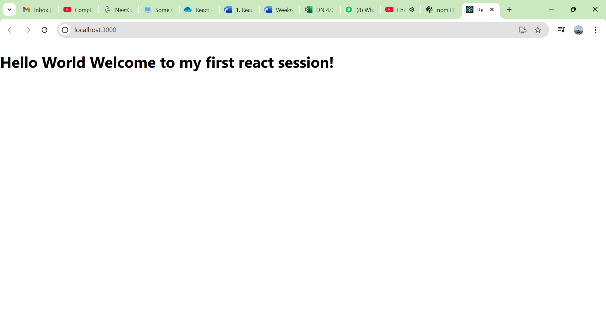

**Exercise 2**

Code:

import './App.css';

import About from './StudentApp/Components/About';

import Contact from './StudentApp/Components/Contact';

import Home from './StudentApp/Components/Home';

function App() {

return (

<div>

<Home />

<About />

<Contact />

</div>

);

}

export default App;

Output:

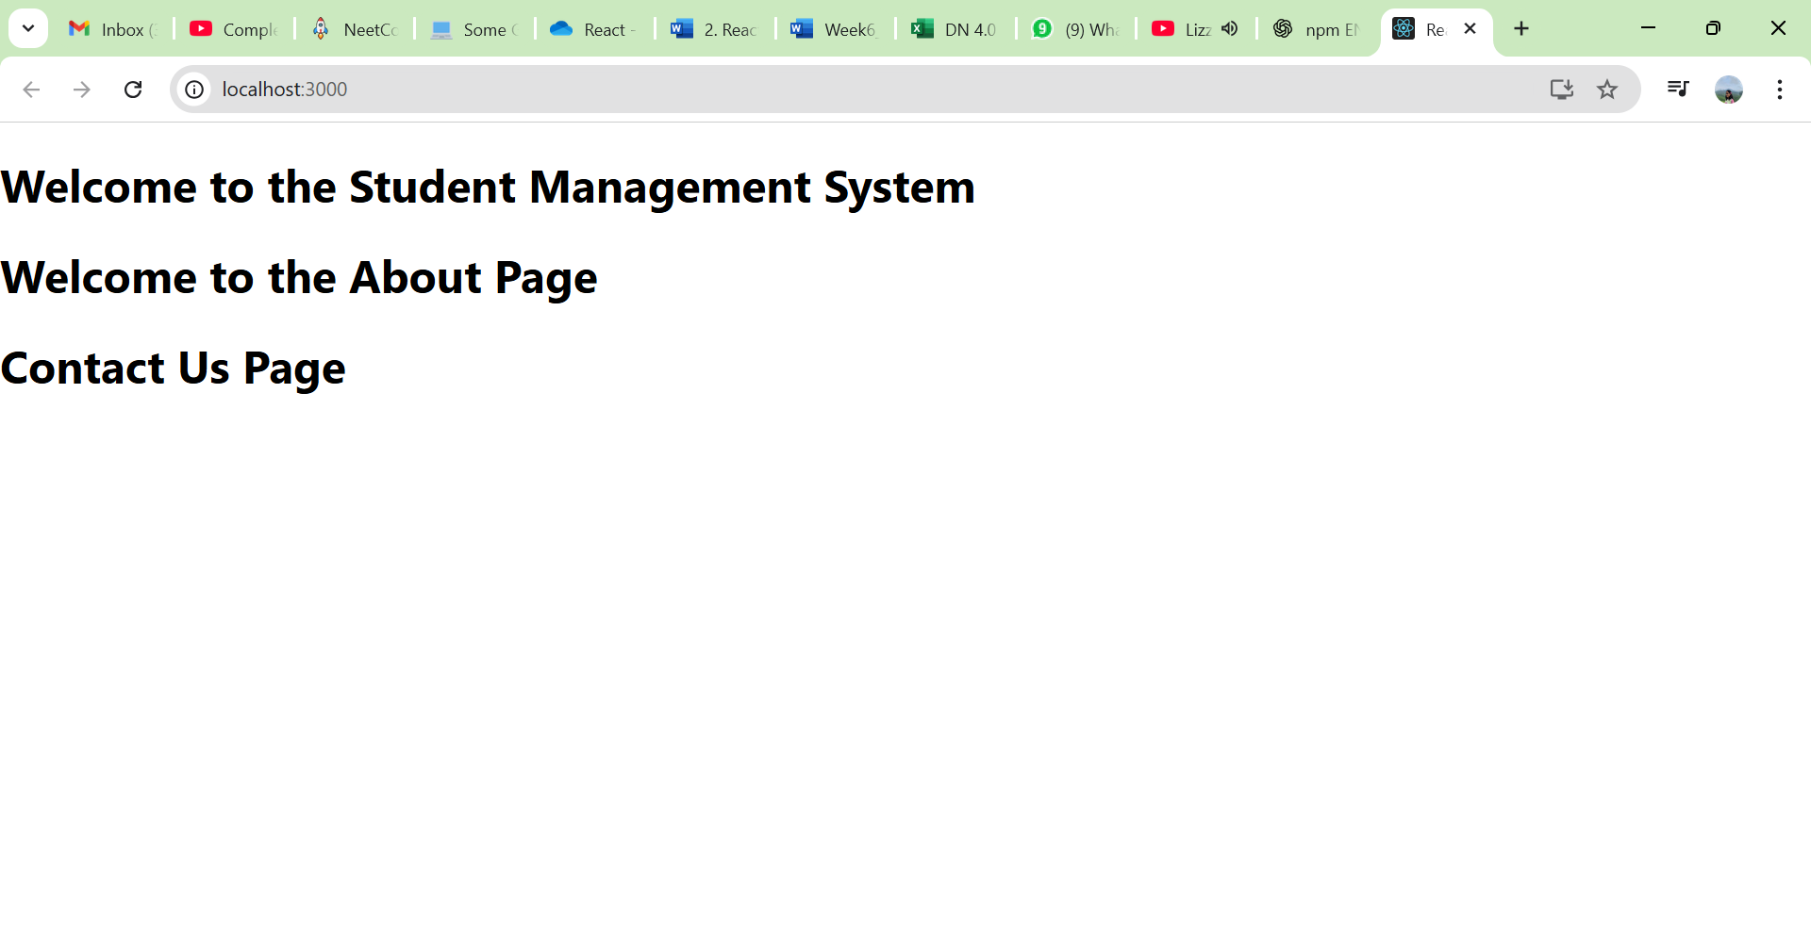

**Exercise 3**

Code:

App.js

import { CalcScore } from "./src/Components/CalcScore";

function App() {

return (

<div>

<CalcScore

Name="Steeve"

School="DNV Public School"

total={284}

goal={3}

/>

</div>

);

}

export default App;

CalcScore.js

import './Stylesheets/mystyle.css';

const percentToDecimal = (decimal) => {

return (decimal.toFixed(2) * 1) + '%';

}

const calcScore = (total, goal) => {

return percentToDecimal(total/goal);

}

export const CalcScore = ({ Name, School, total, goal }) => (

<div className="formatstyle">

<h1><font color="Brown">Student Details:</font></h1>

<div className="Name">

<b><span>Name: </span></b>

<span>{Name}</span>

</div>

<div className="School">

<b><span>School: </span></b>

<span>{School}</span>

</div>

<div className="Total">

<b><span>Total: </span></b>

<span>{total}</span>

</div>

<div className="Score">

<b><span>Score: </span></b>

<span>{calcScore(total, goal)}</span>

</div>

</div>

);

Mystyle.js

.Name {

font-weight: 300;

color: blue;

}

.School {

color: crimson;

}

.Total {

color: darkmagenta;

}

.formatstyle {

text-align: center;

font-size: large;

}

.Score {

color: forestgreen;

}

Output:

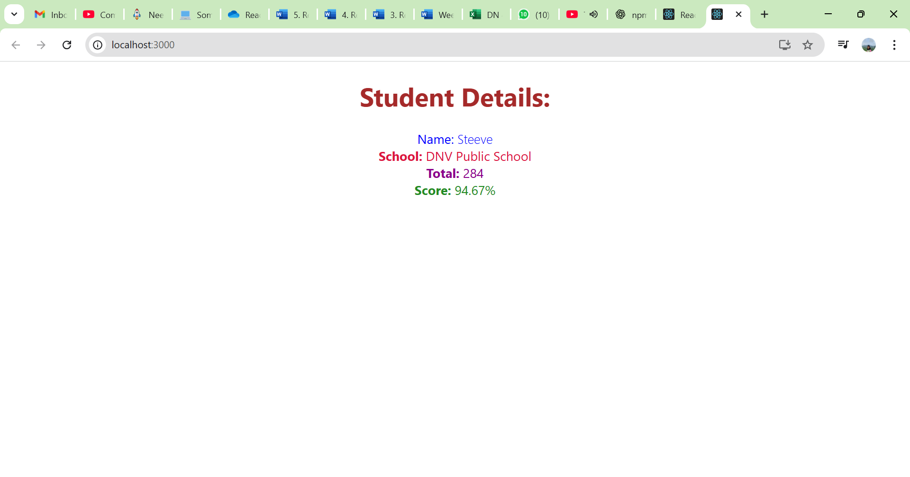

**Exercise 4**

Code:

Posts.js

import React from 'react';

class Posts extends React.Component {

constructor(props) {

super(props);

this.state = {

posts: []

};

}

loadPosts() {

// Logic to load posts

console.log("Loading posts...");

// This could be an API call to fetch posts

fetch('https://jsonplaceholder.typicode.com/posts')

.then(response => response.json())

.then(data => {

console.log("Posts loaded:", data);

// Update state with fetched posts

this.setState({ posts: data.slice(0, 5) });

})

.catch(error => {

console.error("Error loading posts:", error);

});

}

componentDidMount() {

this.loadPosts();

}

render() {

return (

<div>

<h1>Posts</h1>

{/* Render posts here */}

<ul>

{this.state.posts.map(post => (

<li key={post.id}>

{post.title}

<h3>{post.body}</h3>

</li>

))}

</ul>

</div>

);

}

componentDidCatch(error, info) {

console.error("Error occurred:", error);

// Handle error gracefully

}

}

export default Posts;

Post.js

class Post {

constructor(id, title, body){

this.id = id;

this.title = title;

this.body = body;

}

}

export default Post;

App.js

import Posts from './Posts';

function App() {

return (

<div>

<h1>Posts</h1>

<Posts />

</div>

);

}

export default App;

Output:

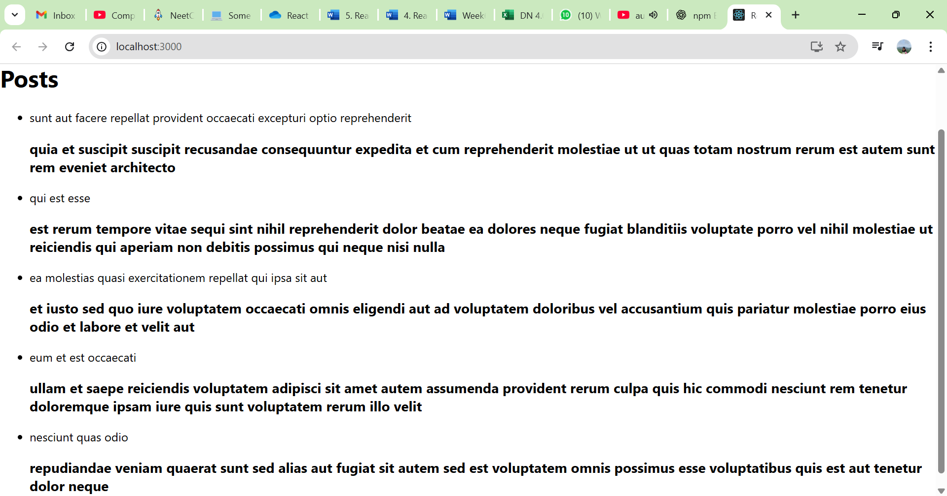

**Exercise 5**

Code:

App.js

import CohortDetails from './CohortDetails';

import './App.css'; // Ensure this import is correct based on your project structure

import './CohortDetails.module.css'; // Ensure this import is correct based on your project structure

function App() {

return (

<div>

<CohortDetails

name="INTADM10F - .NET FSD"

status="ongoing"

startDate="Oct 2022"

endDate="Dec 2022"

coach="John Doe"

/>

<CohortDetails

name="ADM1H-FSD1 Java FSD"

status="completed"

startDate="Sep 2022"

endDate="Nov 2022"

coach="Jane Smith"

/>

</div>

);

}

export default App;

CohortDetails.js

import React from 'react';

import styles from './CohortDetails.module.css';

const CohortDetails = ({ name, status, startDate, endDate, coach }) => {

const headingStyle = {

color: status.toLowerCase() === 'ongoing' ? 'green' : 'blue',

};

return (

<div className={styles.box}>

<h3 style={headingStyle}>{name}</h3>

<dl>

<dt>Status:</dt>

<dd>{status}</dd>

<dt>Start Date:</dt>

<dd>{startDate}</dd>

<dt>End Date:</dt>

<dd>{endDate}</dd>

<dt>Coach:</dt>

<dd>{coach}</dd>

</dl>

</div>

);

};

export default CohortDetails;

CohortDetails.module.css

.box {

width: 300px;

display: inline-block;

margin: 10px;

padding: 10px 20px;

border: 1px solid black;

border-radius: 10px;

}

dt {

font-weight: 500;

}

Output:

