CREATE USER BCMLTD

IDENTIFIED BY pwdbcmtest

DEFAULT TABLESPACE USERS

TEMPORARY TABLESPACE TEMP

PROFILE DEFAULT

ACCOUNT UNLOCK

ALTER USER BCMLTD quota 100M on users

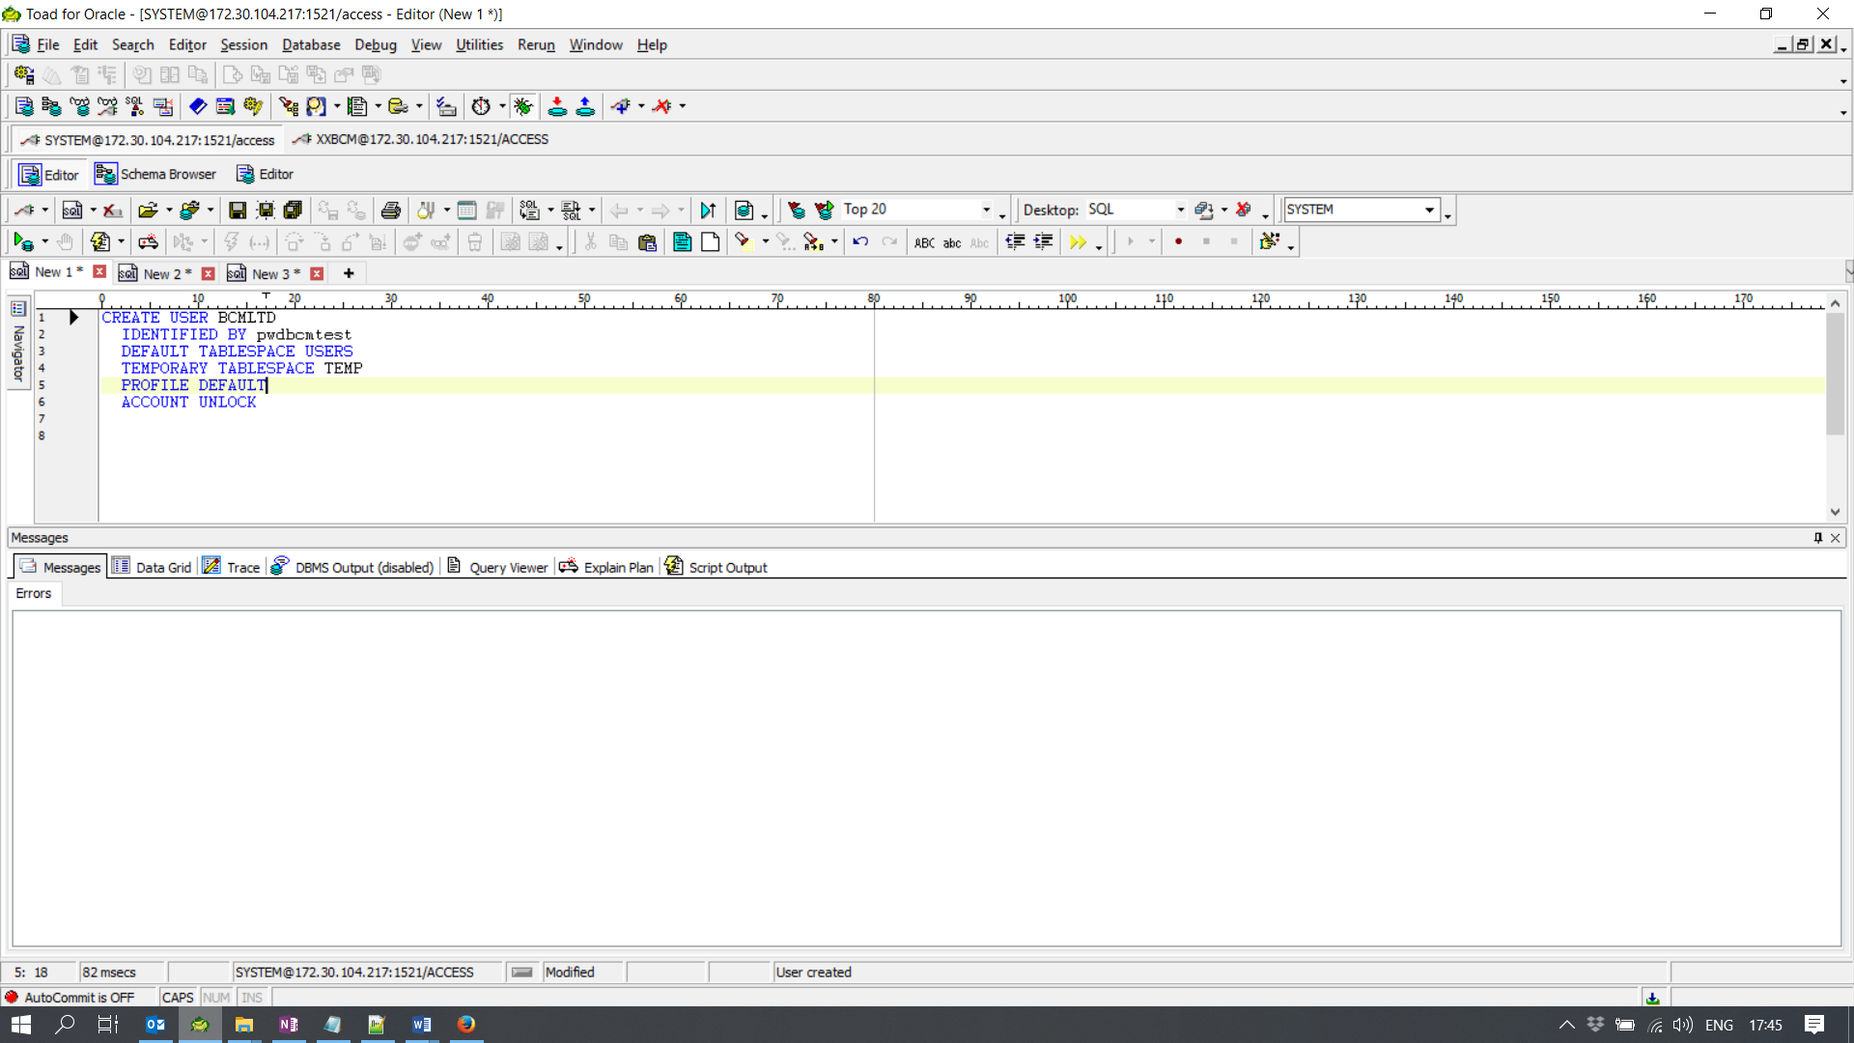

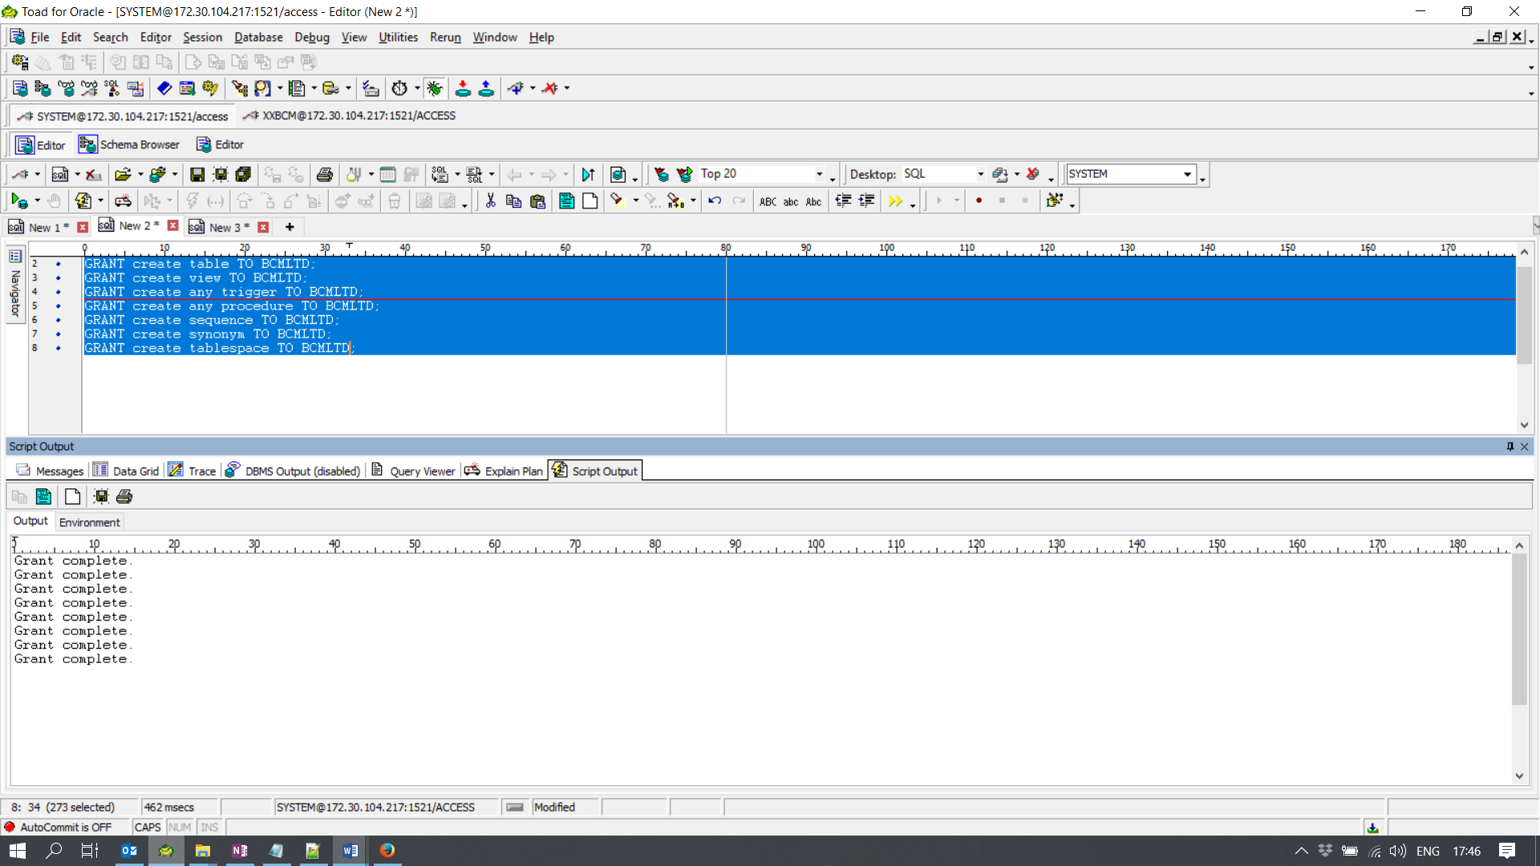

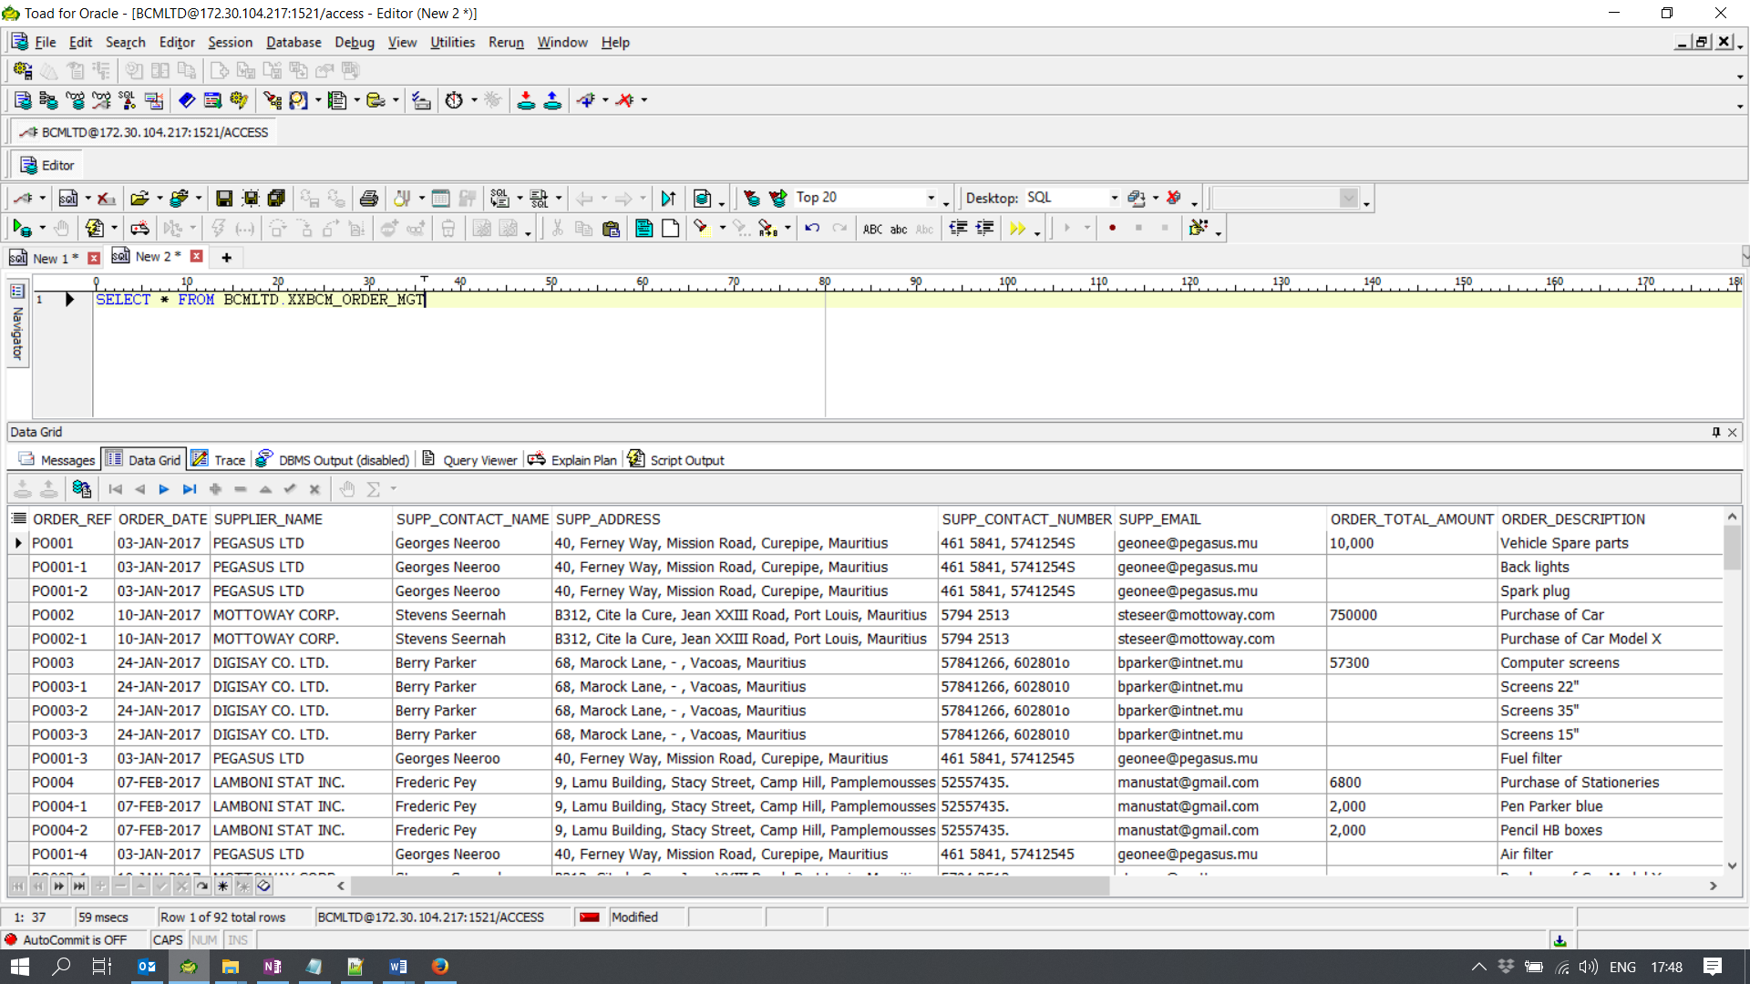

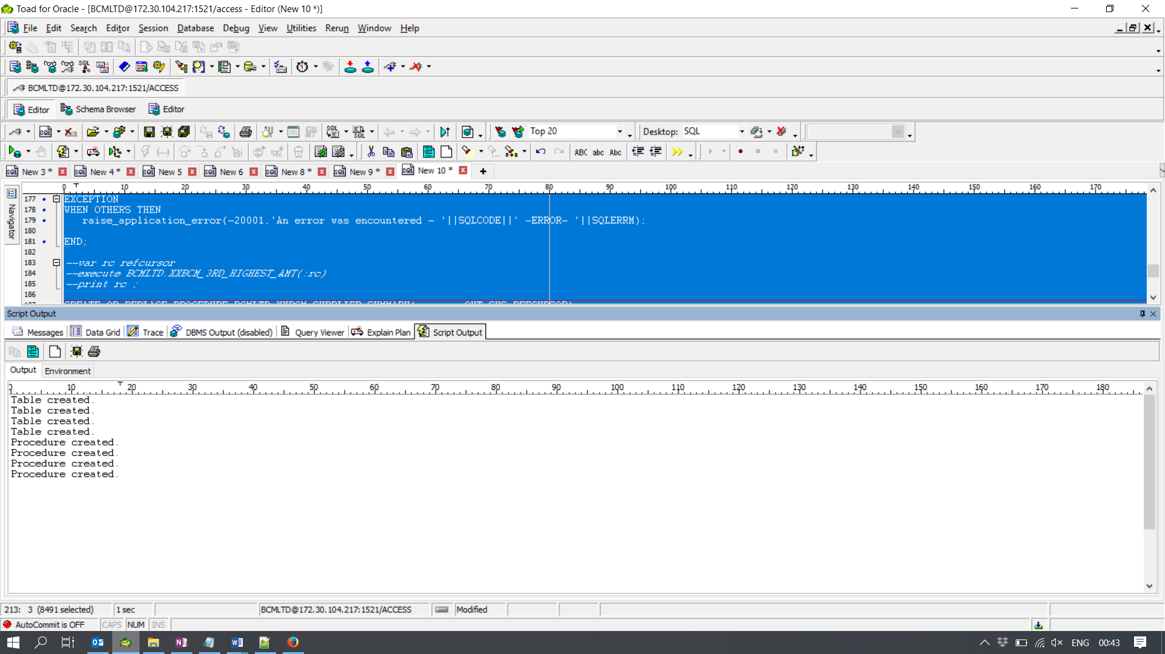

**Question 4:**

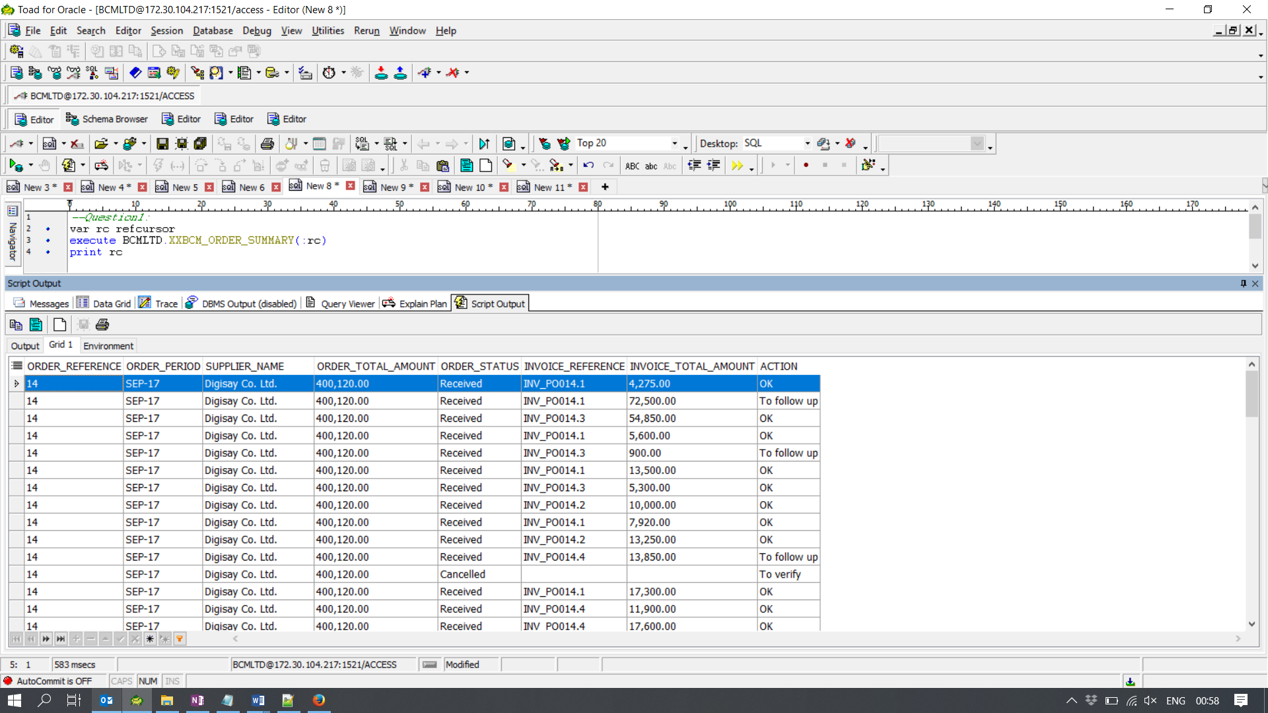

**Question 5:**

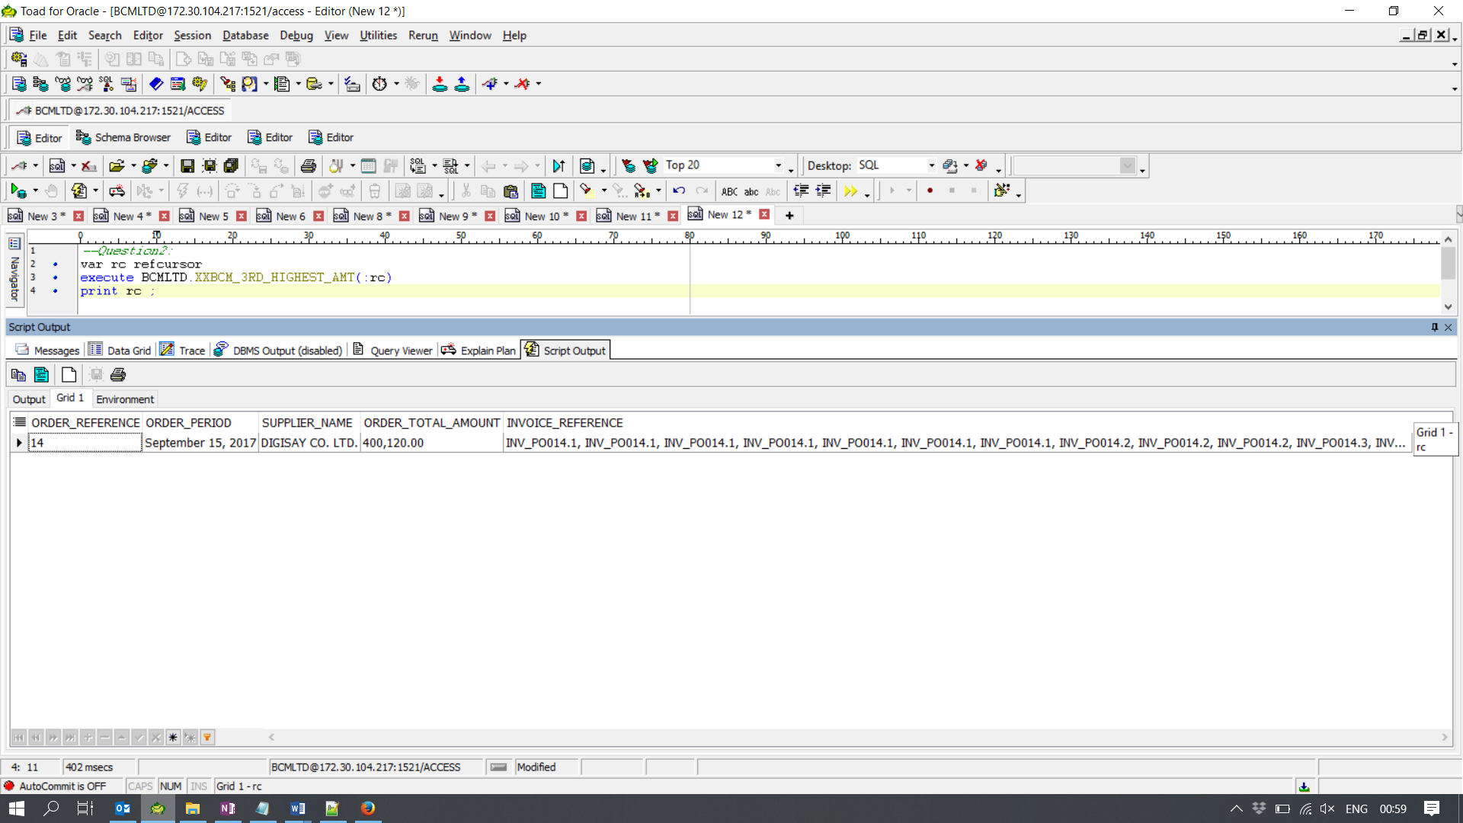

**Question 6:**

