Nama = Ridho Atim Suistaya

Nim = 201402133

Kelas = KOM A

Mata kuliah = Enterprise Development Software

Modul 2

Tools to Work With SAP HANA Cloud

1. Membuat monitoring database

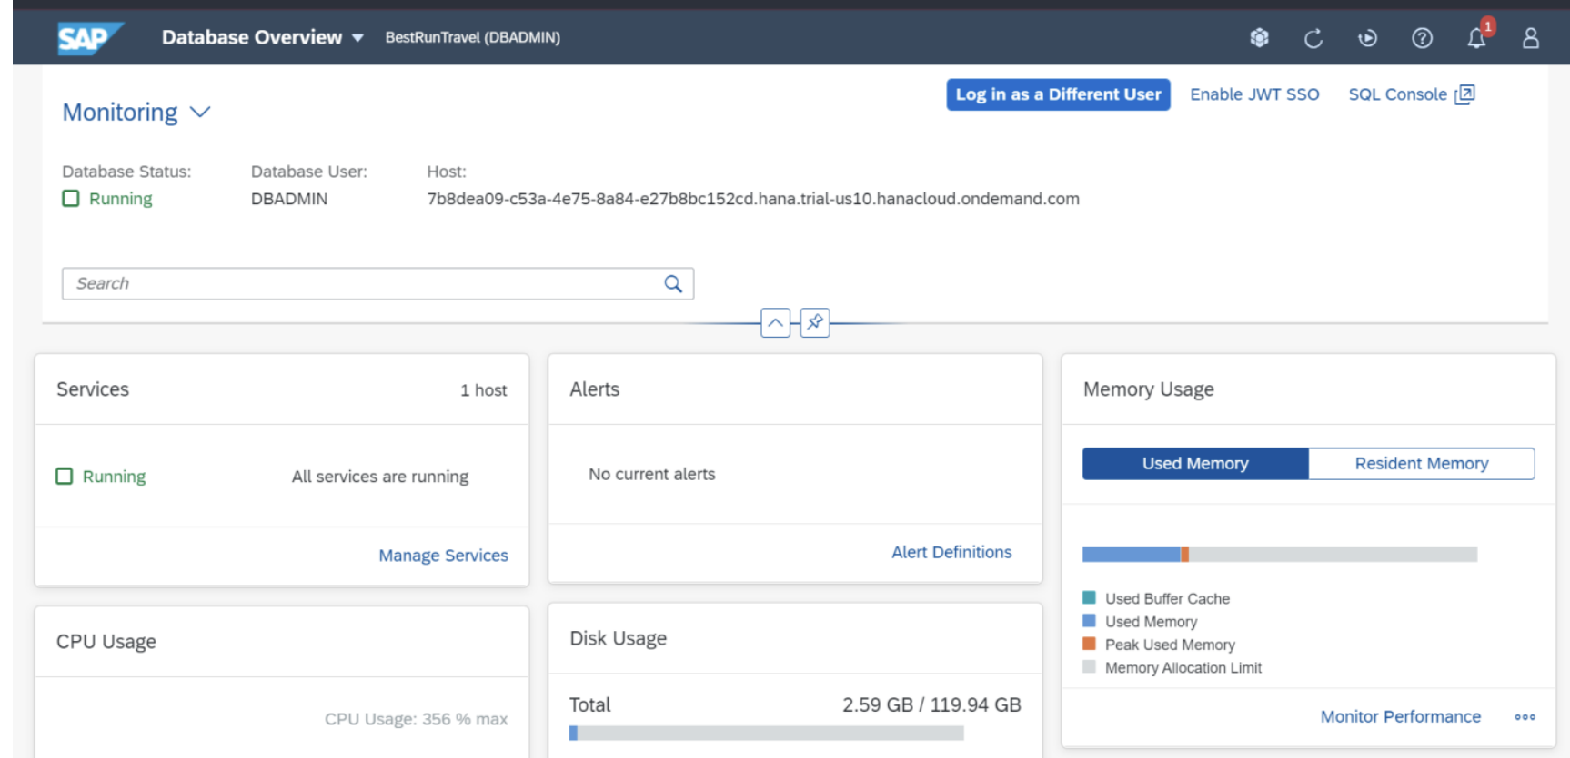

2. berikut tampilan database eksplorer

