Nama = Ridho Atim Suistaya

Nim = 201402133

Kelas = KOM A

Mata kuliah = Enterprise Development Software

Modul 4

Connecting to and Creating Data on the SAP HANA Cloud Data Lake

1. Membuat event GKG mention Table

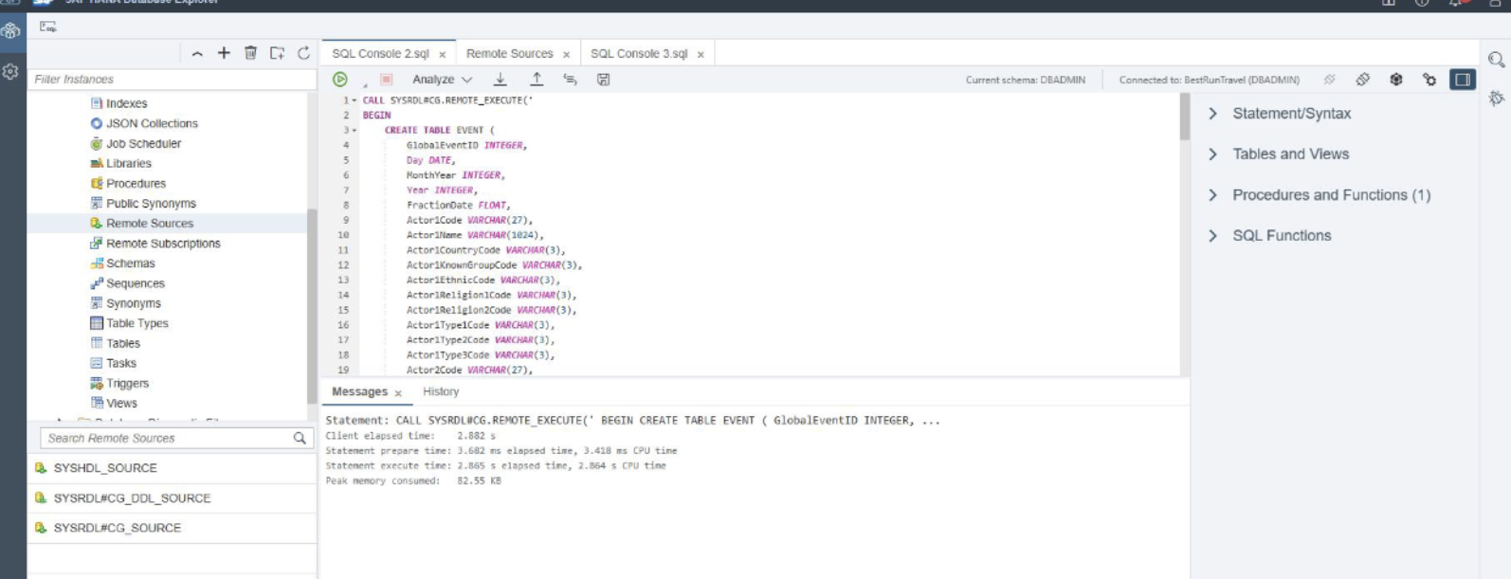

2. Tampilan tabel di remote source

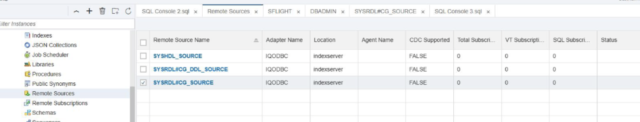

3. Membuat virtual object

