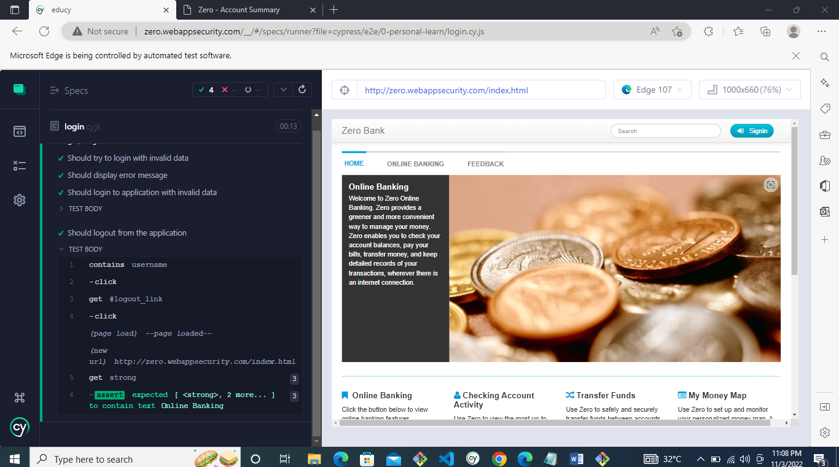

/// <reference types="cypress" />

describe('Login/ Logout Test', () => {

    before(() => {

        cy.visit('http://zero.webappsecurity.com/index.html')

        cy.url().should('include', 'index.html')

        cy.get('#signin_button').click()

    });

    it('Should try to login with invalid data', () => {

        cy.get('#login_form').should('be.visible')

        cy.get('#user_login').type('invalid username')

        cy.get('#user_password').type('invalid password')

        cy.get('input[name="submit"]').click()

    });

    it('Should display error message', () => {

        cy.get('.alert-error').should('be.visible').and('contain.text', 'Login and/or password are wrong.')

    });

    it('Should login to application with invalid data ', () => {

        cy.fixture("user").then(user => {

            const username = user.username

            const password = user.password

            cy.get('#user_login').clear()

            cy.get('#user_login').type('username')

            cy.get('#user_password').clear()

            cy.get('#user_password').type('password')

            cy.get('input[name="submit"]').click()

        cy.get('h2').should('contain.text', 'Cash Accounts')

        })

    });

    it('Should logout from the application', () => {

        cy.contains('username').click()

        cy.get('#logout_link').click()

        cy.get('strong').should('contain.text', 'Online Banking')

    });

        });