Online Shopping Database (E-Commerce Management System)

Student Details

Student Name | Ajay Raja
Register Number | 732119104701
Department | CSE
ID | 8da3a429c5260608bcc40cf1e7433ef3
College | Nandha engineering college, Erode
Date of Submission | 23/09/2026
GitHub Repo | https://github.com/AjayGitPersonal/port-final.git
Deployment Link | http://localhost:5000 (Full-Stack Storefront & Oracle DBA Console)

Problem Statement
A online shopping e-commerce platform needs an efficient database system to manage information about customers, their vehicles, and the products ordered by customers. Maintaining these details manually can make it difficult to track customer order history, retrieve customer information, and calculate order billing costs.

The Online Shopping Database (E-Commerce Management System) is designed to organize this information using a relational database. The database stores customer details, product catalog and warehouse inventory information, and order transactions and itemized line items, while establishing appropriate relationships between the tables. SQL queries are used to perform data management, retrieval, and analysis operations.

Real-World Scenario

Consider a customer visiting a online shopping e-commerce platform with a car.
- The customer represents the person who owns the vehicle.
- The vehicle represents the customer's car or two-wheeler.
- The service represents the maintenance or repair work performed on that vehicle.

The relationship can be represented as:

CUSTOMER
↓
VEHICLE
↓
SERVICE

Example

Customer
Customer ID : 101
Customer Name : Arun Kumar
Contact Number: 9876543210

↓

Vehicle
Vehicle ID : 501
Vehicle Number: PROD-LAP-001
Vehicle Type : Car
Vehicle Model : Apex Pro 16" Creator Laptop

↓

Service
Service ID : 1001
Service Date : 01-08-2026
Service Type : Laptop Purchase (PROD-LAP-001)
Service Status: Completed
Service Cost : ₹2,500.00

This business scenario is converted into a relational database consisting of Categories, Customers, Products, Orders, and Order Items tables.

Objectives
The main objectives of the project are:

- To design a simple relational database for a online shopping e-commerce platform.
- To create and manage tables using Oracle SQL*Plus & Enterprise DBA Console.
- To establish relationships between related tables.
- To apply primary keys, foreign keys, and other basic constraints.
- To perform data manipulation and retrieval using SQL.
- To use SQL queries to generate useful information from the database.
- To understand the practical application of relational database concepts.

Database Design – 10 Marks
  - Database Structure
- The Online Shopping Database (E-Commerce Management System) is a relational database designed to manage customer information, product specifications, SKUs, and stock quantities, and customer order history and purchasing receipts. The database consists of three related tables: Categories, Customers, Products, Orders, and Order Items.
- The tables are connected using primary keys and foreign keys to maintain relationships between customers, their vehicles, and the products ordered by customers. The required relationships are Customers → Orders → Order Items → Products → Categories.

Tables Used

Table Name | Purpose
CATEGORIES | Stores product classification categories, supporting hierarchical category trees
CUSTOMERS | Stores customer profiles, contact numbers, email addresses, and delivery coordinates
PRODUCTS | Stores physical product catalog, SKUs, sales prices, and live warehouse stock levels
ORDERS | Tracks financial checkout transactions, timestamps, payment methods, and fulfillment lifecycle
ORDER_ITEMS | Associative table storing individual line items, quantities, and snapshot prices per order
AUDIT_LOGS | Change Data Capture (CDC) table recording DBA audit trails on inventory mutations
Add any additional tables created as required.

Entity Relationship Diagram

Diagram:

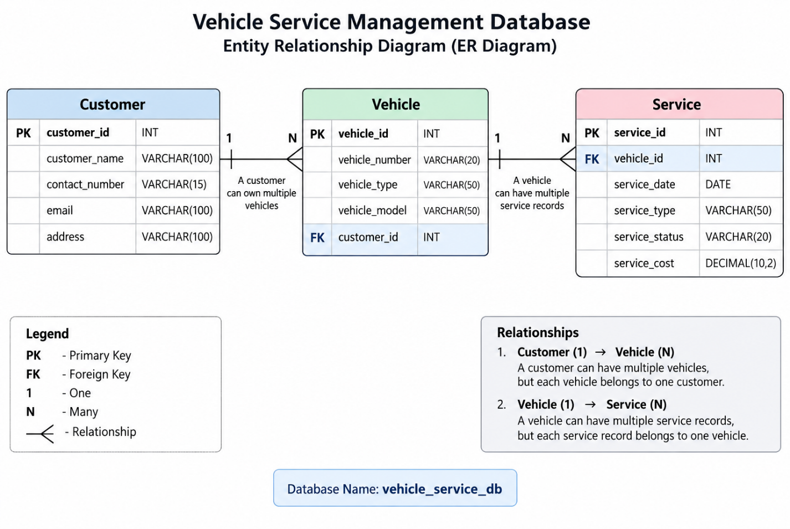

Technologies Used
Mention the technologies/tools used and their purpose.

Technology / Tool | Purpose
Oracle Database 21c XE | Enterprise relational database engine hosting pluggable database XEPDB1
Oracle SQL*Plus | Command-line database administration, tablespace management, and script execution
SQL & PL/SQL | DDL/DML definitions, views, triggers, and atomic inventory checkout packages
Node.js & Express.js | High-performance REST API backend handling connection pooling and transactions
node-oracledb (Thin Mode) | Official native Oracle driver communicating via TCP port 1521 without heavy client binaries
React 18 & Vite | Modern single-page storefront, customer order history UI, and DBA command center
Tailwind CSS | Responsive styling using the enterprise Qorvae golden-amber palette

Practical Implementation
  - Database and Table Creation
The Online Shopping Database (E-Commerce Management System) was implemented using Oracle SQL*Plus & Enterprise DBA Console. A database named ECOMMERCE_DBA (Oracle 21c PDB: XEPDB1) was created, followed by three related tables: Categories, Customers, Products, Orders, and Order Items.

The tables were created in dependency order so that the required foreign-key relationships could be established correctly. The use case requires database/table creation and appropriate primary and foreign keys.

Database Creation
CREATE DATABASE ECOMMERCE_DBA (Oracle 21c PDB: XEPDB1);

USE ECOMMERCE_DBA (Oracle 21c PDB: XEPDB1);
Customer Table

The Customer table stores customer identification and contact information.

CREATE TABLE Customer (
customer_id INT PRIMARY KEY,
customer_name VARCHAR(100) NOT NULL,
contact_number VARCHAR(15) NOT NULL,
email VARCHAR(100) UNIQUE,
address VARCHAR(255)
);
Vehicle Table

The Vehicle table stores product specifications, SKUs, and stock quantities and connects each vehicle to its customer through the customer_id foreign key.

CREATE TABLE Vehicle (
order_id INT PRIMARY KEY,
product_sku VARCHAR(20) NOT NULL UNIQUE,
category_name VARCHAR(50) NOT NULL,
product_name VARCHAR(100) NOT NULL,
customer_id INT NOT NULL,

FOREIGN KEY (customer_id)
REFERENCES Customer(customer_id)
);
Service Table

The Service table stores customer order history and connects each service record to a vehicle through the order_id foreign key.

CREATE TABLE Service (
order_item_id INT PRIMARY KEY,
order_id INT NOT NULL,
order_date DATE NOT NULL,
payment_method VARCHAR(100) NOT NULL,
order_status VARCHAR(50) NOT NULL,
service_cost DECIMAL(10,2) NOT NULL,

FOREIGN KEY (order_id)
REFERENCES Vehicle(order_id)
);
Implementation Summary
ECOMMERCE_DBA (Oracle 21c PDB: XEPDB1)
│
├── Customer
│ PK: customer_id
│
├── Vehicle
│ PK: order_id
│ FK: customer_id
│
└── Service
PK: order_item_id
FK: order_id

The three tables were successfully created and the foreign-key relationships were established between Customers → Orders → Order Items → Products → Categories.
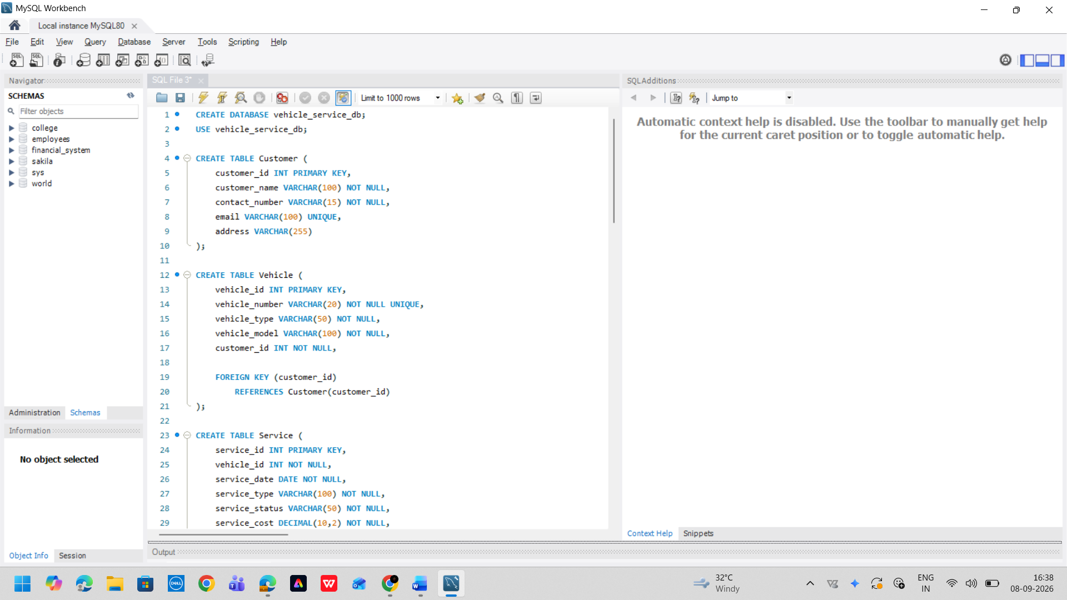

Database Creation

CREATE DATABASE ECOMMERCE_DBA (Oracle 21c PDB: XEPDB1);

Customer Table

CREATE TABLE Customer (
customer_id INT PRIMARY KEY,
customer_name VARCHAR(100) NOT NULL,
contact_number VARCHAR(15) NOT NULL,
email VARCHAR(100) UNIQUE,
address VARCHAR(255)
);

Vehicle Table

CREATE TABLE Vehicle (
order_id INT PRIMARY KEY,
product_sku VARCHAR(20) NOT NULL UNIQUE,
category_name VARCHAR(50) NOT NULL,
product_name VARCHAR(100) NOT NULL,
customer_id INT NOT NULL,

FOREIGN KEY (customer_id)
REFERENCES Customer(customer_id)
);

Service Table

CREATE TABLE Service (
order_item_id INT PRIMARY KEY,
order_id INT NOT NULL,
order_date DATE NOT NULL,
payment_method VARCHAR(100) NOT NULL,
order_status VARCHAR(50) NOT NULL,
service_cost DECIMAL(10,2) NOT NULL,

FOREIGN KEY (order_id)
REFERENCES Vehicle(order_id)
);

Constraints and Relationships
Explain the primary keys, foreign keys, and other constraints applied to the tables.

Table | Primary Key | Foreign Key | Other Constraints
CATEGORIES | category_id | parent_category_id -> CATEGORIES(category_id) | category_name NOT NULL UNIQUE, is_active CHECK (0, 1)
CUSTOMERS | customer_id | None | first_name NOT NULL, last_name NOT NULL, email NOT NULL UNIQUE, status CHECK (ACTIVE, SUSPENDED, INACTIVE)
PRODUCTS | product_id | category_id -> CATEGORIES(category_id) | sku NOT NULL UNIQUE, name NOT NULL, price CHECK (>= 0), stock_quantity CHECK (>= 0)
ORDERS | order_id | customer_id -> CUSTOMERS(customer_id) | order_date NOT NULL, total_amount CHECK (>= 0), status CHECK (PENDING, PROCESSING, SHIPPED, DELIVERED, CANCELLED)
ORDER_ITEMS | order_item_id | order_id -> ORDERS(order_id), product_id -> PRODUCTS(product_id) | quantity CHECK (> 0), unit_price CHECK (>= 0), subtotal CHECK (>= 0), ON DELETE CASCADE on order_id

Data Insertion
Provide the SQL queries used to insert sample records.

Customer Data

INSERT INTO Customer
(customer_id, customer_name, contact_number, email, address)
VALUES
(101, 'Arun Kumar', '9876543210', 'arun@gmail.com', 'Tiruppur'),
(102, 'Priya Devi', '9876543211', 'priya@gmail.com', 'Coimbatore'),
(103, 'Karthik Raj', '9876543212', 'karthik@gmail.com', 'Erode'),
(104, 'Ridhumiga J', '9876543213', 'ridhumiga@gmail.com', 'Tiruppur'),
(105, 'Sanjay Kumar', '9876543214', 'sanjay@gmail.com', 'Salem');

Vehicle Data

INSERT INTO Vehicle
(order_id, product_sku, category_name, product_name, customer_id)
VALUES
(501, 'PROD-LAP-001', 'Car', 'Apex Pro 16" Creator Laptop', 101),
(502, 'PROD-AUD-001', 'Bike', 'AcousticMax Wireless ANC Headphones', 101),
(503, 'PROD-IOT-001', 'Car', 'SmartHub Quantum Controller', 102),
(504, 'PROD-MON-001', 'SUV', 'UltraVision 4K Gaming Monitor', 103),
(505, 'PROD-KBD-001', 'Car', 'Keychron K2 Mechanical Keyboard', 104),
(506, 'PROD-MOU-001', 'Bike', 'Logitech MX Master 3S', 104),
(507, 'PROD-ACC-001', 'Car', 'Thunderbolt 4 Pro Dock', 105);

Service Data

INSERT INTO Service
(order_item_id, order_id, order_date, payment_method, order_status, service_cost)
VALUES
(1001, 501, '2026-08-01', 'Laptop Purchase (PROD-LAP-001)', 'Completed', 2500.00),
(1002, 501, '2026-08-20', 'ANC Headphones (PROD-AUD-001)', 'Completed', 4500.00),
(1003, 502, '2026-08-05', 'Smart Controller (PROD-IOT-001)', 'Completed', 1800.00),
(1004, 503, '2026-08-10', 'Laptop Purchase (PROD-LAP-001)', 'Completed', 2200.00),
(1005, 503, '2026-08-25', 'UltraVision 4K Monitor', 'Pending', 3500.00),
(1006, 504, '2026-08-12', 'DBA Mechanical Keyboard', 'Completed', 7500.00),
(1007, 505, '2026-08-15', 'Smart Controller (PROD-IOT-001)', 'Completed', 3000.00),
(1008, 505, '2026-08-28', 'Wireless Ergonomic Mouse', 'Pending', 9000.00),
(1009, 506, '2026-08-18', 'Laptop Purchase (PROD-LAP-001)', 'Completed', 2000.00),
(1010, 507, '2026-08-22', 'ANC Headphones (PROD-AUD-001)', 'In Progress', 5000.00),
(1011, 504, '2026-08-30', 'UltraVision 4K Monitor', 'Completed', 4200.00),
(1012, 507, '2026-09-05', 'Smart Controller (PROD-IOT-001)', 'Pending', 2800.00);

SQL Operations
Provide the important SQL queries implemented in the database.

INSERT

The INSERT statement is used to add new records to a table.

INSERT INTO Customer
(customer_id, customer_name, contact_number, email, address)
VALUES
(106, 'Meena Priya', '9876543215', 'meena@gmail.com', 'Chennai');

SELECT

The SELECT statement is used to retrieve records from a table.

SELECT *
FROM Customer;

UPDATE

The UPDATE statement is used to modify existing records.

UPDATE Customer
SET address = 'Coimbatore'
WHERE customer_id = 106;

DELETE

The DELETE statement is used to remove a selected record.

DELETE FROM Customer
WHERE customer_id = 106;

WHERE

The WHERE clause is used to filter records based on a specified condition.

SELECT *
FROM Service
WHERE order_status = 'Pending';

This retrieves only order transactions and itemized line items whose status is Pending.

ORDER BY

The ORDER BY clause is used to sort records based on a specified column.

SELECT *
FROM Service
ORDER BY service_cost DESC;

This displays order transactions and itemized line items from highest order total amount to lowest order total amount.

LIKE

The LIKE operator is used to search for records using a partial value.

SELECT *
FROM Vehicle
WHERE product_sku LIKE 'TN38%';

This searches for vehicle numbers that start with TN38.

BETWEEN

The BETWEEN operator is used to retrieve records within a specified range.

SELECT *
FROM Service
WHERE service_cost BETWEEN 2000 AND 5000;

This retrieves services whose cost is between ₹2,000 and ₹5,000.

Aggregate Functions

Aggregate functions are used to perform calculations on multiple records. The following functions were demonstrated: COUNT(), SUM(), AVG(), MAX(), and MIN().

COUNT()

Counts the total number of order transactions and itemized line items.

SELECT COUNT(*) AS total_services
FROM Service;

SUM()

Calculates the total order total amount.

SELECT SUM(service_cost) AS total_service_cost
FROM Service;

AVG()

Calculates the average order total amount.

SELECT AVG(service_cost) AS average_service_cost
FROM Service;

MAX()

Finds the highest order total amount.

SELECT MAX(service_cost) AS highest_service_cost
FROM Service;

MIN()

Finds the lowest order total amount.

SELECT MIN(service_cost) AS lowest_service_cost
FROM Service;

GROUP BY

he GROUP BY clause is used to group order transactions and itemized line items based on a common value. In this project, order transactions and itemized line items are grouped according to service status.

SELECT order_status, COUNT(*) AS total_services
FROM Service
GROUP BY order_status;

This displays the number of order transactions and itemized line items for each status, such as:

Completed
Pending
In Progress

INNER JOIN

The INNER JOIN operation is used to retrieve related information from multiple tables. In this project, Categories, Customers, Products, Orders, and Order Items are joined using their primary-key and foreign-key relationships.

SELECT
c.customer_name,
v.product_sku,
v.product_name,
s.order_date,
s.payment_method,
s.order_status,
s.service_cost
FROM Customer c
INNER JOIN Vehicle v
ON c.customer_id = v.customer_id
INNER JOIN Service s
ON v.order_id = s.order_id;

Project Execution
Briefly explain how the database was created and how the SQL queries were executed using Oracle SQL*Plus & Enterprise DBA Console.

Output Screenshots – 10 Marks
Include screenshots showing the database creation, table structure, executed queries, and query results.

Screenshot 1 – Database and Tables

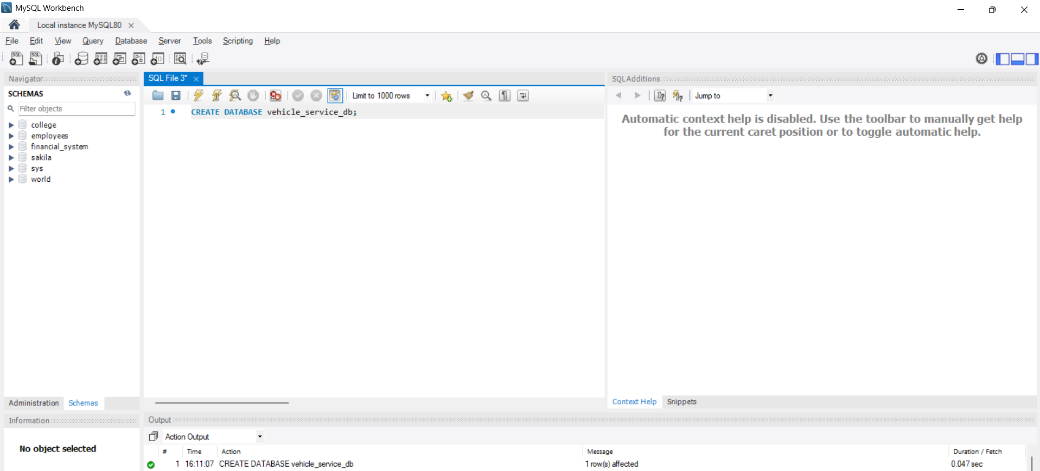

Screenshot 2 – Customer Table with Records

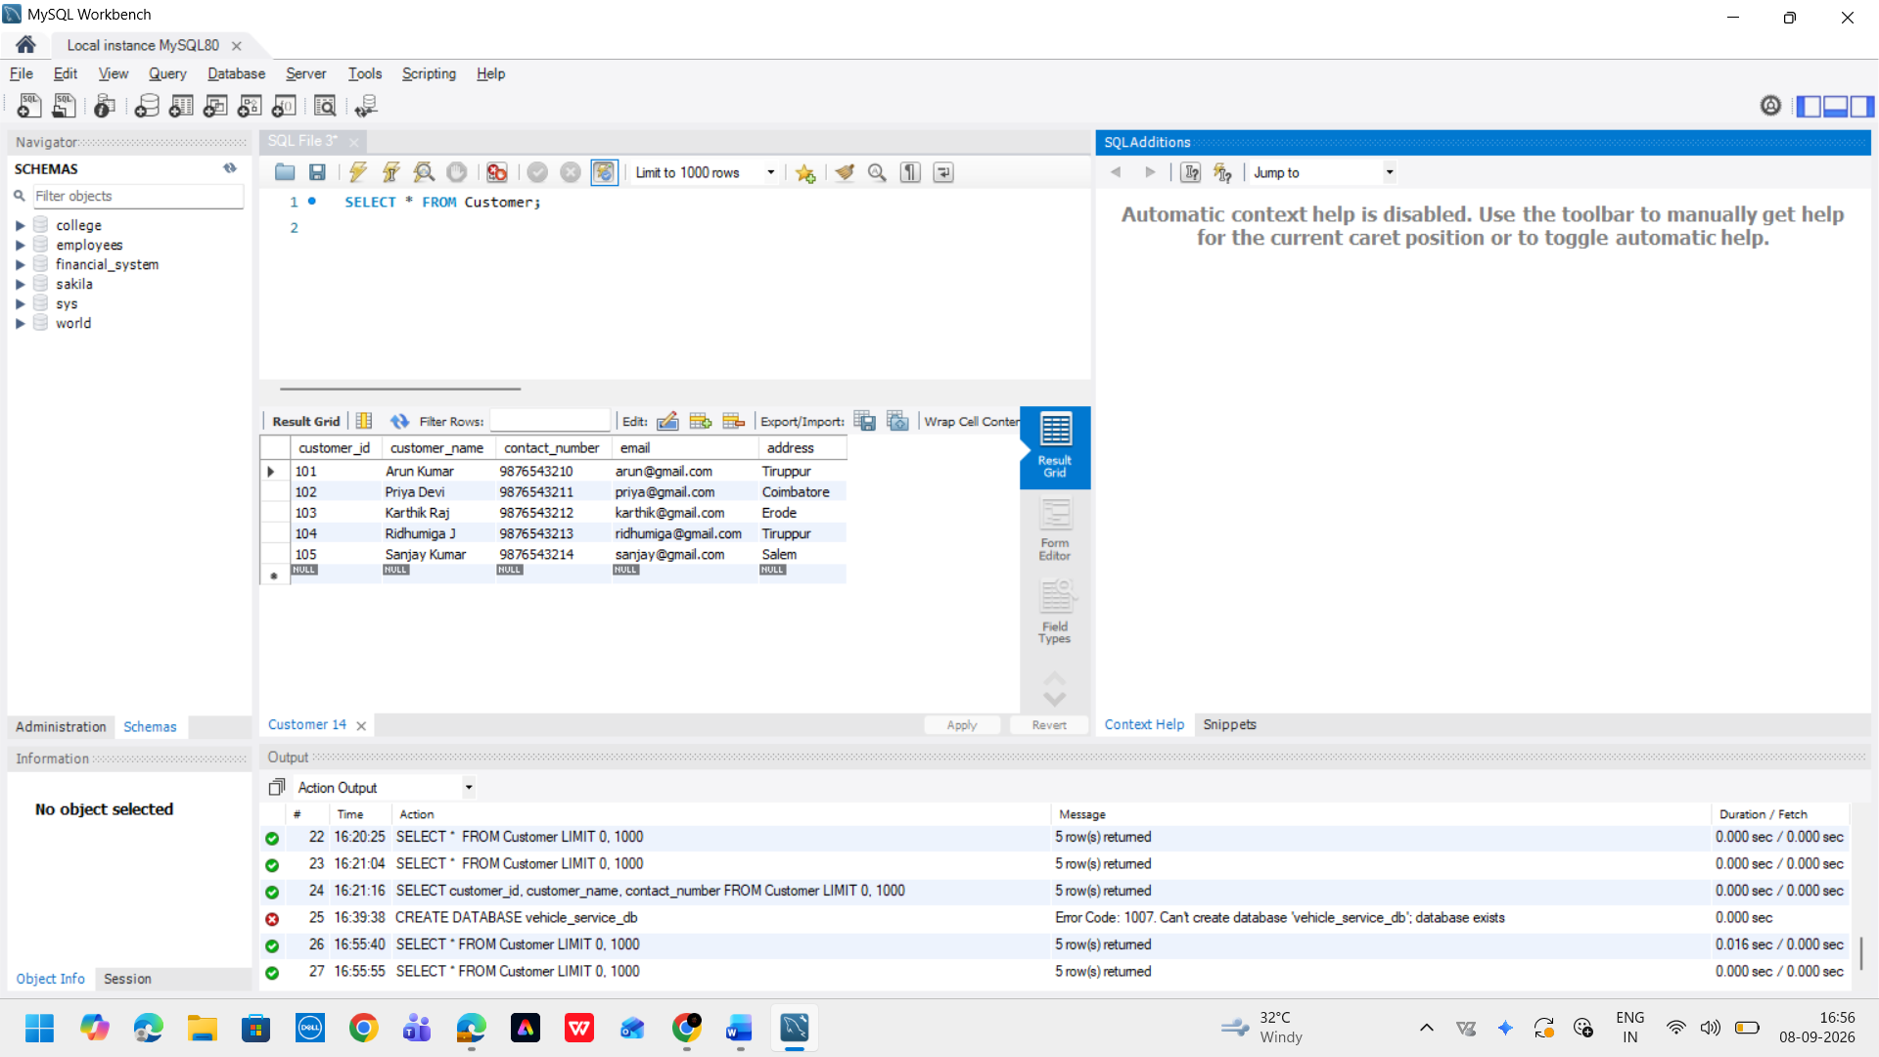

Screenshot 3 – Vehicle Table with Records

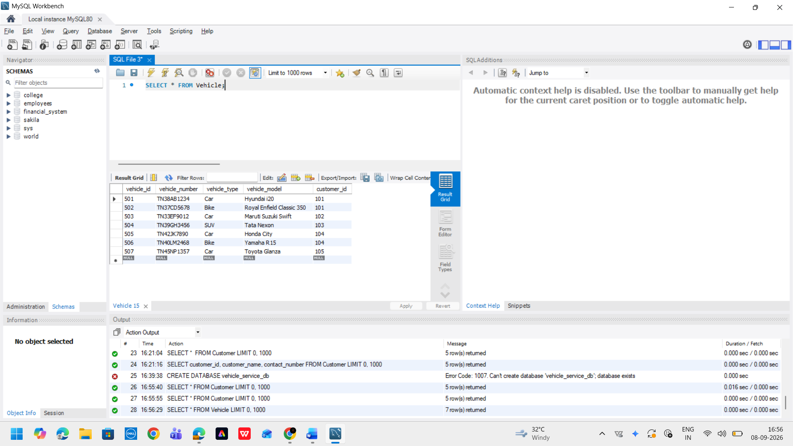

Screenshot 4 – Service Table with Records

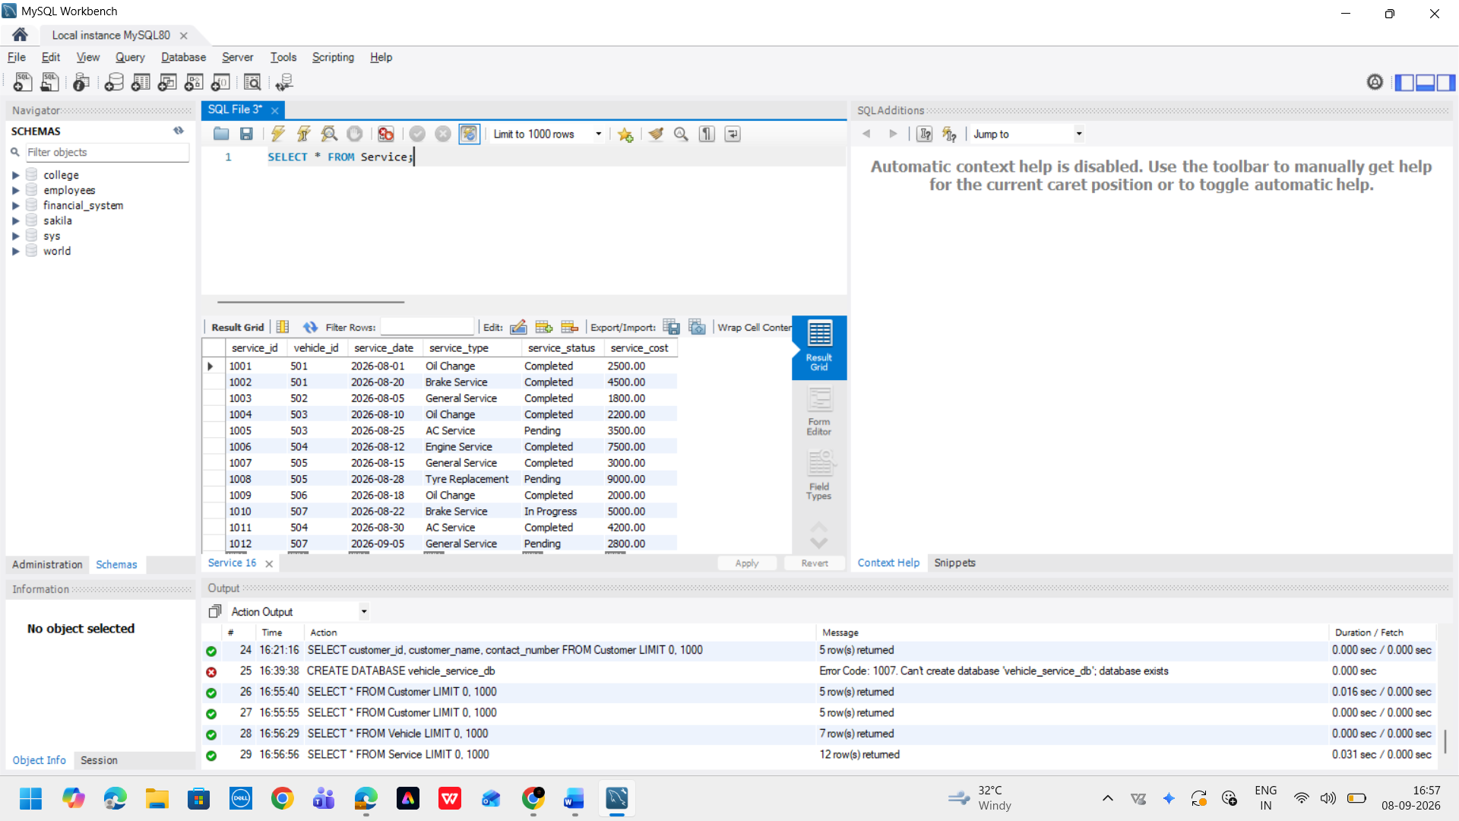

Screenshot 5 – INSERT / UPDATE / DELETE Operations

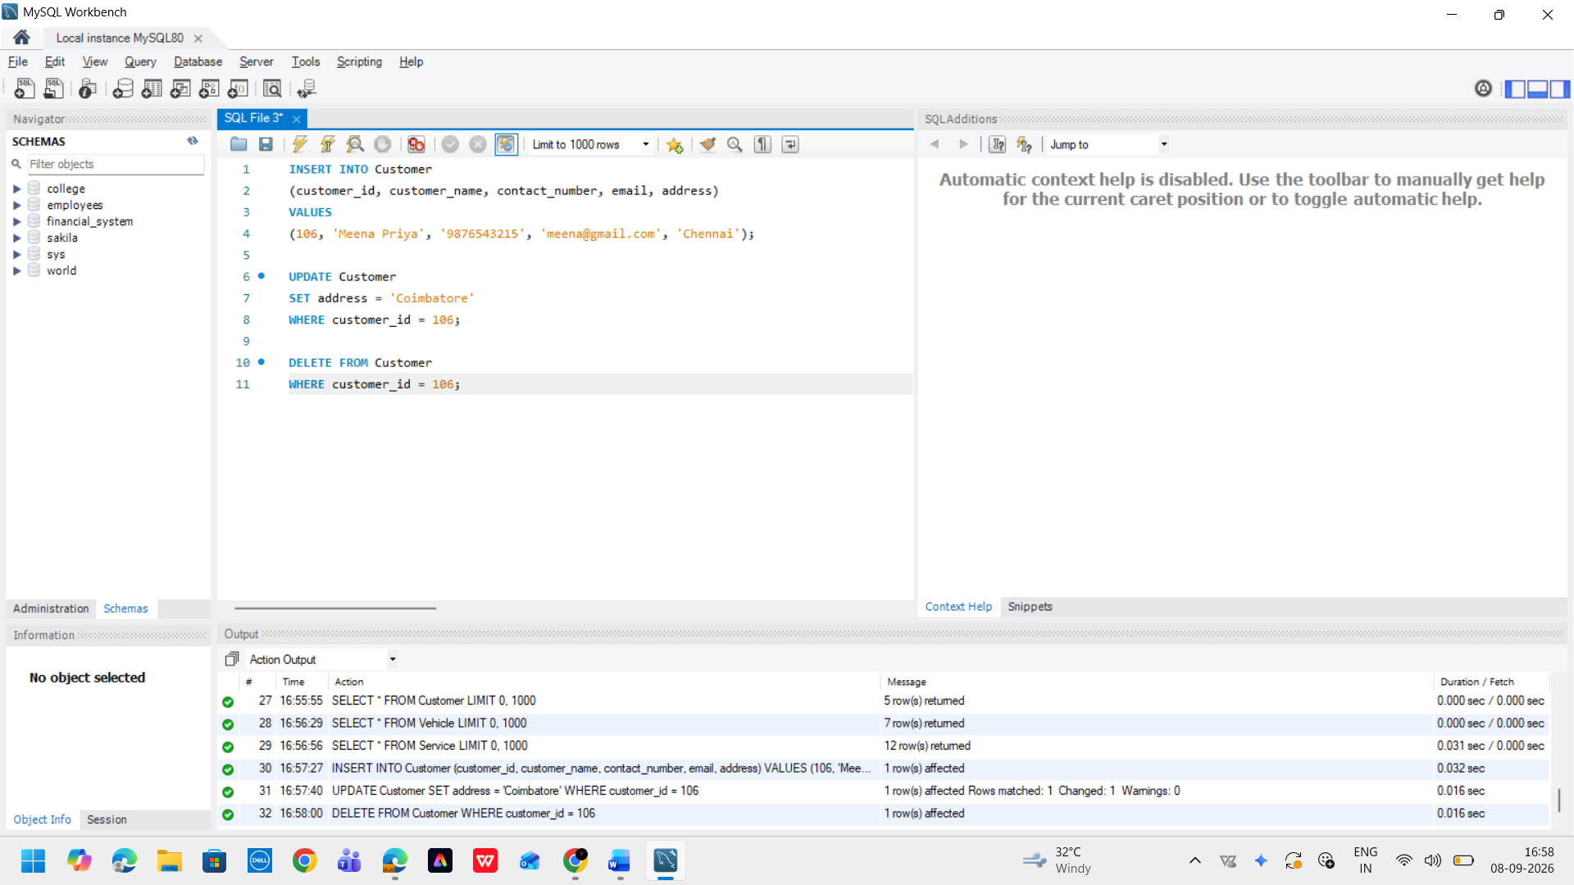

Screenshot 6 – SELECT and Filtering Operations

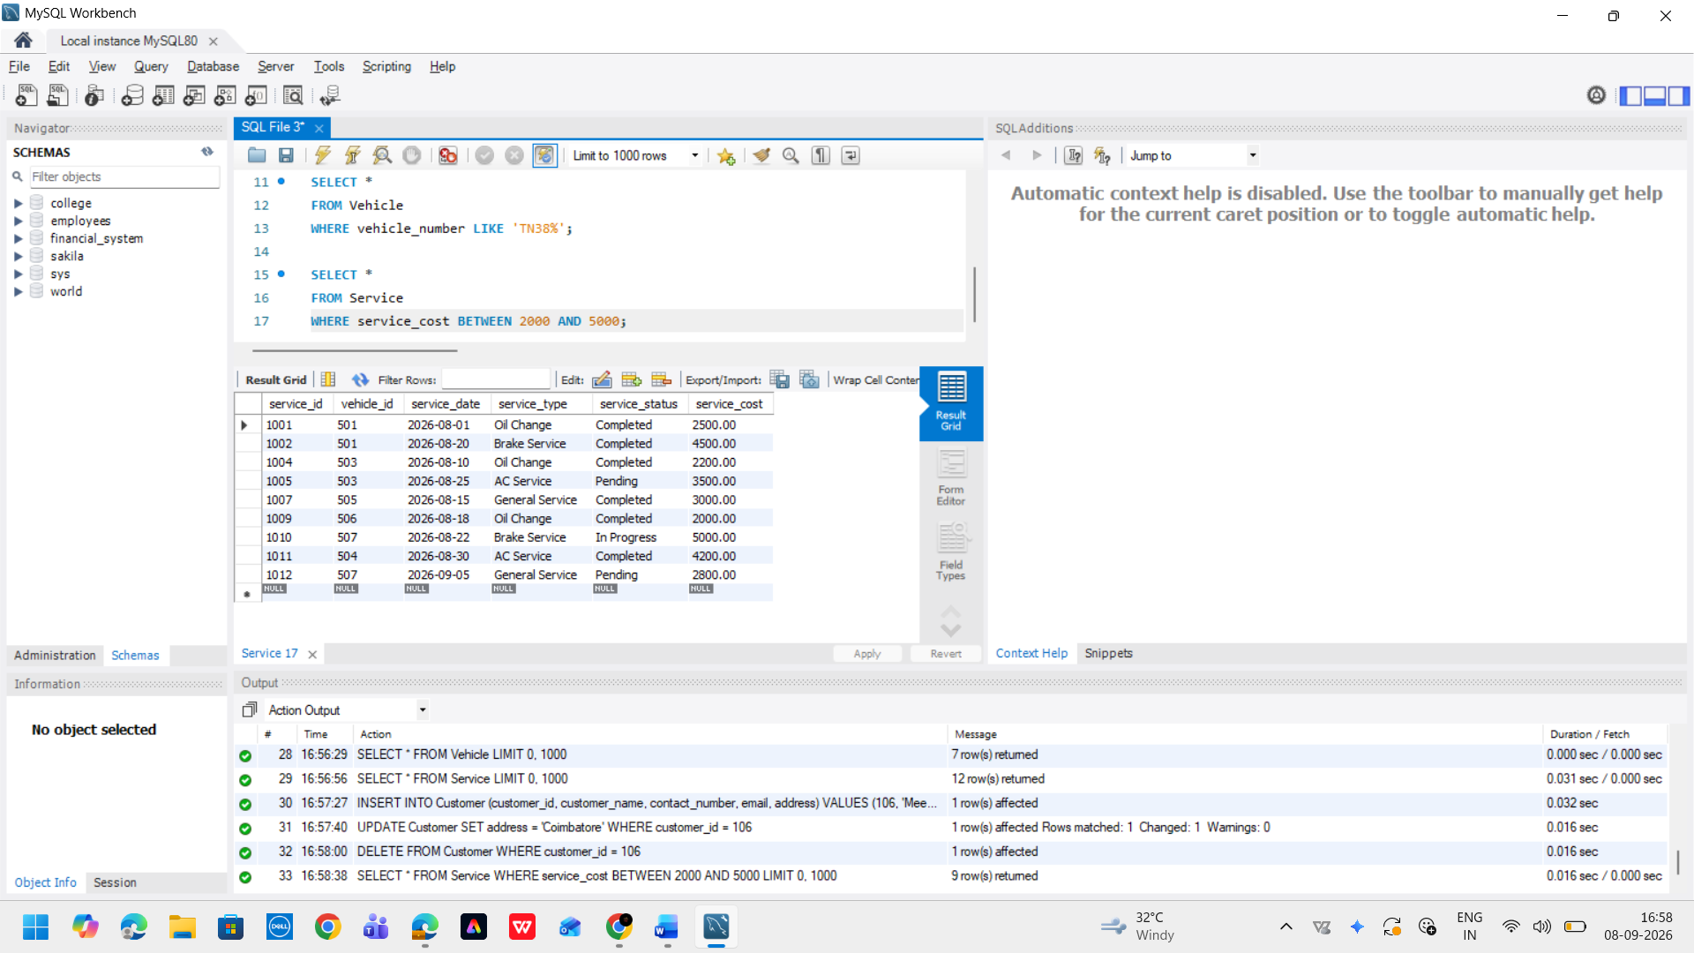

Screenshot 7 – Aggregate Functions

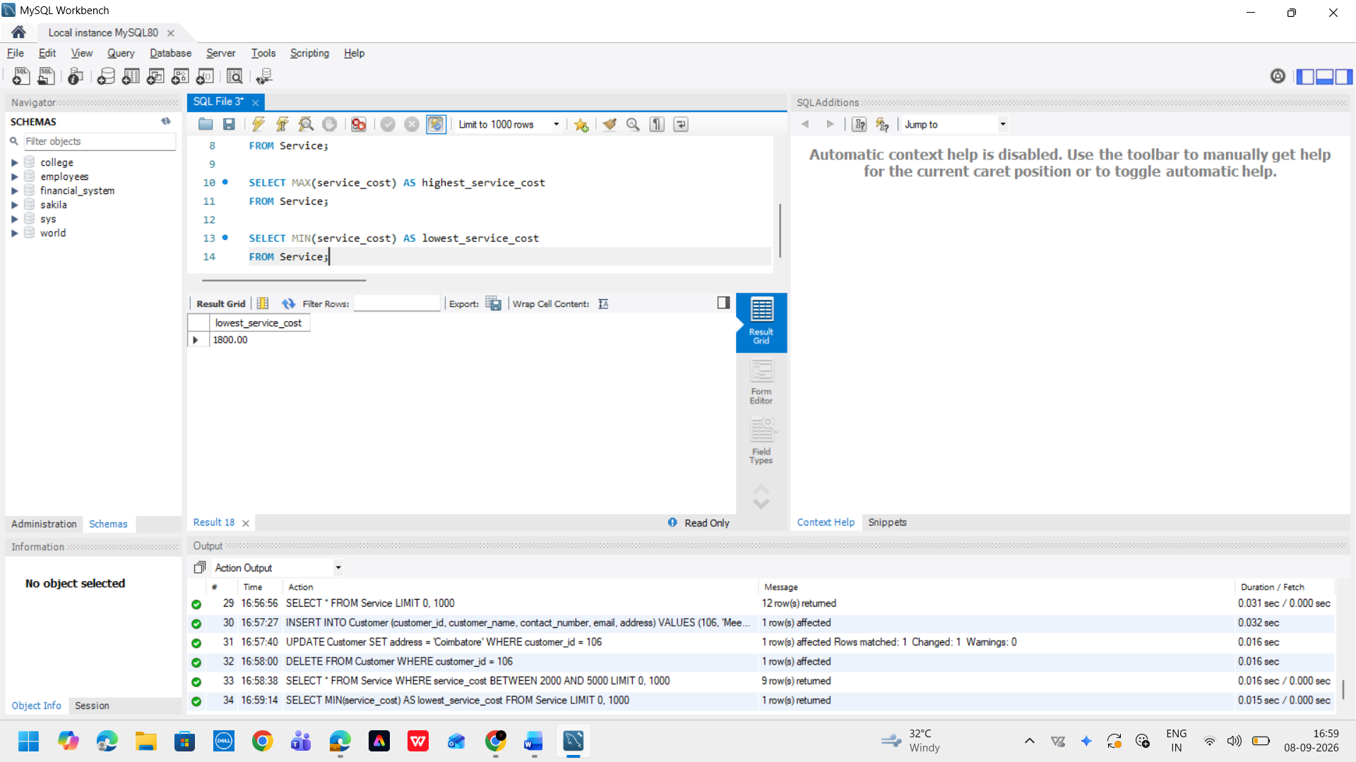

Screenshot 8 – GROUP BY Operation

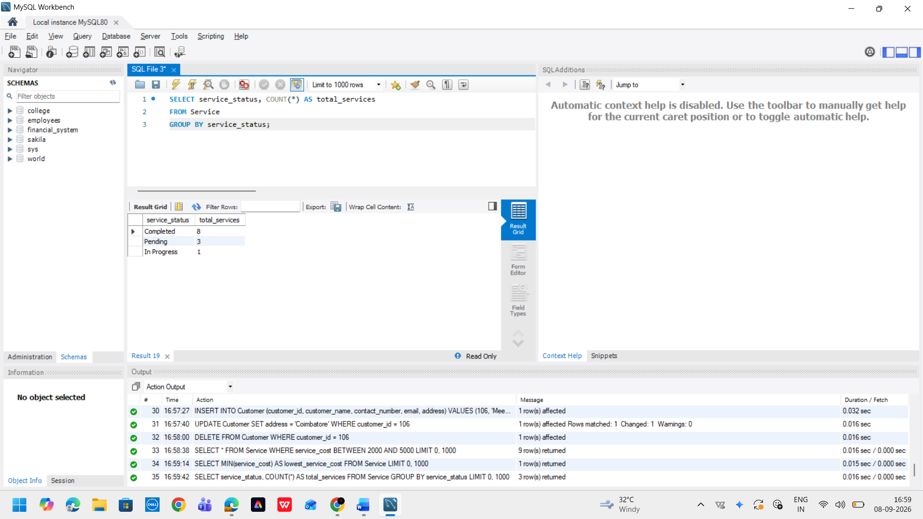

Screenshot 9 – INNER JOIN Operation

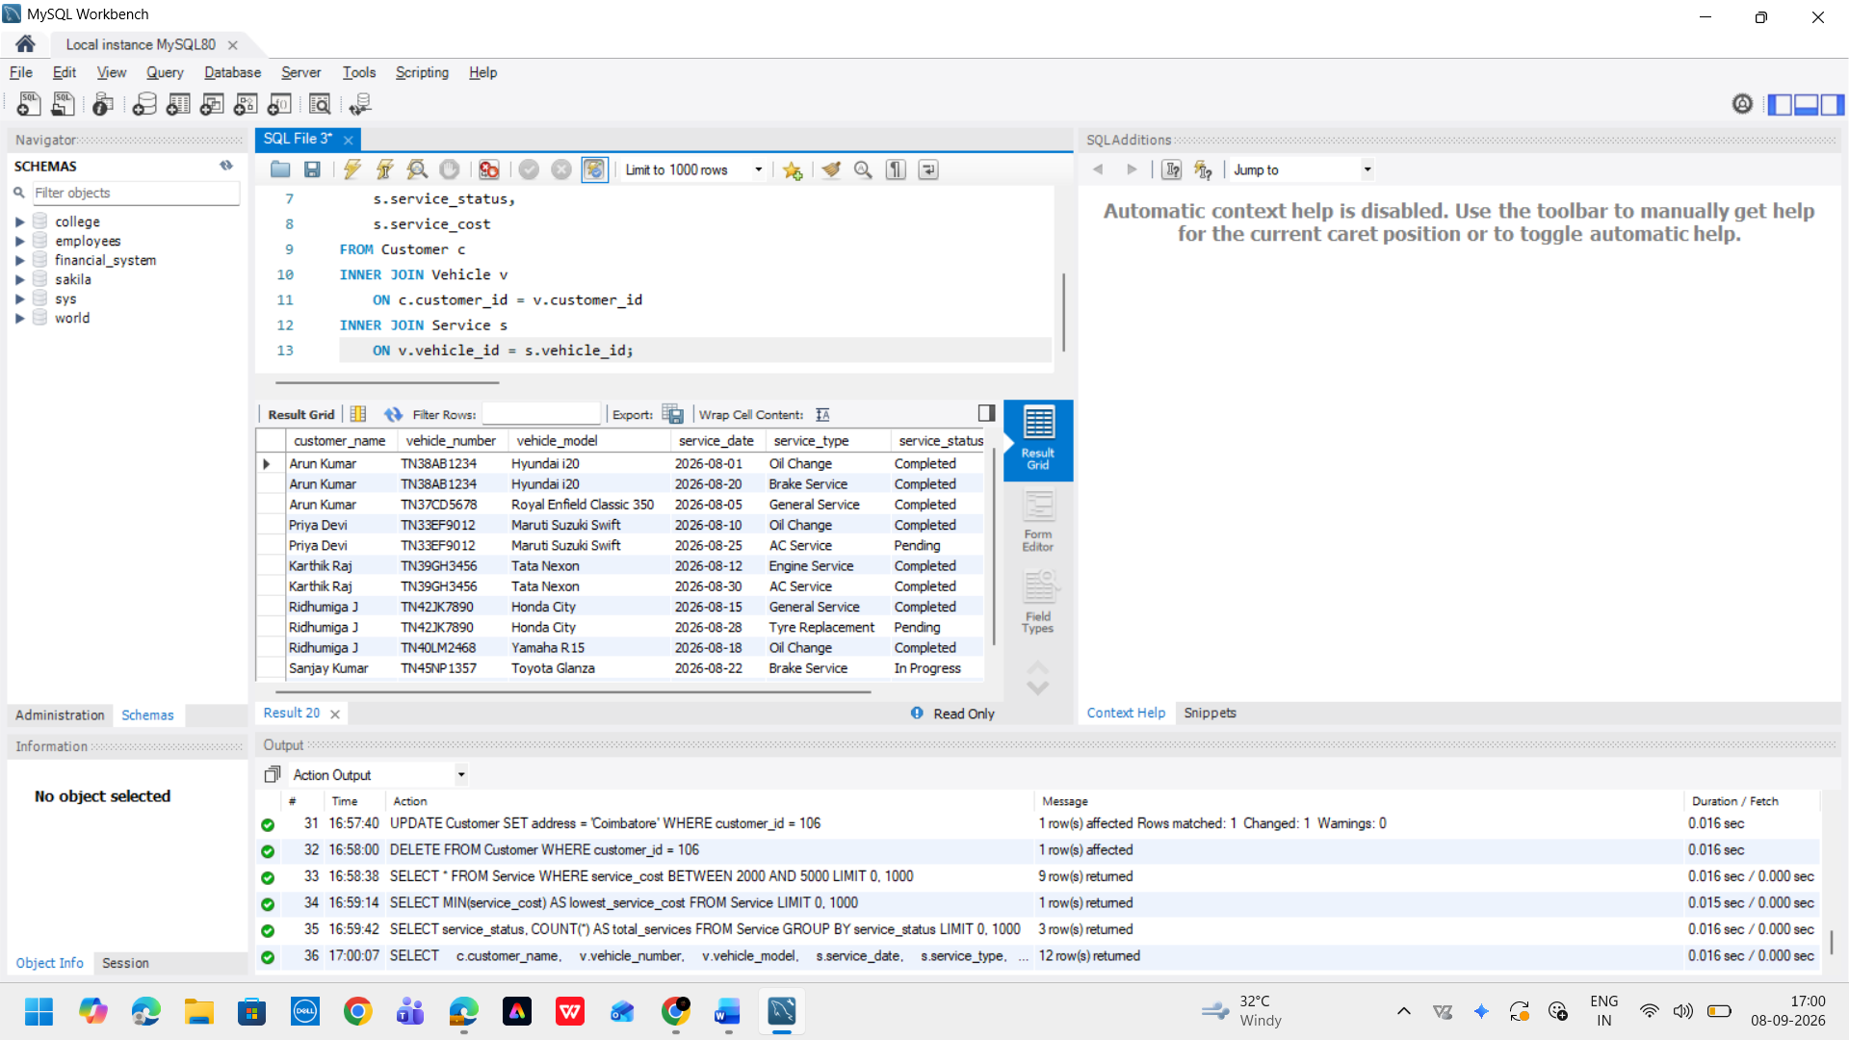

Screenshot 10 – Final Database / Query Results

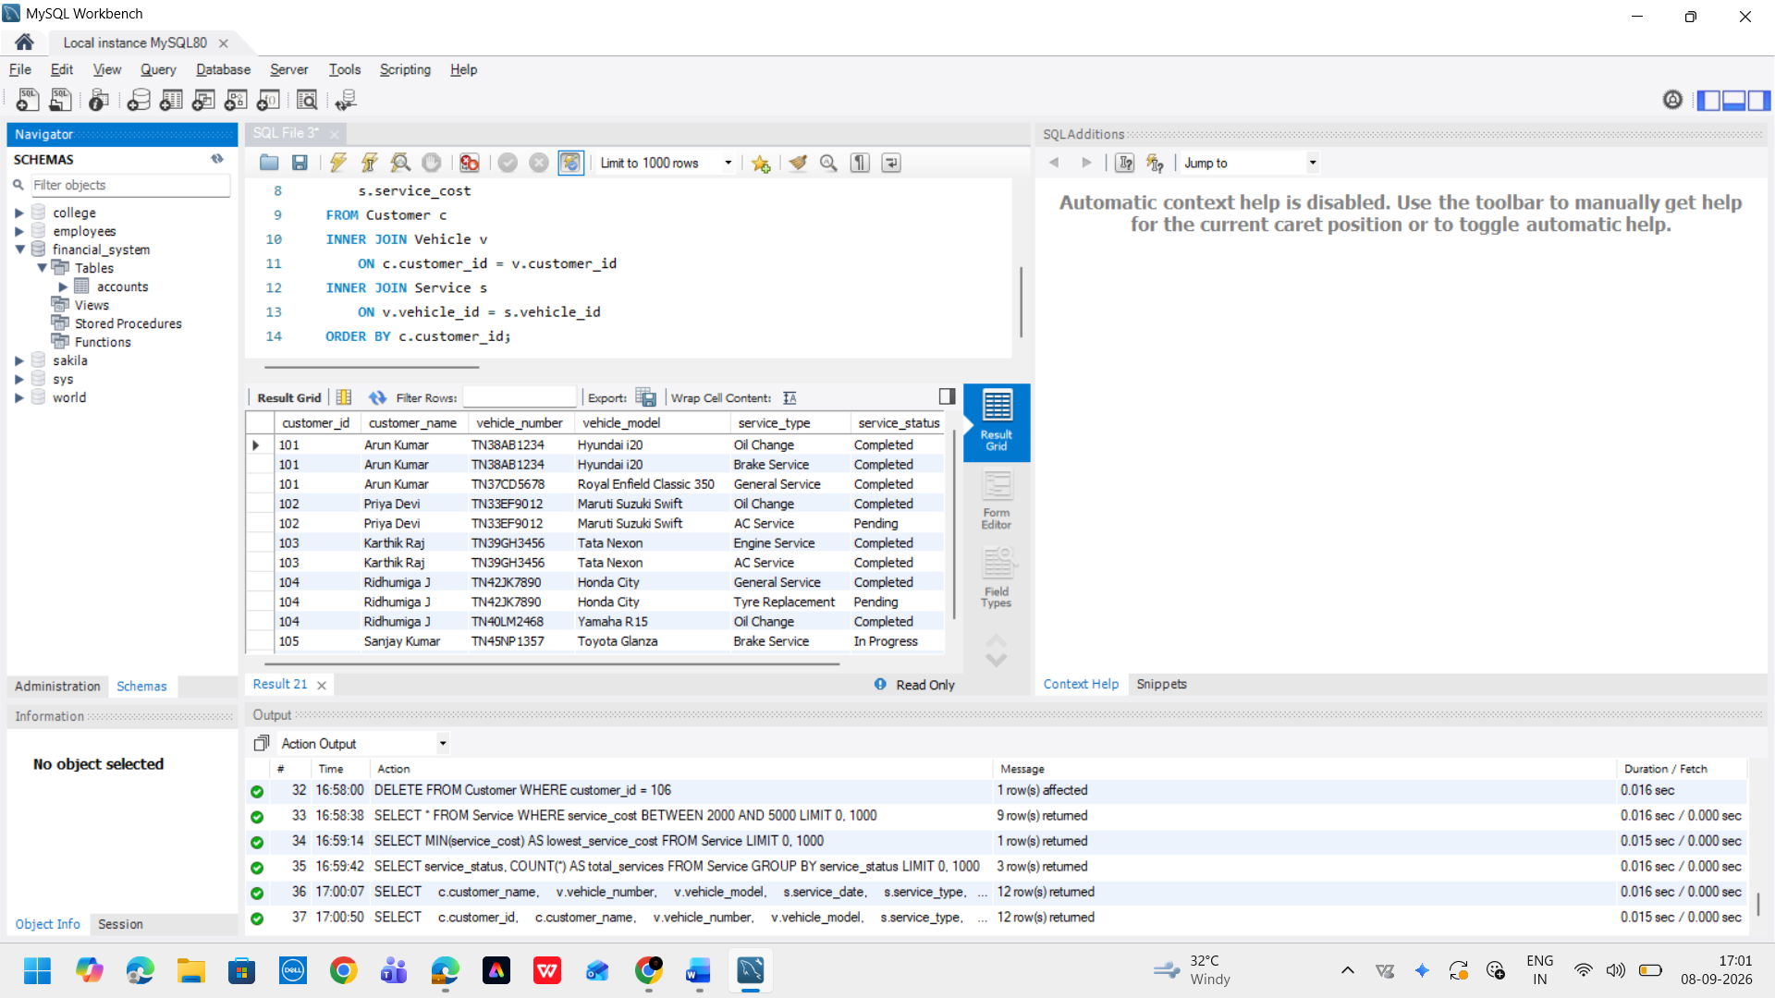

Technical Explanation – 5 Marks
Explain the following:

Database Design

The Online Shopping Database (E-Commerce Management System) is designed using three separate relational tables: Categories, Customers, Products, Orders, and Order Items.
The Customer table stores customer details such as customer ID, name, contact number, email, and address. The Vehicle table stores product specifications, SKUs, and stock quantities and the customer associated with each vehicle. The Service table stores the customer order history of each vehicle, including service date, service type, service status, and order total amount.
The tables were separated to avoid unnecessary duplication of data and to maintain a clear relationship between customers, their vehicles, and their order transactions and itemized line items.

Keys and Constraints

Primary Key:
A primary key uniquely identifies each record in a table. customer_id, order_id, and order_item_id were defined as primary keys in their respective tables.

Foreign Key:
Foreign keys establish relationships between tables. customer_id in the Vehicle table references Customer(customer_id), while order_id in the Service table references Vehicle(order_id).

NOT NULL:
The NOT NULL constraint ensures that important fields cannot contain empty values.

UNIQUE:
The UNIQUE constraint prevents duplicate values. It was applied to customer email addresses and vehicle numbers.

These constraints help maintain data integrity in the database.

SQL Operations

The database uses the four basic CRUD operations:

INSERT – Adds new records to the database.
SELECT – Retrieves records from the tables.
UPDATE – Modifies existing records.
DELETE – Removes selected records.

For example, INSERT was used to add customer, vehicle, and order transactions and itemized line items, while UPDATE and DELETE were used to demonstrate modification and removal of records.

Data Retrieval

Different SQL clauses were used to retrieve specific information from the database:
- WHERE – Filters records based on a condition.
- ORDER BY – Sorts records based on values such as service date or cost.
- LIKE – Searches for records using partial values, such as a vehicle number.
- BETWEEN – Retrieves records within a specified cost or date range.
- GROUP BY – Groups records based on a common value such as service type or service status.
These operations make it easier to search, organize, and analyze service-center data.

Aggregate Functions and Joins

Aggregate functions were used to perform calculations on order transactions and itemized line items:

COUNT() – Counts the number of records.
SUM() – Calculates the total order total amount.
AVG() – Calculates the average order total amount.
MAX() – Finds the highest order total amount.
MIN() – Finds the lowest order total amount.

The INNER JOIN operation was used to combine related information from the Categories, Customers, Products, Orders, and Order Items tables. It allows customer details, product specifications, SKUs, and stock quantities, and service information to be displayed together using their primary-key and foreign-key relationships.

Conclusion – 5 Marks Conclusion
The Online Shopping Database (E-Commerce Management System) was successfully designed and implemented using Oracle Database 21c and Oracle SQL*Plus & Enterprise DBA Console. The database consists of three related tables: Categories, Customers, Products, Orders, and Order Items, with appropriate primary keys, foreign keys, and data-integrity constraints.

Sample records were inserted into the database, and various SQL operations were performed, including INSERT, SELECT, UPDATE, DELETE, WHERE, ORDER BY, LIKE, BETWEEN, aggregate functions, GROUP BY, and INNER JOIN. These operations demonstrated how relational databases can be used to manage, retrieve, and analyze real-world online shopping information.

Through this project, practical knowledge of relational database design, table relationships, keys, constraints, SQL data manipulation, data retrieval, aggregation, grouping, and joins was gained.

Future Enhancements
Different SQL clauses were used to retrieve specific information from the database:
WHERE – Filters records based on a condition.
ORDER BY – Sorts records based on values such as service date or cost.
LIKE – Searches for records using partial values, such as a vehicle number.
BETWEEN – Retrieves records within a specified cost or date range.
GROUP BY – Groups records based on a common value such as service type or service status.
These operations make it easier to search, organize, and analyze service-center data.

- Online service appointment booking.
- Automated service reminders.
- Service history reports.
- Invoice generation.
- Mechanic assignment and management.
- Integration with a web or mobile application.
- Automated database backup and recovery.

