## **Light Dependent Resistor**

An electronic component like LDR or light-dependent resistor is responsive to light. Once light rays drop on it, then immediately the resistance will be changed. The resistance values of an LDR may change over several orders of magnitude. The resistance value will be dropped when the light level increases.

The resistance values of LDR in darkness are several megaohms whereas in bright light it will be dropped to hundred ohms. So due to this change in resistance, these resistors are extremely used in different applications. The LDR sensitivity also changes through the incident light’s wavelength.

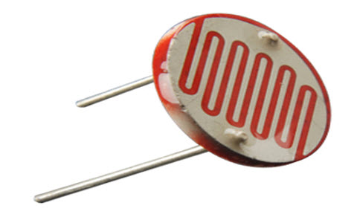

The designing of LDRs can be done by using semiconductor materials to allow their light-sensitive properties. The famous material used in this resistor is CdS (cadmium sulfide), even though the utilization of this material is currently restricted in European countries due to some environmental issues while using this material. Likewise, CdSe (cadmium selenide) is also restricted and additional materials that can be employed mainly include PbS (lead sulfide), InS ( indium antimonide).

Even though for these resistors, a semiconductor material is used, because they are simply passive devices and they do not have a PN-junction. This detaches them from other LDRs such as phototransistors & photodiodes.

### **LDR Symbol**

In electronic circuits, the LDR symbol is used that mainly depends on the resistor symbol; however, it illustrates the light rays in the arrows form. In this way, it follows the same principle which is used for phototransistor & photodiode circuit symbols wherever arrows are utilized to demonstrate the light dropping on these types of components. The LDR circuit symbols are shown below.

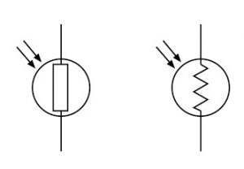

### **Construction of an LDR**

The construction of an LDR includes a light-sensitive material that is placed on an insulating substrate like ceramic. The material is placed in a zigzag shape in order to get the required power rating and resistance. The area of zigzag separates the metal-placed areas into two regions.

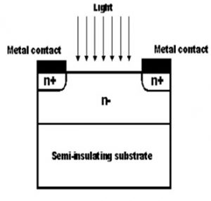

Where the Ohmic contacts are made either on the sides of the area. The resistances of the contacts must be as less as possible to make sure that the resistance, mainly varies due to the light effect only. The use of lead & cadmium materials is avoided as they are injurious to the environment.

### **Working Principle of Light Dependent Resistor**

The working principle of an LDR is photoconductivity, which is nothing but an optical phenomenon. When the light is absorbed by the material then the conductivity of the material enhances. When the light falls on the LDR, then the electrons in the valence band of the material are eager to the conduction band. But, the photons in the incident light must have energy superior to the bandgap of the material to make the electrons jump from one band to another band (valance to conduction).

Hence, when light having ample energy, more electrons are excited to the conduction band which grades in a large number of charge carriers. When the effect of this process and the flow of the current starts flowing more, the resistance of the device decreases.

### **Light Dependent Resistor Specifications**

The LDR specifications mainly include maximum power dissipation, maximum operating voltage, peak wavelength, dark resistance, etc. The values of these specifications mentioned below.

* Maximum power dissipation is 200mW
* The maximum voltage at 0 lux is 200V
* The peak wavelength is 600nm
* Minimum resistance at 10lux is 1.8kΩ
* Maximum .resistance at 10lux is 4.5kΩ
* Typical resistance at100lux is 0.7kΩ
* Dark resistance after 1 sec is 0.03MΩ
* Dark resistance after 5 sec is 0.25MΩ

### **Characteristics of LDR**

The light-dependent resistor is very responsive to light. When the light is stronger, then the resistance is lower which means, when the light intensity increases then the value of resistance for the LDR will be decreased drastically to below 1K.

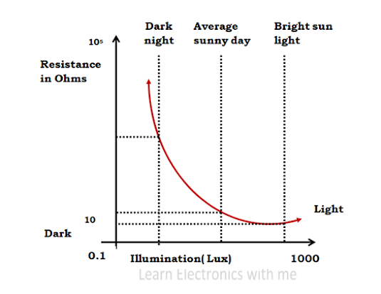

When the light drops on LDR, the resistance will be decreased and when the resistor is placed in the dark then the resistance will be increased which is called dark resistance. If any device absorbs light then its resistance will be reduced radically. If a stable voltage is given to it, the light intensity will be increased & the flow of current starts increasing. So, the following diagram represents the characteristics between resistance & illumination for a specific LDR.

LDRs are not linear devices and their sensitivity changes through the light’s wavelength which drops on them. Some kinds of photocells are not at all sensitive to a specific range of wavelengths because it depends on the used material.

Once light rays fall on a photocell, the resistance will be changed in 8 ms to 12, while it uses few more seconds to rise the resistance back again to its early value once the light is removed. So this is known as a recovery rate of resistance. In audio compressors, this property is applicable.

In addition, these resistors are low responsive to phototransistors & photodiodes. A photo-diode is a PN-junction semiconductor device, used to change the light to electricity, while a photocell is a passive device and it doesn’t include a PN junction but is used to convert light to electricity but it is not.

### **LDR Advantages**

* Sensitivity is High
* Simple & Small devices
* Easily used
* Inexpensive
* There is no union potential.
* The light-dark resistance ratio is high.
* Its connection is simple