## Light Emitting Diode

The lighting emitting diode is a [p-n junction diode](https://www.elprocus.com/p-n-junction-diode-theory-and-working/). It is a specially doped diode and made up of a special type of semiconductors. When the light emits in the forward biased, then it is called a light-emitting diode.

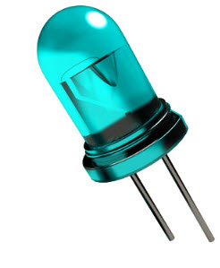

**LED Symbol**

The LED symbol is similar to a diode symbol except for two small arrows that specify the emission of light, thus it is called LED (light-emitting diode). The LED includes two terminals namely anode (+) and the cathode (-). The LED symbol is shown below.

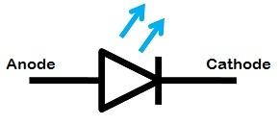

### **Construction of LED**

The construction of LED is very simple because it is designed through the deposition of three semiconductor material layers over a substrate. These three layers are arranged one by one where the top region is a P-type region, the middle region is active and finally, the bottom region is N-type. The three regions of semiconductor material can be observed in the construction. In the construction, the P-type region includes the holes; the N-type region includes elections whereas the active region includes both holes and electrons.

When the voltage is not applied to the LED, then there is no flow of electrons and holes so they are stable. Once the voltage is applied then the LED will forward biased, so the electrons in the N-region and holes from P-region will move to the active region. This region is also known as the depletion region. Because the charge carriers like holes include a positive charge whereas electrons have a negative charge so the light can be generated through the recombination of polarity charges.

### **How does the LED Work?**

The light-emitting diode simply, we know as a diode. When the diode is forward biased, then the electrons & holes are moving fast across the junction and they are combined constantly, removing one another out. Soon after the electrons are moving from the n-type to the p-type silicon, it combines with the holes, then it disappears. Hence it makes the complete atom & more stable and it gives the little burst of energy in the form of a tiny packet or photon of light.

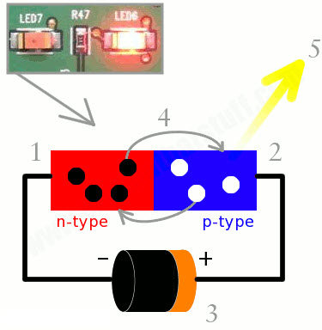

The above diagram shows how the light-emitting diode works and the step by step process of the diagram.

* From the above diagram, we can observe that the N-type silicon is in red color including the electrons which are indicated by the black circles.
* The P-type silicon is in the blue color and it contains holes, they are indicated by the white circles.
* The power supply across the p-n junction makes the diode forward biased and pushing the electrons from n-type to p-type. Pushing the holes in the opposite direction.
* Electron and holes at the junction are combined.
* The photons are given off as the electrons and holes are recombined.

### **Working Principle of LED**

The working principle of the Light-emitting diode is based on the quantum theory. The quantum theory says that when the electron comes down from the higher energy level to the lower energy level then, the energy emits from the photon. The photon energy is equal to the energy gap between these two energy levels. If the PN-junction diode is in the forward biased, then the current flows through the diode.

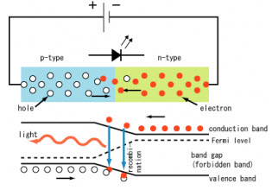

The flow of current in the semiconductors is caused by the flow of holes in the opposite direction of current and the flow of electrons in the direction of the current. Hence there will be recombination due to the flow of these charge carriers.

The recombination indicates that the electrons in the conduction band jump down to the valence band. When the electrons jump from one band to another band the electrons will emit the electromagnetic energy in the form of photons and the photon energy is equal to the forbidden energy gap.

For example, let us consider the quantum theory, the energy of the photon is the product of both the Planck constant and frequency of electromagnetic radiation. The mathematical equation is shown

**Eq = hf**

Where his known as a Planck constant, and the velocity of electromagnetic radiation is equal to the speed of light i.e c. The frequency radiation is related to the velocity of light as an f= c / λ. λ is denoted as a wavelength of electromagnetic radiation and the above equation will become as a

**Eq = he / λ**

From the above equation, we can say that the wavelength of electromagnetic radiation is inversely proportional to the forbidden gap. In general silicon, germanium semiconductors this forbidden energy gap is between the condition and valence bands are such that the total radiation of electromagnetic wave during recombination is in the form of infrared radiation. We can’t see the wavelength of infrared because they are out of our visible range.

The infrared radiation is said to be as heat because the silicon and the germanium semiconductors are not direct gap semiconductors rather these are indirect gap semiconductors. But in the direct gap semiconductors, the maximum energy level of the valence band and minimum energy level of the conduction band does not occur at the same moment of electrons. Therefore, during the recombination of electrons and holes are migration of electrons from the conduction band to the valence band the momentum of the electron band will be changed.

#### **I-V Characteristics of LED**

There are different types of light-emitting diodes are available in the market and there are different LED characteristics which include the color light, or wavelength radiation, light intensity. The important characteristic of the LED is color. In the starting use of LED, there is the only red color. As the use of LED is increased with the help of the semiconductor process and doing the research on the new metals for LED, the different colors were formed.

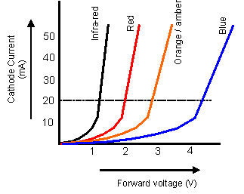

The following graph shows the approximate curves between the forward voltage and the current. Each curve in the graph indicates a different color. The table shows a summary of the LED characteristics.

### **Advantages of LED’s**

* The cost of LED’s is less and they are tiny.
* By using the LED’s electricity is controlled.
* The intensity of the LED differs with the help of the microcontroller.
* Long Lifetime
* Energy efficient
* No warm-up period
* Rugged
* Doesn’t affect by cold temperatures
* Directional
* Colour Rendering is Excellent
* Environmentally friendly
* Controllable