

Rajarata University of Sri Lanka
Department of Computing

ICT/ CS Group Project – ICT3411 / COM3405
Application for EC05

SECTION 01
Team Name: | TATAVISION
Project Title: | AI GUIDED DRAWING AND COLORING ASSISTANT
Link to GitHub Profile: | https://github.com/ridhurshan/tata-vision
Date: | 03.09.2026

SECTION 02

2.0 Overview of Our Research Design
In our project, we aim to provide beginners with progressive guidance for drawing and coloring a reference image. Instead of directly producing only a final image, we divide the drawing process into several understandable stages so that users can observe how the image develops from basic structure to a completed artistic output.
Our current main processing pipeline consists of four AI models:
- Segment Anything Model (SAM ViT-H) – Geometric Shape Extraction
- AnimeGANv2 Hayao – Curve Extraction
- Depth Anything V2 Small – Pencil Shading
- AnimeGANv2 Paprika – Realistic Painted Coloring
In addition to these four main models, we include a separate Automatic Grayscale Image Colorization Model as an input preprocessing component. We use this component only when a user uploads a grayscale reference image.
We also use supporting image-processing techniques such as K-Means color clustering, Lab and HSV color processing, Canny edge detection, progressive color-region generation, pencil hatching, and OpenCV filtering and compositing.
Therefore, our overall workflow is:
User Upload → Grayscale Detection → Automatic Colorization if Required → SAM Geometric Extraction → AnimeGANv2 Hayao Curve Extraction → Depth Anything V2 Shading → AnimeGANv2 Paprika Coloring → Final Output
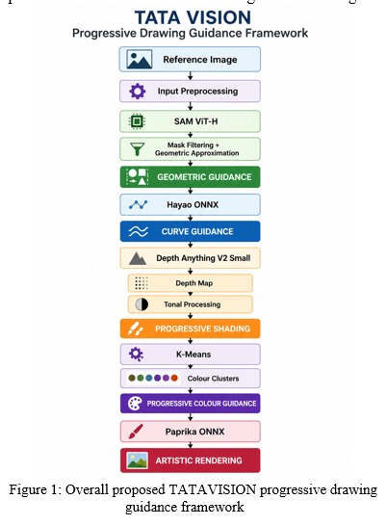
Figure 1: Overall processing workflow implemented in our project

INPUT PREPROCESSING COMPONENT – AUTOMATIC GRAYSCALE IMAGE COLORIZATION

2.1 Automatic Image Colorization

2.1.1 Research Objective
While designing our input workflow, we considered that users may upload either a color image or a grayscale image.
Our later color-dependent stages require color information. Therefore, when a user uploads a grayscale reference image, we first convert it into a plausible color reference using a pretrained automatic image-colorization model.
If the uploaded image already contains color information, we bypass this preprocessing component and pass the original color image directly to our main processing pipeline.
This preprocessing colorization component is separate from our final AnimeGANv2 Paprika coloring model.
The two components perform different tasks:
Input Colorization:
Grayscale Reference → Automatically Colorized RGB Reference
Final Coloring:
Reference Image → Painterly/Realistic Colored Artistic Output

2.1.2 Research Methodology
For grayscale image colorization, we selected a pretrained deep-learning model available in Caffe format.
The model consists of:
- colorization_deploy_v2.prototxt
- colorization_release_v2.caffemodel
- pts_in_hull.npy
We use colorization_deploy_v2.prototxt to define the network architecture.
We use colorization_release_v2.caffemodel as the pretrained network weights.
We use pts_in_hull.npy as the color-cluster information required by the model.
Our preprocessing logic is:
Uploaded Image → Check Whether Grayscale → Run Colorization if Required → Produce Color RGB Reference
If the uploaded image is already a color image, we skip the model.

2.1.3 Data Preparation
We selected a pretrained model, so we do not need to train a grayscale-to-color network from scratch. Before inference, we identify whether the uploaded image is grayscale or already contains color information for grayscale inputs, we prepare the image according to the pretrained model requirements and perform inference. The resulting color image becomes the reference image used by our main processing pipeline.

2.1.4 Model Development
Property | Our Implementation
Component | Automatic Grayscale Image Colorization
Type | Pretrained deep-learning model
Framework/Format | Caffe
Network Definition | colorization_deploy_v2.prototxt
Pretrained Weights | colorization_release_v2.caffemodel
Color Cluster Data | pts_in_hull.npy
Input | Grayscale image
Output | Colorized RGB reference
Pipeline Position | Before the four main models
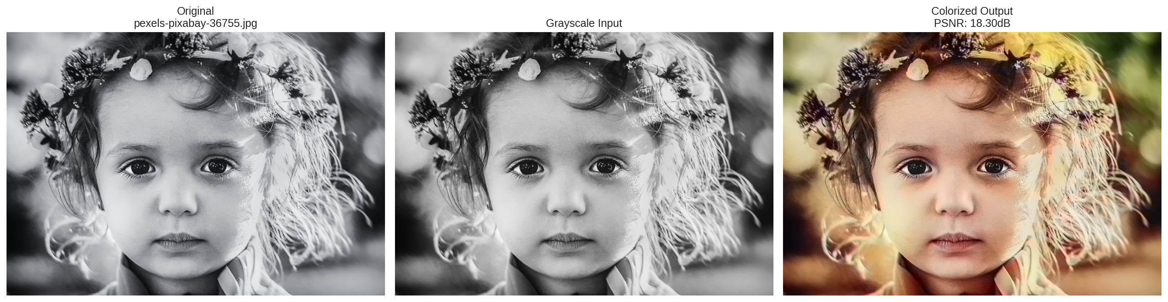
Figure 2: Grayscale input and output generated using our preprocessing colorizer

2.1.5 Testing
We test this component using both grayscale and color reference images.
We verify whether:
- Grayscale images are identified correctly
- Color images bypass the colorizer
- The pretrained model performs inference successfully
- The generated image contains plausible color information
- The original structure is preserved
- The generated RGB image can be processed by our main pipeline.

2.1.6 Experimentation
To evaluate our automatic image colorization preprocessing stage, we conducted experiments focusing on input detection, grayscale image colorization, and compatibility with the subsequent image-processing pipeline.

Experiment 01: Grayscale Detection
Experiment Details | Description
Experiment Number | 01
Target Experiment | Evaluate whether the preprocessing workflow correctly identifies grayscale and color input images
Component / Module Name | Automatic Image Colorization Module
Data Collection / Dataset Preparation | Both grayscale and color reference images were selected as test inputs
Method | Grayscale and color images were provided to the preprocessing workflow to observe whether grayscale images were directed to the colorization process while color images bypassed the colorization stage
Measurement / Evaluation Metrics | Correct input-type identification and correct preprocessing-path selection
Results | The preprocessing workflow distinguished between grayscale and color inputs and selected the corresponding processing path
Analysis:
This experiment was conducted to verify the conditional behaviour of our preprocessing stage. Grayscale images require automatic colorization before entering the main processing pipeline, whereas images that already contain color information do not require this conversion. The experiment allowed us to verify whether the appropriate processing path was selected according to the input-image type.

Experiment 02: Automatic Colorization
Experiment Details | Description
Experiment Number | 02
Target Experiment | Evaluate the ability of the pretrained colorization model to convert grayscale reference images into plausible color images
Component / Module Name | Automatic Image Colorization Module
Data Collection / Dataset Preparation | Grayscale reference images were prepared as inputs for the colorization stage
Method | The grayscale reference images were processed using the pretrained Caffe colorization model consisting of colorization_deploy_v2.prototxt, colorization_release_v2.caffemodel, and pts_in_hull.npy
Measurement / Evaluation Metrics | Visual color consistency, structural preservation, and successful generation of RGB output
Results | The model generated colorized RGB outputs from the tested grayscale reference images while retaining the main visual structure of the inputs

Analysis:
The generated outputs were visually examined to determine whether the model could introduce plausible color information without significantly changing the main structure of the reference image. Since the colors are predicted by the pretrained model, the generated colors are treated as plausible color representations rather than guaranteed original ground-truth colors.

Experiment 03: Main Pipeline Compatibility
Experiment Details | Description
Experiment Number | 03
Target Experiment | Evaluate whether the colorized RGB output can be used as an input for the subsequent stages of our main processing pipeline
Component / Module Name | Automatic Image Colorization Module and Main Processing Pipeline
Data Collection / Dataset Preparation | RGB outputs generated from grayscale reference images using the automatic colorization model
Method | The generated color reference images were passed to the subsequent geometric extraction, curve extraction, shading, and coloring stages to verify compatibility with the main pipeline
Measurement / Evaluation Metrics | Successful image transfer between stages, image readability, compatibility with subsequent models, and successful generation of downstream outputs
Results | The generated color reference images were suitable for use as inputs to the subsequent stages of the processing pipeline
Analysis:
This experiment was used to verify that automatic colorization functions as a preprocessing stage rather than as an isolated feature. After generating an RGB reference from a grayscale input, the resulting image can be forwarded to the geometric, curve, shading, and final coloring stages. This ensures that grayscale user inputs can follow the same main processing workflow as color reference images.

2.1.7 Discussion
By including this component, we allow users to provide grayscale references without manually converting them into color images.
However, we recognize that the model predicts plausible colors. Therefore, the generated colors may not always represent the original real-world colors.
For our application, we use the result as a generated color reference rather than claiming it to be the original ground-truth color image.

MODEL 01 – SEGMENT ANYTHING MODEL (SAM ViT-H)

2.2 Geometric Shape Extraction

2.2.1 Research Objective
For our first main processing stage, we aim to simplify a detailed reference image into basic structural information.
Beginners may find it difficult to identify the main forms and regions directly from a detailed image. Therefore, we use segmentation to identify major image regions and transform them into simplified geometric construction guidance.
Our objectives are to:
- Identify major objects and regions
- Remove insignificant regions
- Extract important boundaries
- Simplify complex contours
- Provide users with an initial construction guide.

2.2.2 Research Methodology
For this stage, we selected the pretrained Segment Anything Model (SAM) with the ViT-H architecture.
Our checkpoint file is:
sam_vit_h_4b8939.pth
We use SamAutomaticMaskGenerator to automatically identify candidate regions.
After reading the reference image, we convert it from OpenCV's BGR representation into RGB.
SAM then generates segmentation masks.
We apply our own filtering to the generated masks.
We calculate:
Area Ratio = Mask Area / Total Image Area
We currently remove masks when:
Area Ratio < 0.002
because these masks usually represent extremely small regions.
We also remove masks when:
Area Ratio > 0.95
because these masks cover almost the complete image.
For each retained mask, we extract external contours using OpenCV.
We remove contours with an area below:
50 pixels
We then calculate the contour perimeter and simplify the contour using polygon approximation.
Our current approximation is:
Epsilon = 0.02 × Contour Perimeter
Finally, we draw the simplified boundaries on a white canvas.

2.2.3 Data Preparation
We use SAM as a pretrained model and therefore do not train a segmentation network from scratch.
Our uploaded images are validated before processing.
Our current supported image formats are:
- JPEG/JPG
- PNG
- WebP
Our backend restricts uploaded images to a maximum size of:
5 MB

2.2.4 Model Development
Property | Our Configuration
Model | Segment Anything Model
Architecture | ViT-H
Model File | sam_vit_h_4b8939.pth
Model Type | Pretrained
Mask Generator | SamAutomaticMaskGenerator
Minimum Area Ratio | 0.002
Maximum Area Ratio | 0.95
Minimum Contour Area | 50 pixels
Polygon Approximation | 0.02 × perimeter
Libraries | PyTorch, SAM, OpenCV, NumPy
We cache the loaded SAM model so that we do not need to reload the complete model for every user request.

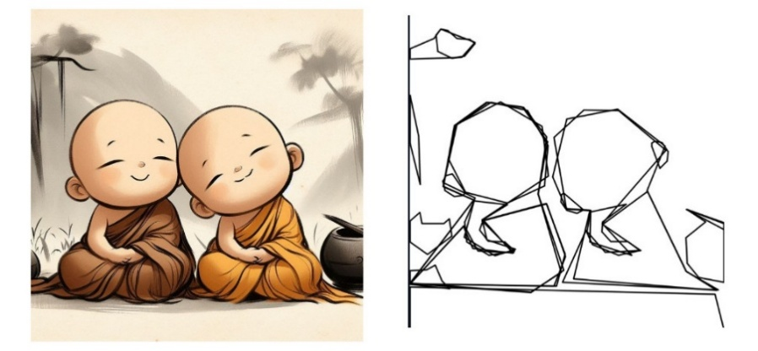

Figure 3: Original reference and geometric output generated using our SAM-based component

2.2.5 Testing
We test our geometric component using reference images with different object structures and backgrounds.
We examine:
- The number of masks generated
- Retained masks after filtering
- Important object preservation
- Unnecessary region removal
- Contour quality
- Polygon simplification
- Readability of the geometric output.

2.2.6 Experimentation – Geometric Shape Extraction
To evaluate our geometric shape extraction stage, we conducted experiments focusing on SAM mask filtering, contour filtering, and polygon approximation. These experiments were used to determine how the raw segmentation information could be transformed into a simpler geometric construction guide suitable for beginners.

Experiment 01: Mask Filtering
Experiment Details | Description
Experiment Number | 01
Target Experiment | Evaluate the effect of area-ratio filtering on the segmentation masks generated by SAM ViT-H
Component / Module Name | Geometric Shape Extraction Module
Data Collection / Dataset Preparation | Reference images were processed using SAM ViT-H to generate raw segmentation masks of different sizes
Method | We compared the raw SAM masks with the masks retained after applying our area-ratio filtering process. Masks that did not satisfy the selected area conditions were excluded from further geometric processing
Measurement / Evaluation Metrics | Relevance of retained regions, reduction of unnecessary masks, preservation of major image structures, and visual clarity
Results | Area-ratio filtering reduced unnecessary segmentation regions while retaining the major regions required for geometric construction
Analysis:
SAM ViT-H can generate multiple segmentation masks for a reference image, including regions that may not be useful for beginner drawing guidance. Through this experiment, we examined how area-ratio filtering could reduce unnecessary segmentation information. The retained masks provided a cleaner basis for subsequent contour extraction while preserving the important structural regions of the reference image.

Experiment 02: Contour Filtering
Experiment Details | Description
Experiment Number | 02
Target Experiment | Evaluate whether removing very small contours improves the clarity of the geometric construction output
Component / Module Name | Geometric Shape Extraction Module
Data Collection / Dataset Preparation | Contours were extracted from the filtered segmentation masks generated during the previous processing stage
Method | We applied contour-area filtering to remove very small contours that represented insignificant details or noise and compared the resulting construction output with the unfiltered contour representation
Measurement / Evaluation Metrics | Reduction of insignificant contours, preservation of important boundaries, structural clarity, and visual readability
Results | Removing very small contours reduced unnecessary details and produced a cleaner geometric construction representation
Analysis:
The raw contour information may contain small regions that are not useful when guiding a beginner through the basic construction of an image. This experiment allowed us to examine the effect of removing such contours. The filtered representation emphasized the more important structural boundaries and reduced unnecessary visual complexity.

Experiment 03: Polygon Approximation
Experiment Details | Description
Experiment Number | 03
Target Experiment | Evaluate the effect of contour simplification on the readability of geometric construction boundaries
Component / Module Name | Geometric Shape Extraction Module
Data Collection / Dataset Preparation | Filtered contours obtained from the retained SAM segmentation regions
Method | We applied polygon approximation to simplify contour boundaries and examined different levels of contour simplification to obtain geometric representations that retained the main object structure without excessive boundary detail
Measurement / Evaluation Metrics | Boundary simplification, preservation of overall object structure, reduction of unnecessary contour complexity, and visual readability
Results | Polygon approximation simplified complex contour boundaries while maintaining the major structural form required for the geometric drawing guide
Analysis:
Detailed contours can be difficult for beginners to reproduce directly. Therefore, this experiment focused on simplifying the extracted boundaries into more manageable geometric forms. Excessive simplification can remove important structural information, while insufficient simplification can leave unnecessary complexity. The selected processing approach was intended to provide a balance between structural preservation and simplicity for beginner drawing guidance.

2.2.7 Discussion
SAM gives us strong general-purpose object and region segmentation without requiring us to train a new segmentation network.
However, raw SAM masks alone do not provide suitable drawing guidance.
Therefore, after SAM inference, we perform additional filtering, contour extraction and polygon simplification.
This allows us to transform general segmentation information into a representation that is more appropriate for our drawing-guidance objective.

MODEL 02 – ANIMEGANv2 HAYAO

2.3 Curve Extraction

2.3.1 Research Objective
After providing the user with basic geometric construction, our next objective is to provide more detailed curves and object boundaries.
For this stage, we aim to preserve visually important shapes and curves while reducing unnecessary photographic detail.

2.3.2 Research Methodology
For our curve extraction stage, we use the pretrained AnimeGANv2 Hayao model.
Our model file is:
Hayao_64.onnx
Instead of using the AnimeGANv2 output directly as the final curve image, we use it as an intermediate stylized representation.
AnimeGANv2 reduces some photographic complexity and generates a more stylized image.
We then apply OpenCV-based image processing to extract the important curve information from this intermediate representation.
Our supporting processing includes:
- Image enhancement
- Grayscale conversion where required
- Canny edge detection
- Noise filtering
- Morphological processing
- Conversion into black curves on a white background.
Therefore, this stage combines:
AnimeGANv2 Hayao inference + OpenCV curve extraction
rather than relying only on conventional edge detection.

2.3.3 Data Preparation
We use the pretrained Hayao ONNX model and therefore do not train AnimeGANv2 from scratch.
Before inference, we prepare the input according to the ONNX model requirements.
After inference, we convert the generated output into a suitable format for our OpenCV curve-processing stage.

2.3.4 Model Development
Property | Our Configuration
Model | AnimeGANv2
Variant | Hayao
Model File | Hayao_64.onnx
Format | ONNX
Model Type | Pretrained
Purpose | Stylized intermediate representation for curve extraction
Post-processing | OpenCV / Canny / filtering
Final Output | Black curves on white background
Our curve stage can therefore be represented as:
Reference Image → AnimeGANv2 Hayao → Stylized Intermediate → Edge/Curve Processing → Final Curve Guide
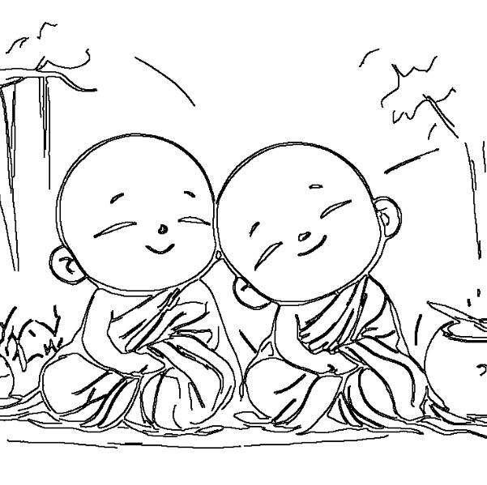
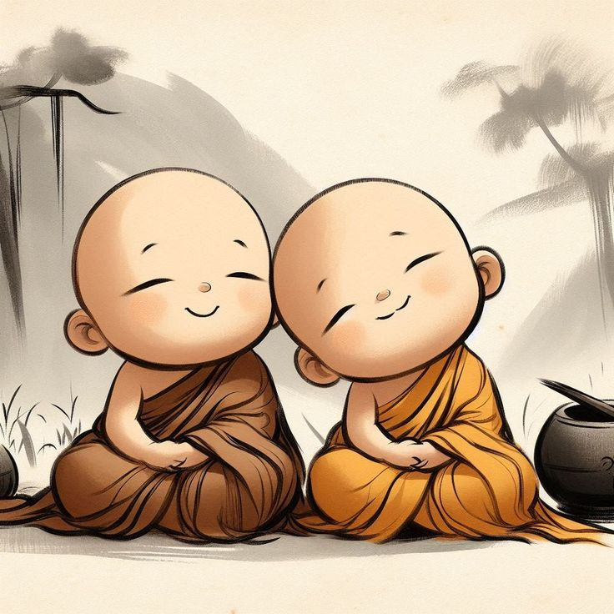

Figure 4: Reference image and our final curve guidance

2.3.5 Testing
We evaluate:
- Preservation of important object boundaries
- Continuity of curves
- Removal of unnecessary photographic texture
- Amount of unwanted edge noise
- Visibility of weak curves
- Readability of the final black-and-white output.

2.3.6 Experimentation – Curve Extraction
To evaluate our curve extraction stage, we conducted experiments focusing on the intermediate output generated by AnimeGANv2 Hayao, extraction of important edges, and cleaning of the resulting curves. These experiments helped us transform the stylized model output into a simplified curve representation suitable for drawing guidance.

Experiment 01: Hayao Intermediate Output
Experiment Details | Description
Experiment Number | 01
Target Experiment | Evaluate how AnimeGANv2 Hayao transforms the original reference image and whether the resulting stylized representation is suitable for subsequent curve extraction
Component / Module Name | Curve Extraction Module
Data Collection / Dataset Preparation | Selected reference images were prepared according to the input requirements of the AnimeGANv2 Hayao ONNX model
Method | We processed the reference images using the pretrained Hayao_64.onnx model and compared the generated intermediate outputs with the corresponding original reference images
Measurement / Evaluation Metrics | Structural preservation, reduction of photographic complexity, visibility of important boundaries, and suitability for subsequent edge extraction
Results | The Hayao model generated stylized intermediate outputs that retained important image structures while reducing some of the photographic complexity of the original reference images
Analysis:
The purpose of this experiment was not to treat the AnimeGANv2 Hayao output as the final curve image. Instead, we examined whether its stylized representation provided a useful intermediate image for extracting drawing curves. The comparison showed how the model transformed photographic information while maintaining major structures and boundaries required by the following processing stages.

Experiment 02: Edge Extraction
Experiment Details | Description
Experiment Number | 02
Target Experiment | Evaluate the extraction of important image boundaries from the AnimeGANv2 Hayao intermediate output
Component / Module Name | Curve Extraction Module
Data Collection / Dataset Preparation | Intermediate stylized images generated using Hayao_64.onnx were used as inputs for edge processing
Method | We applied OpenCV-based image preprocessing and edge-detection techniques, including Canny edge detection, to the Hayao intermediate output to identify significant boundaries and convert them into a curve-oriented representation
Measurement / Evaluation Metrics | Boundary visibility, curve continuity, preservation of important structural edges, unwanted edge noise, and visual readability
Results | Edge processing extracted the major visible boundaries from the Hayao intermediate images and produced an initial curve representation for further refinement
Analysis:
Although the Hayao output simplifies the appearance of the reference image, it still contains color and tonal information that is not required in the final curve guide. Edge extraction was therefore used to isolate important boundaries. The experiment allowed us to observe whether the extracted edges represented the major structures of the reference image while avoiding excessive visual detail.

Experiment 03: Curve Cleaning
Experiment Details | Description
Experiment Number | 03
Target Experiment | Evaluate whether filtering and morphological processing improve the clarity and continuity of the extracted curves
Component / Module Name | Curve Extraction Module
Data Collection / Dataset Preparation | Initial edge representations generated during the edge-extraction stage
Method | We applied OpenCV filtering and morphological operations to reduce unwanted edge noise, remove insignificant line fragments, and strengthen important curve structures before generating the final black-curve representation on a white background
Measurement / Evaluation Metrics | Noise reduction, curve continuity, preservation of important lines, line clarity, and overall visual readability
Results | Curve cleaning reduced unwanted edge information and produced a clearer final curve representation with more visible structural lines
Analysis:
The initial edge representation may contain fragmented lines, minor texture edges, and other details that can make the drawing guide difficult to follow. This experiment focused on refining those edges using filtering and morphological processing. The resulting representation provides cleaner and more readable curves while retaining the important structural information required for progressive drawing guidance.

2.3.7 Discussion
Using AnimeGANv2 Hayao before edge extraction gives us a stylized intermediate image rather than directly extracting all edges from the original photograph.
This can reduce some photographic complexity before curve extraction.
However, the final curve quality still depends on the input image and the post-processing parameters. Therefore, OpenCV processing remains an important part of this stage.

MODEL 03 – DEPTH ANYTHING V2 SMALL

2.4 Depth-Aware Pencil Shading

2.4.1 Research Objective
After providing geometric and curve guidance, our next objective is to help users understand form through shading.
Simple grayscale conversion provides brightness information but does not directly represent the relative spatial structure of objects.
Therefore, for our shading component, we include relative depth information together with image luminance to create depth-aware pencil shading.

2.4.2 Research Methodology
For this stage, we selected:
Depth Anything V2 Small
Model:
depth-anything/Depth-Anything-V2-Small-hf
We use this pretrained depth-estimation model to estimate relative depth from a single reference image.
The model generates a depth representation in which different values represent relative spatial differences within the scene.
However, depth alone is not enough to create useful pencil shading.
Therefore, we combine the estimated depth information with visual luminance information from the original image.
Our shading workflow includes:
- Reference image preprocessing
- Depth Anything V2 inference
- Depth-map normalization
- Luminance extraction
- Depth and luminance combination
- Tonal adjustment
- Pencil hatching/texture generation
- Curve integration
- Final OpenCV compositing.
This allows us to use both structural depth information and the visible light-dark information from the original reference.

2.4.3 Data Preparation
We use Depth Anything V2 Small as a pretrained model.
Therefore, we do not train a monocular depth-estimation model from scratch.
The reference image is prepared according to the requirements of the selected Hugging Face model.
After inference, we resize and normalize the estimated depth map so that it corresponds to the original image dimensions.

2.4.4 Model Development
Property | Our Configuration
Model | Depth Anything V2
Variant | Small
Model ID | depth-anything/Depth-Anything-V2-Small-hf
Model Type | Pretrained
Main Purpose | Relative depth estimation
Additional Input | Image luminance
Additional Processing | Pencil hatching and OpenCV filtering/compositing
Output | Depth-aware pencil shading
Our shading architecture can therefore be represented as:
Reference Image → Depth Anything V2 → Relative Depth Map
combined with:
Reference Image → Luminance Information
followed by:
Depth + Luminance → Tonal Processing → Pencil Hatching → Curve Integration → Shading Output
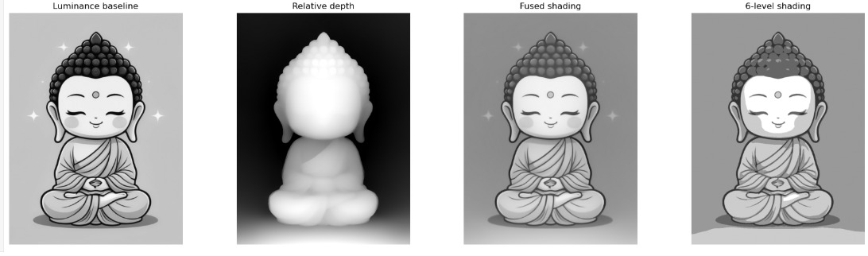
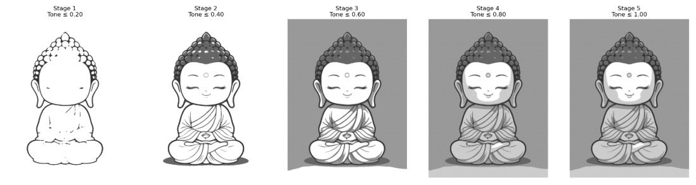
Figure 5: Main stages of our depth-aware pencil-shading component

2.4.5 Testing
We test whether:
- The model successfully generates relative depth
- Foreground and background structures are distinguishable
- Important depth transitions are retained
- Luminance information is preserved
- Shadows and highlights remain readable
- Pencil hatching is visually suitable
- The final shading aligns with our curve output.

2.4.6 Experimentation – Depth-Aware Pencil Shading
To evaluate our depth-aware pencil shading stage, we conducted experiments focusing on depth-based shading, luminance-based shading, the combination of depth and luminance information, pencil hatching, and curve integration. These experiments helped us determine how different visual information contributes to a clear and understandable pencil-shading guide.

Experiment 01: Depth-Only Shading
Experiment Details | Description
Experiment Number | 01
Target Experiment | Evaluate the shading information that can be generated primarily from relative depth
Component / Module Name | Depth-Aware Pencil Shading Module
Data Collection / Dataset Preparation | Selected reference images were prepared as inputs for the Depth Anything V2 Small model
Method | We processed the reference images using the pretrained Depth Anything V2 Small model to generate relative depth maps. The normalized depth information was then used to produce a depth-based shading representation
Measurement / Evaluation Metrics | Depth-region separation, structural visibility, tonal variation, and preservation of major object forms
Results | The depth-based representation provided visible separation between relative image regions and preserved important structural information for shading

Analysis:
This experiment allowed us to examine the contribution of relative depth information independently from the visible brightness of the reference image. The depth map provides information about spatial relationships between image regions, which can help represent object form. However, depth information alone does not fully represent the lighting and tonal characteristics visible in the original reference image.

Experiment 02: Luminance-Only Shading
Experiment Details | Description
Experiment Number | 02
Target Experiment | Evaluate shading generated from the brightness information of the original reference image
Component / Module Name | Depth-Aware Pencil Shading Module
Data Collection / Dataset Preparation | The same reference images used for depth-based shading were processed to obtain luminance information
Method | We extracted luminance information from the reference images and used the resulting light and dark intensity variations to generate a luminance-based shading representation without using relative depth information
Measurement / Evaluation Metrics | Preservation of visible highlights and shadows, tonal variation, structural visibility, and overall shading readability
Results | Luminance-based shading preserved visible light and dark variations from the reference images but did not independently provide the same relative spatial information available from the depth model
Analysis:
This experiment was used to compare image brightness with model-generated depth information. Luminance is useful for preserving visible lighting characteristics such as highlights, mid-tones, and darker areas. However, brightness alone can be influenced by object color and illumination and therefore does not necessarily represent relative depth.

Experiment 03: Depth and Luminance Combination
Experiment Details | Description
Experiment Number | 03
Target Experiment | Evaluate whether combining relative depth and luminance provides more useful structural and tonal guidance than using either source independently
Component / Module Name | Depth-Aware Pencil Shading Module
Data Collection / Dataset Preparation | Corresponding normalized depth maps and luminance information were obtained from the same reference images
Method | We combined the relative depth information generated by Depth Anything V2 Small with the luminance information extracted from the original image and processed the combined representation to generate shading guidance
Measurement / Evaluation Metrics | Structural visibility, tonal variation, preservation of highlights and shadows, depth awareness, and overall visual readability
Results | The combined representation incorporated both relative structural information from the depth map and visible tonal information from the reference image
Analysis:
Depth and luminance provide different but complementary information. Relative depth helps describe spatial structure, while luminance represents visible brightness and tonal variation. By combining both sources, our shading process can use structural information together with the visual light-dark characteristics of the reference image.

Experiment 04: Pencil Hatching
Experiment Details | Description
Experiment Number | 04
Target Experiment | Evaluate the effect of pencil-hatching intensity and texture on the appearance and readability of the shading guide
Component / Module Name | Depth-Aware Pencil Shading Module
Data Collection / Dataset Preparation | Combined depth and luminance shading representations generated during the previous experiment
Method | We applied pencil-style hatching to the shading representation and experimented with the intensity and texture of the hatching to obtain a more drawing-oriented appearance
Measurement / Evaluation Metrics | Hatching visibility, texture consistency, tonal readability, preservation of object structure, and overall pencil-like appearance
Results | Pencil hatching introduced visible drawing texture into the shading representation while maintaining the underlying tonal and structural information

Analysis:
A smooth grayscale shading map can provide tonal information, but it does not necessarily resemble the way a beginner would apply pencil shading. The hatching experiment was therefore used to introduce a more drawing-oriented texture. The hatching needs to remain visible without becoming strong enough to obscure important image structures.

Experiment 05: Curve Integration
Experiment Details | Description
Experiment Number | 05
Target Experiment | Evaluate whether integrating the generated curve guidance with pencil shading improves structural readability
Component / Module Name | Depth-Aware Pencil Shading Module
Data Collection / Dataset Preparation | Final shading representations and the corresponding curve outputs generated by our curve extraction stage
Method | We combined the generated pencil shading with the corresponding curve guidance and examined whether important boundaries remained visible after the shading and curve information were integrated
Measurement / Evaluation Metrics | Curve visibility, structural clarity, shading readability, preservation of important boundaries, and overall visual balance
Results | The integrated representation retained visible structural curves together with the generated pencil shading information
Analysis:
Shading alone can make some structural boundaries less clear, particularly in areas containing similar tonal values. Therefore, this experiment examined the effect of integrating our curve guidance with the final shading representation. The objective was to retain the tonal information produced by the shading stage while keeping important drawing boundaries readable for beginners.

2.4.7 Discussion
Depth Anything V2 provides relative depth information from a single image without requiring a physical depth sensor.
This gives our shading stage additional structural information that cannot be obtained from grayscale intensity alone.
However, the predicted depth is relative and estimated from a two-dimensional image. We therefore do not treat it as exact physical distance.
We combine depth with luminance because depth and visible illumination represent different information. The combination is more appropriate for our drawing-guidance objective than using either source independently.

MODEL 04 – ANIMEGANv2 PAPRIKA

2.5 Realistic Painted Coloring

2.5.1 Research Objective
For our final main AI stage, our objective is to generate a visually appealing painted color representation while retaining important information from the original reference.
Instead of using only the raw output of the artistic model, we combine the generated artistic appearance with information from the original image.

2.5.2 Research Methodology
For this stage, we selected:
AnimeGANv2 Paprika
Model file:
Paprika_54.onnx
The pretrained model produces a painterly artistic representation of the reference image.
However, directly using only the AnimeGANv2 output may alter some original color and detail information.
Therefore, our complete coloring process includes additional image processing.
We use:
- AnimeGANv2 Paprika inference
- Original-image detail preservation
- Lab color processing
- HSV color processing
- Chroma preservation
- K-Means color clustering where required
- Progressive color-region generation
- Soft local outline generation
- OpenCV blending and compositing.
Our objective is to retain the artistic appearance produced by Paprika while preserving useful color and structural information from the original image.

2.5.3 Data Preparation
We use the pretrained Paprika ONNX model and therefore do not train AnimeGANv2 from scratch.
We resize and normalize the reference image according to the ONNX model requirements.
After inference, we combine the model output with color and detail information extracted from the reference image.

2.5.4 Model Development
Property | Our Configuration
Model Family | AnimeGANv2
Variant | Paprika
Model File | Paprika_54.onnx
Format | ONNX
Model Type | Pretrained
Main Purpose | Painterly artistic rendering
Color Processing | Lab and HSV
Additional Processing | K-Means, progressive regions, local outlines
Final Processing | OpenCV blending/compositing
Output | Realistic painted coloring
Our final coloring workflow is:
Reference Image → AnimeGANv2 Paprika → Painterly Representation
combined with:
Original Detail + Original Chroma + Color Processing + Local Outlines
to generate:
Final Painted Color Output
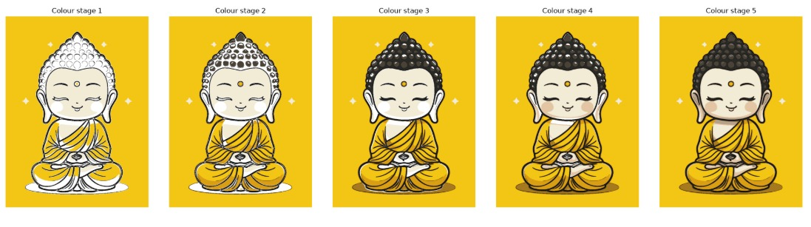
Figure 6: Paprika model output and our final realistic painted coloring

2.5.5 Testing
We evaluate:
- Preservation of important object structures
- Quality of the painterly appearance
- Preservation of useful original colors
- Local-detail retention;
- Color consistency
- Outline quality
- Overall visual quality of the final output.

2.5.6 Experimentation – Realistic Painted Coloring
To evaluate our realistic painted coloring stage, we conducted experiments focusing on the raw AnimeGANv2 Paprika output, preservation of original image details, color preservation, local outline integration, and final compositing. These experiments helped us evaluate how the pretrained model output could be progressively refined into a painted representation while preserving important information from the original reference image.

Experiment 01: Raw Paprika Output
Experiment Details | Description
Experiment Number | 01
Target Experiment | Evaluate the direct artistic output generated by AnimeGANv2 Paprika before applying additional post-processing
Component / Module Name | Realistic Painted Coloring Module
Data Collection / Dataset Preparation | Selected reference images were prepared according to the input requirements of the AnimeGANv2 Paprika ONNX model
Method | We processed the reference images using the pretrained Paprika_54.onnx model and examined the direct model outputs before applying our additional detail, color, and outline processing
Measurement / Evaluation Metrics | Visual quality, structural consistency, color appearance, preservation of important image information, and overall painterly appearance
Results | AnimeGANv2 Paprika generated stylized painterly representations of the tested reference images that could be used as the base for further refinement
Analysis:
This experiment provided the baseline output of our coloring stage. By examining the raw Paprika output separately, we could identify the characteristics introduced directly by the pretrained model before applying our additional image-processing techniques. The raw output was therefore used as the starting point for the subsequent refinement experiments.

Experiment 02: Original Detail Blending
Experiment Details | Description
Experiment Number | 02
Target Experiment | Evaluate whether blending information from the original reference image with the Paprika output improves detail preservation
Component / Module Name | Realistic Painted Coloring Module
Data Collection / Dataset Preparation | Original reference images and their corresponding raw outputs generated using Paprika_54.onnx
Method | We blended selected detail information from the original reference image with the raw Paprika output and compared the resulting representation with the direct model output
Measurement / Evaluation Metrics | Detail preservation, structural consistency, visibility of important features, and overall visual quality
Results | Original-detail blending retained additional reference-image information while preserving the painterly characteristics of the model-generated output
Analysis:
The raw model output may alter or simplify some fine image details as part of the artistic transformation. Therefore, this experiment examined whether selected information from the original image could be reintroduced without removing the desired painterly appearance. The resulting representation provided a balance between artistic transformation and preservation of useful reference details.

Experiment 03: Color Preservation
Experiment Details | Description
Experiment Number | 03
Target Experiment | Evaluate whether important chromatic information from the original reference image can be preserved in the processed painted output
Component / Module Name | Realistic Painted Coloring Module
Data Collection / Dataset Preparation | Original color reference images and their corresponding AnimeGANv2 Paprika outputs
Method | We used Lab and HSV color-space processing to obtain and combine relevant chromatic information from the reference image with the model-generated representation
Measurement / Evaluation Metrics | Color consistency, preservation of important chromatic regions, visual similarity of major colors, and overall color balance
Results | Lab and HSV-based processing helped retain important color information from the original reference image in the refined painted output
Analysis:
AnimeGANv2 Paprika can modify color characteristics as part of its artistic transformation. Since our application uses the reference image as guidance for drawing and coloring, preserving important color information is useful. This experiment examined the contribution of Lab and HSV processing to maintaining relevant chromatic information while retaining the artistic characteristics of the model output.

Experiment 04: Local Outlines
Experiment Details | Description
Experiment Number | 04
Target Experiment | Evaluate whether soft local outlines improve structural readability in the painted representation
Component / Module Name | Realistic Painted Coloring Module
Data Collection / Dataset Preparation | Refined painted outputs generated after model inference and color/detail processing
Method | We generated local structural outlines and softly integrated them with the painted output instead of applying strong outlines across the entire image
Measurement / Evaluation Metrics | Boundary visibility, structural readability, outline intensity, preservation of painterly appearance, and overall visual balance
Results | Soft local outlines increased the visibility of important structural boundaries without completely dominating the painted appearance
Analysis:
Strong outlines can make a painted image appear overly artificial or reduce the effect of the painterly rendering. On the other hand, removing structural boundaries completely can make some regions difficult to distinguish. This experiment examined the use of softer local outlines to retain important visual structure while maintaining the overall painted appearance.

Experiment 05: Final Compositing
Experiment Details | Description
Experiment Number | 05
Target Experiment | Evaluate the complete coloring workflow after combining the selected model output and post-processing techniques
Component / Module Name | Realistic Painted Coloring Module
Data Collection / Dataset Preparation | Paprika outputs together with the corresponding original-image detail, color information, and local structural information
Method | We combined the selected AnimeGANv2 Paprika output, original-detail information, Lab/HSV-based color processing, soft local outlines, and OpenCV filtering and compositing to generate the final painted representation
Measurement / Evaluation Metrics | Overall visual quality, structural clarity, color consistency, detail preservation, painterly appearance, and suitability as the final coloring output
Results | The final compositing process produced a painted representation that combined the artistic characteristics of AnimeGANv2 Paprika with selected color, detail, and structural information from the original reference image
Analysis:
This experiment evaluated the complete coloring workflow rather than considering the pretrained model in isolation. The final output is produced through a combination of AnimeGANv2 Paprika and our supporting image-processing operations. This allows us to preserve the painterly transformation while maintaining useful color, structural, and detail information from the reference image.

2.5.7 Discussion
AnimeGANv2 Paprika provides the main learned artistic transformation for our coloring stage.
However, our final coloring output is not simply the raw AnimeGANv2 output.
We further combine it with original image detail, chroma and local structural information to obtain an output that better matches our project objective.
This also allows us to control the balance between artistic stylization and preservation of the original reference.

2.6 SUPPORTING IMAGE-PROCESSING TECHNIQUES
In addition to our AI models, we use several conventional image-processing techniques throughout the pipeline.
These techniques support the AI-generated outputs rather than acting as separate trained AI models.
Technique | Purpose in Our Work
K-Means Color Clustering | Reduces color complexity and supports color-region generation
Lab Color Processing | Separates luminance and chromatic information
HSV Processing | Supports color and saturation adjustment
Canny Edge Detection | Extracts important edges for curve processing
Progressive Color Regions | Generates simplified stages of color application
Pencil Hatching | Creates drawing-oriented texture in the shading stage
OpenCV Filtering | Removes noise and improves intermediate outputs
OpenCV Compositing | Combines model outputs with structural and color information
This distinction is important because we do not describe these operations as independently trained AI models.

2.7 ADDITIONAL MODEL FILES
Our repository also contains:
- Shinkai_53.onnx
- Hayao-60.onnx
These model files are available in our project resources, but they are not currently used in our main processing pipeline.
Therefore, we do not present them as active models in our final architecture.

SECTION 03: DATA MANAGEMENT

3.1 Constraints
In our system, we use a relational MySQL database to manage user accounts, projects, uploaded reference images, generated AI outputs, and project-processing information.
The two main database entities used in our current implementation are:
- users
- projects
We apply primary keys, unique constraints, user-to-project relationships, parameterized queries, authentication mechanisms, and role-based authorization to maintain data integrity and security.

3.1.1 Primary Keys
We use a unique primary key for each main database entity.
The primary keys are:
- users.id
- projects.id
Both identifiers uniquely identify their corresponding records.
The id field in the users table identifies an individual user account, while the id field in the projects table identifies an individual drawing project.
This allows us to retrieve, update, and manage specific records without ambiguity.

3.1.2 Unique Constraint
We maintain the user's email address as a unique value. Therefore, two user accounts cannot be created using the same email address.
The corresponding field is:
email VARCHAR(100) UNIQUE NOT NULL
This constraint supports unique account identification during registration and authentication.

3.1.3 User–Project Relationship
Each project in our system is associated with a particular user.
We maintain this association using the user_id field in the projects table:
projects.user_id → users.id
Therefore, the logical relationship between the two entities is:
One User → Many Projects
A user can create multiple drawing projects, while each individual project is associated with one user.
The user_id field is also used when retrieving projects belonging to a particular user. This relationship allows project records to be associated with their corresponding user accounts.

3.2 Physical Database Design

3.2.1 Users Table
We use the users table to store user account, authentication, email verification, and account-related information.
The main fields used in our current implementation are:
Field | Description
id | Unique identifier of the user
full_name | Full name of the user
email | Unique email address of the user
password | Hashed user password
role | Authorization role assigned to the user
is_verified | Indicates whether the user's email address has been verified
verification_code | Stores the verification code used during email verification
verification_expires_at | Stores the expiration date and time of the verification code
verification_attempts | Stores the number of verification attempts
last_code_sent_at | Stores the date and time when the most recent verification code was sent
created_at | Stores the account creation date and time
updated_at | Stores the date and time of the most recent record update
The structure of the users table in our current database implementation can be represented as:
CREATE TABLE users (
id INT NOT NULL AUTO_INCREMENT,
full_name VARCHAR(150) NOT NULL,
email VARCHAR(255) NOT NULL UNIQUE,
password VARCHAR(255) NOT NULL,
role VARCHAR(50) NOT NULL DEFAULT 'user',
is_verified TINYINT(1) NOT NULL DEFAULT 0,
verification_code VARCHAR(64) DEFAULT NULL,
verification_expires_at DATETIME DEFAULT NULL,
verification_attempts INT NOT NULL DEFAULT 0,
last_code_sent_at DATETIME DEFAULT NULL,
created_at TIMESTAMP NOT NULL DEFAULT CURRENT_TIMESTAMP,
updated_at TIMESTAMP NOT NULL
DEFAULT CURRENT_TIMESTAMP
ON UPDATE CURRENT_TIMESTAMP,
PRIMARY KEY (id)
);
The email field is unique and is used to identify individual user accounts. User passwords are stored as hashed values rather than plain-text passwords. The role field supports authorization, while the verification-related fields are used to manage the email-verification process.
The is_verified field indicates the verification state of an account. The verification_code, verification_expires_at, verification_attempts, and last_code_sent_at fields support verification-code generation, expiration, attempt tracking, and resend-related operations.
The created_at and updated_at fields are used to maintain account creation and modification timestamps.
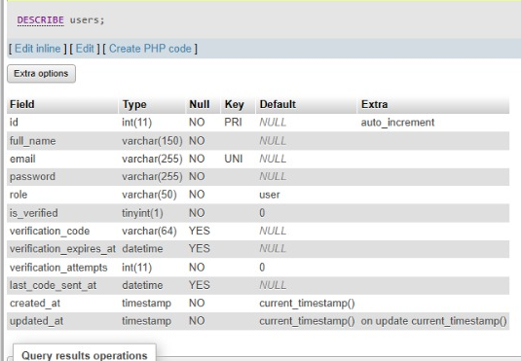

Figure 3.2.1: Users table used in our database implementation

3.2.2 Projects Table
We use the projects table to maintain information related to the drawing projects created by users, uploaded reference images, preprocessing outputs, AI-generated outputs, and project-processing status.
The fields used in our current database implementation are:
Field | Description
id | Unique project identifier
user_id | Identifies the user associated with the project
title | Stores the title of the project
description | Stores the project description
original_image | Stores the path of the original reference image
colorized_image | Stores the path of the automatically colorized image when grayscale preprocessing is applied
status | Stores the current project-processing status
created_at | Stores the project creation date and time
updated_at | Stores the date and time of the most recent project update
generated_image | Stores the path of a generated project image where applicable
input_image | Stores the path of the input image used by the processing pipeline
geometric_image | Stores the path of the generated geometric output
curve_image | Stores the path of the generated curve output
shading_image | Stores the path of the generated shading output
colouring_image | Stores the path of the generated final colouring output
The structure of the projects table in our current database implementation can be represented as:
CREATE TABLE projects (
id INT NOT NULL AUTO_INCREMENT,
user_id INT NOT NULL,
title VARCHAR(255) NOT NULL,
description TEXT DEFAULT NULL,

original_image VARCHAR(255) DEFAULT NULL,
colorized_image VARCHAR(255) DEFAULT NULL,

status VARCHAR(50) DEFAULT 'Pending',

created_at TIMESTAMP
NOT NULL DEFAULT CURRENT_TIMESTAMP,

updated_at TIMESTAMP
NOT NULL DEFAULT CURRENT_TIMESTAMP
ON UPDATE CURRENT_TIMESTAMP,

generated_image VARCHAR(255) DEFAULT NULL,

input_image VARCHAR(500) DEFAULT NULL,
geometric_image VARCHAR(500) DEFAULT NULL,
curve_image VARCHAR(500) DEFAULT NULL,
shading_image VARCHAR(500) DEFAULT NULL,
colouring_image VARCHAR(500) DEFAULT NULL,

PRIMARY KEY (id),
KEY user_id (user_id)
);
The generated image files themselves are stored in the application file system, while the corresponding image paths are stored in the MySQL database.
For the main processing pipeline, our database can maintain paths for:
- The original reference image;
- The automatically colorized image;
- The processing input image;
- The geometric output;
- The curve output;
- The shading output; and
- The final coloring output.
The colorized_image field is particularly relevant to our grayscale-input preprocessing stage. When a grayscale reference image is processed using the Automatic Image Colorization Model, the corresponding colorized-image path can be stored in this field.
The geometric_image, curve_image, shading_image, and colouring_image fields store the output paths produced by the four main AI-processing stages.
The status field is used to represent the current processing state of a project. For example, a project can move from an initial status such as Pending or Waiting to Processing and finally to Completed after successful AI processing.
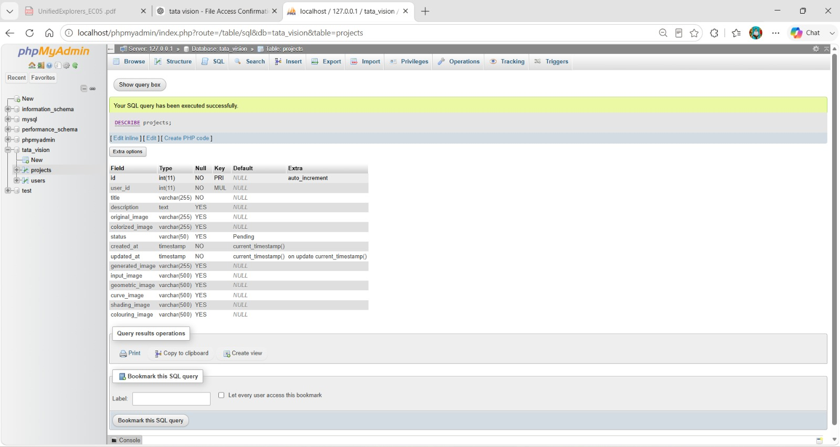

Figure 3.2.2 : Projects table used in our database implementation

3.2.3 Database Relationship
The relationship between our two main database entities can be represented as:
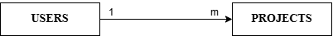

Figure 3.2.3: User–Project Relationship in Our Database Design
Each project contains a user_id that identifies the user associated with the project.

3.3 Security Design: User Roles, Access Control and Password Security
We apply multiple security mechanisms to protect user accounts and project information.
Our current security implementation includes:
• Password hashing
• JWT-based authentication
• Role-based administrative authorization
• Email-verification management
• Parameterized SQL queries
• Controlled image-upload formats
• Upload-size restrictions
• User-to-project associations

3.3.1 User Roles
Our current implementation primarily distinguishes between normal users and administrators.
User Role | Permission | Access-Control Method
User | Register an account | Registration and database validation
User | Login to the system | Email/password authentication
User | Create projects | Project is associated with a user_id
User | Upload reference images | Upload middleware validates the file
User | View user-associated projects | Projects can be retrieved using user_id
User | Generate AI outputs | Generated paths are stored against the relevant project
Admin | Access administrative functions | JWT role checked using isAdmin middleware
Admin | Manage authorised user operations | Admin role must be present in the verified token
Our isAdmin middleware checks:
if (!req.user || req.user.role !== "Admin") {
return res.status(403).json({
message: "Access denied. Admins only."
});
}
Therefore, a normal user cannot access an endpoint protected using the isAdmin middleware.

3.3.2 Authentication and Access Control
Our system uses JWT authentication to identify authenticated users.
For protected requests, the expected authorization-header structure is:
Authorization: Bearer <token>
Our middleware obtains the token and verifies it using:
jwt.verify(token, process.env.JWT_SECRET);
After successful verification, the decoded user information is assigned to req.user. This information can include the user's id, email, and role, which can then be used by protected operations for authentication and authorization.
Our current security mechanisms can be summarized as follows:
Security Feature | Description | Current Implementation
User Authentication | Identifies authenticated users | JWT
Token Verification | Validates authentication tokens | jwt.verify()
Role-Based Authorization | Restricts administrator operations | isAdmin middleware
Project Association | Associates projects with users | projects.user_id
Parameterized Queries | Separates values from SQL statements | ? placeholders
File-Type Validation | Restricts uploaded image formats | Multer fileFilter
File-Size Validation | Prevents oversized image uploads | 5 MB limit
Account Status | Stores user account state | users.status

For enhanced access control, project-specific retrieval, modification, and deletion operations can additionally validate the authenticated user ID together with the project ID to ensure that users access only their associated projects.

3.3.3 Password Security
We do not store user passwords as readable plain text.
Our authentication implementation uses password hashing before storing passwords in the database.
During login, the entered password is verified against the stored password hash rather than comparing two plain-text passwords.
The security design can be represented as:
Security Feature | Description | Implementation
Password Hashing | Converts passwords into non-readable hashes | bcrypt
Salt | Incorporated into password hashing | bcrypt-generated salt
Password Verification | Compares submitted password with stored hash | bcrypt.compare()
Authentication Token | Generated after successful authentication | JWT
Token Verification | Validates protected requests | JWT middleware
Therefore, the original password does not need to be stored in plain-text form.

3.3.4 Image Upload Security
Our system restricts reference-image uploads to supported image formats. The Multer upload middleware validates the MIME type of each uploaded file and accepts only JPG/JPEG, PNG, and WebP images.
The maximum permitted upload size is 5 MB, configured as:
limits: {
fileSize: 5 * 1024 * 1024
}
Files with unsupported formats or files exceeding the configured size limit are rejected before they are passed to the AI-processing pipeline. These restrictions help control the type and size of files processed by our system.
These restrictions help us control the type and size of files submitted to the AI-processing pipeline.

3.4 Data Retrieval Queries
We use SQL SELECT queries to retrieve user information, project information, and generated AI-output paths from our MySQL database.

3.4.1 Retrieve User by Email
During operations such as login, registration checking, and forgot-password processing, we retrieve a user using the email address.
SELECT *
FROM users
WHERE email = ?
LIMIT 1;
Purpose:
- Identify an existing user;
- Retrieve authentication information;
- Support login;
- Support registration validation; and
- Support forgot-password operations.
Input: Email address
Output: Matching user record

3.4.2 Retrieve User by ID
We retrieve a specific user's profile information using:
SELECT
id,
full_name,
email,
role,
status,
created_at
FROM users
WHERE id = ?;
Purpose:
- Retrieve user information
- Display account information
- Support user-management operations.
Input: User ID
Output: User information

3.4.3 Retrieve All Users
For authorised administrative operations, our user model can retrieve all users.
SELECT
id,
full_name,
email,
role,
status,
created_at
FROM users
ORDER BY created_at DESC;
Purpose:
- Display registered users to authorised administrators
- Support account-management functions.

3.4.4 Retrieve All Projects
Our current project model provides:
SELECT *
FROM projects
ORDER BY created_at DESC;
Purpose:
- Retrieve all project records for operations where access is appropriately authorised.
For normal-user operations, user-specific project retrieval should be used instead of exposing all project records.

3.4.5 Retrieve a Project by ID
Our current project model retrieves an individual project using:
SELECT *
FROM projects
WHERE id = ?;
Input: Project ID
Output: Matching project record
For normal-user requests, ownership verification should additionally be applied in the final implementation:
SELECT *
FROM projects
WHERE id = ?
AND user_id = ?;
This ensures that the requested project belongs to the authenticated user.

3.4.6 Retrieve Projects by User
We retrieve projects associated with a particular user using:
SELECT *
FROM projects
WHERE user_id = ?
ORDER BY created_at DESC;
Purpose:
- Retrieve projects associated with a user
- Display a user's project history.
Input: User ID
Output: User-associated projects

3.4.7 Retrieve Generated AI Outputs
The generated output paths are maintained within each project record.
The relevant fields are:
geometric_image
curve_image
shading_image
colouring_image
Therefore, retrieving a project also allows the application to obtain the paths required to display its generated stages.
The automatic grayscale colorization output is used as an intermediate preprocessing image and is not currently stored as one of the main project-output fields.

3.4.8 Count All Users
Our user model supports counting registered users using:
SELECT COUNT(*) AS total
FROM users;
Purpose:
- Provide user-count information for administrative functions.

3.4.9 Count Users by Status
We can count users according to their account status using:
SELECT COUNT(*) AS total
FROM users
WHERE status = ?;
Purpose:
- Identify the number of users associated with a particular account status.

3.5 Data Manipulation Queries
We use data-manipulation queries to create projects, update project information, store AI outputs, update user information, and delete records.

3.5.1 Insert Queries

3.5.1.1 Insert a New User
During registration, a new user account is created with the required account information.
The operation stores information such as:
- full_name
- email
- hashed password
- role
- status
The password stored in the database is the generated password hash rather than the user's original plain-text password.

3.5.1.2 Insert a New Project
Our current project model creates a project using:
INSERT INTO projects (
user_id,
title,
description,
input_image
)
VALUES (?, ?, ?, ?);
Purpose:
- Create a new drawing project;
- Associate the project with a user;
- Store the project title and description; and
- Store the uploaded reference-image path.
After the project is created, we obtain the generated project ID using:
result.insertId

3.5.2 Update Queries

3.5.2.1 Update Project Information
Our current implementation updates project information using:
UPDATE projects
SET
title = ?,
description = ?,
status = ?
WHERE id = ?;
Purpose:
- Modify the project's title;
- Modify its description; and
- Modify its processing status.
For normal-user operations, ownership verification should also be applied in the final implementation.

3.5.2.2 Update Project Processing Status
Before starting AI processing, the project status can be updated using:
UPDATE projects
SET status = ?
WHERE id = ?;
For example, after creating a project, our controller updates the project status to Processing before initiating the AI-processing pipeline.

3.5.2.3 Update AI-Generated Outputs
After our Python AI service successfully completes the main processing pipeline, we store the generated image paths together.
UPDATE projects
SET
geometric_image = ?,
curve_image = ?,
shading_image = ?,
coloring_image = ?,
status = 'Completed'
WHERE id = ?;
This query stores the outputs generated by:
- Geometric shape extraction
- Curve extraction
- Depth-aware pencil shading
- Realistic painted coloring.
It also changes the project status to:
Completed
The automatic grayscale colorization result is used as a preprocessing input and therefore does not require a separate output field in this query under the current database design.

3.5.2.4 Update User Status
For administrative account-management operations, we use:
UPDATE users
SET status = ?
WHERE id = ?;
Purpose:
- activate or deactivate a user account according to authorised administrative actions.

3.5.2.5 Save Password Reset Code
Our forgot-password implementation stores reset information using:
UPDATE users
SET
reset_code = ?,
reset_code_expires_at = ?,
reset_attempts = 0
WHERE id = ?;
This allows us to maintain reset-code information and its expiration time.

3.5.2.6 Increment Password Reset Attempts
When required, we increment the reset-attempt count using:
UPDATE users
SET reset_attempts = reset_attempts + 1
WHERE id = ?;
This allows the system to keep track of unsuccessful reset-code attempts.

3.5.2.7 Update User Password
After successful password-reset verification, we update the stored password using:
UPDATE users
SET
password = ?,
reset_code = NULL,
reset_code_expires_at = NULL,
reset_attempts = 0
WHERE id = ?;
The new password value stored in the database is the generated password hash.
After the password is successfully changed, the reset information is cleared.

3.5.3 Delete Queries

3.5.3.1 Delete a Project
Our current project model deletes a project using:
DELETE FROM projects
WHERE id = ?;
Purpose:
- Remove the selected project record from the database.
For final implementation, a normal user should be able to delete only a project associated with that authenticated user.
A security-hardened version is:
DELETE FROM projects
WHERE id = ?
AND user_id = ?;
For administrator operations, deletion can be handled according to administrator authorization.

3.6 Data Flow Between Database and AI Pipeline
When a user submits a new drawing project, the reference image is validated and stored before being sent to the AI-processing service.
The preprocessing stage determines whether the uploaded reference image is grayscale or already in colour.
If the uploaded image is grayscale, the Automatic Image Colorization Model converts it into a colour representation before it proceeds to the main processing pipeline.
If the uploaded reference image is already in colour, the automatic colorization preprocessing stage is bypassed.
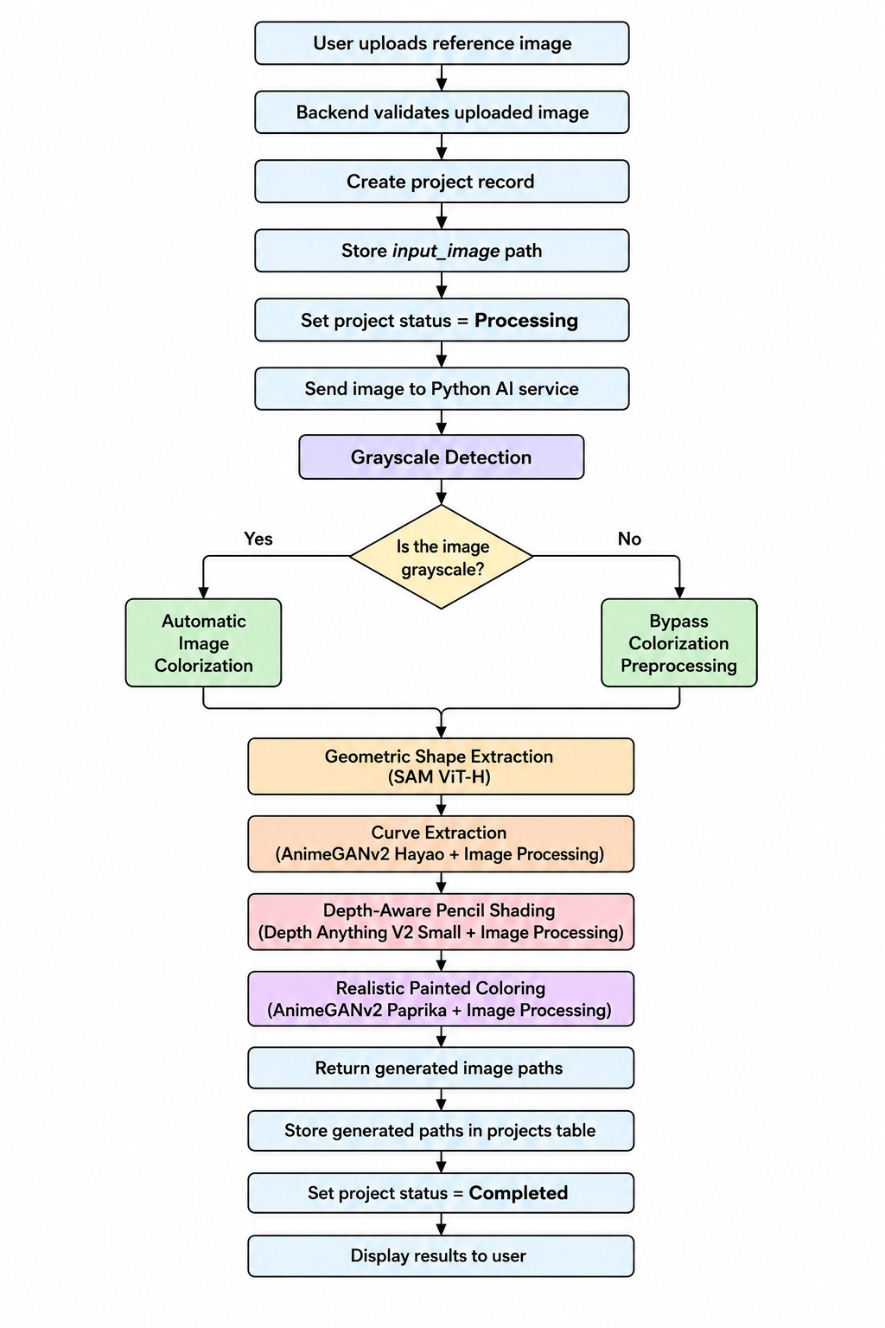
Our overall data flow is:

The generated image files are stored in the application's upload/output directories, while the database stores the corresponding file paths.
For the main processing stages, the database maintains:
- input_image
- geometric_image
- curve_image
- shading_image
- coloring_image
The automatic colorization result is an intermediate preprocessing output and is therefore not required as a separate persistent field in the current projects table.
This approach prevents us from storing large image binary data directly inside the database. Instead, the image files are maintained in the application's file system while their corresponding paths are stored in MySQL. This allows the backend and frontend to retrieve and display the required project images efficiently.

SECTION 04: INTERFACE DESIGN ASPECTS

4.1 Input Design
In our interface design, we aim to keep the workflow understandable for users who may not have previous experience with AI-based drawing applications.

4.1.1 Registration Interface
In our registration interface, we collect:
- Full Name
- Email
- Password
- Confirm Password
We validate whether the password and confirmation match before submitting the request.
We also perform password validation and direct the user to the verification process after successful registration.

Figure : Registration interface implemented in our application
4.1.2 Login Interface
Our login interface contains:
- Email
- Password
- Remember Me
- Forgot Password
After successful authentication, we maintain the user information through our authentication context and redirect the user to the dashboard.
If authentication fails, we display the corresponding error message.

Figure : Login interface implemented in our application

4.1.3 Project Upload Interface
Our upload interface allows the user to:
- select a reference image;
- drag and drop an image where supported;
- preview the selected image;
- enter a project title;
- enter an optional description; and
- submit the project for AI processing.
We currently support:
JPG, PNG and WebP
with a maximum upload size of:
5 MB
After submission, our backend creates the project record, changes the project status to Processing, and sends the reference image to our Python AI service.
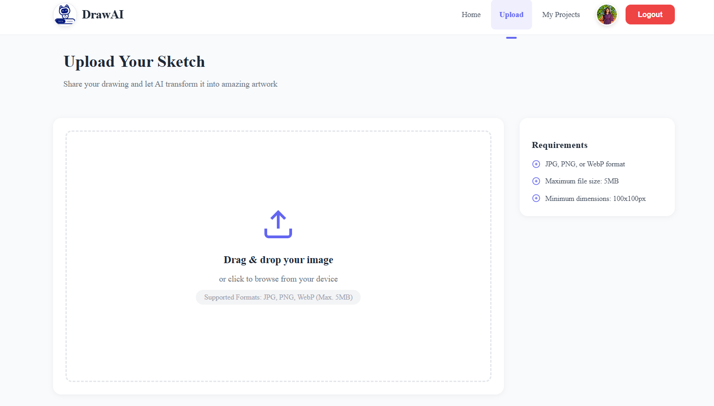
Figure : Project upload interface implemented in our application

4.2 OUTPUT DESIGN
After AI processing, we present the generated stages to the user.
Our output design allows the user to observe the progression from basic construction to the final coloured output.

Geometric Output
We display the simplified structural output generated using SAM and our geometric post-processing.

Curve Output
We display the curve guide generated using the AnimeGANv2 Hayao intermediate representation and our edge-processing techniques.

Shading Output
We display the depth-aware pencil shading generated using Depth Anything V2 together with luminance, hatching and compositing.

Coloring Output
We display the final painterly coloring generated using AnimeGANv2 Paprika and our color/detail-preservation processing.
Our project status is updated during processing.
The main states include:
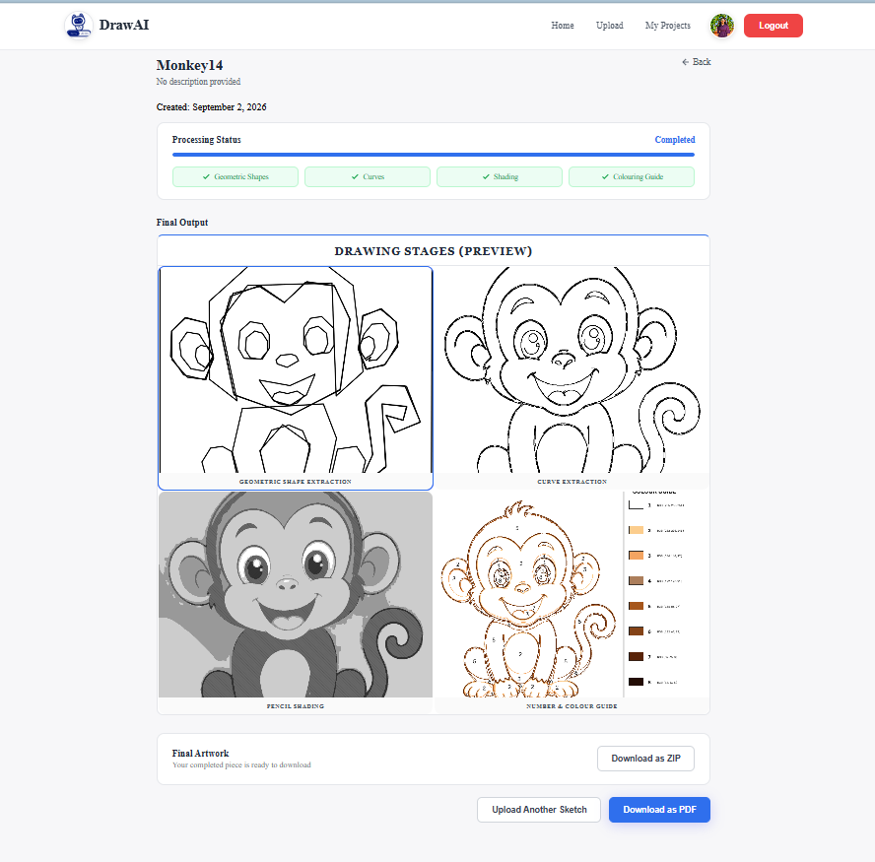
Waiting → Processing → Completed

Figure : Generated stages displayed in our View Project interface
4.3 DIALOG DESIGN
We provide feedback messages for validation, authentication and AI-processing operations.

Upload Validation
Examples include:
Reference image is required.
Only JPG, PNG and WebP images are allowed.

Authentication
Examples include:
No token provided. Please log in.
Session expired or invalid token. Please log in again.
For administrator-only operations:
Access denied. Admins only.

Processing Feedback
When a project is submitted, we change its status to Processing.
After successful processing, we save the generated output paths and change the project status to Completed.
When an error occurs, we return an error response so that the frontend can inform the user.

Section 05: Students' Declaration
DRAFT COMPLETION NOTE: Replace all 'required/planned EC05 experiments', placeholders and conditional statements above with actual measured results, final model names, screenshots and implemented database behavior before signing this declaration.
All the information stated in section 1,2, 3, and 4 is completed and ready to demonstrate in the examination of EC05.
Registration Number | Index Number | Name | Signature
ICT/2022/079 | 5683 | M. Ridhurshan | 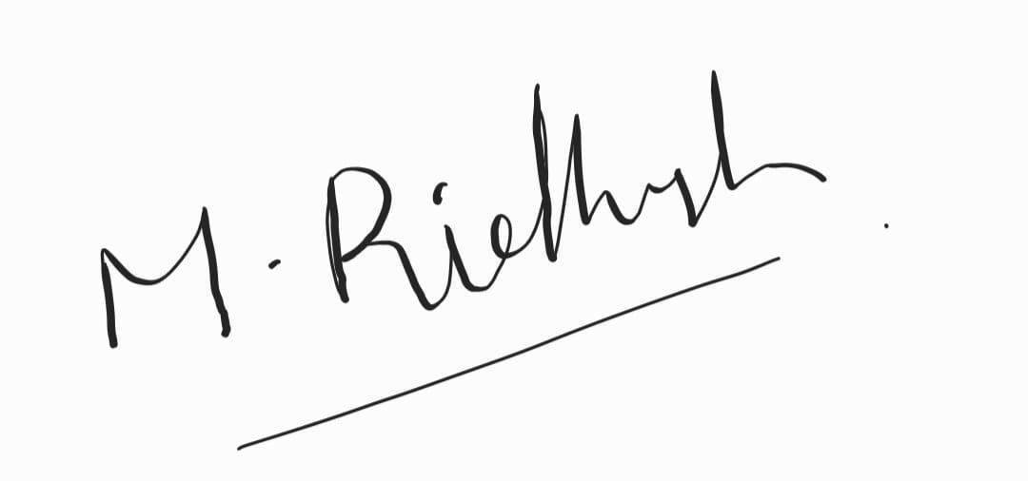
ICT/2022/016 | 5623 | R. Shobana | 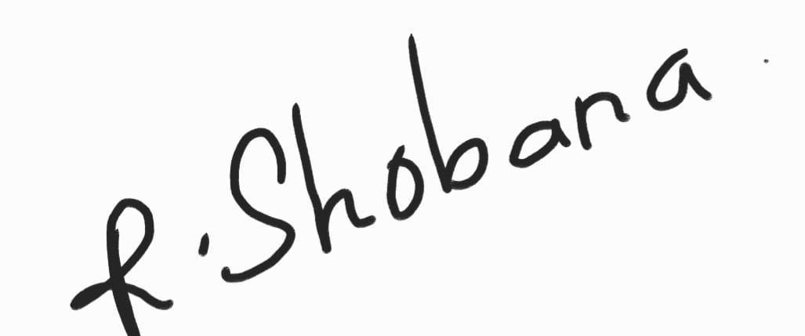
ICT/2022/017 | 5624 | S. Danusha | 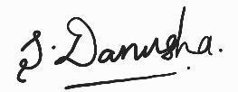
ICT/2022/134 | 5735 | R. Anusha | 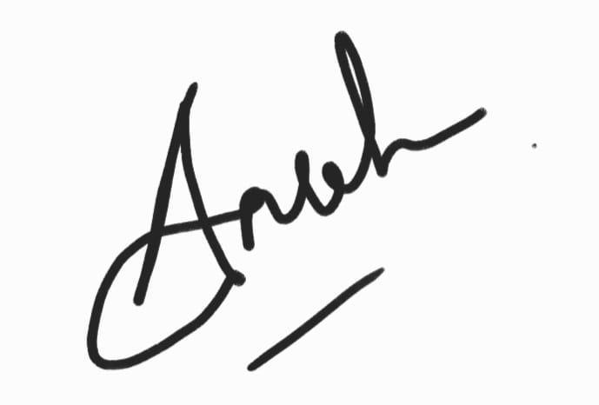
ICT/2022/127 | 5728 | A.N.M. Rifky

Date: 03.09.2026

Section 06
Supervisor Declaration
Supervisor Declaration I agree / disagree with the information stipulated in this application form.
Name: Mrs. M. M. A. Nisansala and Ms. A.S.S.P. Subasingha
Department :Department of Computing Faculty of Applied Sciences
Signature:……………………………..
Date: …………………………………..

