COVID-19’s Economic Impact

Master’s Final Research Projecy

Ridhwaan Ali

Abstract

This report will discuss and show how much COVID-19 has impacted the world economically. The report shows data that was collected to establish the visualizations of how much the economy was affected. With the data it also draws conclusions and shows how the economy would look in the future with predicted data. The purpose is to help high level enterprises see the impact a pandemic of this caliber can affect the world, and how should they prepare for another pandemic of this caliber.

Introduction

Covid-19 also known as the Corona Virus was a big pandemic that will forever be remembered in history. According to the CDC’s page, Covid-19 officially was reported in China in December of 2019, and the vaccine was approved by July 2022 (CDC 2023). This pandemic started the new decade of 2020 to be chaotic health wise. With human health suffering, it was difficult for companies to run their businesses if their employees were constantly getting sick from this virus. This caused many small companies to go out of business, and many big companies to decrease in business. This resulted in the entire world to face economic struggles due to this pandemic. Many enterprises should be aware and prepared of such tragedy occurring once again. In this report, I will show what could happen to the economy if caution isn’t taken into consideration beforehand. There is no telling when another pandemic can happen, but now the world is aware of the signs if another one approaches; such as it spreading rapidly across the globe. I will discuss my approach which is my idea, the process of how I go through with this idea, the world economy data and visualization, and the results.

Approach

With Covid-19 ending around 2022 or 2023, I wanted to study how much this pandemic effected the entire world. I needed to think of a metric to use to measure the economy of countries, or on a bigger scale, continents. At the moment I was taking a data analytics / data science course that actually deals with economic metrics. It was then I decided, I was going to study the GDP of each continent. The GDP according to a site called Investopedia, is the Gross Domestic Product, and it measures he overall domestic production and it is measured by score of the economic health (Fernando, 2024). I needed a suitable time table to show how much the economy changes because of this pandemic. I decided to gather data starting from 2014 and ending in 2023, to study how the economy was before covid-19 and after. I needed a way to predict data because I need to show how it can affect the future; I decided to do that through Jupyter Notebook because Jupyter Notebook can predict future data with machine learning and give visuals as well. With all of that planned out, I began my research.

Process

I started my research by looking for GDP data, and I found the data on the INF’s, International Monetary Fund’s, website. This website has the GDP recorded from all the regions of the world and also from every recordable time period, as well as the predicted GDP. I gathered data from Africa, Asia, Middle East and Western Hemisphere. After gathering the data, I started to organize it and trim down the data to what is only needed. With the Africa and Asia data, I had to separate it two separate parts because I later realized some data was missing. I loaded the data into Jupyter Notebook to begin manipulating data. I was able to load them into Jupyter Notebook and trim down data and also merge data frames. However, as I was in the process of making prediction variables for the data, I encountered errors with the data. It was most likely an issue with the file type because it could not recognize the number type in the data frame itself. After various trouble shooting, I decided to think of another plan to predict data. I used excel and took the average difference from 2019 to 2022 of each continent, because that was the start and end of covid-19. With that average difference, I then used the predicted data from 2024 and 2025 from the INF website, and multiplied the difference of each region to predict 2026 to 2028. With that I was able to create a visual to show what would happen if another pandemic with same level of difference were to occur in the future. When it came to making visuals, the same issue occurred for me in Jupyter Notebook; so then I decided to use PowerBi to make the charts to show the GDP from 2014-2023, and the predicted GDP from 2024-2028.

Africa

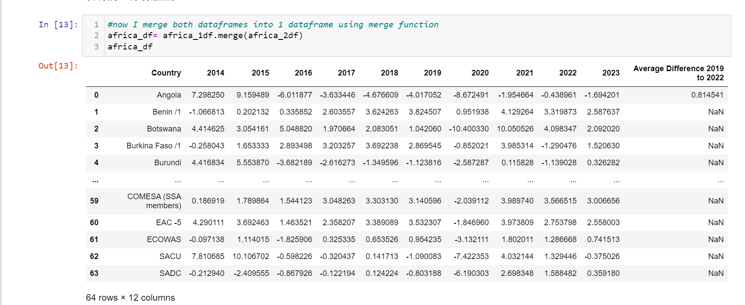

This is Africa’s GDP from 2014-2023. I added the average difference from 2019-2022 shown in the last column.

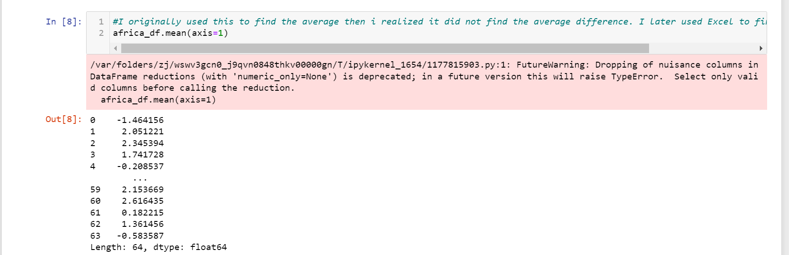

This is the average difference that Jupyter Notebook found for Africa’s GDP.

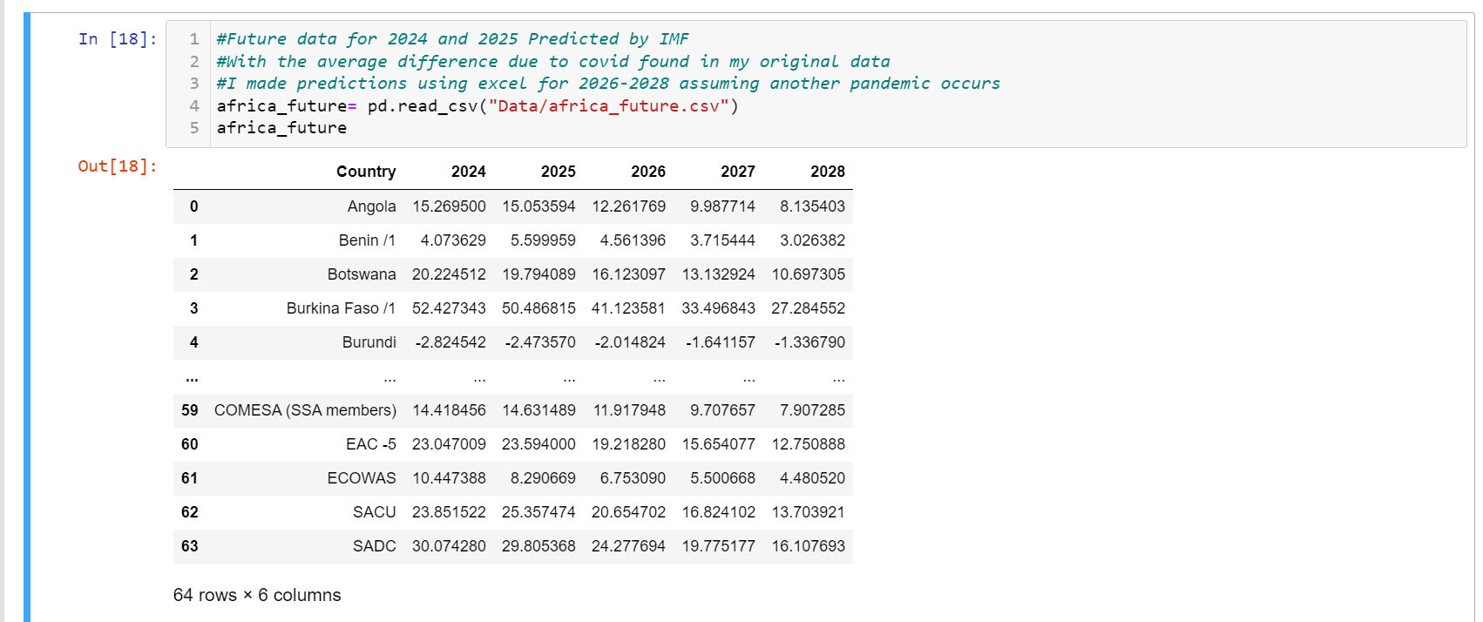

This is the predicted GDP for Africa from 2024-2028. 2024 and 2025 was predicted from INF, but I used the average difference found in excel to predict 2026 to 2028. I multiplied the percentage from 2025 to get 2026, and then multiplied that same percentage to 2026 to get 2027, and so on.

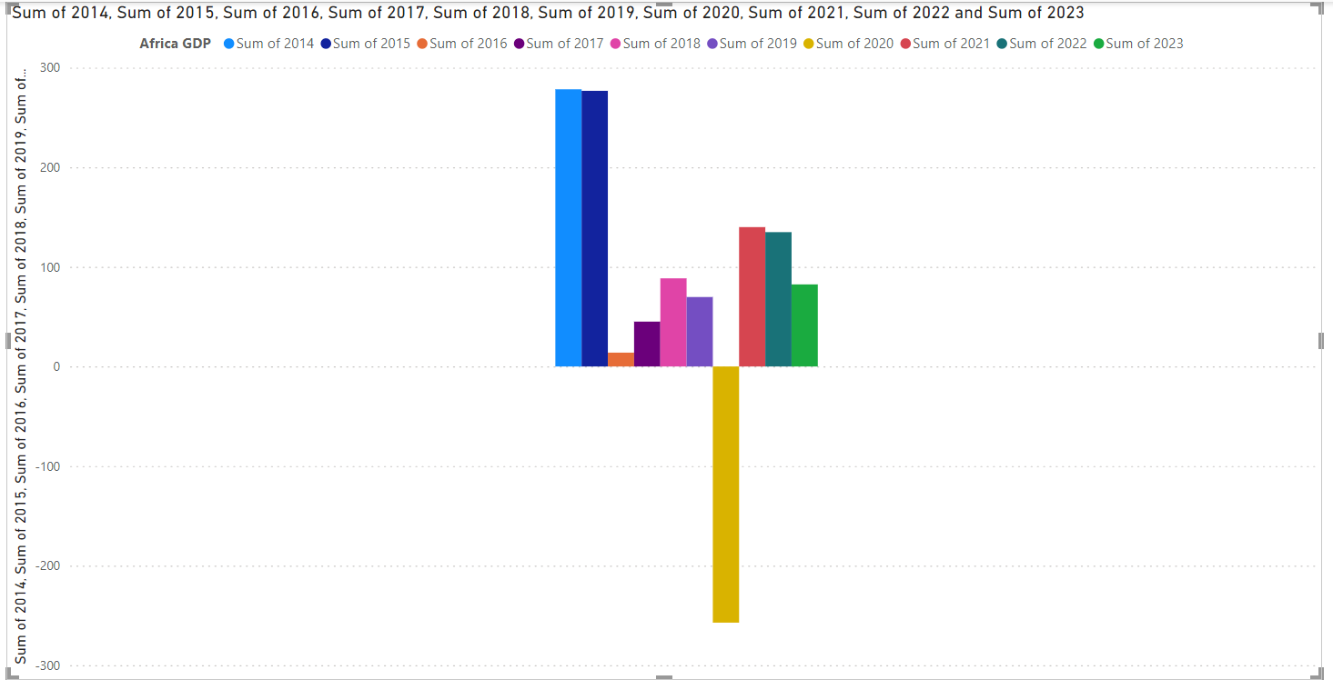

This is the bar chart of Africa’s GDP from 2014 to 2023. Note 2020 which is the yellow bar, it went to the negatives. This was actually the second lowest recorded GDP region found reaching a near -300 GDP score.

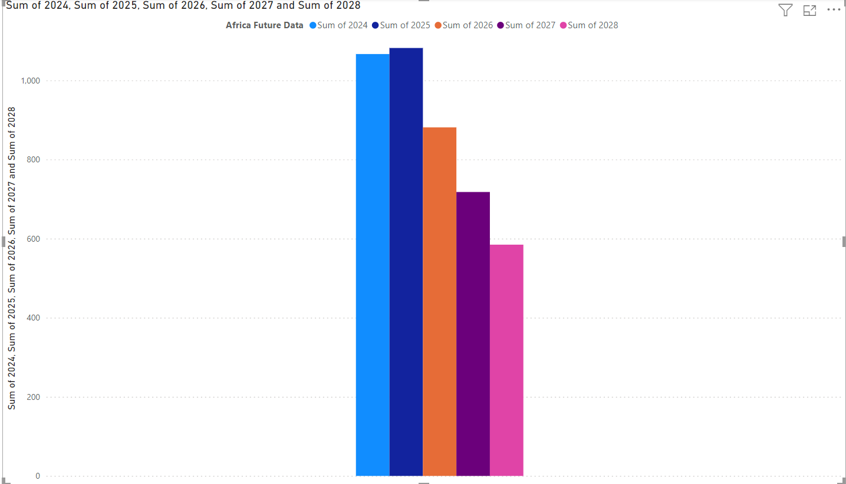

This is the predicted GDP from 2024 to 2028 for Africa. It is noted that it is a steady decrease mainly because I used a constant decrease; even though realistically speaking it won’t constantly decrease, but it shows how much of a difference it has on the economy.

Asia

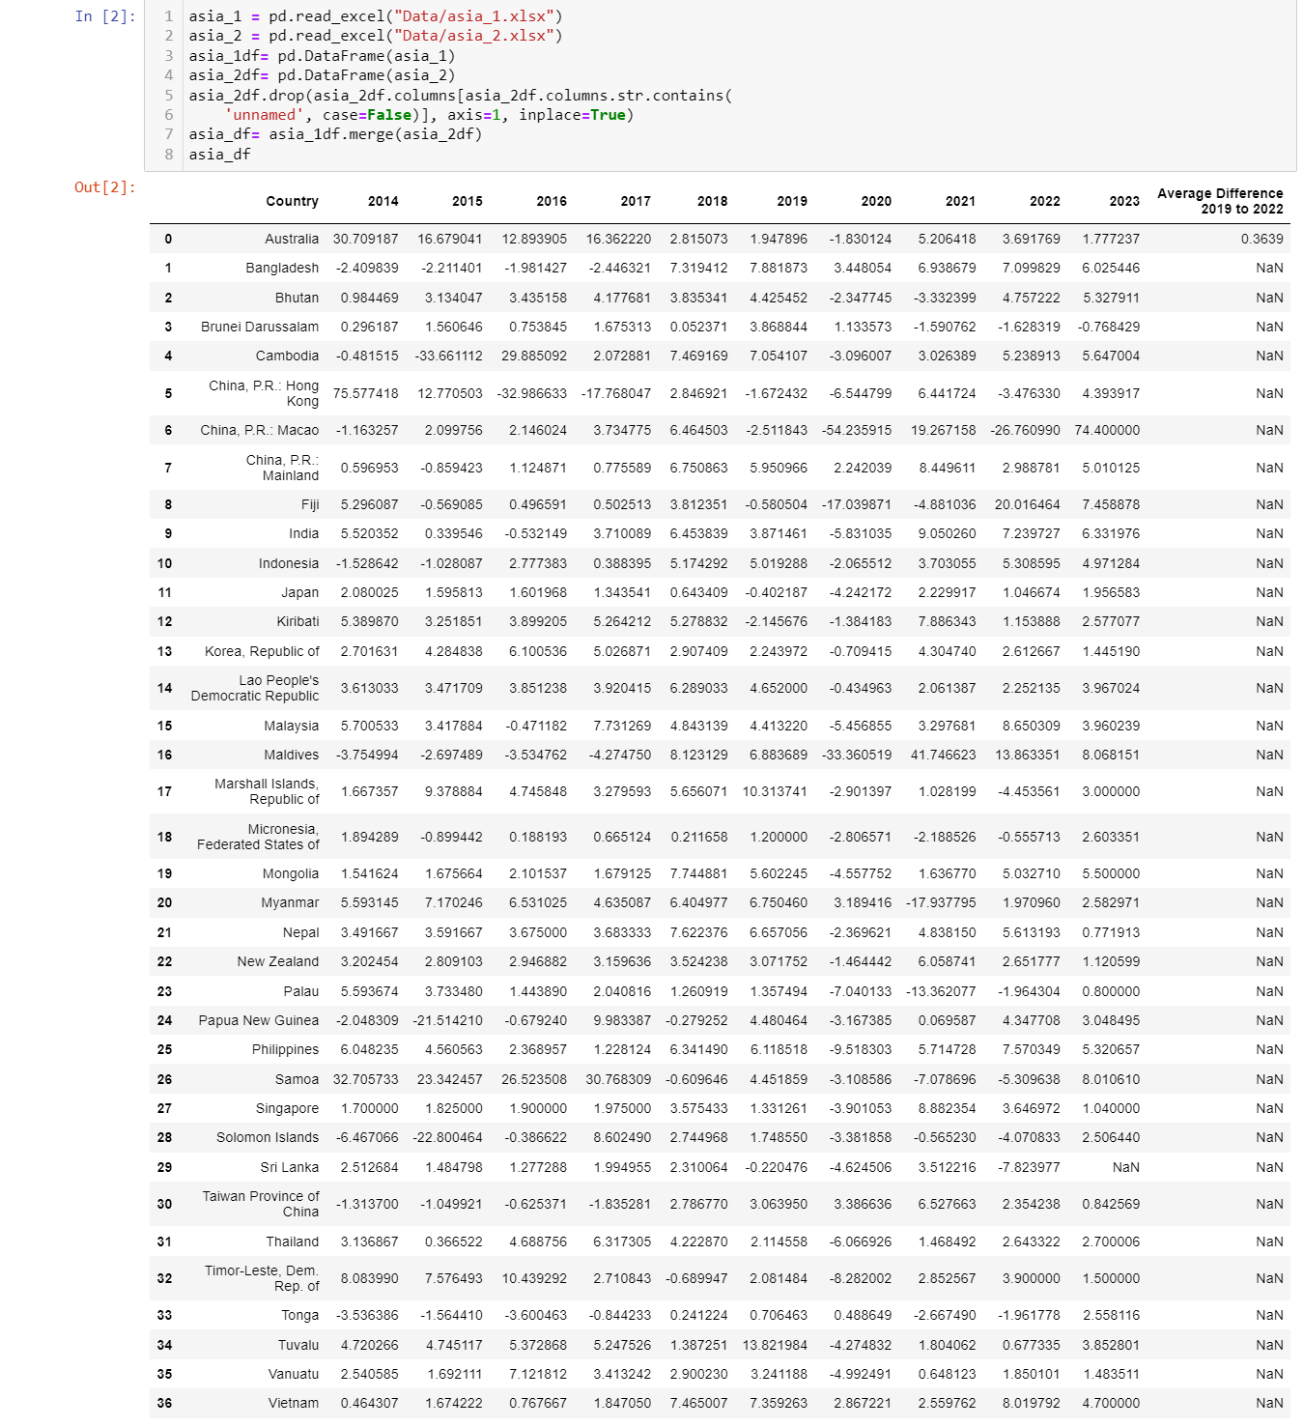

This is the GDP for Asia in 2014-2023. I found the Average difference same way for all the tables and left it on the last column.

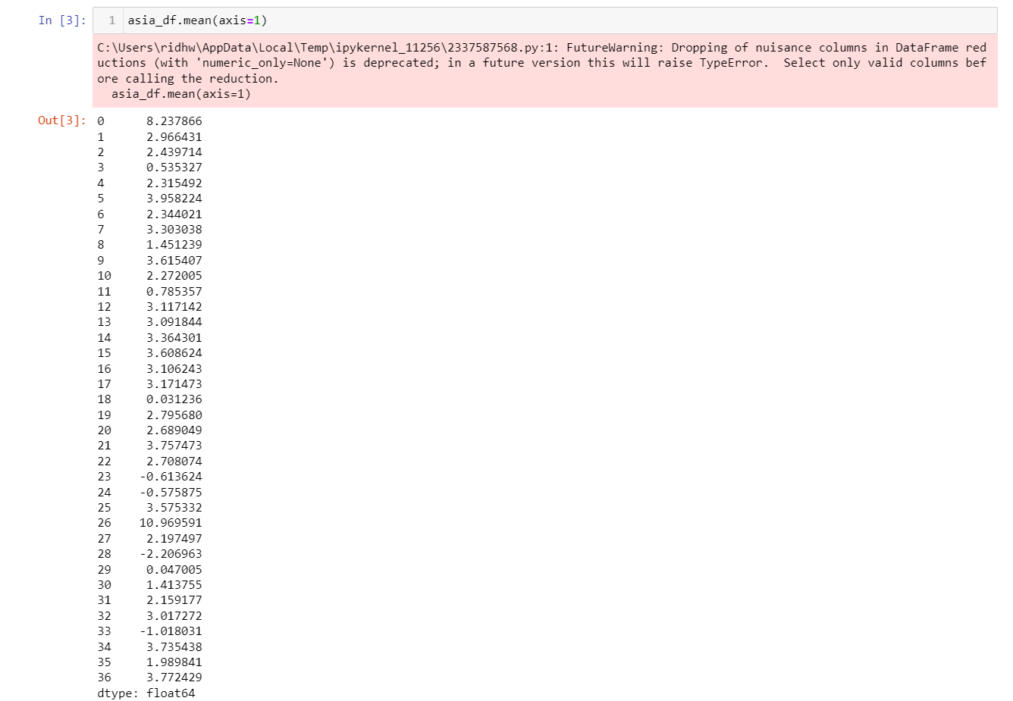

This is the average difference found for Asia using Jupyter Notebook

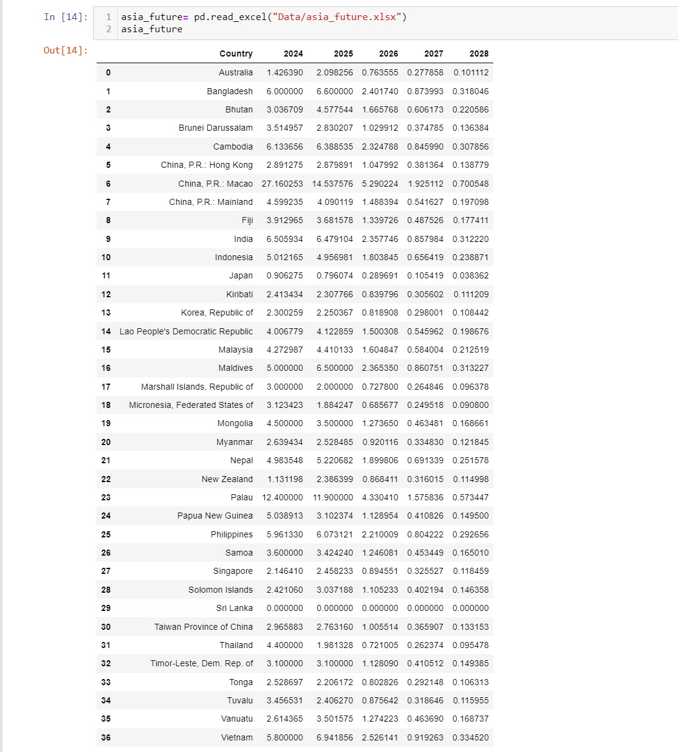

This is the predicted GDP for Asia from 2024 to 2028. 2024 and 2025 are from INF’s website and 2026 to 2028 was found by multiplying the average difference to 2025 and so on.

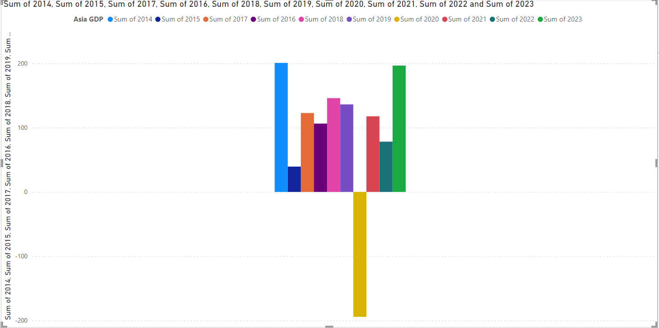

This is the chart of Asia’s GDP from 2014 to 2023. Again it is noted in 2020, the yellow bar, the decrease was substantial. This was the third lowest GDP recorded for 2020 reaching nearly -200 GDP score.

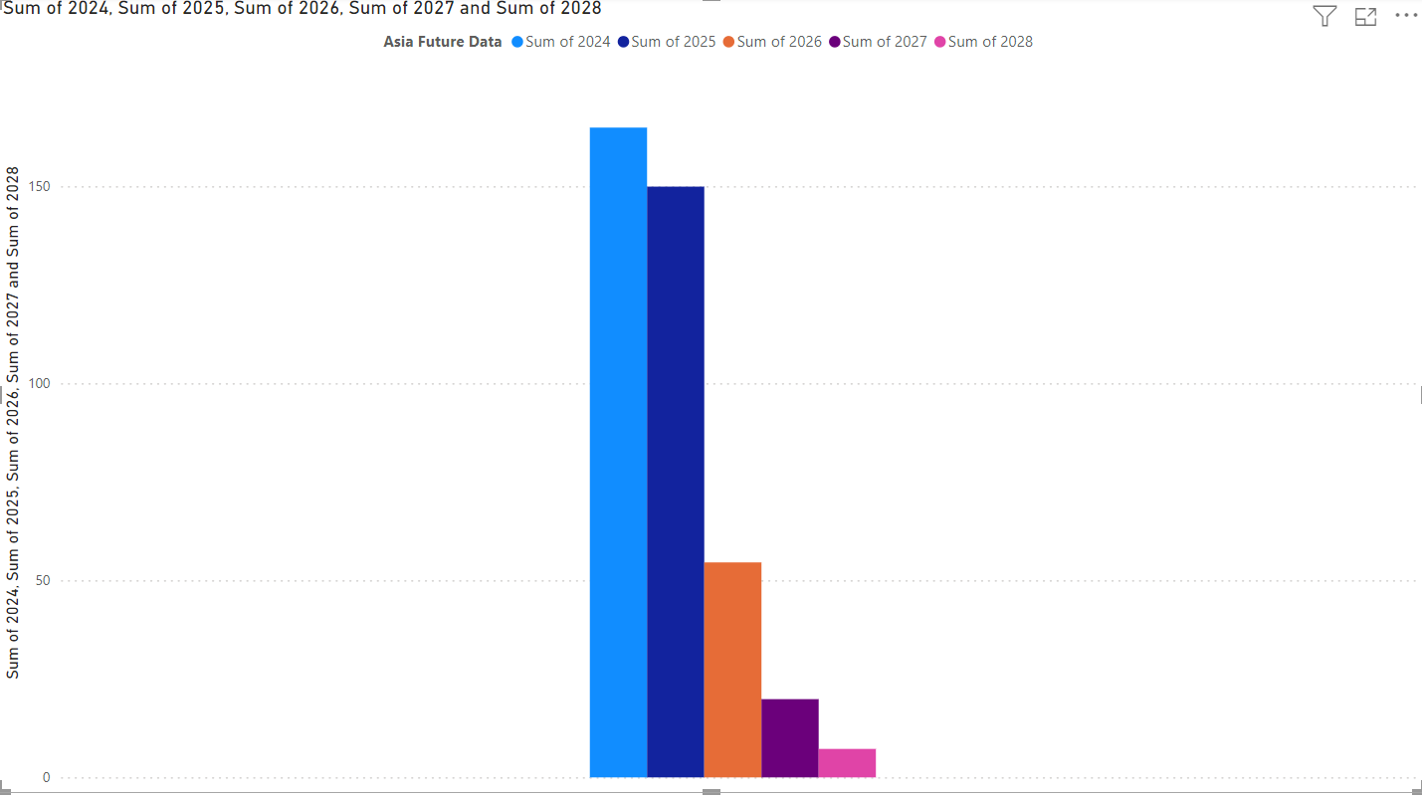

This is the predicted data for Asia’s GDP from 2024 to 2028. The average difference was pretty big which caused a drastic dip in 2026 shown in the orange bar.

Middle East

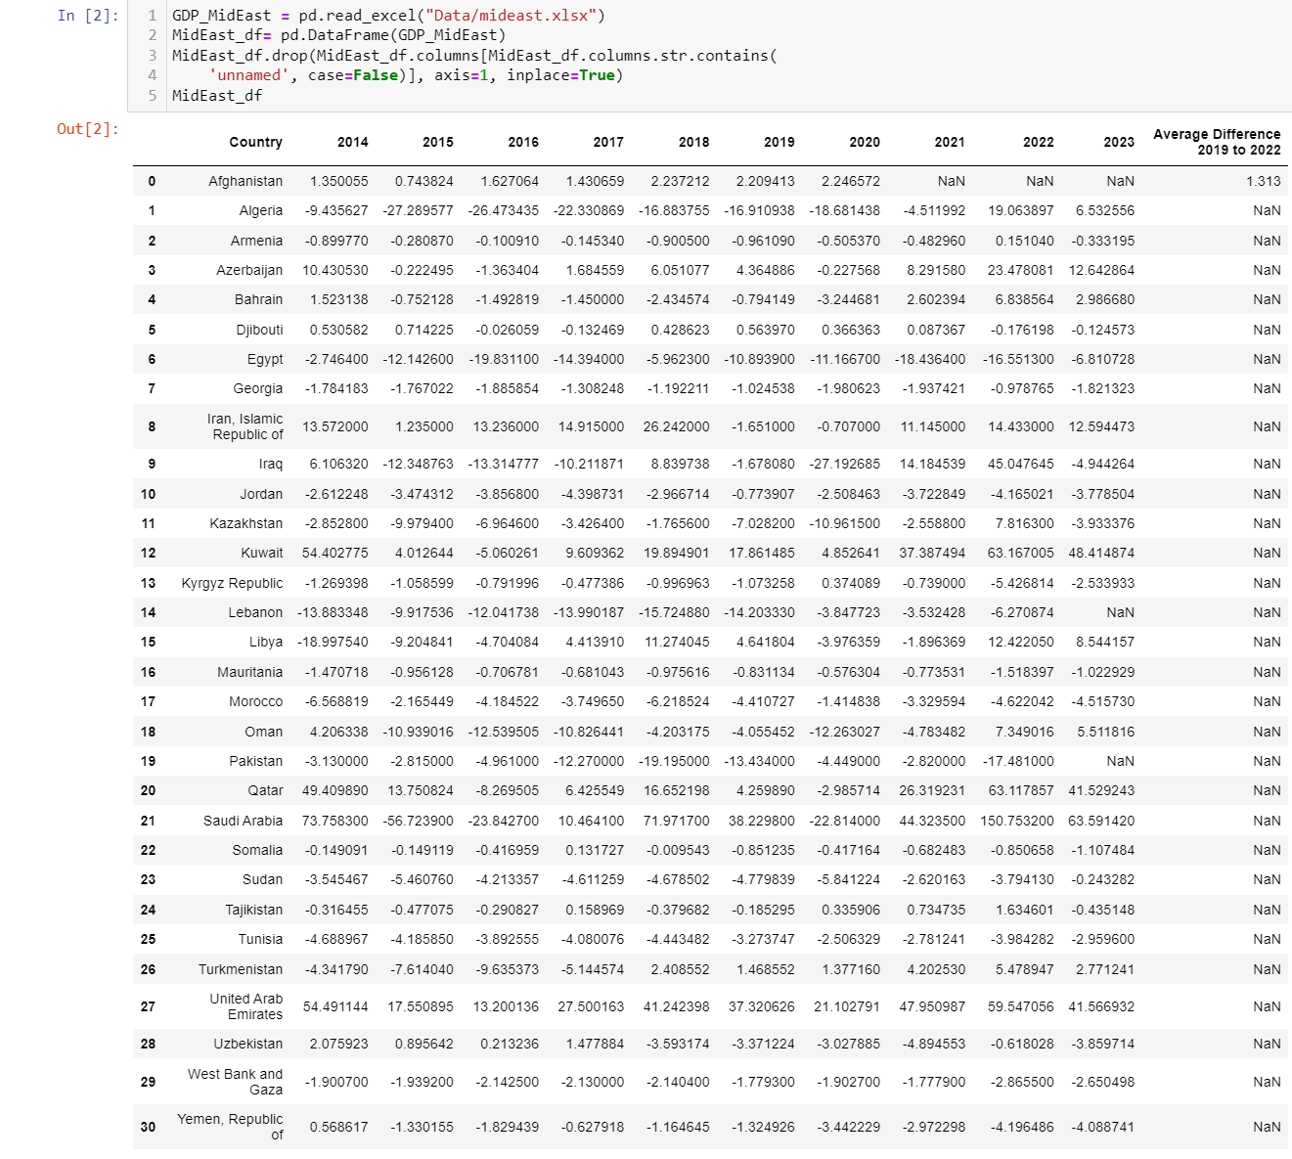

This is the GDP of the middle east from 2013 to 2024. Average Difference found in the last column. It is noted of all the average difference found, middle east had the lowest average difference, meaning it effected the economy the least. Also it is noted that GDP were insanely high reaching past 3 digits in comparison to the other religions.

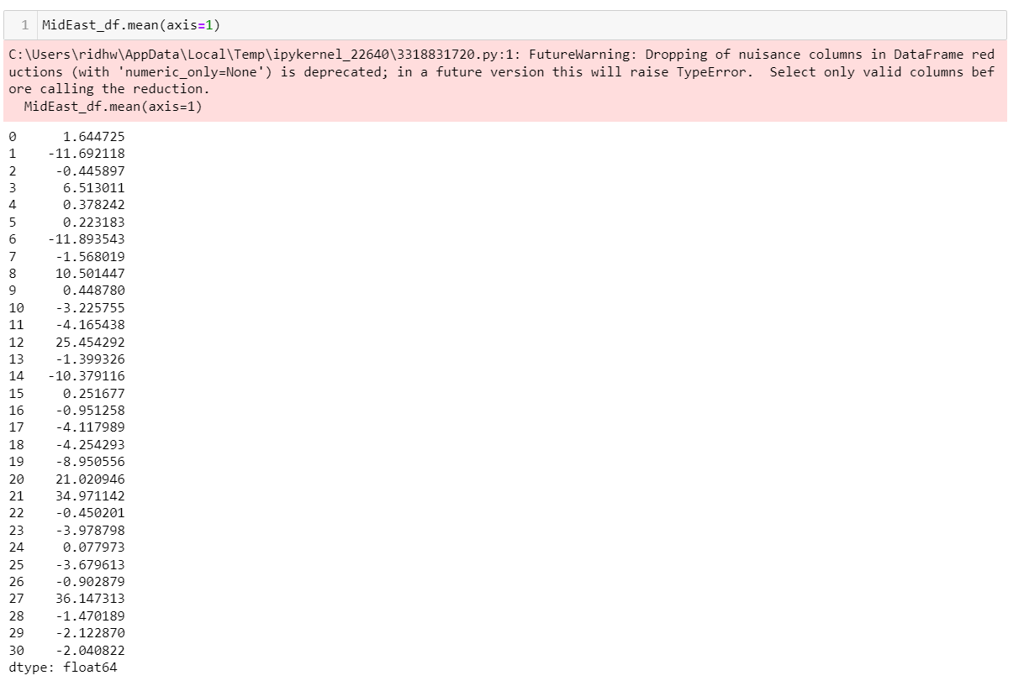

This is the average difference found in Jupyter notebook

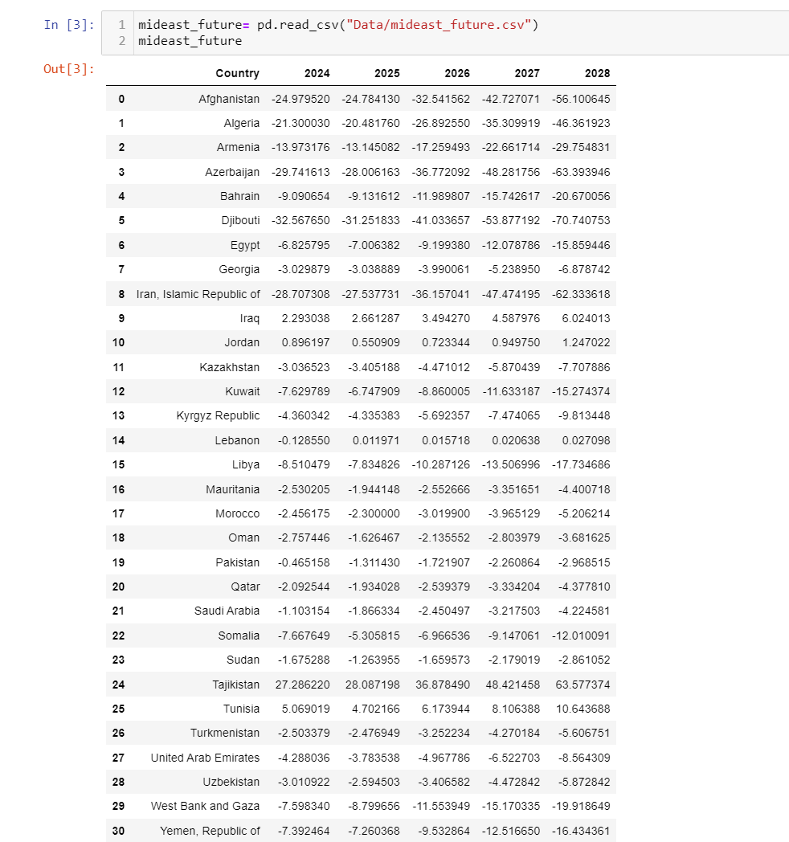

This is the future GDP from 2024 to 2028. I noticed the numbers were still very substantial.

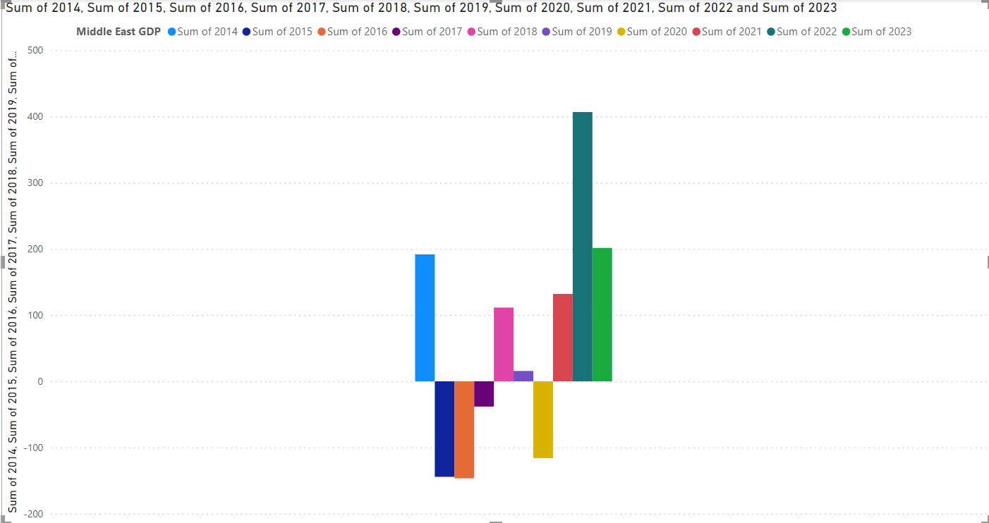

This is the chart of the GDP from 2014 to 2023. This chart was very interesting, considering the chart shows a lot of difference in increase and decrease. It is noted that 2020 was not the biggest decrease either. My only assumption for this, has to due with war conflicts effecting the economy even more.

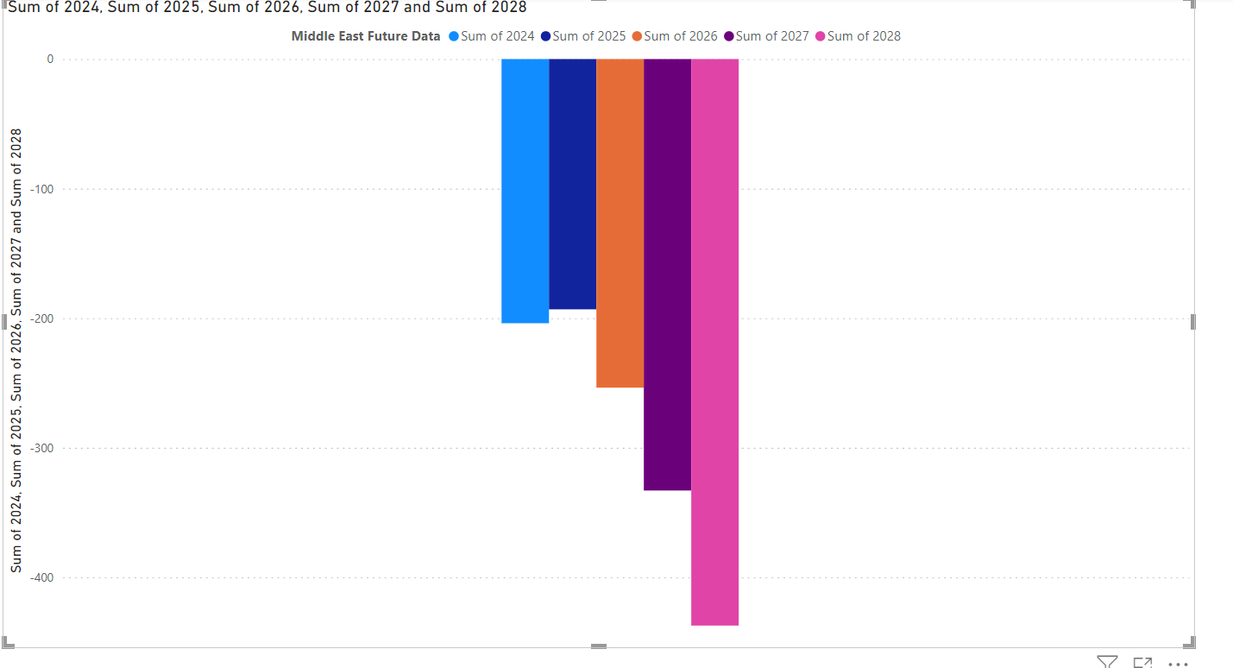

This is the future GDP chart. This was very interesting as it is predicted 2024 and 2025 will have negatives and if the average difference is multiplied it does not change the economy much.

Western Countries

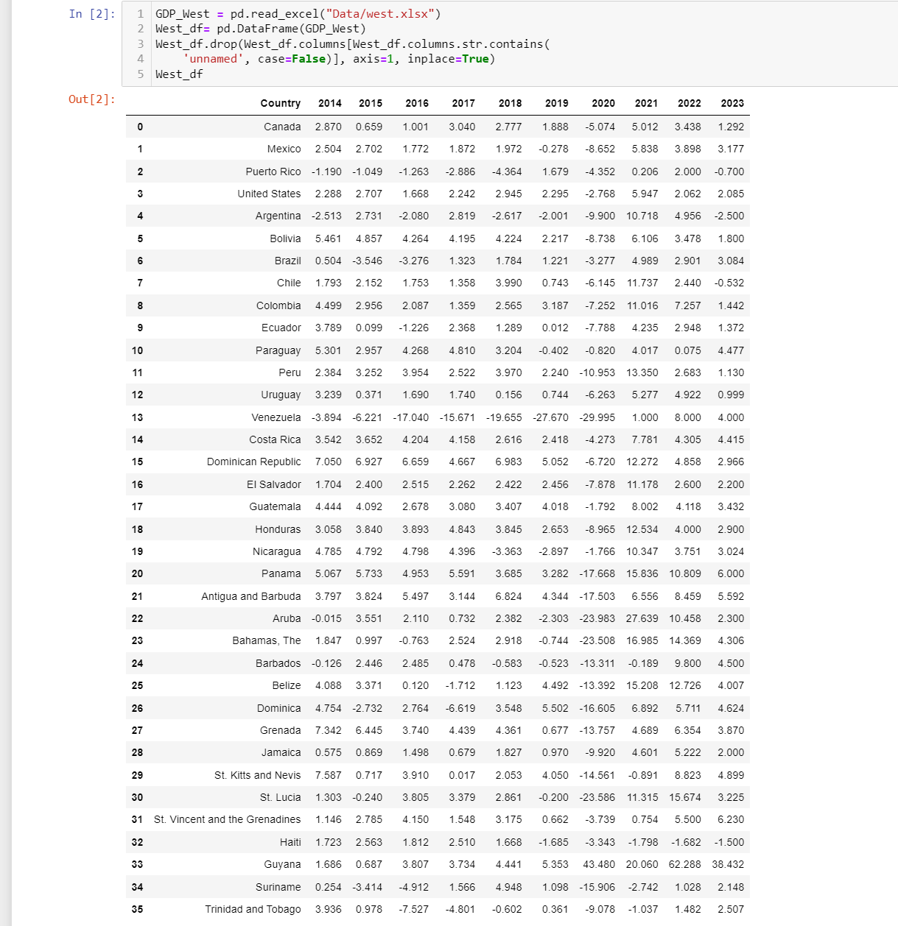

This is the GDP of the western countries. For some reason the average difference column did not load on this table.

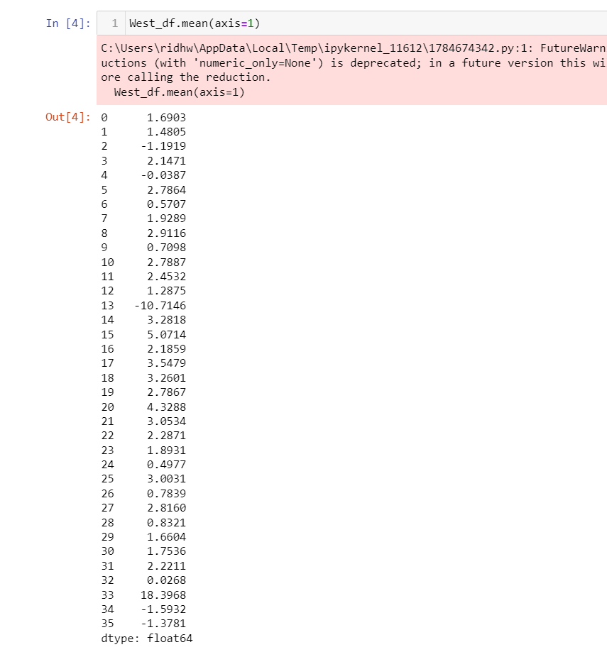

The average difference found in Jupyter notebook

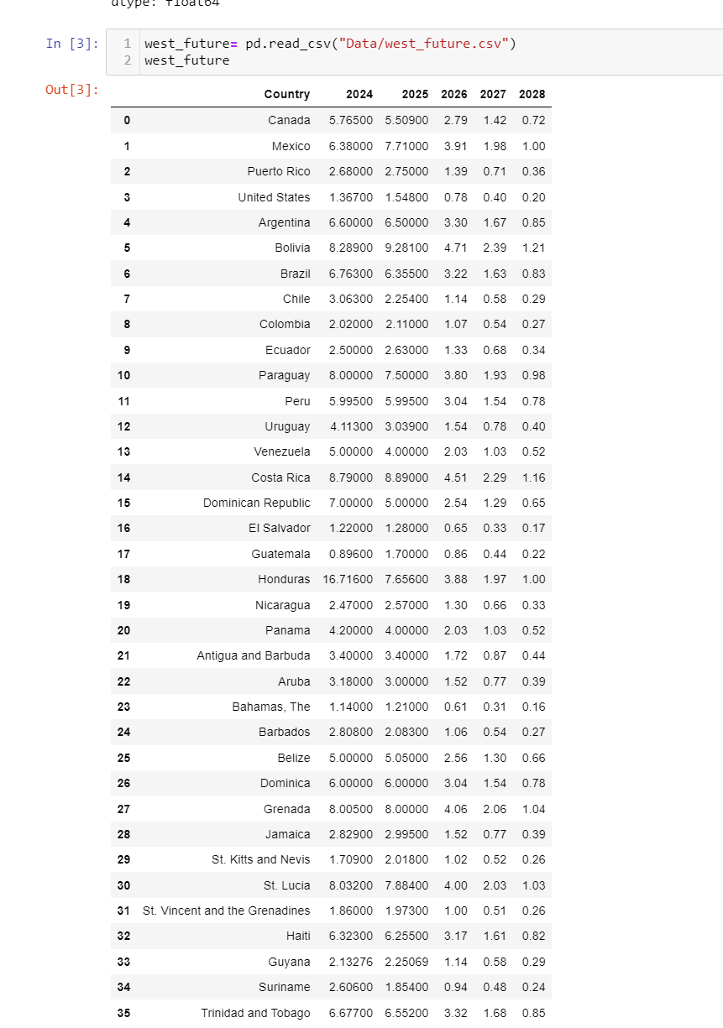

This is the predicted GDP from 2024 to 2028. At first I did not believe the decrease was going to be that significant, but once I saw it on the chart it showed a huge difference.

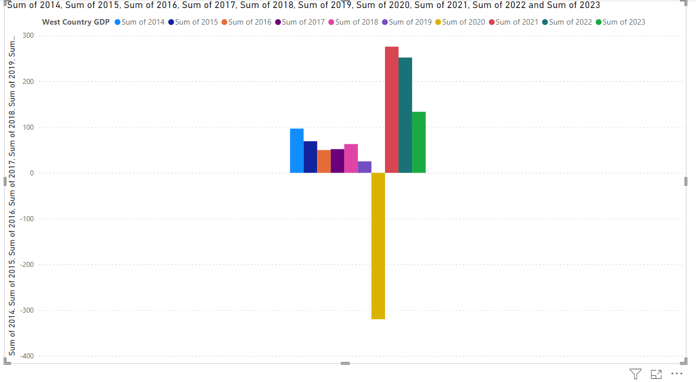

This is the GDP from 2014 to 2023. Of all the regions this is the lowest GDP recorded in 2020 reaching passed -300. However it is also noted this was the biggest increase following 2020 because the GDP is almost at positive 300 the following year.

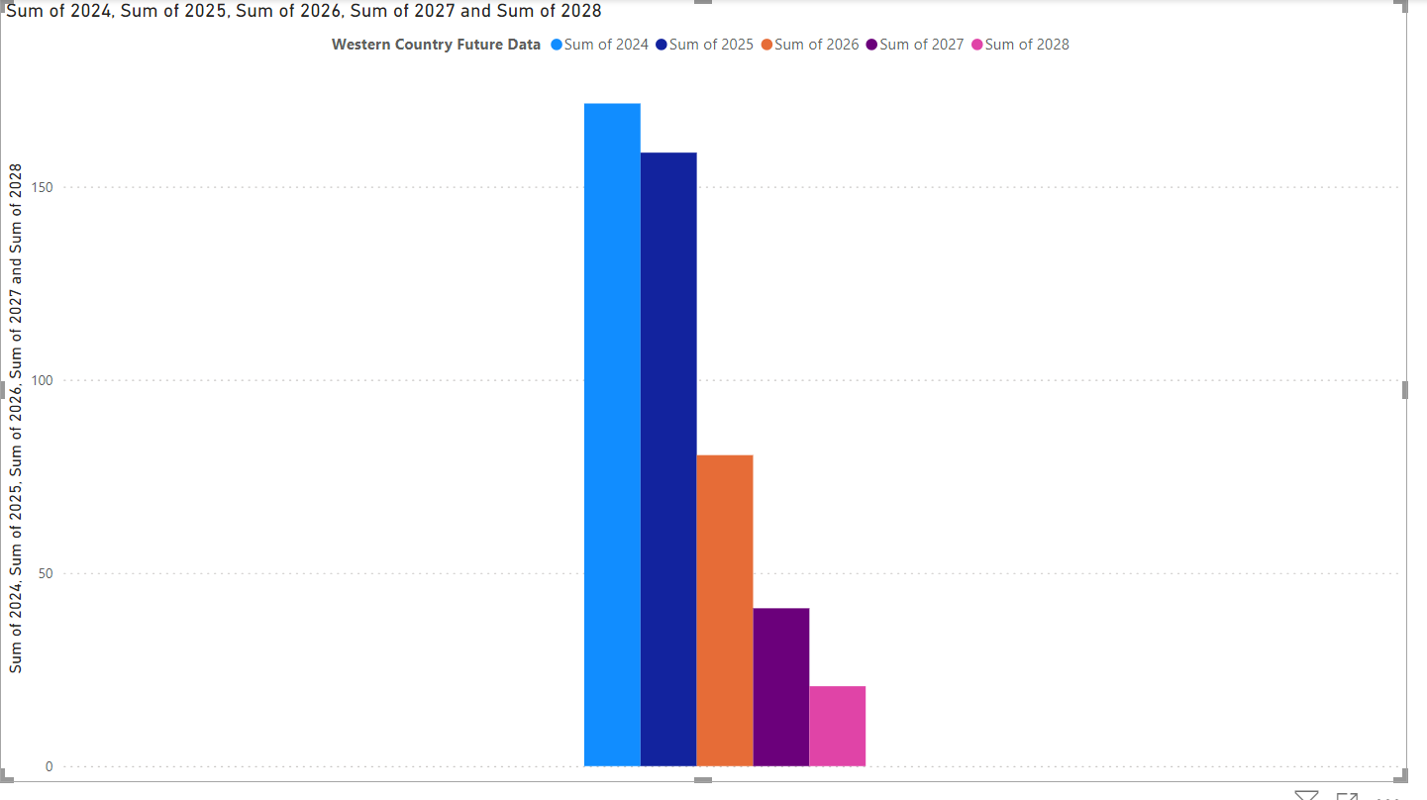

This is the predicted GDP from 2024 to 2028. As mentioned before, as soon as I saw this data visually, I saw a drastic decrease in the economy. It should be expected considering this region had the lowest GDP in 2020 which was the peak of covid-19’s impact.

Conclusion

Based on the data I found and visualized, Covid-19 has affected the world economically. It is shown to effect mainly the western countries with the lowest GDP score in 2020; which means the western countries need to be extra prepared for another pandemic to hit. Since it was said Covid-19 began in December 2019, and it took about a few months for it to spread around the world, the best course of action would be to prepare after a few weeks of seeing the first case. Considering if the measures aren’t taken cautiously, it will effect the world’s economy for several years as shown. There is no telling when another pandemic can occur, but a pandemic of this caliber changes the economy drastically and effect the future of enterprises.

Citation

“CDC Museum COVID-19 Timeline.” *Centers for Disease Control and Prevention*, 15 Mar. 2023, www.cdc.gov/museum/timeline/covid19.html.

Fernando, Jason. “Gross Domestic Product (GDP) Formula and How to Use It.” *Investopedia*, 29 Apr. 2024, www.investopedia.com/terms/g/gdp.asp#:~:text=Gross%20domestic%20product%20(GDP)%20is,in%20a%20specific%20time%20period.