Alberto Clocks
Sitemap & Navigation Flow
eProject (CPiSM) · Single-Page Application built with React and CSS · 27 October 2026

1. Overview
Alberto Clocks is a single-page, responsive website for a watch repair, appraisal and retail store. The whole site is one React application loaded from a single index.html. Choosing a menu item does not load a new page; React swaps the section shown in the main area, while the header and footer stay in place.
This document shows how the site is organised and how a visitor moves through it, using four diagrams:
- Figure 1 – Sitemap: every section of the site and what it contains.
- Figure 2 – Page layout: where the logo, visitor count, menu, content and ticker sit on desktop and mobile.
- Figure 3 – Navigation flow: what happens from the moment a visitor opens the site.
- Figure 4 – React component tree: how the sitemap maps onto React components and data files.

Technology choices
- React (created with Vite) for the single-page application.
- React Router (HashRouter) gives each section its own address, e.g. #/products/luxury, so the browser Back button works and the site runs on any static host.
- Plain CSS for all styling: colour scheme, menu hover and active colours, fade-in / fade-out transitions, the scrolling ticker (CSS keyframes) and media queries for mobile.
- JSON files as the data store: products.json for the watches and gallery.json for gallery images.

2. Sitemap
The root of the site is the React app. It has ten main menu sections. Products is the deepest branch: a visitor picks a line-up, sees the watches in it, then opens a popup for the details of one watch. The header and footer shown in the band at the top appear on every view.
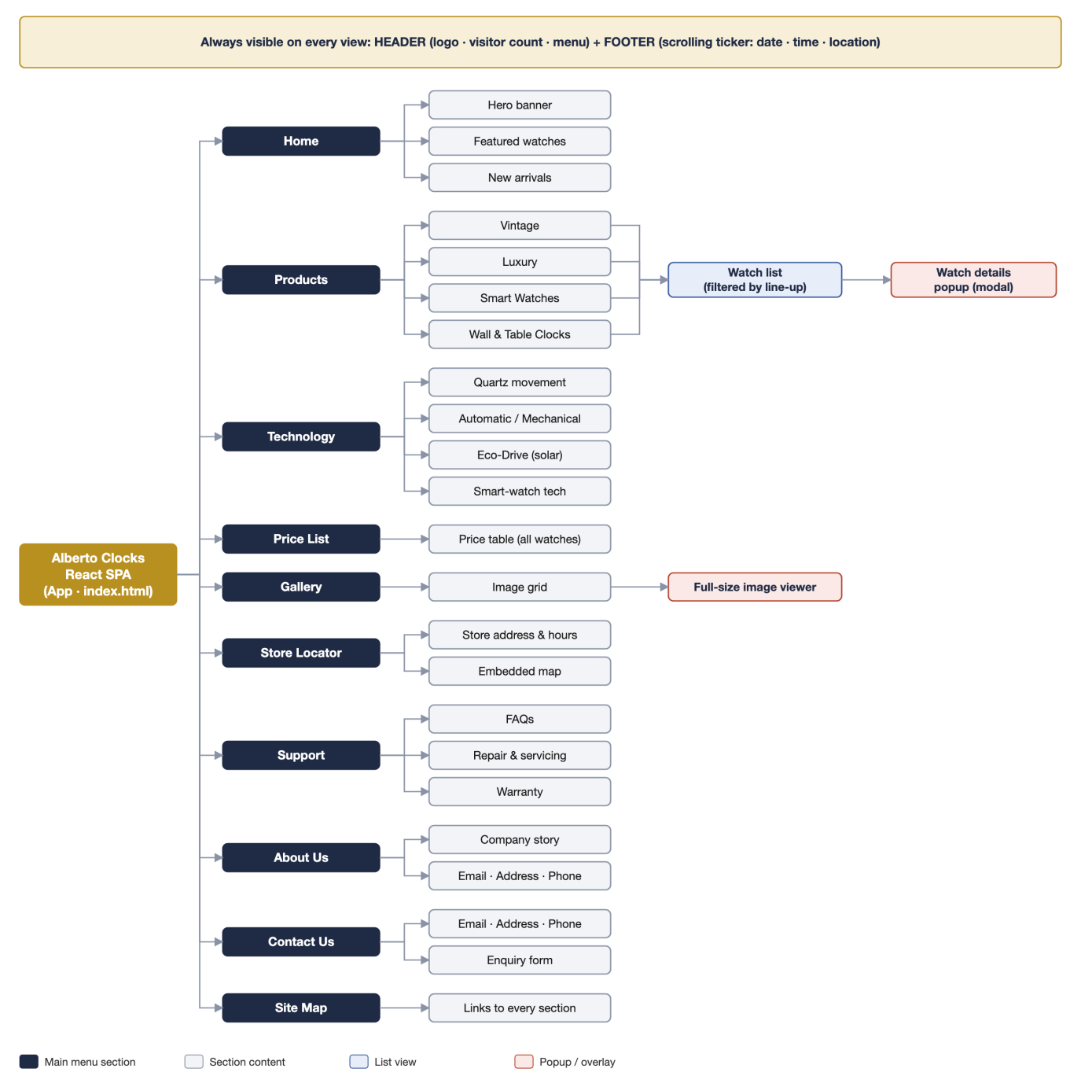
Figure 1 – Sitemap of the Alberto Clocks website

Sections, routes and requirements covered
Section | Route | What it shows | Requirement met
Home | / | Hero banner, featured watches, new arrivals | Logo, colour scheme, landing view
Products | /products/:lineup | Line-up tabs (Vintage, Luxury, Smart Watches, Clocks), watch cards, details popup | Product line-ups, full list per line-up, details in popup
Technology | /technology | Quartz, automatic, Eco-Drive and smart-watch technology | Technology used in the watches
Price List | /prices | Table of every watch with brand, line-up and price | Price list for all watches
Gallery | /gallery | Image grid; click to open full-size viewer | Gallery for viewing images
Store Locator | /store-locator | Store address, opening hours, embedded map | Store Locator menu option
Support | /support | FAQs, repair & servicing, warranty | Support menu option
About Us | /about | Company story, email, address, phone | About Us with contact details
Contact Us | /contact | Email, address, phone and an enquiry form | Contact Us with contact details
Site Map | /sitemap | Links to every section | Site map link

Header and footer (every page): logo and visitor count at the top right, the main menu that changes colour on hover and when clicked, and a continuously scrolling ticker at the bottom with the current date, time and location.

3. Page layout
Every view uses the same frame. Only the main area changes: the old section fades out and the selected one fades in. On screens 768 px wide or less, CSS media queries collapse the menu into a hamburger button and show one product card per row.
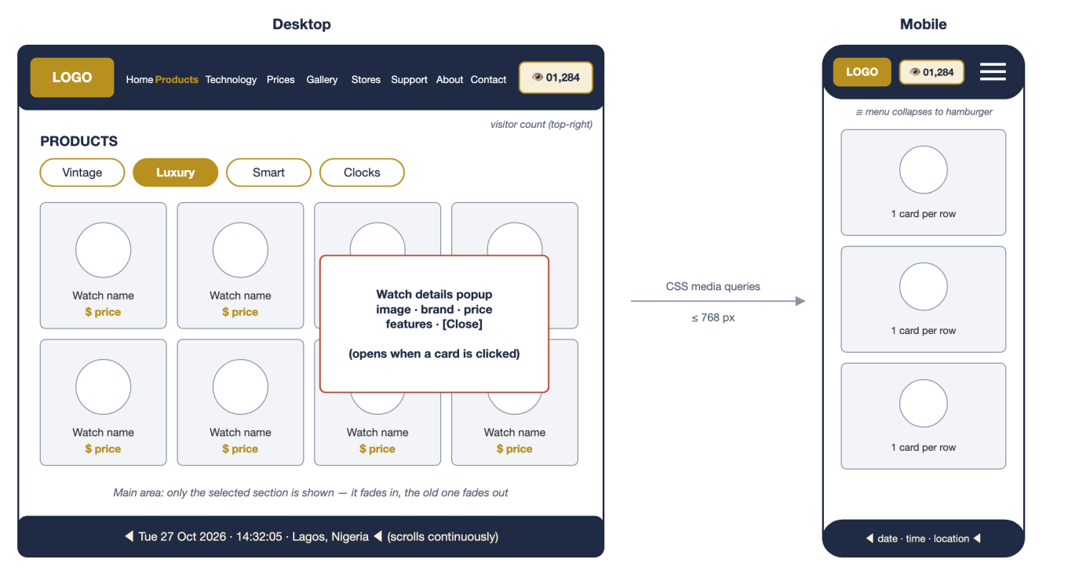
Figure 2 – Page layout on desktop and mobile

4. Navigation flow
When the site opens, it loads the product data, adds one to the visitor count and asks for the visitor's location for the ticker. If location is refused, the ticker still shows the date and time. After that, the visitor moves between sections with the menu; the Products branch leads to the watch list and the details popup.
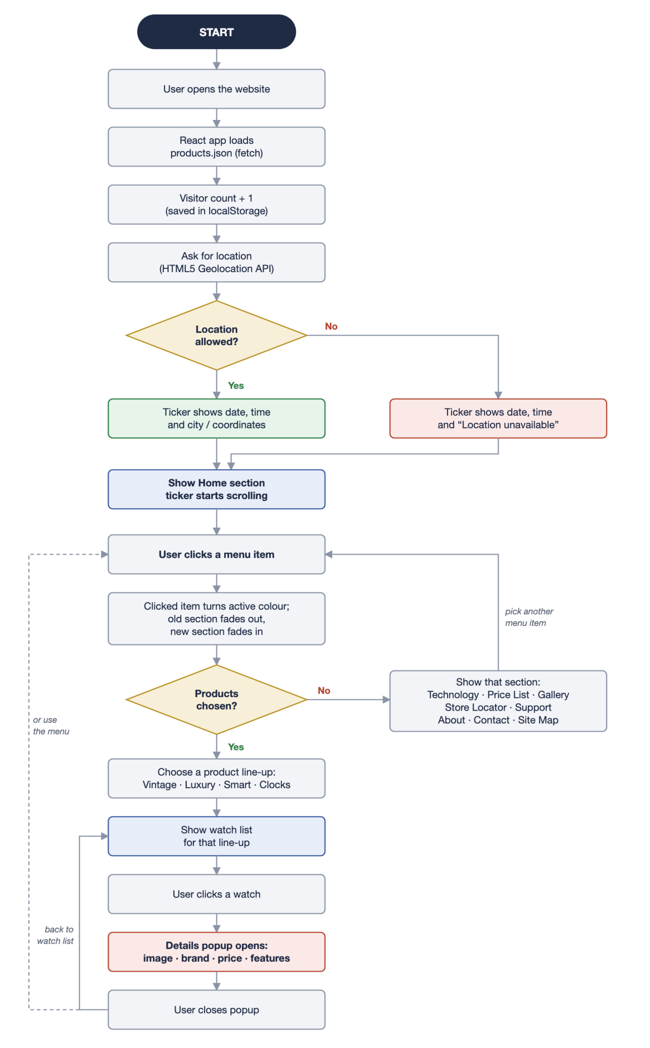
Figure 3 – User navigation flowchart

5. React component structure
Each box in the sitemap becomes a React component. <App /> wraps everything in the router; <Header /> and <Footer /> are always rendered, and <Routes> picks which page component to show. Custom hooks handle the visitor count, the clock and geolocation.
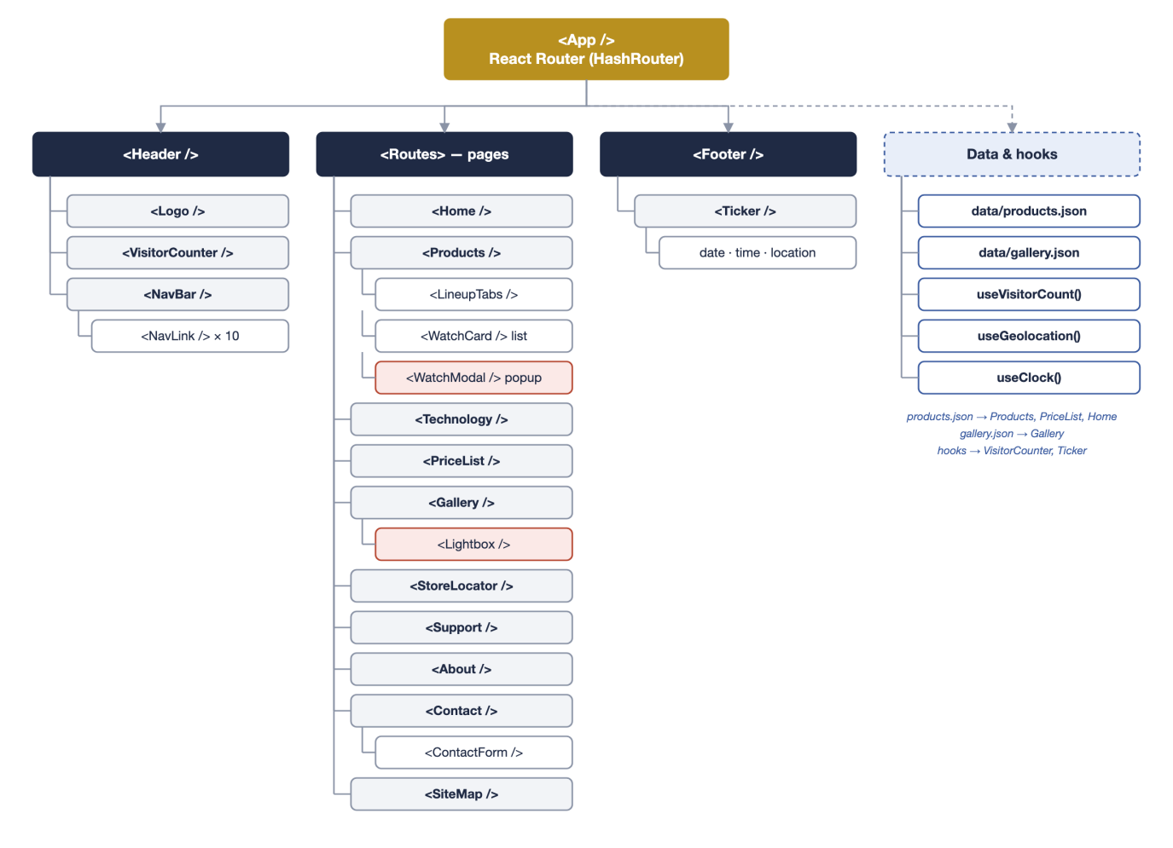
Figure 4 – React component tree and data sources

Project folder structure
alberto-clocks/
├── index.html
├── public/
│ ├── data/products.json watches: id, name, brand, lineup, price, image, features
│ ├── data/gallery.json
│ └── images/ logo, products/, gallery/
└── src/
├── main.jsx mounts <App /> inside <HashRouter>
├── App.jsx Header + Routes + Footer
├── components/ Header, NavBar, VisitorCounter, Ticker, WatchCard, WatchModal, Lightbox
├── pages/ Home, Products, Technology, PriceList, Gallery,
│ StoreLocator, Support, About, Contact, SiteMap
├── hooks/ useVisitorCount, useClock, useGeolocation
└── styles/ global.css, header.css, products.css, ticker.css ...

6. Assumptions
- The visitor count is stored in the browser's localStorage, so it counts visits from that browser only. A shared count would need a server, which is outside this project's scope.
- Location needs the visitor's permission and works only on https:// or localhost. If it is refused, the ticker shows “Location unavailable”.
- Internet Explorer is retired; the site targets Edge, Chrome, Firefox and Safari as listed in the requirements.
- Product names, prices and images are sample data for demonstration.

