Final Project Report

Course: Bioinformatics Advanced Computational Aspects

Abstract
SARS-CoV-2 is an RNA virus whose ongoing evolution is driven by the accumulation of point mutations and, less frequently, insertion-deletion (indel) events. To study its viral diversity and transmission dynamics, it is important to understand the distribution of these mutations and their relationships across genomes. In this study, 1,001 SARS-CoV-2 genome sequences were analyzed using a reference-based computational pipeline. Global alignments were performed against a reference genome (MT324062.1) using a traceback-based alignment model to identify single nucleotide polymorphisms (SNPs) and indels. Detected variants statistics were used to compute mutation frequencies and substitution patterns. Statistical analyses were used to assess mutational characteristics across the genome and visualize positional and categorical mutation patterns via plots. A mutation network was constructed using pairwise mutation distances, and a minimum spanning tree (MST) was generated to model genome similarity relationships. The MST structure was evaluated against NCBI sequencing metadata to test whether parent–child relationships were consistent with chronological sequencing order. The results demonstrate sparse mutation frequencies relative to the reference genome, a predominance of SNPs, and moderate temporal consistency in the MST structure, highlighting both the strengths and limitations of mutation-based network approaches for viral genome analysis.

Introduction
SARS-CoV-2, which caused the COVID-19 pandemic, is a positive-sense single-stranded RNA virus that has resulted in an unprecedented global sequencing effort since its emergence in late 2019 (WHO; NCBI Virus). The availability of large-scale genomic data has enabled computational analyses of viral mutation patterns and genome relationships, offering insights into the extent of viral genetic diversity and evolutionary constraints. While several variants of SARS-CoV-2 have emerged over time, most of the viral genomes are distinguished by a relatively small number of nucleotide changes, reflecting both biological constraints and limitations within the replication machinery of the virus.
The SARS-CoV-2 genome is approximately 30 kb in length and encodes several biologically important regions. The spike (S) protein, particularly the receptor-binding domain (RBD), mediates host cell entry via the ACE2 receptor and is a primary target of neutralizing antibodies; mutations in this region have defined major circulating lineages (Walls et al., 2020; Harvey et al., 2021). SARS-CoV-2 contains a polybasic furin cleavage site within the spike protein that is unique among closely related betacoronaviruses and enhances viral entry and transmissibility (Hoffmann et al., 2020). Other biologically relevant regions include the nucleocapsid protein, which plays a role in viral replication and diagnostic detection, as well as conserved RNA structural elements located in the 5’ untranslated region (UTR), the programmed ribosomal frameshift element within ORF1ab, and the 3’ UTR, all of which are critical for genome replication and translation control (Kim et al., 2020).
Despite being an RNA virus, SARS-CoV-2 shows a comparatively moderate mutation rate because of the presence of proofreading exonuclease (nsp14), which reduces replication errors relative to many other RNA viruses (Denison et al., 2011). As a result, single nucleotide polymorphisms (SNPs) are the dominant form of variation, while insertion and deletion events are relatively rare. This keeps many genomic regions highly conserved, and observed mutations are often distributed sparsely across the genome. Visualizing these mutation patterns and computing genome similarity can provide insight into viral evolution without relying only on full phylogenetic reconstruction.
In this study, a reference-based computational pipeline was applied to 1,001 SARS-CoV-2 genomes obtained from public databases (NCBI Virus). To reduce heterogeneity and ensure high-quality comparisons, we exclusively focused on complete SARS-CoV-2 genome sequences collected from Africa. Traceback-based global alignment was used to identify mutations relative to a reference genome, mutation frequencies were quantified, and positional patterns were visualized using Manhattan plots and bar charts. We constructed a mutation network using pairwise mutation distances, and a minimum spanning tree (MST) to model genome similarity. Sequencing metadata from NCBI was further used to evaluate whether the inferred MST structure was consistent with the chronological order of genome collection. Together, these analyses provide a biologically informed framework for interpreting SARS-CoV-2 mutation patterns and mutation-based network structure.

Methodology

Dataset Selection and Preprocessing
A total of 1,001 complete SARS-CoV-2 genome sequences from Africa were analyzed using a reference-based approach. Only complete genomes consisting of unambiguous nucleotide bases (A, C, G, T) were retained. Sequences containing ambiguous bases (e.g., N), non-standard characters, or duplicate genome sequences were removed during preprocessing to ensure data quality and consistency. One genome (MT324062.1) was selected as the fixed reference sequence, and the remaining genomes were treated as query sequences.

Traceback-Based Alignment and Variant Identification
Each query genome was aligned to the reference genome using then given code, which is a global Needleman-Wunsch alignment with affine gap penalties, implemented via Parasail alignment library. This implements traceback of aligned reference and query sequences. Traceback parsing was used to identify sequence differences at single-nucleotide resolution and to distinguish between SNPs, insertions (INS), and deletions (DEL). Variant positions were reported using 1-based reference genome coordinates. For each detected variant, the following information was recorded: sample identifier, mutation type (SNP, INS, or DEL), reference position, reference nucleotide, alternate nucleotide, length and inserted or deleted parts of sequences when applicable. The result was exported as structured tabular files as shown in Figure 1.
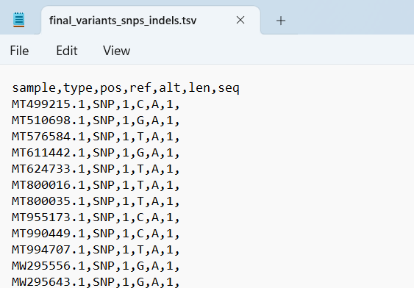
Figure 1: Variants, SNPs, Indels

Mutation Frequency and Statistical Analysis
Mutation frequencies were computed by counting the occurrence of each mutation type and the number of mutations observed at each genomic position. These data were summarized in frequency tables and used to generate bar charts representing mutation type distributions and Manhattan plots showing the positional distribution of mutations across the genome.
Basic statistical analyses were applied to characterize mutation patterns, including calculation of the transition-to-transversion (Ti/Tv) ratio and a chi-square test for mutation type distribution. Linear regression was used to evaluate positional trends in mutation frequency. All statistical analyses were conducted using standard Python scientific libraries.

Pairwise Mutation Distance and Network Construction
To assess genomic relatedness among sequences, complete SARS-CoV-2 genomes were first aligned using MEGA to ensure consistent positional correspondence across sequences. Pairwise mutation distances were then computed from the aligned genomes by counting the total number of nucleotide mismatches between each pair of sequences, excluding alignment columns composed entirely of gaps or ambiguous bases. These distances were used to quantify mutation-based similarity among genomes. A minimum spanning tree (MST) was generated from the resulting distance matrix using the SciPy implementation of Prim’s algorithm. The MST preserves global connectivity among genomes while minimizing the total mutational distance required to connect all sequences. Network representations of the MST were visualized using Cytoscape, as it enables interactive exploration.

Temporal Validation Using Sequencing Metadata (Graduate Requirement)
Sequencing metadata were obtained from NCBI by looking up accession IDs from our dataset, and genome collection dates were parsed and associated with accession identifiers. To evaluate the temporal consistency of the MST structure, random subsampling of 1,000 genomes was performed across 1,000 independent iterations. For each iteration, an MST was reconstructed from the subsampled genomes. The genome with the earliest collection date was selected as the root of each MST, and a breadth-first search (BFS) was used to define parent-child relationships. Each parent-child pair was evaluated for chronological consistency: a relationship was considered a success if the parent genome was sequenced earlier than or at the same time as its child genome, and a failure otherwise. The success rate was calculated as the proportion of temporally consistent parent-child relationships per iteration. Summary statistics across all iterations were computed to assess robustness.

Results:

Mutation Identification Summary
A total of 1,001 SARS-CoV-2 genomes were analyzed relative to the reference genome MT324062.1. Traceback-based global alignment identified 393 total mutations, with each mutation occurring in a distinct genome, resulting in 393 unique samples containing variants (Figure 2). All detected variants were single nucleotide polymorphisms (SNPs), and no insertion or deletion (indel) events were observed relative to the reference genome. The absence of indels indicate a low overall level of divergence among the analyzed genomes. This outcome is consistent with the use of complete genomes and a single reference for variant calling.
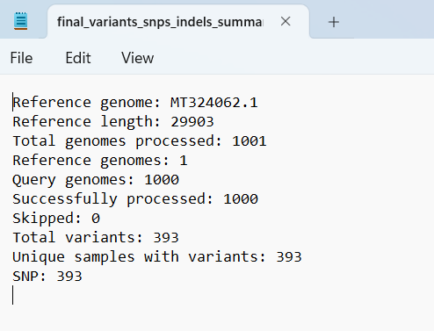
Figure 2: Variant Summary

Mutation Type Distribution
Mutation type frequencies are summarized in Figure 3. All detected variants were classified as SNPs, corresponding to 100% of observed mutations. As only a single mutation category was present, statistical comparison across mutation types was not applicable, and no deviation from uniformity could be assessed using a chi-square test. This result reflects the dominance of nucleotide substitutions relative to larger structural changes within our dataset.
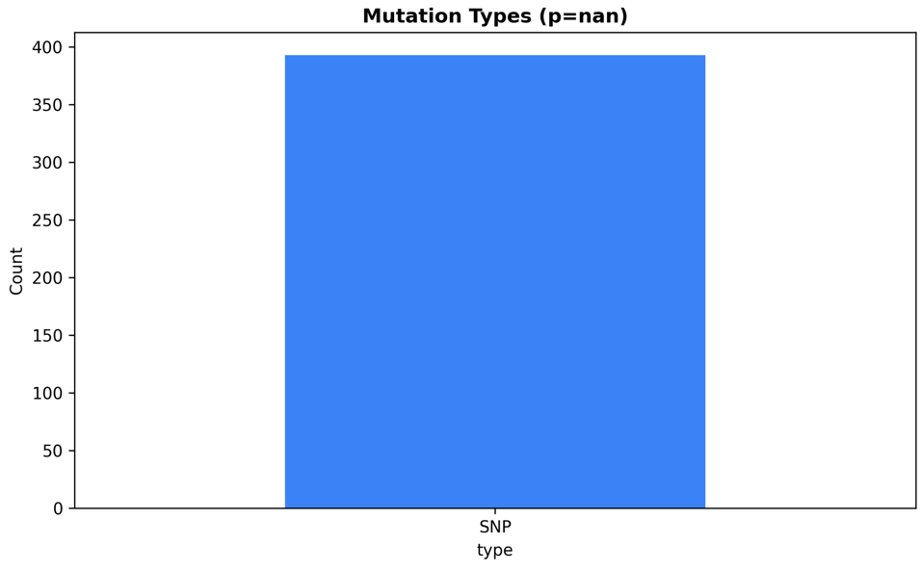
Figure 3: Mutation Type Distribution

Positional Distribution of Mutations (Manhattan Plot)
The positional distribution of mutations across the SARS-CoV-2 genome is shown in the Manhattan plot (Figure 4). Mutations were sparsely distributed, with most genomic positions showing no recurrent variation. All mutation positions were represented by a single event, indicating that mutations were not concentrated at specific hotspots. Mutations were observed at early genomic positions, including position 1 only, corresponding to the 5’ untranslated region (UTR); which resulted in a flat Manhattan plot profile. This sparse pattern limits the applicability of regression-based trend analysis, as mutation counts per position were insufficient to support meaningful statistical modeling.
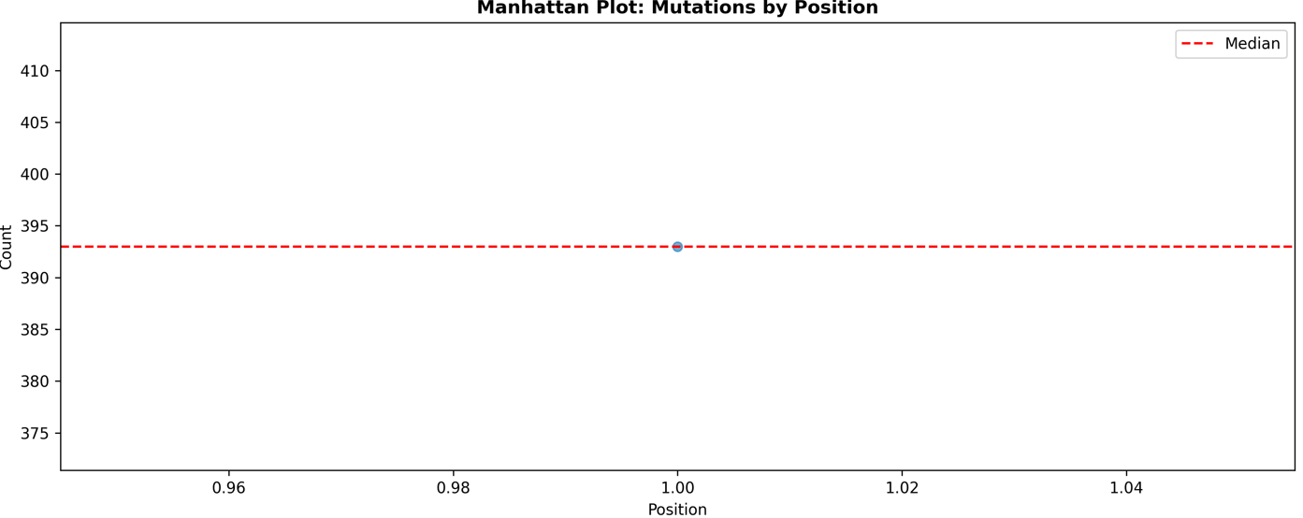
Figure 4: Manhattan Plot

SNP Substitution Patterns
Among SNPs, substitution types were further examined by calculating transition and transversion frequencies. A total of 40 transitions and 353 transversions were observed, resulting in a transition-to-transversion (Ti/Tv) ratio of 0.113. The predominance of transversions indicates an uneven distribution of substitution types within the dataset. (Figure 5)
The most frequent individual SNP substitutions are shown in Figure 4, highlighting the top observed ref-to-alt nucleotide changes across the analyzed genomes.
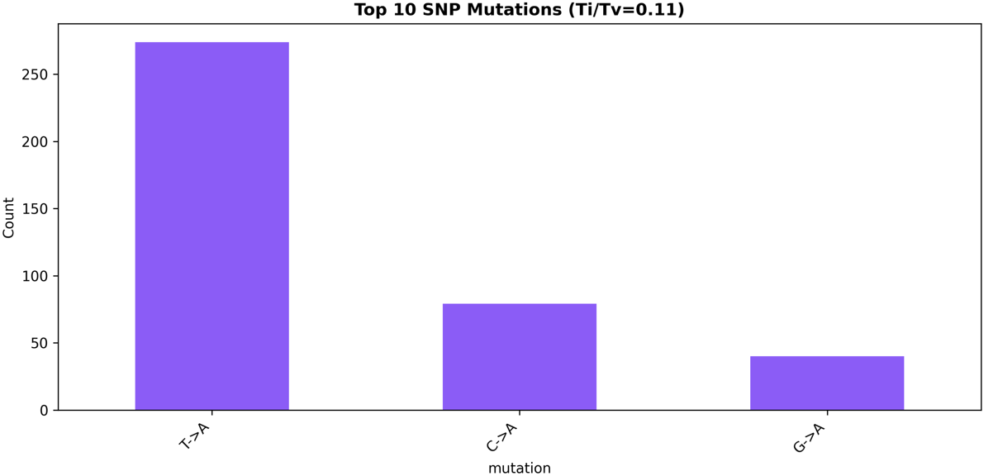
Figure 5: SNP mutations

Statistical Summary
Statistical analyses were applied to quantify mutation characteristics (Figure 6). Due to the presence of a single mutation class and sparse positional recurrence, some statistical measures were not well-defined. Specifically, linear regression of mutation count versus genomic position yielded an undefined coefficient of determination (R²), reflecting insufficient repeated observations across positions. These outcomes highlight the limited statistical power inherent to sparse mutation distributions rather than analytical error.
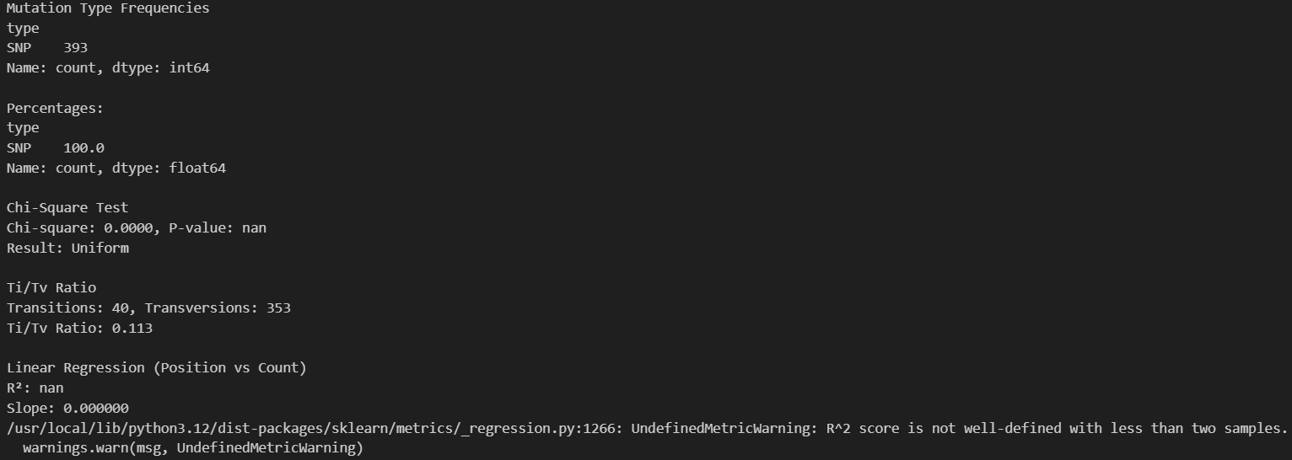
Figure 6: Statistical Summary
All computed mutation frequencies, substitution counts, and statistical summaries were exported as tabular files.

Transition to Network Analysis
While mutation frequency and positional analyses describe the distribution of individual variants, they do not capture relationships among genomes. To address this, pairwise mutation distances were computed across all genomes and used to construct a mutation-based network and MST, enabling downstream analysis of genome similarity and temporal consistency using sequencing metadata. These network-based results are presented in the following section.

Mutation Network and Minimum Spanning Tree Structure
Using the pairwise mutation distance matrix, a mutation-based network was constructed in which each node represents a SARS-CoV-2 genome and edges represent mutational similarity. From this network, a MST was generated to connect all genomes while minimizing the total mutational distance across the dataset.
The resulting MST contains 1,001 nodes and 1,000 edges, consistent with the expected properties of a spanning tree. The network shows a highly connected, branching structure, with no single dominant hub genome (Figure 7). Instead, genomes are linked through short mutational paths, producing a dense, radial topology. Many nodes are connected by edges with low mutation weights, reflecting the limited number of nucleotide differences between most genomes in the dataset. Visual inspection of the MST, where the root is indicated in yellow, shows that genomes are distributed evenly throughout the network rather than forming strongly separated clusters. This pattern indicates a relatively homogeneous level of genetic divergence among the analyzed sequences. The absence of long linear chains or isolated subgraphs further suggests that no subset of genomes has highly diverged from the remainder of the dataset.
Importantly, the MST represents a mutation similarity network rather than a phylogenetic tree. While the structure captures relative mutational distances between genomes, it does not imply direct ancestry or transmission pathways.
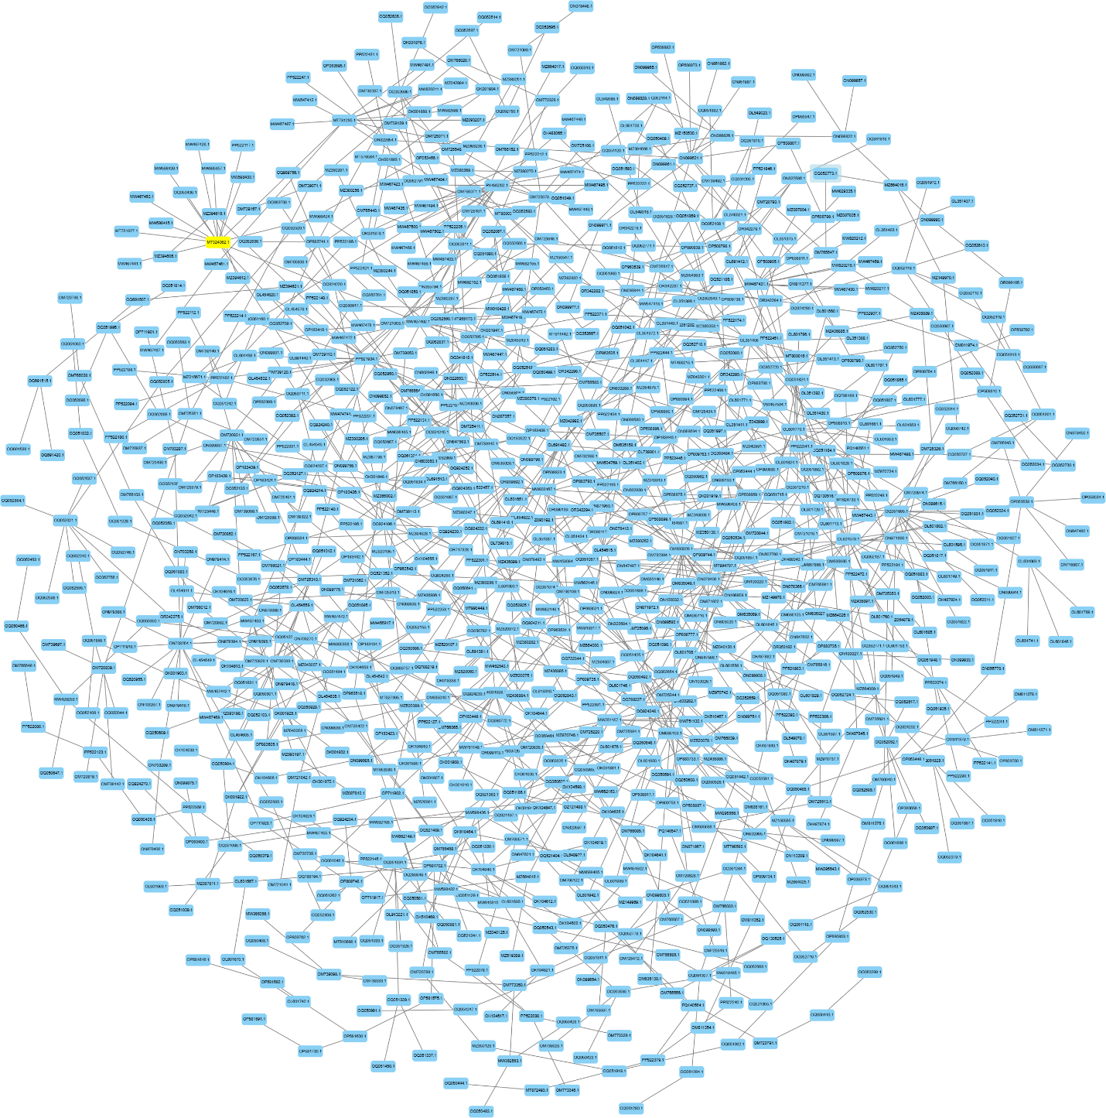
Figure 7: Minimum Spanning Tree

Temporal Consistency of the MST with Sequencing Metadata
To evaluate whether the mutation-based MST aligns with sequencing chronology, genome metadata from NCBI with collection dates was used. For each iteration, the genome with the earliest collection date was selected as the root of the MST, and a breadth-first search (BFS) was performed to define parent-child relationships. Across 1,000 random subsampling iterations, the average success rate, defined as the proportion of parent-child pairs in which the parent genome was sequenced earlier than or at the same time as the child genome, was 0.612. The success rate showed limited variability across iterations, with values ranging from approximately 0.589 to 0.635 and a standard deviation of 0.0067 (Figure 8 and 9).
These results indicate that, in a majority of cases, the MST structure is temporally consistent with sequencing order. However, a substantial fraction of parent-child relationships does not follow chronological ordering. This shows the limitations of mutation-based network inference when applied to densely sampled genomes with minimal divergence.
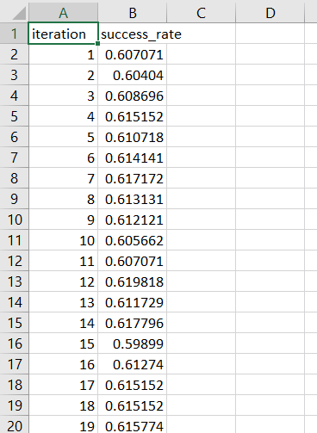
Figure 8: Success Rates
Figure 9: Success Summary

Discussion
This study examined mutation patterns and genome similarity among 1,001 complete SARS-CoV-2 genomes from Africa using a reference-based, mutation network approach. Overall, the results indicate low genetic divergence relative to the reference genome, a predominance of SNPs and a compact mutation network with moderate temporal consistency.
Mutation frequencies were low, with each detected mutation occurring in only a single genome. This sparse pattern is consistent with the biology of SARS-CoV-2, which possesses a proofreading exonuclease that limits replication errors compared to many RNA viruses. Restricting the analysis to complete genomes from a single geographic region likely further reduced heterogeneity, limiting the accumulation of recurrent mutations across samples.
The Manhattan plot showed a flat profile with isolated mutation events and no clear hotspots, reflecting strong conservation across most genomic regions. Mutations observed at early genomic positions, including the 5’ untranslated region, may reflect localized variability; however, the absence of repeated mutations at specific sites explains why regression-based trend analyses were not informative. No insertion or deletion events were detected, which is consistent with the rarity of indels in SARS-CoV-2 and the use of stringent sequence quality filtering.
The mutation-based minimum spanning tree (MST) revealed a dense, branching structure with short mutational distances between genomes and no dominant hub, indicating high overall genetic similarity. Comparison with sequencing metadata yielded an average temporal success rate of approximately 61%, suggesting partial alignment between mutation-based similarity and chronological sequencing order. Repeated subsampling showed low variability in success rates, indicating that this result is robust and not driven by random fluctuation.
Several limitations should be acknowledged. The analysis was geographically constrained and based on a single reference genome, which may bias mutation detection toward rare, sample-specific variants. Additionally, mutation-based networks reflect genetic similarity rather than true evolutionary or transmission history. Despite these limitations, the results demonstrate that SARS-CoV-2 genomes in this dataset are highly conserved and that mutation-based network approaches can provide useful, though limited, insight into genome relationships.

Conclusion
In this study, a reference-based computational pipeline was used to identify mutation patterns and genome similarity among 1,001 complete SARS-CoV-2 genomes from Africa. The results demonstrate low overall genetic divergence, sparse mutation frequencies, and a compact mutation network structure with moderate temporal consistency. Together, these findings highlight both the biological constraints shaping SARS-CoV-2 evolution, and the strengths and limitations of mutation-based network approaches for analyzing viral genomes.

References:
- Denison, M. R., Graham, R. L., Donaldson, E. F., Eckerle, L. D., & Baric, R. S. (2011).
Coronaviruses: An RNA proofreading machine regulates replication fidelity and diversity. RNA Biology, 8(2), 270–279.
https://doi.org/10.4161/rna.8.2.15013

- Harvey, W. T., Carabelli, A. M., Jackson, B., Gupta, R. K., Thomson, E. C., Harrison, E. M., … Rambaut, A. (2021).
SARS-CoV-2 variants, spike mutations and immune escape. Nature Reviews Microbiology, 19(7), 409–424.
https://doi.org/10.1038/s41579-021-00573-0

- Hoffmann, M., Kleine-Weber, H., Schroeder, S., Krüger, N., Herrler, T., Erichsen, S., … Pöhlmann, S. (2020).
SARS-CoV-2 cell entry depends on ACE2 and TMPRSS2 and is blocked by a clinically proven protease inhibitor. Cell, 181(2), 271–280.e8.
https://doi.org/10.1016/j.cell.2020.02.052

- Kim, D., Lee, J.-Y., Yang, J.-S., Kim, J. W., Kim, V. N., & Chang, H. (2020).
The architecture of the SARS-CoV-2 transcriptome. Cell, 181(4), 914–921.e10.
https://doi.org/10.1016/j.cell.2020.04.011

- National Center for Biotechnology Information. (n.d.).
NCBI Virus: SARS-CoV-2 data hub.
https://www.ncbi.nlm.nih.gov/labs/virus/vssi/#/virus?SeqType_s=Nucleotide

- SciPy Developers. (2023).
SciPy documentation: Minimum spanning tree.
https://docs.scipy.org/doc/scipy/reference/generated/scipy.sparse.csgraph.minimum_spanning_tree.html

- Walls, A. C., Park, Y.-J., Tortorici, M. A., Wall, A., McGuire, A. T., & Veesler, D. (2020).
Structure, function, and antigenicity of the SARS-CoV-2 spike glycoprotein. Cell, 181(2), 281–292.e6.
https://doi.org/10.1016/j.cell.2020.02.058

- World Health Organization. (2020).
Coronavirus disease (COVID-19) pandemic.
https://www.who.int/emergencies/diseases/novel-coronavirus-2019

Contributions
Ridma Hoq
- Dataset selection and preprocessing
- Traceback-based alignment and variant identification (using the given SNP code)
- Mutation frequency and statistical analysis
- Pairwise mutation distance and network construction
- Network visualization with Cytoscape Web
- Temporal validation using sequencing metadata
Kwame Kyem Y Aggrey
- Dataset selection
- Background analysis
- Variant statistics visualization (Manhattan and bar plots)
- Code review
- Project presentation

