Aanalysing with Excel

Columns
- Row Order
- Order ID
- Order Date Ship Mode
- Customer ID
- Customer Name
- Segment
- Country
- City
- State
- Postal Code
- Region
- Product ID
- Category
- Subcategory
- Product Name
- Sales
- Quantity
- Discount
- Profit

Objective of the analysis
- Finding which product category makes the most sales and profit
- Finding which region performs best
- Finding whether there are any products that are losing money (negative profit)

Column | Why you need it
Category | Group products into 3 types
Region | See which area performs best
Sales | Total revenue
Profit | Actual money made after costs
Order Date | Optional for time trends

Formatted Sales and Profit columns as Number (2 decimal places). Formatted Order Date and Ship Date columns as Short Date. Category and Region kept as heneral and no changes needed.

Short Date looks like this:
11/8/2016
Long Date looks like this:
Monday, November 8, 2016

Long Date is for reading a document like a letter or report. Short Date is for working with data in a spreadsheet.

Checked all columns for blank cells. No missing values found. Dataset contains 9,994 rows of complete data.

Pivot table
A pivot table is a tool in Excel that summarizes large amount of data into small, easy-to-read summery tables. It is a powerful, drag-and-drop tool used to automatically summarize, sort, count, or average large amounts of data without writing a single formula. It allows you to transform a messy, flat list into an interactive and organized summary report in just a few seconds.

The Main Parts of a Pivot Table
When you create a Pivot Table, you work with a panel containing your dataset's column headers, which you can drag into four main areas:
- Rows: Displays selected data going down the left side (e.g., placing "Salesperson" here lists all staff names). The column you want to group by
- Columns: Displays selected data stretching across the top (e.g., placing "Months" here organizes data chronologically).
- Values: The numbers you want to calculate (e.g., dropping "Revenue" here will sum the total or average the sales for each person/month).
- Filters: Allows you to isolate specific categories and hide the rest (e.g., filtering by "Region" to only see North America's numbers)

Analysis and Findings

  - Category Analysis

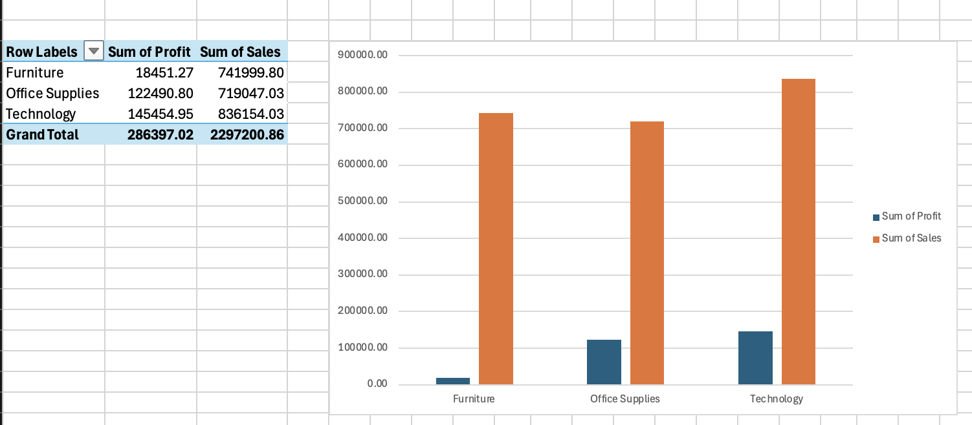

The products in technology category has given the highest sum of sales and the highest sum of profit.The lowest sum of sales has taken by the Furniture category.The lowest profit has given by Furnitures.Despite being the lowest in the sales, Office sumplies has given a higher sum of profit than the Furnitures.

  - Region Aanalysis
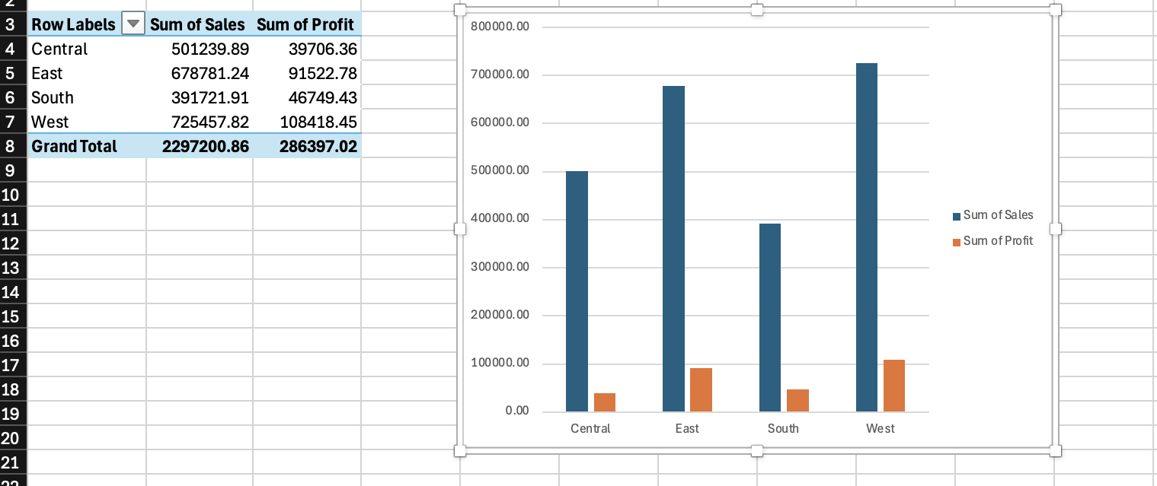

The highest sum of sales and sum of profit is given by the West region. The second highest in both sum of sales and sum of profit is the East region. The lowest profit has given by Central region. The lowest sales have taken by the South region. Despite being the lowest in the sales, South region has given a higher sum of profit than the Central region.

  - Loss making Products

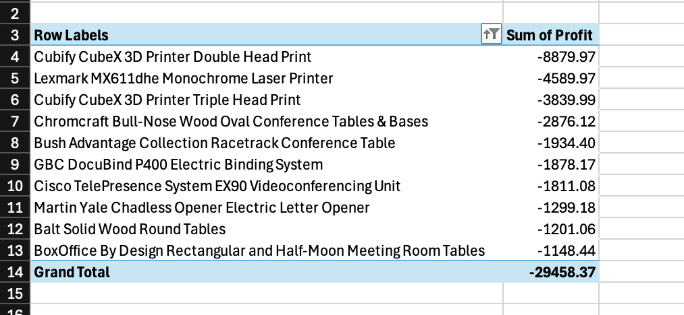

The table shows top 10 worst performing products from all 302 of negative profit giving products. top 10 worst performing products give a combined loss of 29,458.37.

The biggest loss is given by Cubify CubeX 3D Printer Double Head Print which is nearly double the second biggest loss.

Analyzing with MySQL

Tool Setup
Tools used:VS Code with SQLTools extension and MySQL 9.6.0 installed via Homebrew on Mac.
Connection:Connected SQLTools to MySQL using Server: 127.0.0.1, Port: 3306, Username: root, Database: superstore.

Database and Table Creation
Created a database called superstore.
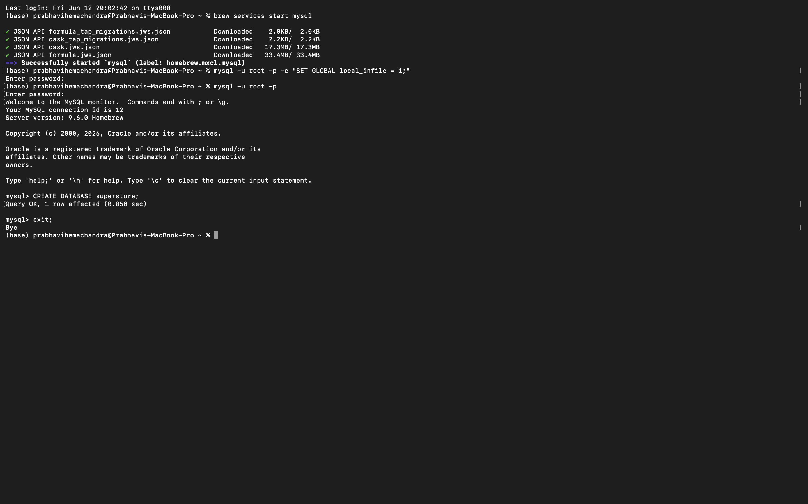

Then created a table called superstore_sales with 21 columns matching the CSV dataset structure. Data types used: INT for whole numbers, VARCHAR for text, DATE for dates, DECIMAL(10,2) for sales and profit, DECIMAL(5,2) for discount. 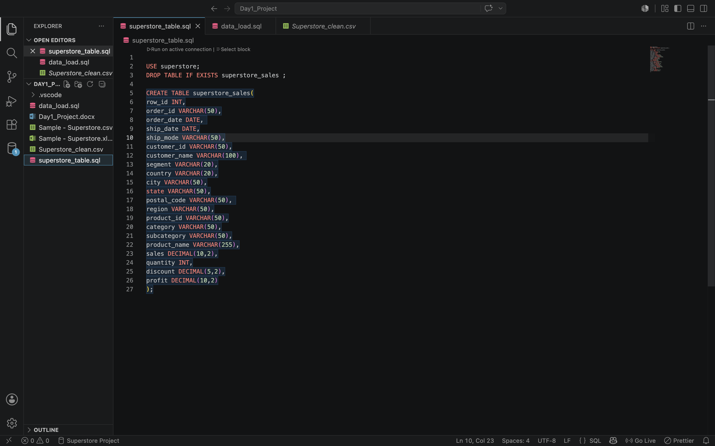

Files created:superstore_table.sql. It contains CREATE TABLE statements.

Data Loading
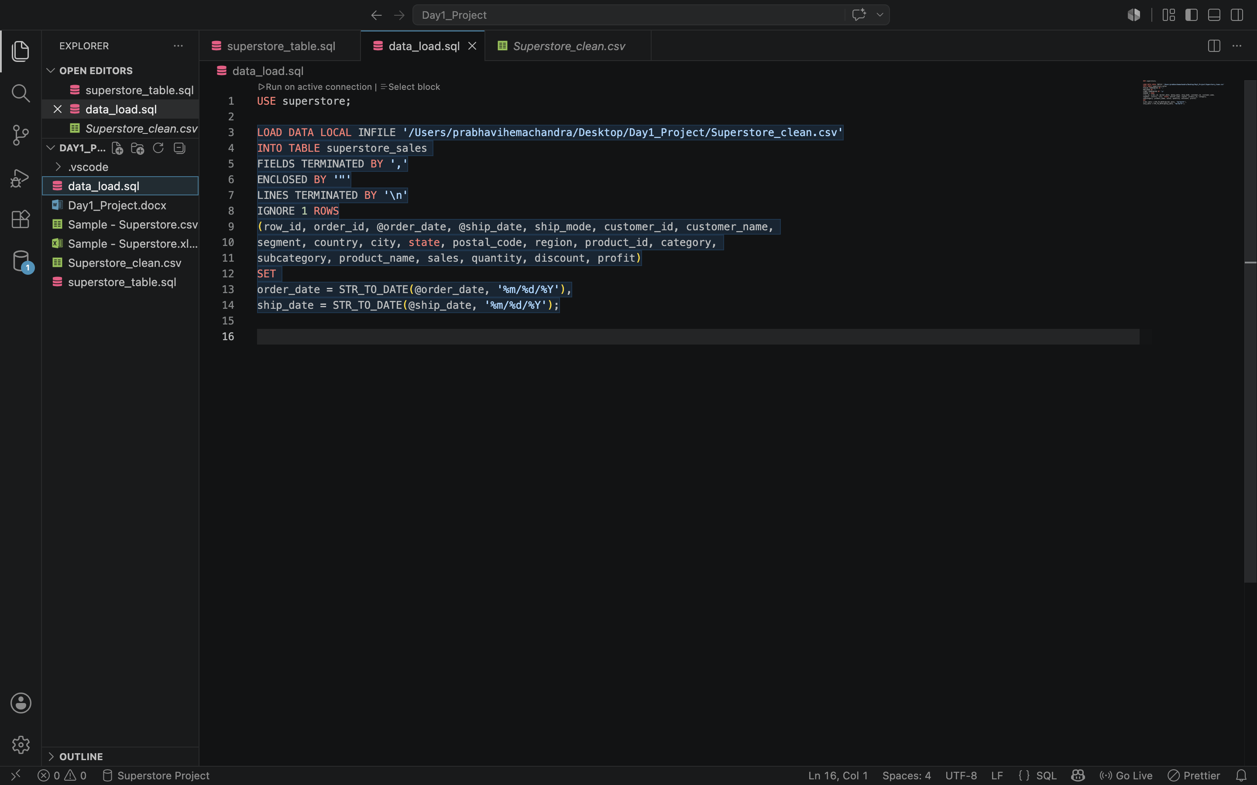

SQLTools returned "streamFactory option" error when trying to load CSV data directly in VS Code.
.
Why:
SQLTools extension in VS Code does not support bulk loading of local files. This is a known limitation of the extension.

Solution:
Created a separate data_load.sql file and ran it from the Mac Terminal using the command: mysql -u root -p --local-infile=1 < /Users/prabhavihemachandra/Desktop/Day1_Project/data_load.sql

Important note:
This is the standard workflow for every new project in VS Code with SQLTools. Always use Terminal to load CSV data, then use SQLTools for writing analysis queries.

Data Loading Problems and Solutions

No Database Selected Error

Error:ERROR 1046 (3D000): No database selected.

Why:MySQL did not know which database to load the data into because the database name was not specified. USE superstore; part was missing

Solution:Added USE superstore ; par and added the database name directly in the terminal command after --local-infile=1 flag: mysql -u root -p --local-infile=1 superstore < data_load.sql
Adding the database name directly in the terminal command is alternative.

Invalid UTF8MB4 Character Error

Error:ERROR 1300 (HY000): Invalid utf8mb4 character string: "Konftel 250 Conference".

Why:Some product names in the CSV contained special characters like registered trademark symbols (R) that the default CSV encoding could not represent properly in MySQL.

Solution:Re-saved the original CSV file from Excel as "CSV UTF-8 (Comma delimited)" format — saved as Superstore_clean.csv. This preserves all data but fixes the character encoding. Then added --default-character-set=utf8mb4 to the terminal command.

Important note:Original CSV file kept unchanged for Python. UTF-8 copy used only for MySQL. No data was lost in conversion.

Date Format Mismatch

Problem:CSV dates were in MM/DD/YYYY format (e.g. 11/8/2016) but MySQL DATE columns require YYYY-MM-DD format (e.g. 2016-11-08).

Solution:Used STR_TO_DATE() function in the LOAD DATA command to convert dates on the fly: SET order_date = STR_TO_DATE(@order_date, '%m/%d/%Y'). This reads the date as text first and converts it to proper MySQL DATE format automatically.

Final Working Command
The final command that successfully loaded all 9,994 rows into MySQL:
mysql -u root -p --local-infile=1 --default-character-set=utf8mb4 superstore < /Users/prabhavihemachandra/Desktop/Day1_Project/data_load.sql

