Zharkynbek Eskendir 13.00-14.00  
1task 

Python:

import matplotlib.pyplot as mp

import numpy as np

from sympy import *

#

Error = 0.01

#functions:

x = symbols('x')

f_x = x**3+6*x-1

g_x = x**3+7*x-1

diff_f = diff(f_x, x)

diff_g = diff(g_x, x)

#interval:

x0, x1 = 0, 1

ex_diff_g_in_x0 =diff_g.subs(x, x0)

ex_diff_g_in_x1 =diff_g.subs(x, x1)

if(abs(ex_diff_g_in_x0)<1 and abs(ex_diff_g_in_x1)<1):

    print("Conferges")

else:

    print("Diverges, so evaluate another method")

    ex_diff_f_in_x0 = diff_f.subs(x, x0)

    ex_diff_f_in_x1 = diff_f.subs(x, x1)

    M = max(ex_diff_f_in_x0, ex_diff_f_in_x1)+1

    h_x = x - (f_x)/M

    p0 = x1

    i = 0

    cond = f_x.subs(x, p0)

    last_p= 0

    while cond>Error:

        i+=1

        last_p  = p0

        p0 = float(h_x.subs(x, p0))

        cond = float(f_x.subs(x, p0))

        print(f'x{i}= {p0},  f(x){i}={cond}')

    else:

        R_ERROR = abs(p0 - last_p)

        print("Error:", Error)

        print("R_Error:", R_ERROR)

        print(f'x={p0},   f(x)={cond}')

x = np.linspace(x0,x1)

g_x = x**3+7*x-1

mp.figure()

mp.plot(x, g_x, color = 'blue')

mp.plot(x, x, color = "red")

mp.plot(p0, cond, color = "black")

mp.scatter( p0 , cond , s = 100, c="black" )

mp.show()

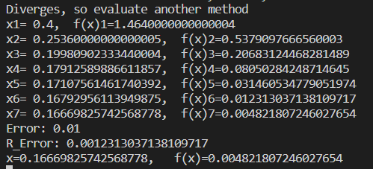

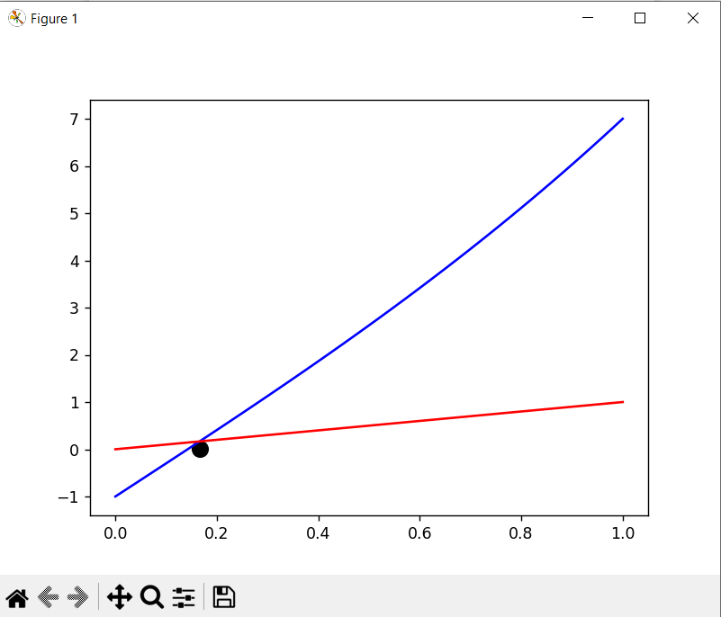

2 task: Bisection

import matplotlib.pyplot as mp

import numpy as np

Error = 0.01

#functions:

f = lambda x: x**3+6*x-1

#interval:

def interval():

    for i in range(0, 2):

        for j in range(0,2):

            if f(i)*f(j)<0:

                return [i, j]

a, b = interval()

if a>b:

    a, b = b, a

x0, x1 = a, b

print('{a:^10}{f_a:^20}|{c:^10}{f_c:^20}|{b:^10}{f_b:^20}|'.format(a='a', f_a="f(a)",c='c', f_c="f(c)",b='b', f_b="f(b)"))

print('-'*90)

c= float((a+b)/2)

arr = []

while abs(f(c))>Error:

    arr.append(c)

print('{a1:^10}{f_a1:^20}|{c1:^10}{f_c1:^20}|{b1:^10}{f_b1:^20}|'.format(a1=a, f_a1=f(a),c1=c, f_c1=f(c),b1=b, f_b1=f(b))

    if f(c)>0:

        b = c

    else:

        a = c

    c= float((a+b)/2)

arr.pop()

print(f"Answer: {c} ", f(c))

x = np.linspace(x0,x1)

mp.figure()

mp.plot(x, f(x), color = 'blue')

for i in arr:

    mp.scatter( i , f(i) , s = 50, c="red" )

mp.scatter( c , f(c), s = 100, c="yellow" )

mp.show()

