 **AMERICAN INTERNATIONAL UNIVERSITY-BANGLADESH**COMPUTER GRAPHICS  – PROJECT DOCUMENTATION 

|  |  |
| --- | --- |
| Course name | Computer Graphics |
| Section | H |
| Tutor | **ANEEM AL AHSAN RUPAI** |

**Group Members Information:**

|  |  |
| --- | --- |
| **Name** | **Id** |
| Muhammad Ridowan Ahad | 18-37919-2 |
| Saim Ahmed | 17-36009-3 |
| Asibur Rahman | 19-40588-1 |
| M. Kowser Ahmad Robin | 20-43172-1 |

**Table of Content:** 

|  |  |
| --- | --- |
| **Content List** | **Page No.** |
| Introduction | 02 |
| Proposal | 02 |
| Schematic Diagram | 03 |
| List of Objects | 03 |
| Functions to Represent the Objects | 04 |
| Interactive Functions | 06 |
| Task Assignment and Codes of Functions | 06 |
| Output | 08 |
| Conclusion | 09 |

**Introduction**

The project is about a scenario, where we have created a “City side view “type scenario. In this scenario we have used several Objects where, some of are with animations and some of are without animation. We have created all the objects with a specific ID which was one of the core instructions of the project. 

**Proposal**

We want to create a scenario, where we will create a “City side view “type scenario. In this scenario we will use several Objects where, some of are with animations and some of are without animation. In this scenario we will try our best to add "A bird" and there will be boats where the water will flow also there will be cars, cloud, sun, night stars, moon, trees, buildings. If we can complete the scenario within the time limit, we will try our best to add a man walking on footpath.  
 **Schematic Diagram**   
  
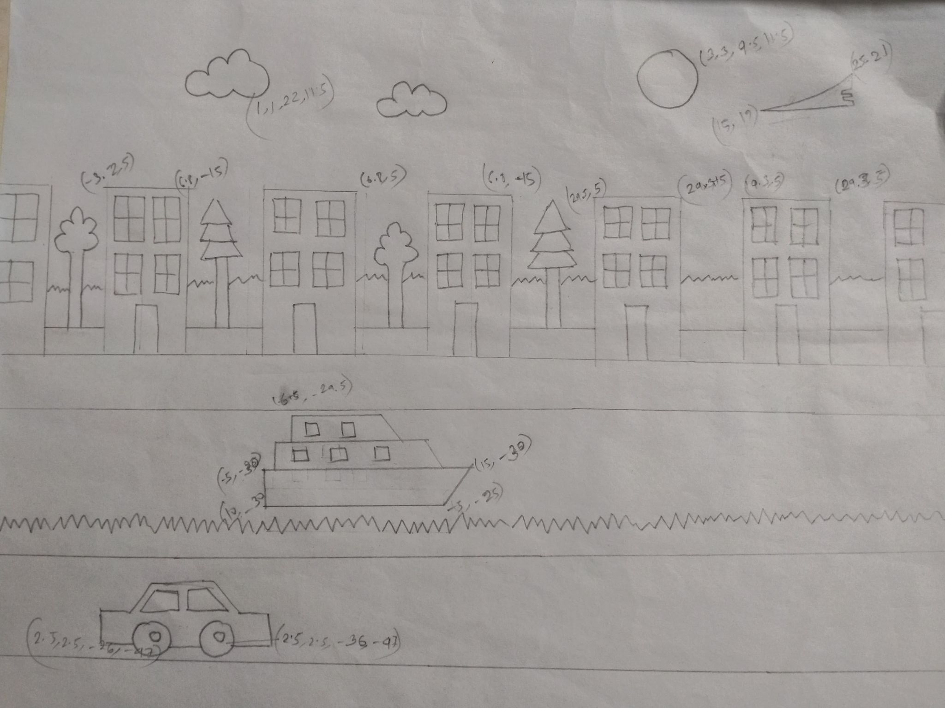  
**List of Objects**

1. Car 1
2. Car 2
3. Car 3
4. Boat 1
5. Boat 2
6. Cloud 1
7. Cloud 2
8. Cloud 3
9. Cloud 4

10 Cloud 5

11 Cloud 6

12 Cloud 7

13 Plane

14 Sky

15 Ground

16 River

17 Front wall

18 Back wall

19 Tree 1

20 Tree 2

21 Tree 3

22 House 1

23 House 2

24 House 3

1. House 4

26.House 5

27. House 6

28.House 7  
29.Road 1  
30. Road 2  
31.Sun

32. lamp

33. bench

**Funtions to Represent The Objects**

|  |  |  |
| --- | --- | --- |
| **Object** | **Function** | **Id** |
| Car 1 | void car() | 101 |
| Car 2 | void car2() | 102 |
| Car 3 | void car3() | 103 |
| Boat 1 | void boat() | 104 |
| Boat 2 | void boat2() | 105 |
| Cloud 1 | void cloud1() | 106 |
| Cloud 2 | void cloud2() | 107 |
| Cloud 3 | void cloud3() | 108 |
| Cloud 4 | void cloud4() | 109 |
| Cloud 5 | void cloud5() | 110 |
| Cloud 6 | void cloud6() | 111 |
| Cloud 7 | void cloud7() | 112 |
| Plane | void plane() | 113 |
| Sky | void sky() | 114 |
| Ground | void ground() | 115 |
| River | void river() | 116 |
| Front wall | void Front_Wall() | 117 |
| Back wall | void back_wall() | 118 |
| Tree 1 | void Tree1() | 119 |
| Tree 2 | void Tree2() | 120 |
| Tree 3 | void Tree3() | 121 |
| House 1 | void House1() | 122 |
| House 2 | void House2() | 123 |
| House 3 | void House3() | 124 |
| House 4 | void House4() | 125 |
| House 5 | void House5() | 126 |
| House 6 | void House6() | 127 |
| House 7 | void House7() | 128 |
| Road 1 | void Road1() | 129 |
| Road 2 | void Road2() | 130 |
| Sun | void Sun() | 131 |
| Lamp | void lamp() | 132 |
| Bench | void bench() | 133 |

**Interactive Functions**

|  |  |  |
| --- | --- | --- |
| **Function** | **Interactive Functions** | **ID** |
| Plane move | Plane move() | 501 |
| Boat Move | Boat Move() | 504 |
| Cloud move | Cloud move() | 505,506,507,508 |
| Car move | Car move() | 502,503 |

**Task Assignment and Codes of Functions**   
**Contribution Table:** 

|  |  |  |  |  |
| --- | --- | --- | --- | --- |
| **Member-1** | **Member-2** | **Member-3** | **Member-4** | **Total** |
| 25% | 25% | 25% | 25% | 100% |

|  |  |
| --- | --- |
| **Name ID** | **Contribution in project** |
| **Member-1** | 1. House (7)  2.Lamp  3. Star.  4. Road 1  5. Bench  6. Boat 3  7. Cloud 6,7 |
| **Member -2** | 1.River  2. Boat 1  3. Boat 2  4. Ground  5. Tree (4) |
| **Member -3** | 1.Car 1  2.Car 2  3.  Car 3  4. Road 2 |
| **Member -4** | 1. Cloud (5)  2. Plane  3.Sun  4. Sky |

**Output**

|  |  |
| --- | --- |
| **Day View** |  |
| **Night View** |  |

**Conclusion** 

To conclude this project, we used simple graphics to show how the environment in a simple part of a city looks like in a day view and night view. We used various type of polygons, various modes and to produce the necessary graphic we needed to show for our project and we successfully ended up with a nice final product which ultimately produced an animation which shows how the city looks like.  Due to time constraint, we could have added more things which could have showed better emphasis itself. But to end it all, we have completed all the requirements needed for the project and finished it properly.