BEARS IN CANADA

REPORT

Name: Shah Riddhi

NN: 30

**Functional Dependencies**

Species Code->Average PHT

Species Code->Species Name

Region ID->Region Name

Region ID->Size

Study ID->Study Name

Study ID->Region ID

ClassID->ClassName

StatusCode->StatusName

StatusCode->Description

ParticipantID->ParticipantName

ParticipantID->StartDate

ParticipantID->EndDate

{Animal Number, Study ID}->Sex

{Animal Number, Study ID}->Sample Number

{Sample Number, Animal Number, Study ID}->Location

{Sample Number, Animal Number, Study ID}->Sample Date

{Sample Number, Animal Number, Study ID}->Participant ID

{Sample Number, Animal Number, Study ID}->Species Code

{Sample Number, Animal Number, Study ID}->Status Code

{Sample Number, Animal Number, Study ID}->Class ID

{Sample Number, Animal Number, Study ID}->PHT Value

{Sample Number, Animal Number, Study ID}->Number Samples

|  |  |  |
| --- | --- | --- |
| Region ID | Region Name | Size |

|  |  |  |
| --- | --- | --- |
| Species Code | Species Name | Average PHT |

|  |  |  |
| --- | --- | --- |
| Study ID | Study Name | Region ID |

|  |  |
| --- | --- |
| Class ID | Class Name |

|  |  |  |
| --- | --- | --- |
| Status Code | Status Name | Description |

|  |  |  |  |
| --- | --- | --- | --- |
| Participant ID | Participant Name | Start Date | End Date |

|  |  |  |  |
| --- | --- | --- | --- |
| Animal Number | Study ID | Sex | Sample Number |

|  |  |  |  |  |  |  |  |  |  |  |
| --- | --- | --- | --- | --- | --- | --- | --- | --- | --- | --- |
| Sample Number | Animal Number | Study ID | Sample Date | Location | Participant ID | Species Code | Status Code | Class ID | PHT Value | Number Sample |

**Logical Model**

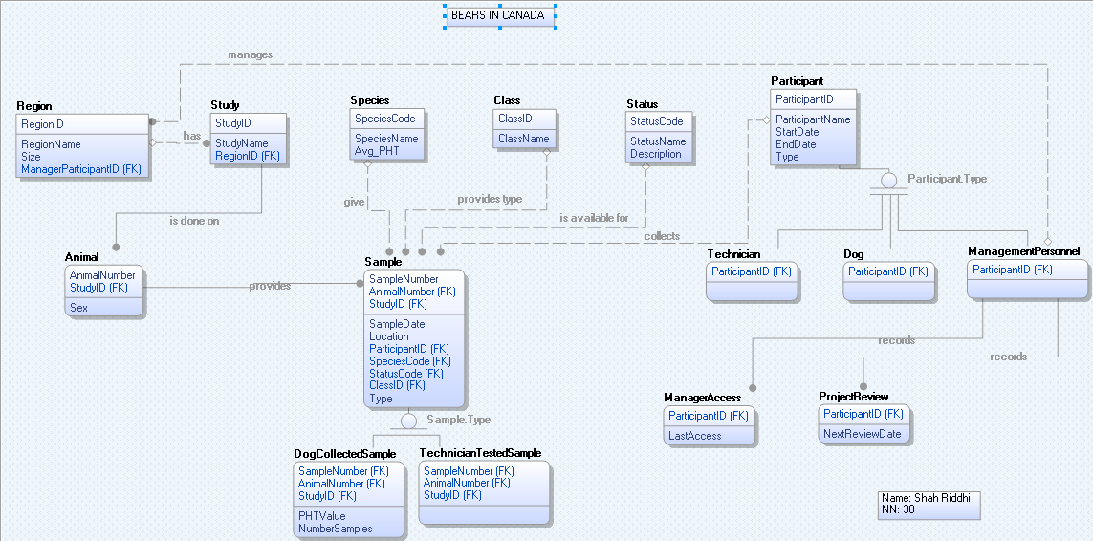

**Physical Model**

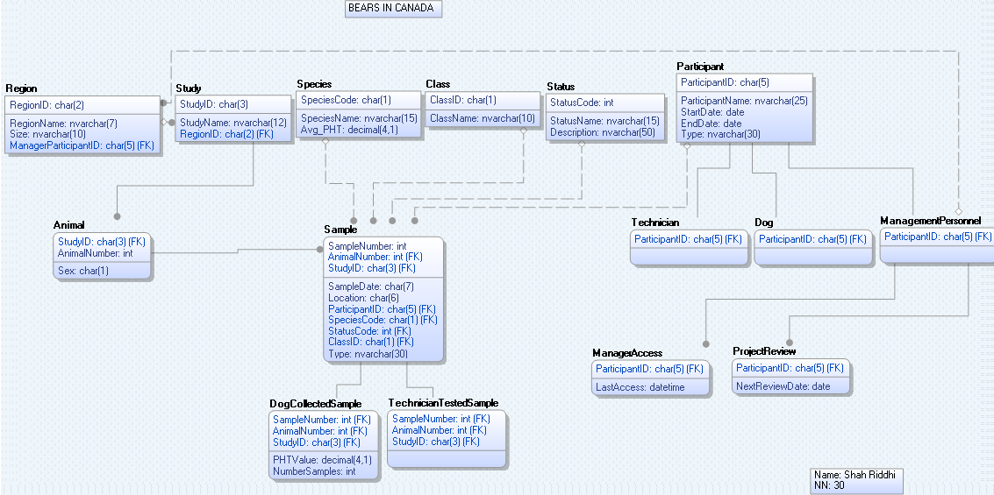

**DML Insert Statements**

USE BIC30;

INSERT INTO Participant VALUES('P2001','Bill Brown','2014-02-14','','Technician');

INSERT INTO Participant VALUES('P2004','Jane Smith','2014-02-14','','Technician');

INSERT INTO Participant VALUES('P2036','Frank Martin','2012-08-15','2014-01-01','Technician');

INSERT INTO Participant VALUES('P2045','Anne Dough','2013-06-12','','Technician');

INSERT INTO Participant VALUES('P2046','Mike Green','2012-10-28','','Technician');

INSERT INTO Participant VALUES('D0004','Max','2014-06-01','','Dog');

INSERT INTO Participant VALUES('D0008','Sampson','2014-02-05','','Dog');

INSERT INTO Participant VALUES('D0013','Cindy','2013-12-10','2014-12-20','Dog');

INSERT INTO Participant VALUES('D0022','Rover','2014-05-20','','Dog');

INSERT INTO Participant VALUES('P0000','Bob Bureaucrat','','','ManagementPersonnel');

INSERT INTO Participant VALUES('P0101','Sam Supervisor','','','ManagementPersonnel');

INSERT INTO Participant VALUES('P0102','Mary Manager','','','ManagementPersonnel');

INSERT INTO Participant VALUES('P0103','Fred Foreman','','','ManagementPersonnel');

INSERT INTO ManagementPersonnel VALUES('P0000');

INSERT INTO ManagementPersonnel VALUES('P0101');

INSERT INTO ManagementPersonnel VALUES('P0102');

INSERT INTO ManagementPersonnel VALUES('P0103');

INSERT INTO Region VALUES('NR','North','9x9','P0101');

INSERT INTO Region VALUES('CR','Central','9x9','P0102');

INSERT INTO Region VALUES('SR','South','5x5','P0103');

INSERT INTO Study VALUES('N14','North 2014','NR');

INSERT INTO Study VALUES('C14','Central 2014','CR');

INSERT INTO Study VALUES('C15','Central 2015','CR');

INSERT INTO Study VALUES('S14','South 2014','SR');

INSERT INTO Animal VALUES('N14','42','M');

INSERT INTO Animal VALUES('S14','89','F');

INSERT INTO Animal VALUES('C14','59','M');

INSERT INTO Animal VALUES('C14','113','F');

INSERT INTO Animal VALUES('C15','59','F');

INSERT INTO Animal VALUES('C15','50','?');

INSERT INTO Animal VALUES('N14','118','F');

INSERT INTO Animal VALUES('C15','112','M');

INSERT INTO Animal VALUES('C14','66','F');

INSERT INTO Animal VALUES('N14','66','?');

INSERT INTO Animal VALUES('S14','66','M');

INSERT INTO Animal VALUES('N14','113','F');

INSERT INTO Animal VALUES('S14','63','M');

INSERT INTO Animal VALUES('C14','114','F');

INSERT INTO Species VALUES('B','Black Bear','113.0');

INSERT INTO Species VALUES('G','Grizzly Bear','142.0');

INSERT INTO Species VALUES('U','Undetermined',NULL);

INSERT INTO Status VALUES('1','Sample exists','Sample exists and available for further analysis');

INSERT INTO Status VALUES('0','Sample used up','Sample used up and not available');

INSERT INTO Class VALUES('T','Telemetry');

INSERT INTO Class VALUES('H','Hair snag');

INSERT INTO Class VALUES('S','Scat');

INSERT INTO Sample VALUES ('17','42','N14','2014/07','05:8:3','D0004','B','1','S','DogCollectedSample');

INSERT INTO Sample VALUES ('22','89','S14','2014/11','93:2:4','P2045','B','1','H','TechnicianTestedSample');

INSERT INTO Sample VALUES ('44','59','C14','2014/09','32:1:9','P2001','B','0','T','TechnicianTestedSample');

INSERT INTO Sample VALUES ('45','113','C14','2015/10','40:1:1','P2046','G','0','H','TechnicianTestedSample');

INSERT INTO Sample VALUES ('47','59','C14','2014/09','41:2:3','P2045','B','0','T','TechnicianTestedSample');

INSERT INTO Sample VALUES ('48','59','C15','2015/09','34:4:4','D0013','B','1','S','DogCollectedSample');

INSERT INTO Sample VALUES ('56','50','C15','2015/07','40:1:1','D0004','B','1','S','DogCollectedSample');

INSERT INTO Sample VALUES ('59','118','N14','2014/06','07:1:2','D0022','B','1','S','DogCollectedSample');

INSERT INTO Sample VALUES ('79','112','C15','2014/07','32:5:5','D0004','G','1','S','DogCollectedSample');

INSERT INTO Sample VALUES ('82','66','C14','2014/11','31:5:8','P2045','G','0','T','TechnicianTestedSample');

INSERT INTO Sample VALUES ('100','66','N14','2014/07','01:1:9','D0022','U','0','S','DogCollectedSample');

INSERT INTO Sample VALUES ('68','66','S14','2014/07','80:3:2','P2004','B','0','H','TechnicianTestedSample');

INSERT INTO Sample VALUES ('27','42','N14','2014/08','15:2:6','D0008','B','1','S','DogCollectedSample');

INSERT INTO Sample VALUES ('11','113','N14','2014/07','19:4:7','D0008','G','0','S','DogCollectedSample');

INSERT INTO Sample VALUES ('45','63','S14','2014/07','90:3:4','D0013','B','0','S','DogCollectedSample');

INSERT INTO Sample VALUES ('17','114','C14','2014/10','38:4:1','P2004','G','1','T','TechnicianTestedSample');

INSERT INTO Sample VALUES ('18','114','C14','2014/10','38:4:1','D0004','G','1','S','DogCollectedSample');

INSERT INTO TechnicianTestedSample VALUES('22','89','S14');

INSERT INTO TechnicianTestedSample VALUES('44','59','C14');

INSERT INTO TechnicianTestedSample VALUES('45','113','C14');

INSERT INTO TechnicianTestedSample VALUES('47','59','C14');

INSERT INTO TechnicianTestedSample VALUES('82','66','C14');

INSERT INTO TechnicianTestedSample VALUES('68','66','S14');

INSERT INTO TechnicianTestedSample VALUES('17','114','C14');

INSERT INTO Technician VALUES('P2001');

INSERT INTO Technician VALUES('P2004');

INSERT INTO Technician VALUES('P2036');

INSERT INTO Technician VALUES('P2045');

INSERT INTO Technician VALUES('P2046');

INSERT INTO ProjectReview VALUES('P0000','2016-04-30');

INSERT INTO DogCollectedSample VALUES('17','42','N14','109','4');

INSERT INTO DogCollectedSample VALUES('48','59','C15','100','2');

INSERT INTO DogCollectedSample VALUES('56','50','C15','103.5','4');

INSERT INTO DogCollectedSample VALUES('59','118','N14','120','2');

INSERT INTO DogCollectedSample VALUES('79','112','C15','135','4');

INSERT INTO DogCollectedSample VALUES('100','66','N14',NULL,'2');

INSERT INTO DogCollectedSample VALUES('27','42','N14','115','2');

INSERT INTO DogCollectedSample VALUES('11','113','N14','135','2');

INSERT INTO DogCollectedSample VALUES('45','63','S14','117','2');

INSERT INTO DogCollectedSample VALUES('18','114','C14','150','4');

INSERT INTO Dog VALUES('D0004');

INSERT INTO Dog VALUES('D0008');

INSERT INTO Dog VALUES('D0013');

INSERT INTO Dog VALUES('D0022');

**Select * for All tables**

**Animal:**

USE BIC30;

USE BIC30;

SELECT StudyID, AnimalNumber, Sex FROM Animal;

StudyID AnimalNumber Sex

------- ------------ ----

C14 59 M

C14 66 F

C14 113 F

C14 114 F

C15 50 ?

C15 59 F

C15 112 M

N14 42 M

N14 66 ?

N14 113 F

N14 118 F

S14 63 M

S14 66 M

S14 89 F

(14 row(s) affected)

**Class:**

USE BIC30;

SELECT ClassID, ClassName FROM Class;

ClassID ClassName

------- ----------

H Hair snag

S Scat

T Telemetry

(3 row(s) affected)

**Dog:**

USE BIC30;

SELECT ParticipantID FROM Dog;

ParticipantID

-------------

D0004

D0008

D0013

D0022

(4 row(s) affected)

**DogCollectedSample:**

USE BIC30;

SELECT SampleNumber, AnimalNumber, StudyID, PHTValue, NumberSamples FROM DogCollectedSample;

SampleNumber AnimalNumber StudyID PHTValue NumberSamples

------------ ------------ ------- --------------------------------------- -------------

11 113 N14 135.0 2

17 42 N14 109.0 4

18 114 C14 150.0 4

27 42 N14 115.0 2

45 63 S14 117.0 2

48 59 C15 100.0 2

56 50 C15 103.5 4

59 118 N14 120.0 2

79 112 C15 135.0 4

100 66 N14 NULL 2

(10 row(s) affected)

**ManagementPersonnel:**

USE BIC30;

SELECT ParticipantID FROM ManagementPersonnel;

ParticipantID

-------------

P0000

P0101

P0102

P0103

(4 row(s) affected)

**ManagerAccess:**

USE BIC30;

SELECT ParticipantID, LastAccess FROM ManagerAccess;

ParticipantID LastAccess

------------- -----------------------

(0 row(s) affected)

To keep track of last time each manager accessed the database a trigger can be set while login that will update this table’s last access with the login time.

**Participant:**

USE BIC30;

SELECT ParticipantID, ParticipantName, StartDate, EndDate, Type FROM Participant;

ParticipantID ParticipantName StartDate EndDate Type

------------- ------------------------- ---------- ---------- ------------------------------

D0004 Max 2014-06-01 1900-01-01 Dog

D0008 Sampson 2014-02-05 1900-01-01 Dog

D0013 Cindy 2013-12-10 2014-12-20 Dog

D0022 Rover 2014-05-20 1900-01-01 Dog

P0000 Bob Bureaucrat 1900-01-01 1900-01-01 ManagementPersonnel

P0101 Sam Supervisor 1900-01-01 1900-01-01 ManagementPersonnel

P0102 Mary Manager 1900-01-01 1900-01-01 ManagementPersonnel

P0103 Fred Foreman 1900-01-01 1900-01-01 ManagementPersonnel

P2001 Bill Brown 2014-02-14 1900-01-01 Technician

P2004 Jane Smith 2014-02-14 1900-01-01 Technician

P2036 Frank Martin 2012-08-15 2014-01-01 Technician

P2045 Anne Dough 2013-06-12 1900-01-01 Technician

P2046 Mike Green 2012-10-28 1900-01-01 Technician

(13 row(s) affected)

**ProjectReview:**

USE BIC30;

SELECT ParticipantID, NextReviewDate FROM ProjectReview;

ParticipantID NextReviewDate

------------- --------------

P0000 2016-04-30

(1 row(s) affected)

**Region:**

USE BIC30;

SELECT RegionID, RegionName, Size, ManagerParticipantID FROM Region;

RegionID RegionName Size ManagerParticipantID

-------- ---------- ---------- --------------------

CR Central 9x9 P0102

NR North 9x9 P0101

SR South 5x5 P0103

(3 row(s) affected)

**Sample:**

USE BIC30;

SELECT SampleNumber, AnimalNumber, StudyID, SampleDate, Location, ParticipantID, SpeciesCode, StatusCode, ClassID, Type FROM Sample;

SampleNumber AnimalNumber StudyID SampleDate Location ParticipantID SpeciesCode StatusCode ClassID Type

------------ ------------ ------- ---------- -------- ------------- ----------- ----------- ------- ------------------------------

11 113 N14 2014/07 19:4:7 D0008 G 0 S DogCollectedSample

17 42 N14 2014/07 05:8:3 D0004 B 1 S DogCollectedSample

17 114 C14 2014/10 38:4:1 P2004 G 1 T TechnicianTestedSample

18 114 C14 2014/10 38:4:1 D0004 G 1 S DogCollectedSample

22 89 S14 2014/11 93:2:4 P2045 B 1 H TechnicianTestedSample

27 42 N14 2014/08 15:2:6 D0008 B 1 S DogCollectedSample

44 59 C14 2014/09 32:1:9 P2001 B 0 T TechnicianTestedSample

45 63 S14 2014/07 90:3:4 D0013 B 0 S DogCollectedSample

45 113 C14 2015/10 40:1:1 P2046 G 0 H TechnicianTestedSample

47 59 C14 2014/09 41:2:3 P2045 B 0 T TechnicianTestedSample

48 59 C15 2015/09 34:4:4 D0013 B 1 S DogCollectedSample

56 50 C15 2015/07 40:1:1 D0004 B 1 S DogCollectedSample

59 118 N14 2014/06 07:1:2 D0022 B 1 S DogCollectedSample

68 66 S14 2014/07 80:3:2 P2004 B 0 H TechnicianTestedSample

79 112 C15 2014/07 32:5:5 D0004 G 1 S DogCollectedSample

82 66 C14 2014/11 31:5:8 P2045 G 0 T TechnicianTestedSample

100 66 N14 2014/07 01:1:9 D0022 U 0 S DogCollectedSample

(17 row(s) affected)

**Species:**

USE BIC30;

SELECT SpeciesCode, SpeciesName, Avg_PHT FROM Species;

SpeciesCode SpeciesName Avg_PHT

----------- --------------- ---------------------------------------

B Black Bear 113.0

G Grizzly Bear 142.0

U Undetermined NULL

(3 row(s) affected)

**Status:**

USE BIC30;

SELECT StatusCode, StatusName, Description FROM Status;

StatusCode StatusName Description

----------- --------------- --------------------------------------------------

0 Sample used up Sample used up and not available

1 Sample exists Sample exists and available for further analysis

(2 row(s) affected)

**Study:**

USE BIC30;

SELECT StudyID, StudyName, RegionID FROM Study;

StudyID StudyName RegionID

------- ------------ --------

C14 Central 2014 CR

C15 Central 2015 CR

N14 North 2014 NR

S14 South 2014 SR

(4 row(s) affected)

**Technician:**

USE BIC30;

SELECT ParticipantID FROM Technician;

ParticipantID

-------------

P2001

P2004

P2036

P2045

P2046

(5 row(s) affected)

**TechnicianTestedSample:**

USE BIC30;

SELECT SampleNumber, AnimalNumber, StudyID FROM TechnicianTestedSample;

SampleNumber AnimalNumber StudyID

------------ ------------ -------

17 114 C14

22 89 S14

44 59 C14

45 113 C14

47 59 C14

68 66 S14

82 66 C14

(7 row(s) affected)

**Query Results**

1) What is the largest physiological health value observed for a black bear?

USE BIC30;

SELECT max(PHTValue) as 'Maximum PHT Value' FROM DogCollectedSample, Sample, Species

WHERE Species.SpeciesName = 'Black Bear'

AND DogCollectedSample.SampleNumber = Sample.SampleNumber

AND DogCollectedSample.AnimalNumber = Sample.AnimalNumber

AND DogCollectedSample.StudyID = Sample.StudyID

AND Sample.SpeciesCode = Species.SpeciesCode;

Maximum PHT Value

---------------------------------------

120.0

(1 row(s) affected)

2) For each animal, list all of its sample classifications in chronological (date) order.

USE BIC30;

SELECT Species.SpeciesName as 'Animal', Class.ClassName as 'Classification', Sample.SampleDate FROM Sample, Species, Class

WHERE Sample.SpeciesCode = Species.SpeciesCode

AND Sample.ClassID = Class.ClassID

ORDER BY Sample.SampleDate ASC

Animal Classification SampleDate

--------------- -------------- ----------

Black Bear Scat 2014/06

Black Bear Hair snag 2014/07

Grizzly Bear Scat 2014/07

Undetermined Scat 2014/07

Grizzly Bear Scat 2014/07

Black Bear Scat 2014/07

Black Bear Scat 2014/07

Black Bear Scat 2014/08

Black Bear Telemetry 2014/09

Black Bear Telemetry 2014/09

Grizzly Bear Telemetry 2014/10

Grizzly Bear Scat 2014/10

Black Bear Hair snag 2014/11

Grizzly Bear Telemetry 2014/11

Black Bear Scat 2015/07

Black Bear Scat 2015/09

Grizzly Bear Hair snag 2015/10

(17 row(s) affected)

3) In what region is the Central 2014 study and what size grid pattern is used on that study?

USE BIC30;

SELECT Region.RegionName, Region.Size FROM Region, Study

WHERE Study.StudyName='Central 2014' AND Region.RegionID = Study.RegionID;

RegionName Size

---------- ----------

Central 9x9

(1 row(s) affected)

4) List the animals that are within 5 units of their average physiological health value.

USE BIC30;

SELECT DISTINCT Species.SpeciesName, DogCollectedSample.AnimalNumber FROM Species, DogCollectedSample, Sample

WHERE DogCollectedSample.PHTValue < Species.Avg_PHT+5

AND DogCollectedSample.SampleNumber = Sample.SampleNumber

AND DogCollectedSample.AnimalNumber = Sample.AnimalNumber

AND DogCollectedSample.StudyID = Sample.StudyID

AND Sample.SpeciesCode = Species.SpeciesCode

SpeciesName AnimalNumber

--------------- ------------

Black Bear 42

Black Bear 50

Black Bear 59

Black Bear 63

Grizzly Bear 112

Grizzly Bear 113

(6 row(s) affected)

5) List the sample information for the Central 2014 studies made in September 2014 and November 2014.

USE BIC30;

SELECT SampleNumber, AnimalNumber, Sample.StudyID, Study.StudyName, SampleDate, Location, ParticipantID,

Sample.SpeciesCode, Species.SpeciesName, Sample.StatusCode, Status.StatusName, Sample.ClassID, Class.ClassName, Type

FROM Sample

INNER JOIN Study

ON Study.StudyID = Sample.StudyID

INNER JOIN Species

ON Species.SpeciesCode = Sample.SpeciesCode

INNER JOIN Class

ON Sample.ClassID = Class.ClassID

INNER JOIN Status

ON Sample.StatusCode = Status.StatusCode

WHERE Study.StudyName = 'Central 2014'

AND Sample.SampleDate = '2014/09' OR Sample.SampleDate = '2014/11'

SampleNumber AnimalNumber StudyID StudyName SampleDate Location ParticipantID SpeciesCode SpeciesName StatusCode StatusName ClassID ClassName Type

------------ ------------ ------- ------------ ---------- -------- ------------- ----------- --------------- ----------- --------------- ------- ---------- ------------------------------

22 89 S14 South 2014 2014/11 93:2:4 P2045 B Black Bear 1 Sample exists H Hair snag TechnicianTestedSample

44 59 C14 Central 2014 2014/09 32:1:9 P2001 B Black Bear 0 Sample used up T Telemetry TechnicianTestedSample

47 59 C14 Central 2014 2014/09 41:2:3 P2045 B Black Bear 0 Sample used up T Telemetry TechnicianTestedSample

82 66 C14 Central 2014 2014/11 31:5:8 P2045 G Grizzly Bear 0 Sample used up T Telemetry TechnicianTestedSample

(4 row(s) affected)

6) What studies have animals for which samples were gathered in July 2014?

USE BIC30;

SELECT Sample.StudyID, Study.StudyName, Sample.AnimalNumber, Sample.SpeciesCode, Species.SpeciesName, Sample.SampleDate

FROM Sample

INNER JOIN Study ON Sample.StudyID = Study.StudyID

INNER JOIN Species ON Sample.SpeciesCode = Species.SpeciesCode

WHERE Sample.SampleDate = '2014/07';

StudyID StudyName AnimalNumber SpeciesCode SpeciesName SampleDate

------- ------------ ------------ ----------- --------------- ----------

N14 North 2014 113 G Grizzly Bear 2014/07

N14 North 2014 42 B Black Bear 2014/07

S14 South 2014 63 B Black Bear 2014/07

S14 South 2014 66 B Black Bear 2014/07

C15 Central 2015 112 G Grizzly Bear 2014/07

N14 North 2014 66 U Undetermined 2014/07

(6 row(s) affected)

7) What type of samples were collected in the South 2014 study?

USE BIC30;

SELECT DISTINCT Sample.ClassID, Class.ClassName FROM Sample

INNER JOIN Class ON Sample.ClassID = Class.ClassID

INNER JOIN Study ON Sample.StudyID = Study.StudyID

WHERE Study.StudyName = 'South 2014';

ClassID ClassName

------- ----------

H Hair snag

S Scat

(2 row(s) affected)

8) Who (Name and ID) manages the Central Region?

USE BIC30;

SELECT Participant.ParticipantName, Region.ManagerParticipantID FROM Region

INNER JOIN Participant ON Participant.ParticipantID = Region.ManagerParticipantID

WHERE Region.RegionName = 'Central';

ParticipantName ManagerParticipantID

------------------------- --------------------

Mary Manager P0102

(1 row(s) affected)

9) Who (Name and ID) has access data on South Region sample data?

USE BIC30;

SELECT Participant.ParticipantName, Technician.ParticipantID FROM Participant

INNER JOIN Technician ON Technician.ParticipantID = Participant.ParticipantID

INNER JOIN Sample ON Participant.ParticipantID = Sample.ParticipantID

INNER JOIN Study ON Study.StudyID = Sample.StudyID

INNER JOIN Region ON Region.RegionID = Study.RegionID

WHERE Region.RegionName = 'South' ;

ParticipantName ParticipantID

------------------------- -------------

Anne Dough P2045

Jane Smith P2004

(2 row(s) affected)

10) How many times has each animal has been sampled?

USE BIC30;

SELECT Species.SpeciesName, DogCollectedSample.AnimalNumber, DogCollectedSample.NumberSamples FROM DogCollectedSample

INNER JOIN Sample ON Sample.SampleNumber = DogCollectedSample.SampleNumber AND Sample.AnimalNumber = DogCollectedSample.AnimalNumber AND Sample.StudyID = DogCollectedSample.StudyID

INNER JOIN Species ON Species.SpeciesCode = Sample.SpeciesCode

SpeciesName AnimalNumber NumberSamples

--------------- ------------ -------------

Grizzly Bear 113 2

Black Bear 42 4

Grizzly Bear 114 4

Black Bear 42 2

Black Bear 63 2

Black Bear 59 2

Black Bear 50 4

Black Bear 118 2

Grizzly Bear 112 4

Undetermined 66 2

(10 row(s) affected)

11) List the samples analysed by P2045.

USE BIC30;

SELECT Sample.SampleNumber FROM Sample WHERE Sample.ParticipantID = 'P2045';

SampleNumber

------------

22

47

82

(3 row(s) affected)

12) List the names of the dogs that have worked in each study.

USE BIC30;

SELECT DISTINCT Dog.ParticipantID, Participant.ParticipantName, Study.StudyName FROM Sample

INNER JOIN Participant ON Sample.ParticipantID = Participant.ParticipantID

INNER JOIN Dog ON Participant.ParticipantID = Dog.ParticipantID

INNER JOIN Study ON Sample.StudyID = Study.StudyID;

ParticipantID ParticipantName StudyName

------------- ------------------------- ------------

D0004 Max Central 2014

D0004 Max Central 2015

D0004 Max North 2014

D0008 Sampson North 2014

D0013 Cindy Central 2015

D0013 Cindy South 2014

D0022 Rover North 2014

(7 row(s) affected)

**New Data**

1. New Data from Bob

The new data from Bob has missing animal number and sample number in b and a respectively. According to the current design animal number and sample number cannot be null. So this will create an issue. The last record has animal number 118, sample number 59 and study id N14. These three fields together form the primary key for samples and thus cannot be duplicate. As there is already one record with the same values this record will not enter the database. To incorporate these records change in logical model is needed. A new primary key needs to be identified such that even if animal number and sample number are null the record is accepted and there will also be no issue of duplicate value if the primary key is changed.

2. Information from Sam

To include the new study of Central 2016 we need to insert a record in the Study table.

INSERT INTO Study VALUES('C16','Central 2016','CR');

To change the average PHT value for Black Bear from 113 to 115 we need to update the species table.

UPDATE Species SET Avg_PHT = '115' WHERE SpeciesName = 'Black Bear' AND Avg_PHT = '113'

3. Data items from Bob that “look different”

These two records do not have the average PHT value. Since the average PHT value is decided species wise if the average PHT value for his record is not known then instead of null it will automatically assume the average PHT value which is there in the database for Black Bear. If that is unwanted then the logical model needs to be changed to satisfy the null average PHT value.

4. Number of samples field

The “number samples” is to keep count of the number of times a dog locates a sample. This field is unnecessary. If a situation arises where we need this information it is possible to query this information from the database using count.

SELECT count(Sample.SampleNumber), Participant.ParticipantName, Participant.ParticipantID FROM Sample

INNER JOIN Participant ON Sample.ParticipantID = Participant.ParticipantID

INNER JOIN Dog ON Dog.ParticipantID = Participant.ParticipantID

WHERE Sample.ParticipantID = Participant.ParticipantID

GROUP BY Participant.ParticipantName, Participant.ParticipantID

**APPENDIX**

**OLD LOGICAL MODEL Memo 5**

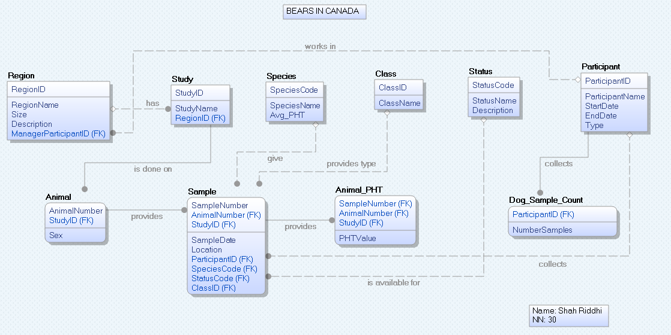

**OLD PHYSICAL MODEL Memo 5**

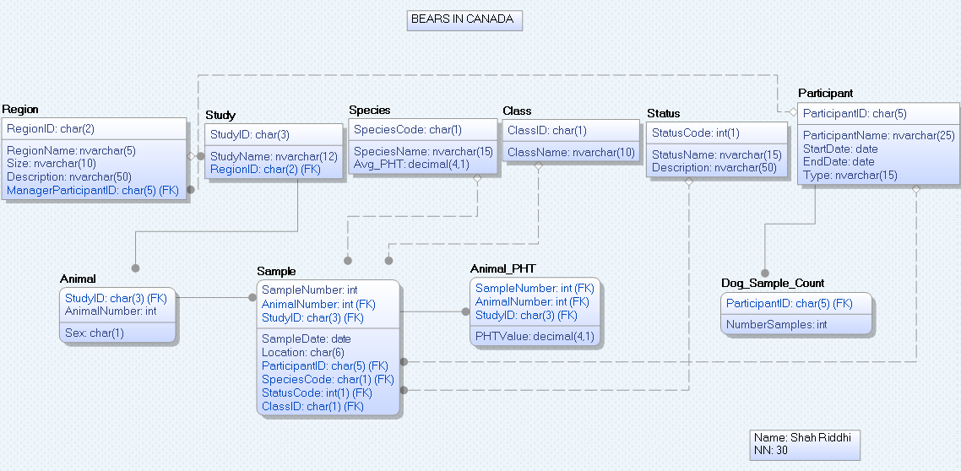

**OLD LOGICAL MODEL Memo 4**

