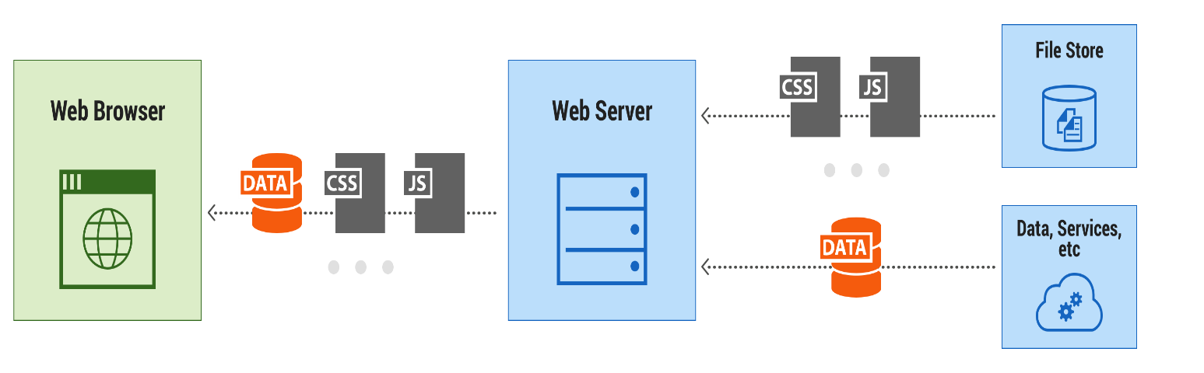

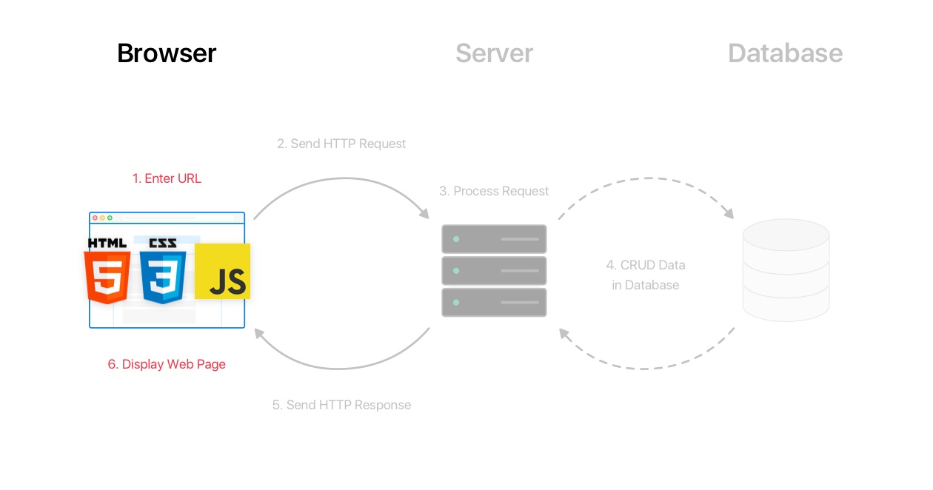

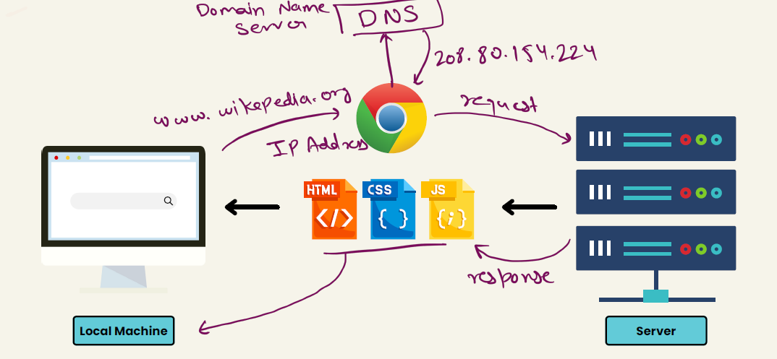

**HTML/CSS/JavaScript uses in web development->**

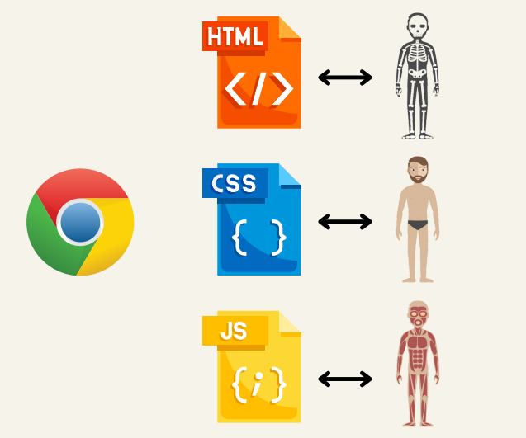

**Tools-> VS Code(auto save) , Live server, any browser for compiling HTML/CSS/JS**

**HTML**

**HTML is the standard markup language for creating Web pages.**

What is HTML?

* HTML describes the structure of a Web page
* HTML consists of a series of elements
* HTML elements tell the browser how to display the content
* HTML elements label pieces of content such as "this is a heading", "this is a paragraph", "this is a link", etc.

Understandings Term using Example with code->

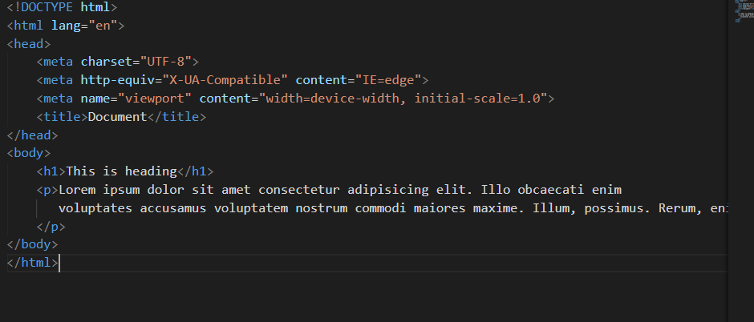

* The <!DOCTYPE html> declaration defines that this document is an HTML5 document
* The <html> element is the root element of an HTML page
* The <head> element contains meta information about the HTML page
* The <title> element specifies a title for the HTML page (which is shown in the browser's title bar or in the page's tab)
* The <body> element defines the document's body, and is a container for all the visible contents, such as headings, paragraphs, images, hyperlinks, tables, lists, etc.
* The <h1> element defines a large heading
* The <p> element defines a paragraph

## HTML Elements

The HTML **element** is everything from the start tag to the end tag:

<tagname>Content goes here...</tagname>

HTML Formatting Elements

Formatting elements were designed to display special types of text:

* <b> - Bold text
* <u> - underline text
* <strong> - Important text
* <i> - Italic text
* <em> - Emphasized text
* <mark> - Marked text
* <small> - Smaller text
* <del> - Deleted text
* <ins> - Inserted text
* <sub> - Subscript text
* <sup> - Superscript text
* <hr> - a horizontal line

## HTML Links

## <a href=<https://www.w3schools.com> target=”_blank” >This is a link</a>

## (adding self html file as a link)

<a href="index.html">head</a>

## 

## HTML Images

## <img src="w3schools.jpg" alt="W3Schools.com" width="104" height="142">

HTML Attributes

* All HTML elements can have **attributes**
* Attributes provide **additional information** about elements
* Attributes are always specified in **the start tag**
* Attributes usually come in name/value pairs like: **name="value"**

<tag att1=”xyz” att2=”xyz2” att3=”xyz3”>conten……..<\tag>

**HTML List-**

<ul>

        <li type="squre">burger</li>  <!-- disc circle -->

        <li>tea</li>

        <li>pasta</li>

    </ul>

    <ol type="1" start="5">     <!-- type="1","A","a" -->

    <li>vikas</li>

    <li>rohit</li>

    <li>saumik</li>

    </ol>

    <p>A description list, with terms and descriptions:</p>

    <dl>

        <dt>Coffee</dt>

        <dd>Black hot drink</dd>

        <dt>Milk</dt>

        <dd>White cold drink</dd>

      </dl>

HTML Table-

 <table border="6" cellspacing="15px" cellpadding="5px"  >

        <tr> <!-- tr->table row -->

            <th>name</th>    <!-- th->table head -->

            <th>dist</th>

            <th>roll</th>

        </tr>

        <tr bgcolor="blue" >

            <td bgcolor="red" colspan="2" rowspan="3">vikas</td>

 <!-- rowspan->number of rows filled, colspan->number of colom filled -->

           <!-- th->table data -->

<td>azamgarh</td>

            <td>056</td>

        </tr>

        <tr >

            <td>jitendra</td>

            <td>bikaner</td>

            <td>023</td>

        </tr>

<tr >

            <td>kisan</td>

            <td>pune</td>

            <td>093</td>

        </tr>

</table>

# HTML <input> Tag-

* <input type="button">
* <input type="checkbox">
* <input type="color">
* <input type="date">
* <input type="datetime-local">
* <input type="email">
* <input type="file">
* <input type="hidden">
* <input type="image">
* <input type="month">
* <input type="number">
* <input type="password">
* <input type="radio">
* <input type="range">
* <input type="reset">
* <input type="search">
* <input type="submit">
* <input type="tel">
* <input type="text"> (default value)
* <input type="time">
* <input type="url">
* <input type="week">
* <form action="/action_page.php">
* <label for="fname">First name:</label>
* <input type="text" id="fname" name="fname"><br><br>
* <label for="lname">Last name:</label>
* <input type="text" id="lname" name="lname"><br><br>
* <input type="submit" value="Submit">
* </form>

## Input tag -Type Attribute-

## button checkbox color date datetime-local email file hidden image month number password radio range reset search submit tel text time url week

**HTML Form tag-**

 <form action="" method="post">

        <label for="name">Name</label>

        <input type="text">

        <br><br>

        <label for="name">District</label>

        <input type="text">

        <br><br>

        <label for="email">Email</label>

        <input type="email">

        <br><br>

        <label for="date">Date</label>

        <input type="date">

        <br><br>

        <label for="date">button</label>

        <input type="button" value="click">

        <br><br>

        <label for="">please select your plan</label>

        <select name="choose" id="">

            <option value="defalt">select</option>

            <option value="personel">personel</option>

            <option value="business">business</option>

            <option value="premium">premium</option>

            <option value="">super premium</option>

        </select>

        <br> <br> <br>

        <p> which subject do you prefer in class 12th =</p>

        physics<input type="checkbox" name="" id="">

        chemistry<input type="checkbox" name="" id="">

        mathmetics<input type="checkbox" name="" id="">

        punjabi<input type="checkbox" name="" id="">

        english<input type="checkbox" name="" id="">

        <br><br>

        textarea <br>

        <textarea name="" id="" cols="30" rows="10">

         sumit your feedback

        </textarea>

        <br><br>

        <label for="">Gender</label>

        <input type="radio" name="gender" id="">Male

        <input type="radio" name="gender" id="">Female

        <input type="radio" name="gender" id="">Trans

        <br><br><br>Time

        <input type="time" name="" id="" value="23">

        <br><br>Range

        <input type="range" id="a" value="50">

    </form>