GOLLIS UNIVERSITY
HARGAISA TEXT
Hargeisa Municipal Tax & Property Management System
SOFTWARE REQUIREMENTS SPECIFICATION

Document Detail | Information
Prepared by | Ridwaan Cabdirahman Maxamed
Institution | Gollis University
Document version | 1.0
Date | August 7, 2026
Status | University Project Documentation

This specification describes only the behavior confirmed in the supplied source code, configuration, database schema, tests, and user interface.

Table of Contents and Document Information
Section | Content | Page
1 | Cover Page | 1
2 | Table of Contents and Document Information | 2
3 | Introduction | 3
4 | Overall System Description | 4
5 | Functional Requirements | 5
6 | User Roles, Use Cases, and User Flow | 6
7 | Data and Database Requirements | 7
8 | External Interface and UI Requirements | 8
9 | Non-Functional Requirements | 9
10 | Constraints, Testing, Conclusion, and Future Enhancements | 10

2.1 Document Control
Item | Value
Title | Hargaisa Text – Software Requirements Specification
Version / date | 1.0 / August 7, 2026
Author / institution | Ridwaan Cabdirahman Maxamed / Gollis University
Source basis | Repository code, README, SQL schema, tests, configuration, UI pages, and existing documentation

2.2 Purpose and Audience
This document defines the verified software requirements of the Hargeisa municipal property portal. It provides a shared reference for academic supervisors, students, municipal administrators, software developers, testers, deployment staff, and future maintainers.
Interpretation rule: anything not confirmed by the current implementation is labelled “Not specified in the current project” or “Future Enhancement.”

3. Introduction

3.1 Background and Problem Statement
Municipal property information is difficult to manage when ownership contacts, listings, maps, status changes, reports, and administrative records are kept in separate files. The implemented system centralizes these activities in a browser-based portal for authorized personnel. It gives staff one controlled source for property and client records, operational reporting, and audit evidence.

3.2 Purpose and Objectives
The project purpose is to support consistent property administration for Hargeisa. Its verified objectives are to:
- authenticate personnel and enforce role-based access;
- create, search, filter, update, map, export, and where authorized delete property listings;
- maintain client records and link clients to properties;
- present dashboards, counts, trends, realized revenue, and a property-location map;
- produce analytics exports and an illustrative per-property tax bill;
- record activity, manage users, notifications, preferences, and database backups.

3.3 Scope
The scope includes a responsive React web client, an Express REST API, MySQL/MariaDB persistence, uploaded property/avatar images, OpenStreetMap display through Leaflet, and administrator-controlled operational tools. The system is an internal administrative portal rather than a public citizen service.

3.4 Definitions and Abbreviations
Term | Meaning
SRS | Software Requirements Specification
RBAC | Role-Based Access Control
GIS | Geographic Information System
JWT / CSRF | Signed session token / cross-site request-forgery protection
Property listing | A rent or sale record with status, price, location, optional client, coordinates, and images
Assessed value | In this implementation, the sum of listing prices; it is not a formal valuation workflow

4. Overall System Description

4.1 System and Product Perspective
Hargaisa Text is a three-tier full-stack application. A React 19 and TypeScript client runs in the browser; an Express 4 API applies validation, security, and business rules; and MySQL/MariaDB stores operational data. Vite proxies /api and /uploads during development. Docker Compose can deploy client, server, and MariaDB containers.
Layer | Implemented responsibility
Presentation | Responsive pages, tables, forms, charts, map, theme/language preferences, and protected navigation
Application/API | Authentication, RBAC, validation, CRUD operations, analytics, exports, audit, uploads, and backup/restore
Data | Relational records, foreign keys, indexes, JSON audit snapshots, and shared rate-limit buckets

4.2 Main Modules
Implemented modules are: sign-in/session; regional dashboard; property inventory and listings; clients; property analytics; tax management; GIS map; reports/exports; notifications; profile and settings; user management; activity logs; and database backup/restore.

4.3 User Categories
Role | System access
Administrator | All modules; user administration; analytics/tax pages; audit logs; backups; destructive record actions
Agent | View all shared operational pages; create and edit properties/clients and manage property images; no admin-only modules or delete
Viewer | Read-only access to shared dashboards, property/client information, GIS, reports, profile, and settings

4.4 Operating Environment, Assumptions, and Dependencies
- Modern browser; Node.js 20.19+ or 22.12+; MySQL-compatible server; network access between browser, API, database, and map tiles.
- Uploaded files and backups require writable persistent storage; mysql and mysqldump are required for restore/backup.
- Production requires HTTPS and secure secrets. Municipal tax law, formal assessment rules, SLA, hardware baseline, and data-retention policy are not specified in the current project.

5. Functional Requirements
The following grouped requirements cover the observable functions found across the UI, routes, controllers, services, schema, and tests. “Input → process → output” is summarized to keep each requirement testable.
ID | Name | Actor | Input | Process | Expected output
FR-01 | Authenticate | All | Username, password, remember option | Validate credentials; rate-limit; issue JWT cookie | Authorized session or clear error
FR-02 | Dashboard | All | Authenticated request | Aggregate counts, types, statuses, trends, sold-price revenue | Overview cards/charts/listings
FR-03 | Properties | All / Agt+ | Search, filters, fields | List/read; admin/agent create or edit; admin delete | Paged validated property records
FR-04 | Images | Admin, Agent | JPG/PNG/WebP files | Validate size/type; attach or remove from property | Stored image URLs/gallery
FR-05 | Clients | All / Agt+ | Contact data, search/page | List/read; admin/agent create/edit; admin delete | Client record linked to property
FR-06 | GIS | All | Latitude/longitude | Plot eligible properties on Leaflet map | Interactive mapped markers
FR-07 | Reports | All; admin analytics | Filters and export choice | Generate CSV/Excel; admin analytics PDF | Downloadable report file
FR-08 | Tax bill | Admin | Property identifier | Apply flat illustrative 1% to listing price | Per-property PDF bill
FR-09 | Personal tools | All | Profile, password, avatar, preferences | Validate and persist changes; list/read notifications | Updated account/settings/read state
FR-10 | Users/RBAC | Admin | User details, role/status/password | Create and administer accounts; enforce protected routes | Controlled admin/agent/viewer access
FR-11 | Audit | Admin | Date/page filters | Record key changes with actor, IP, before/after JSON | Searchable activity log
FR-12 | Backup | Admin | Create/download/SQL upload | Run mysqldump or mysql after filename/file checks | Backup file, download, or restore result

Authorization shorthand: “Agt+” means Administrator or Agent. All record-changing requests are validated by the API.

6. User Roles, Use Cases, and User Flow

6.1 Role Rules
Administrators control sensitive modules and deletions. Agents maintain operational property and client data. Viewers consume shared information without changing it. The client hides restricted navigation, while the API independently rejects unauthorized requests.

6.2 Representative Use Cases
Use case | Actor | Preconditions | Main steps | Expected result
UC-01 Sign in | Any user | Active account exists | Enter credentials → validation → session cookie | Role-appropriate workspace opens
UC-02 Maintain listing | Admin/Agent | Signed in; valid data | Open listings → add/edit → optionally upload images | Validated property is saved and logged
UC-03 Review map/report | Any user | Signed in | Choose GIS or Reports → filter/view/export | Map or CSV/Excel output is shown
UC-04 Administer system | Admin | Admin session | Manage users, review logs, create/download/restore backup | Administrative action completes or fails safely
UC-05 Tax document | Admin | Property exists | Open tax page → filter → generate bill | Illustrative 1% PDF bill downloads

6.3 Main User Flow
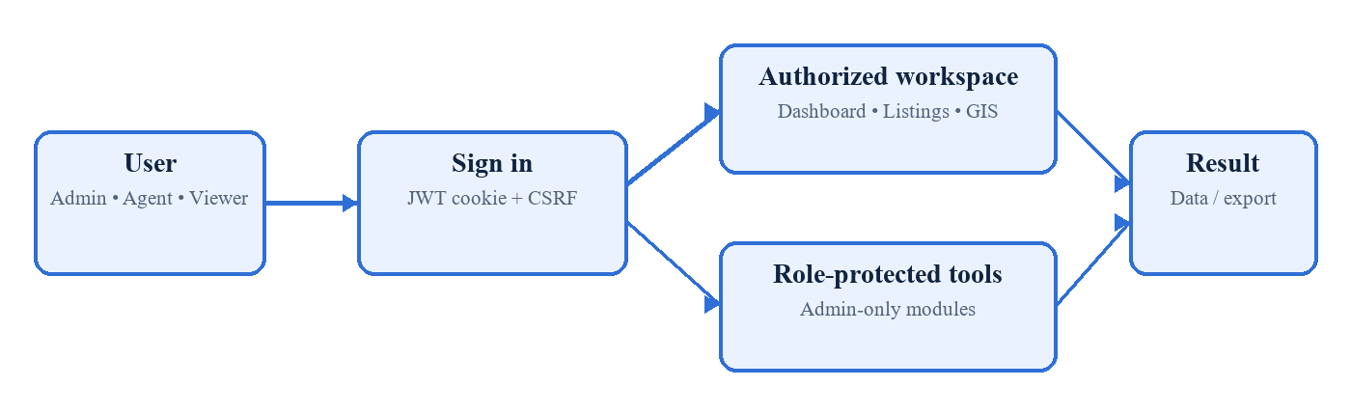
Figure 1. Authentication precedes shared or role-protected work; results are displayed or exported.

7. Data and Database Requirements

7.1 Storage Model
The API uses MySQL/MariaDB with InnoDB and utf8mb4. Keys, foreign-key actions, indexes, ENUM constraints, timestamps, and server-side validation protect the data model. Passwords are stored as bcrypt hashes, never as plain text.
Entity/table | Important stored information
users | Accounts, role, active state, creator, avatar reference
clients | Owner/contact information and optional notes
properties | Listing details, price, location, coordinates, type/status, client and creator
property_images | Many image URLs for one property; cascade delete
notifications / reads | Events plus per-user read status
user_settings | One preference record per user
activity_logs | Actor, action, entity, IP, description, old/new JSON
rate_limit_buckets | Shared request-window counters

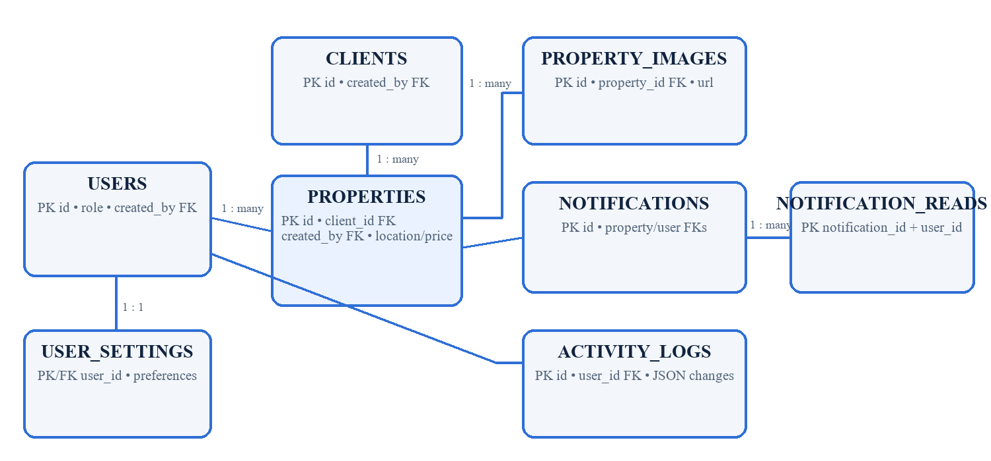
Figure 2. Simplified ERD; properties connect users, clients, images, and notifications. Supporting user data connects settings, reads, and logs.
Key validation: positive prices; latitude −90…90; longitude −180…180; type rent/sale; status available/sold/rented; role admin/agent/viewer; unique username and email.

8. External Interface and UI Requirements

8.1 Main Screens and Navigation
Screen group | Interface requirement
Sign In | Credentials, show/hide password, remember device, validation feedback
Dashboard / Inventory | Regional cards, counts, composition, trend, property-image listings
Property Listings / Clients | Paged tables, search, filters, CRUD forms, image management, exports
Analytics / Tax | Admin charts and PDF analytics; illustrative property-tax roll and bill
GIS / Reports | Leaflet property markers; filtered CSV and full Excel reports
Profile / Settings | Identity, password, avatar; theme, language, timezone, date and notification choices
Admin screens | User management, activity log, and backup/restore

8.2 Software and API Interfaces
- Browser ↔ Express JSON REST API under /api; uploaded files under /uploads; Swagger UI at /api/docs and OpenAPI JSON at /api/docs.json.
- Express ↔ MySQL/MariaDB through mysql2; mysql/mysqldump command-line tools for restore/backup; PDFKit and ExcelJS for documents.
- Leaflet/react-leaflet displays OpenStreetMap tiles. No payment gateway or other production third-party business service is implemented.

8.3 Responsive, Accessibility, and Hardware
The layout includes desktop navigation and a mobile drawer; tables/forms should remain operable on common modern browsers and screen sizes. Existing controls use labels, button text, icons, keyboard-focusable elements, status text, and feedback messages. Formal WCAG conformance testing is not specified in the current project. Dedicated hardware interfaces are not required; a normal client computer, server, storage, and network connection are assumed.

8.4 Navigation Rule
Unauthenticated user → Sign In. Authenticated user → shared workspace. Administrator → additional analytics, tax, activity, user, and backup pages. Unknown routes → Sign In.

9. Non-Functional Requirements
Where the code provides no numeric service target, the requirement below states the observable control and records the missing threshold explicitly.
ID | Quality | Verified requirement
NFR-01 | Performance | Lists shall be paged (limit 1–100); export processing is capped. Response-time target: not specified.
NFR-02 | Security | Use bcrypt, signed httpOnly JWT cookies, CSRF tokens, CORS, Helmet, validation, sanitization, RBAC, and rate limiting.
NFR-03 | Privacy | Restrict data to authenticated municipal personnel and avoid exposing password hashes. Retention/privacy policy: not specified.
NFR-04 | Reliability | Return structured errors, verify DB health, preserve relational integrity, and log important changes.
NFR-05 | Availability | Containers may restart automatically and health checks detect DB failure. SLA/uptime target: not specified.
NFR-06 | Usability | Provide consistent navigation, filters, labels, feedback, status badges, loading states, confirmation prompts, and readable exports.
NFR-07 | Maintainability | Separate UI, routes, controllers, services, models, middleware, types, and automated tests; document API with OpenAPI.
NFR-08 | Scalability | Use indexed queries, pagination, shared DB rate-limit buckets, and stateless signed sessions; capacity target: not specified.
NFR-09 | Compatibility | Support modern browsers, Node.js 20.19+/22.12+, and a MySQL-compatible DB; Docker is an optional deployment path.
NFR-10 | Backup/Recovery | Allow administrators to create, list, download, and restore SQL backups; RPO/RTO and schedule are not specified.

9.1 Security Boundary
Frontend route protection improves usability but is not the trust boundary. The Express API verifies the session and required role for every protected operation. Production configuration must use HTTPS, a strong JWT secret, protected environment files, least-privilege database credentials, and persistent secured upload/backup storage.

10. Constraints, Testing, Conclusion, and Future Enhancements

10.1 Constraints and Acceptance Criteria
Technical constraints are the selected React/Express/MySQL stack, browser-based access, writable upload/backup storage, and availability of mysql utilities. Business rules for statutory assessment, invoices, payments, penalties, appeals, and public access are not specified in the current project.
- AC-01: active users sign in and see only role-permitted screens/actions; unauthorized API access is rejected.
- AC-02: valid property/client data can be listed, filtered, saved, linked, mapped, and exported according to role.
- AC-03: admin analytics, tax PDF, audit, user administration, and backup operations produce correct controlled results.

10.2 Recommended Testing
Retain the implemented Vitest component tests, Jest unit/integration tests, and Playwright end-to-end tests. Test RBAC denials as well as success paths; validation boundaries; CRUD and image workflows; reports/PDFs; map coordinates; settings; audit entries; backup restore in an isolated database; security headers, CSRF and rate limits; responsive layouts; and a production-like Docker deployment. Use a dedicated test database.

10.3 Known Limitations and Future Enhancements
Status | Item
Known limitation | The 1% tax is explicitly illustrative and based on listing price, not a formal assessment.
Known limitation | Forgot-password delivery, formal WCAG result, SLA, retention policy, and automated backup schedule are not specified.
Future Enhancement | Add governed assessments, configurable rates, exemptions, invoices, payments, receipts, arrears, penalties, appeals, and reconciliation.
Future Enhancement | Add citizen self-service, approved public information, stronger accessibility testing, scheduled off-site backups, and disaster-recovery targets.

10.4 Conclusion
The current system is a coherent, test-backed administrative property platform with strong role separation, reporting, mapping, audit, and recovery foundations. It supports an academic demonstration well, provided the illustrative tax output is not presented as a complete statutory tax-payment system.

10.5 Approval
Prepared by | Reviewed by | Approved by
Name: __________________  Signature: _______________  Date: ___________________ | Name: __________________  Signature: _______________  Date: ___________________ | Name: __________________  Signature: _______________  Date: ___________________

