**128**

Throughput: 69.333

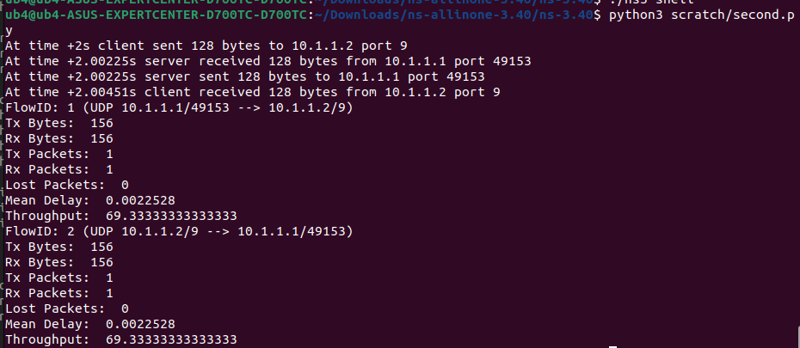

**256**

Throughput: 126.223

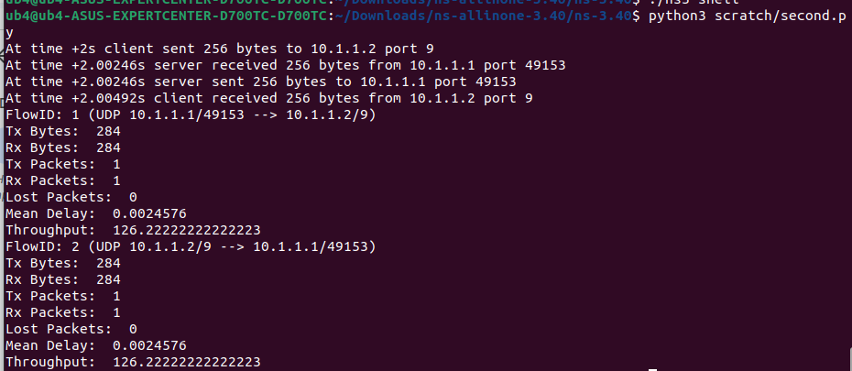

**512**

Throughput: 240

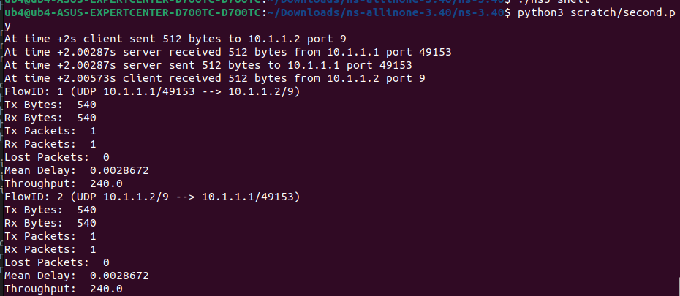

**1024**

Throughput: 467.554

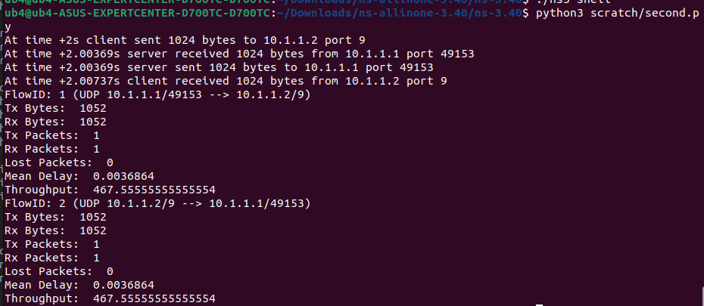

**2048**

Throughput: 922.666

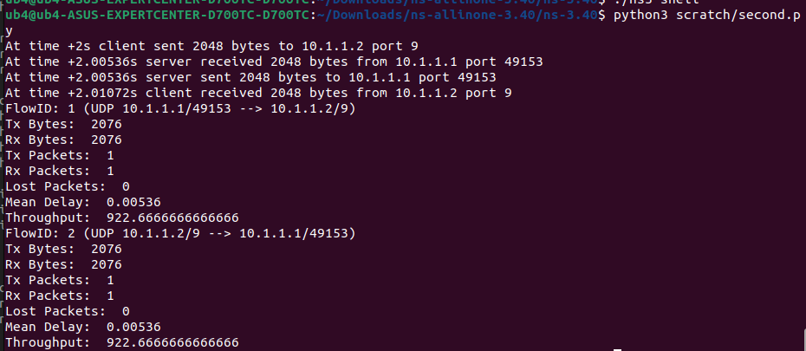

**Graph**

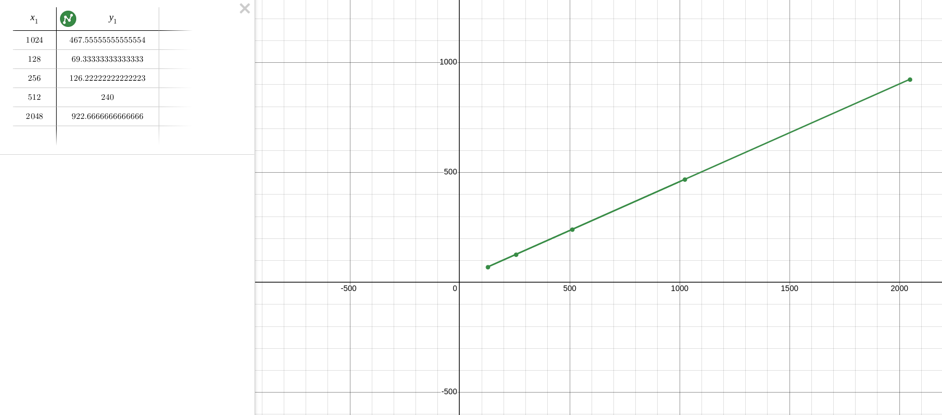

In the graph, x-axis is the packet sizes and y-axis is the throughput. We know that the throughput is the actual rate of data successfully transmitted over a network in a given time. In the graph, we can see that by increasing the packet sizes, the throughput values also increase linearly, which also makes sense. Because, if you send larger packets, more data is transmitted per unit of time, increasing throughput.That’s why, by increasing the packet sizes, the throughput also increases. Here, the max value of throughput is 922.666 which is for 2048 packet sizes. And the minimum throughput is 69.333 which is for 128 packet sizes.